COLLEGE MANAGEMENT SYSTEM
a sOFTWARE REPORT
Shiva Sagar B(12CO83)
Siddartha L K (12CO91)
Thejdeep G (12CO99)

Contents
1.Abstract and Introductio

2.Requirement Tool :RTH 2
3. Requirements Table After Data: 4
4.Design Tool :ArgoUML 5
5.FRAMEWORKS:- 11
6.Web Servers:- 12
7. Conclusion
8. References
ABSTRACT:
College Management Software is a web based college management system offering high flexibility and an abundance of features to collaborate and create a quality education system. Its main feature is to provide seamless networked campus and a paperless administration. It provides a communication link between faculty and students so that a good feedback system and a knowledge rich environment can be created to improve the education system. This system works across the Internet as well as the organizations intranet and extranet. This software is developed using latest technologies in the software engineering field.

INTRODUCTION:
Educational institutions are now driven by paper work administration which becomes increasingly complex as the number of students increase to large numbers. To avoid this monotonic way of administering college or school activities, a viable and dependable product is needed for the educational sector of the society. This software to be developed aims to be a one-stop solution to all the needs currently lacking by other similar competing software products available in the market. This software is developed after a pretty extensive research done on the sector today, identifying the needs and demands as of now.
RequirementTool :RTH
REQUIREMENT and TESTING HUB is an open source test management tool which also has requirement-management and bug tracking capabilities.
Tool mainly helped in correcting and editing the requirements of the modules that are the parts of the software. Here we can lock the requirements at any time we want and also update it periodically.
But the data in this tool will remain long for a day and it will erase automatically. The changes and update should be made within the time duration given by the RTH tool.
How it is helped:
-It is an open source and online web tool
- Helps to have a clear understanding of requirements
- It can be also used as a testing tool

Snapshots:
1.Requirements fill up:
Ex :Attendance 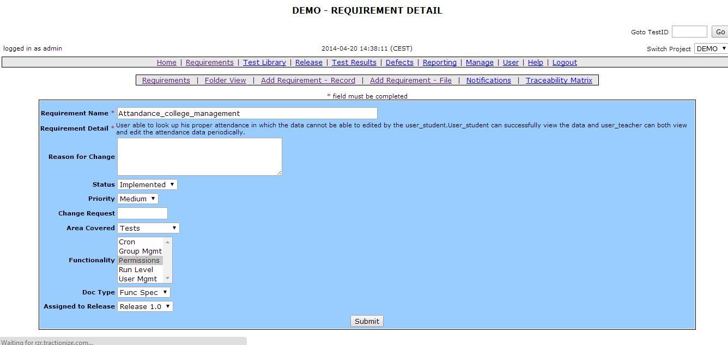

2.Requirements Table After Data:
Ex : Attendance requirements

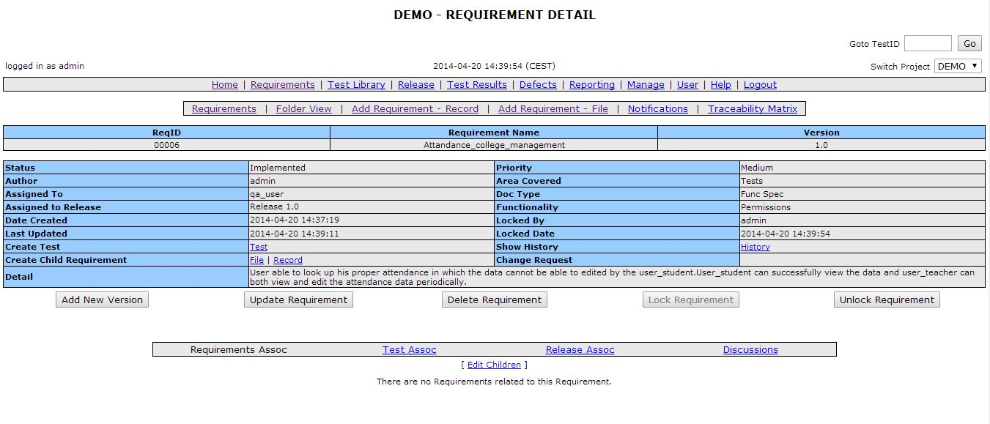
3.Requirements Final Table:
Ex :Calendar requirements
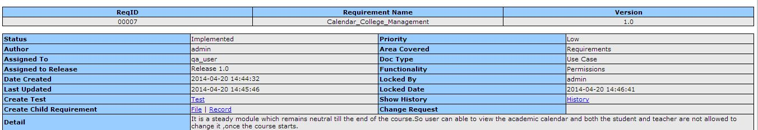

Design Tool :ArgoUML
Argo UML is the leading open source UML modeling tool and includes support for all standard UML 1.4 diagrams. It runs on any Java platform.

Snapshots:
1. Activity Diagram:
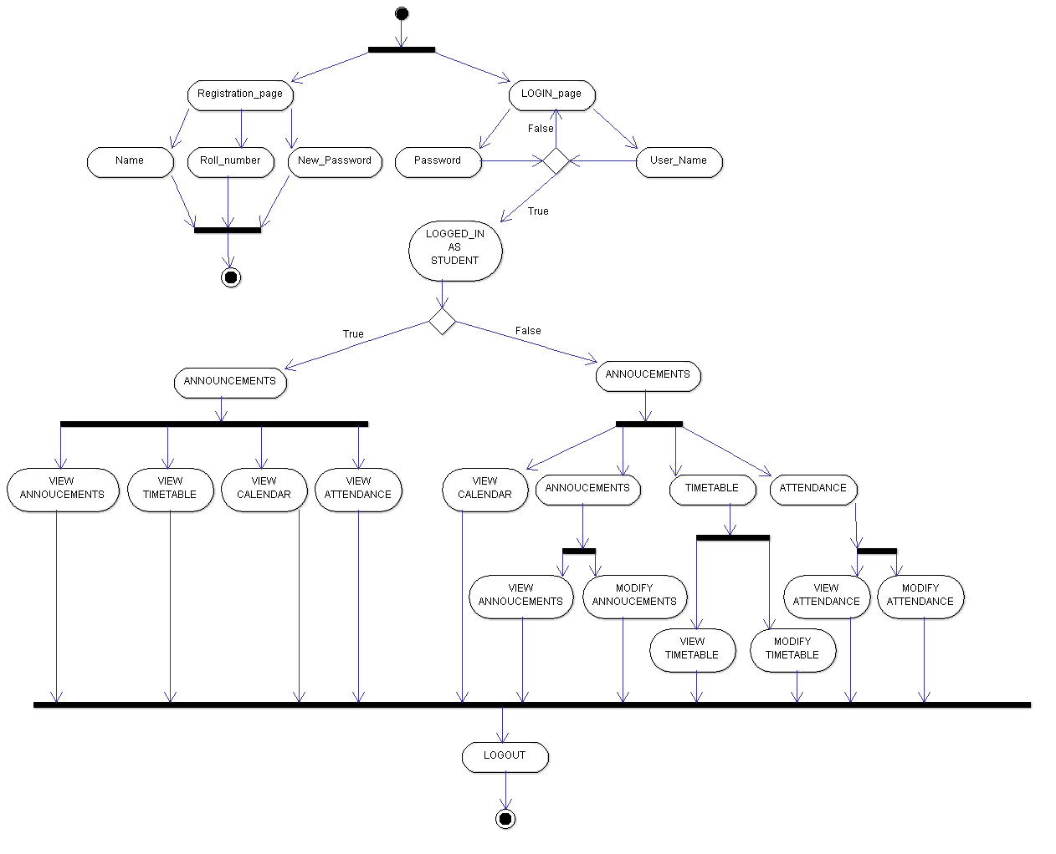

2. Class Diagram:
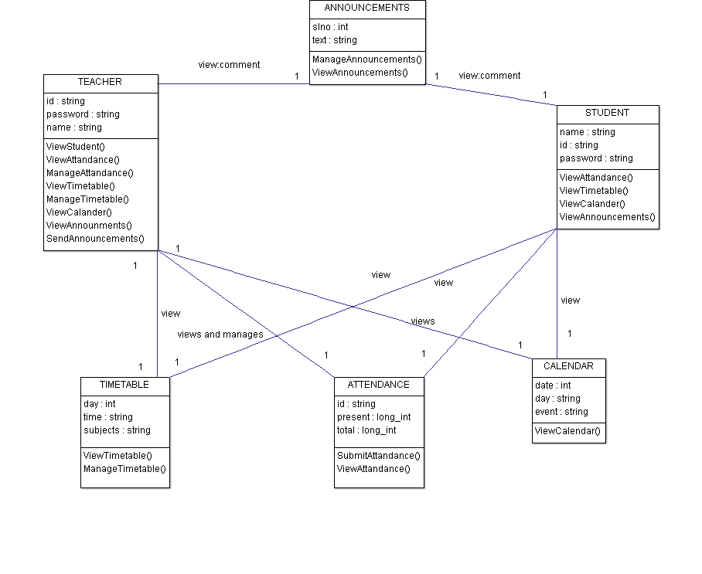
3. Deployment Diagram:
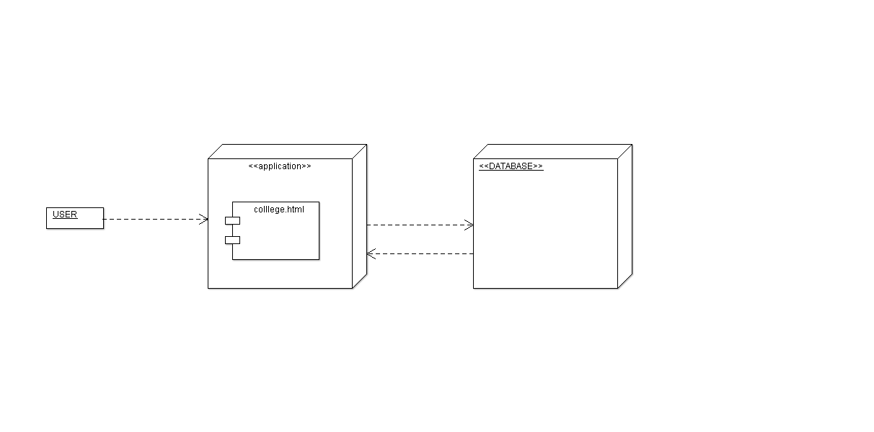
4. Component Diagram:
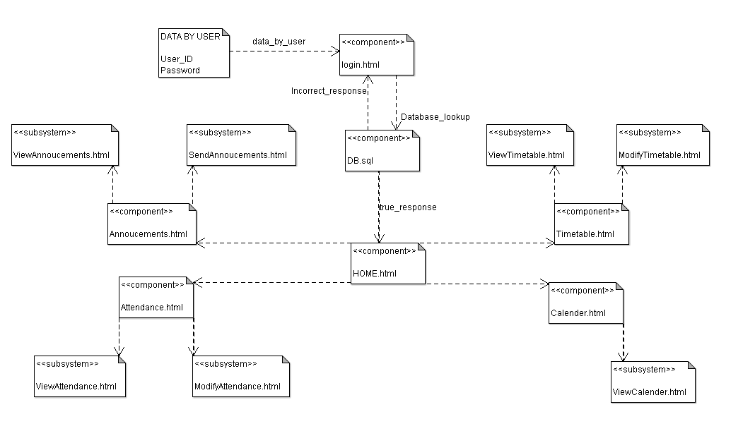
5. Collaboration Diagram:
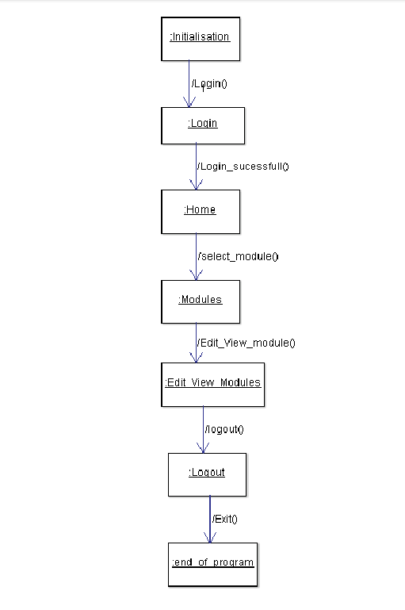
6. Sequence Diagram:
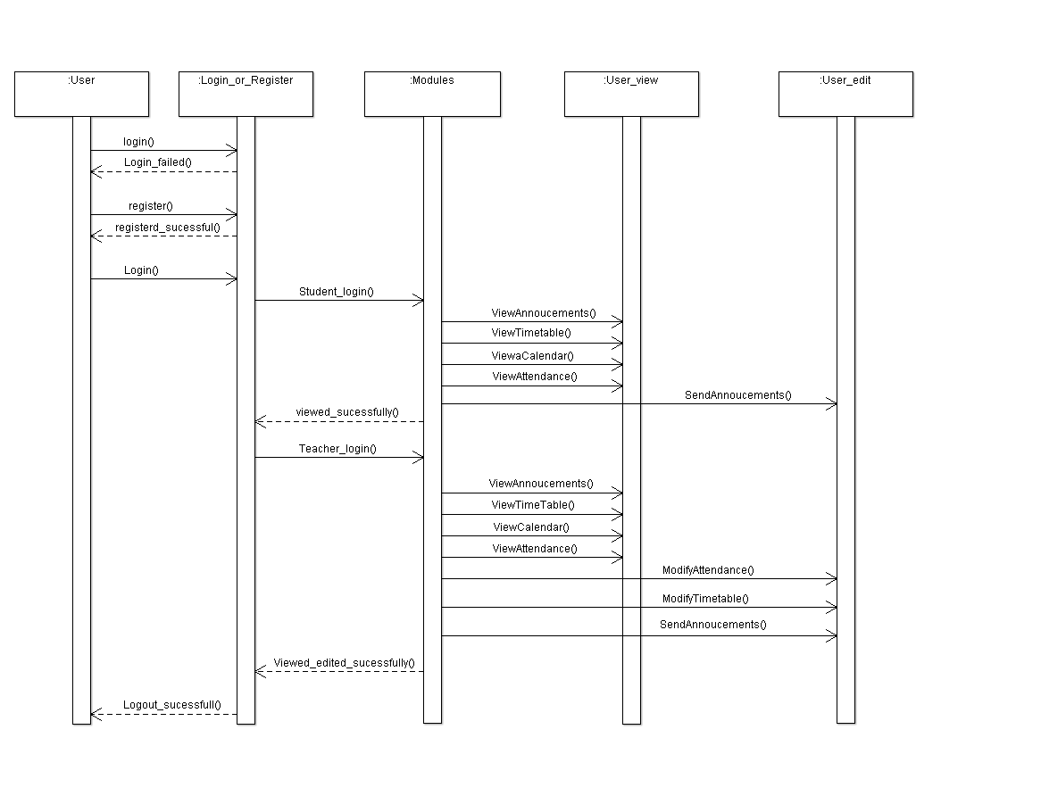
7. Use Case Diagram:
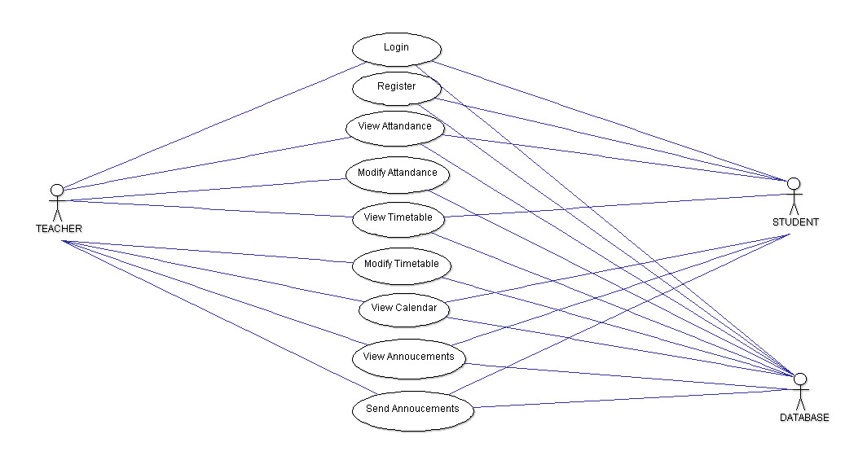
8. State Diagram:
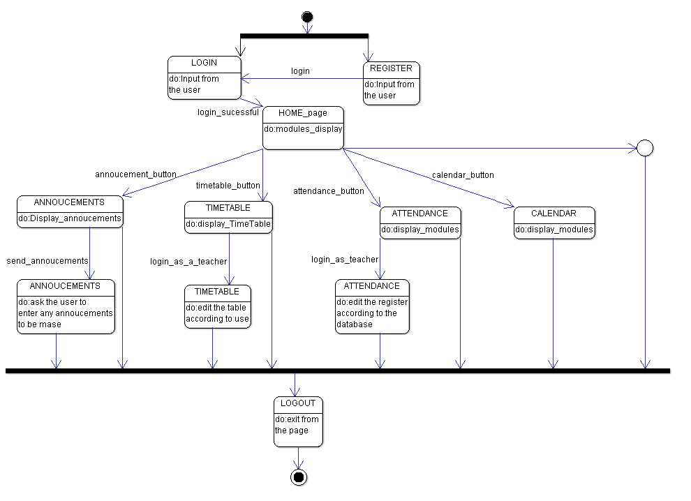

How it helped?
- Argo UML runs on any platform which has Java installed on it
- Diagrams can be easily exported to various image formats
- Supports modeling of various UML diagrams and also editing
- Code generation using the models

DEVELOPMENT TOOLS:
1. Notepad ++
It is a text editor for the Windows Operating System. This
helped in coding part of our software.
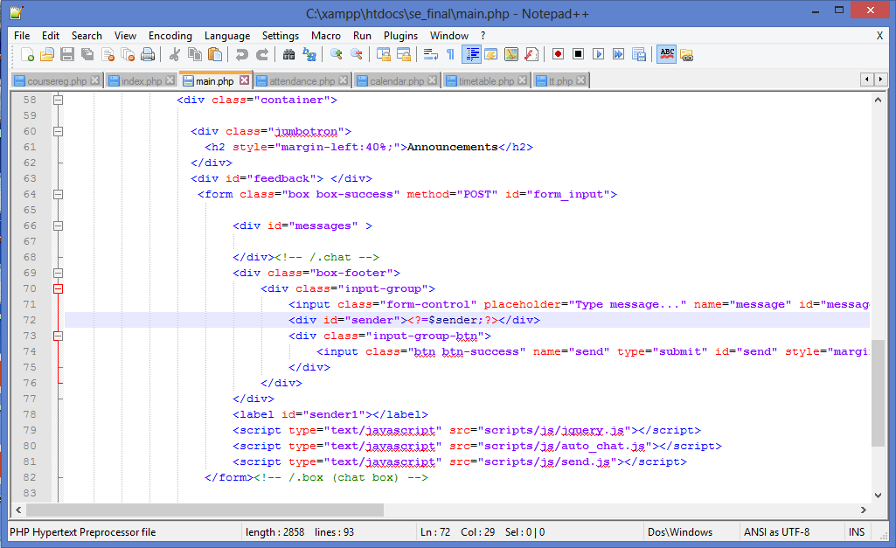
2. Chrome:
Chrome is the web browser which helps to run the
developed websites. This gives a console in browser screen so that
easily the page can be modified according to circumstances.
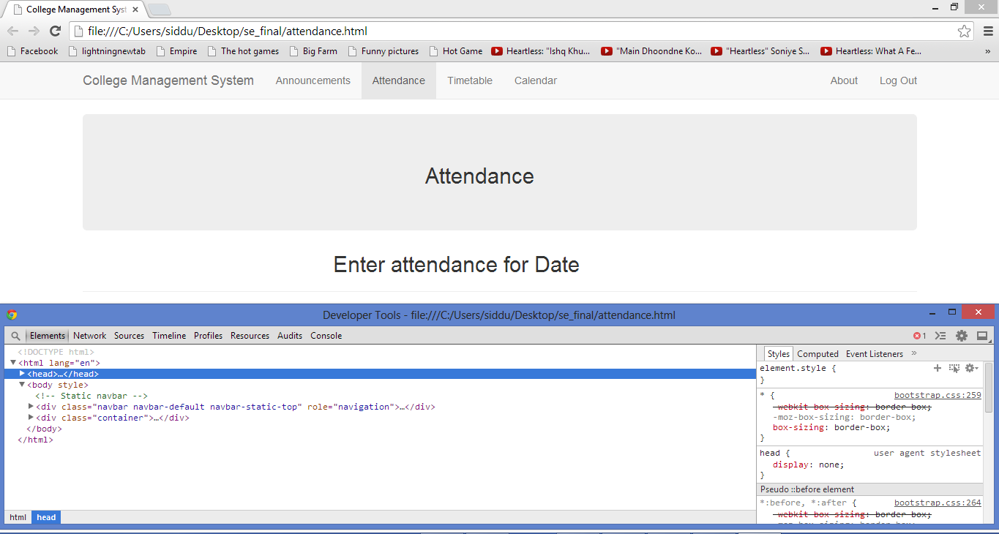
FRAMEWORKS:-
1. Bootstrap:
Bootstrap, a sleek, intuitive, and powerful mobile first
front-end framework for faster and easier web development.
2. JQuery:
jQuery is a cross-platform JavaScript library designed to simplify the client-side scripting of HTML.

DATABASE TOOLS:-
1.MySQL:
MySQL is one of the best RDBMS (relational database management
system) being used for developing web-based software applications.
PHP My Admin -
PHP MyAdmin is a free and open source tool written in PHP
intended to handle the administration of MySQL with the use of a web
browser.
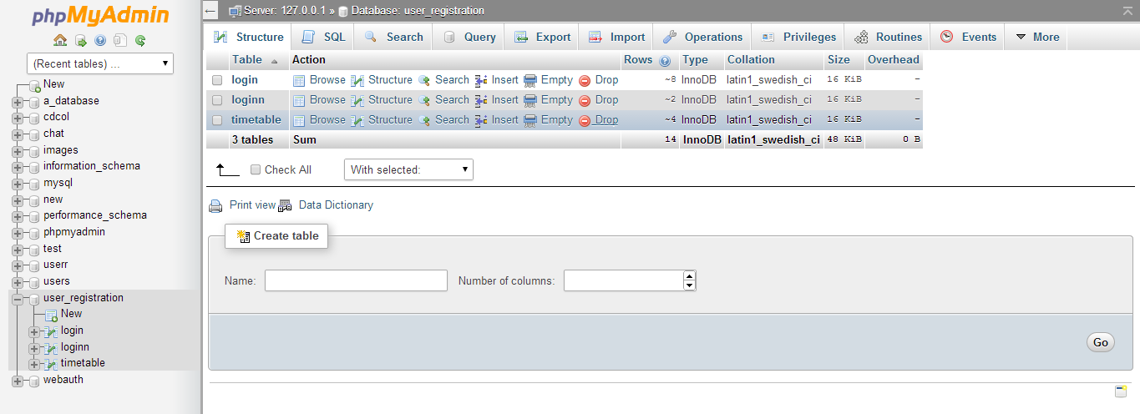

Web Servers:-
XAMPP:
It is a free and open source cross-platform web server solution stack package, consisting mainly of the Apache HTTP Server, MySQL database, and interpreters for scripts written in the PHP and Perl programming languages.
 It is for windows OS.
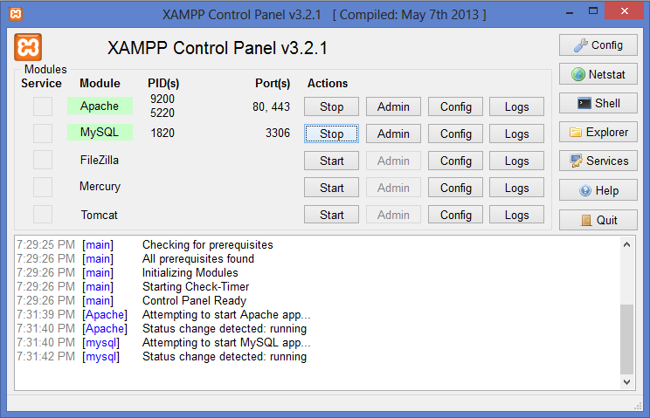

APACHE:
Apache webserver is used to create a local web server for hosting the
website.
This is a list of AMP (Apache, MySQL, Perl/PHP/Python) solution stacks for all computer platforms; these software bundles are used to run dynamic Web sites or servers. There are LAMPs (for Linux); WAMPs (for Windows); MAMPs (for Macintosh); SAMPs (for Solaris); and FAMPs (for FreeBSD).
TESTING TOOLS:
Selenium:
Selenium is a portable software testing framework for web applications. Selenium provides a record/playback tool for authoring tests without learning a test scripting language. The tests can be run against most modern web browsers. Selenium IDE is implemented as a Firefox add-on, and allows recording, editing and debugging tests.

SCREENSHOTS:-
1. This is the proper linking for the modules(pages) that is the linking between
attendance, announcements, Timetable, calendar and logout.
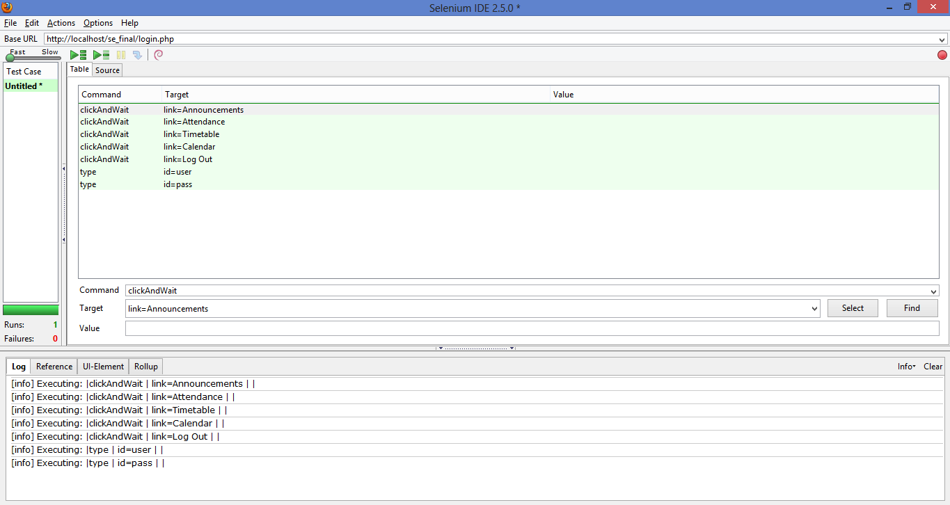Failures 0 represents the pages are linked together.
2. This is the improper linking between login page and announcements page.
This displays error because without login there is no direct navigation
between login page and announcements page.
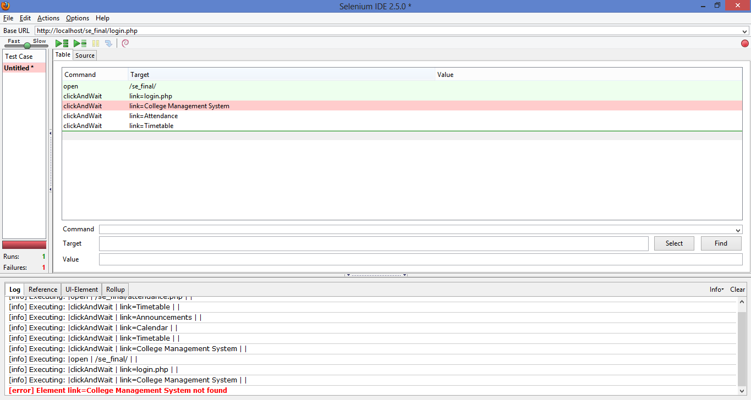
3. Registration successful :
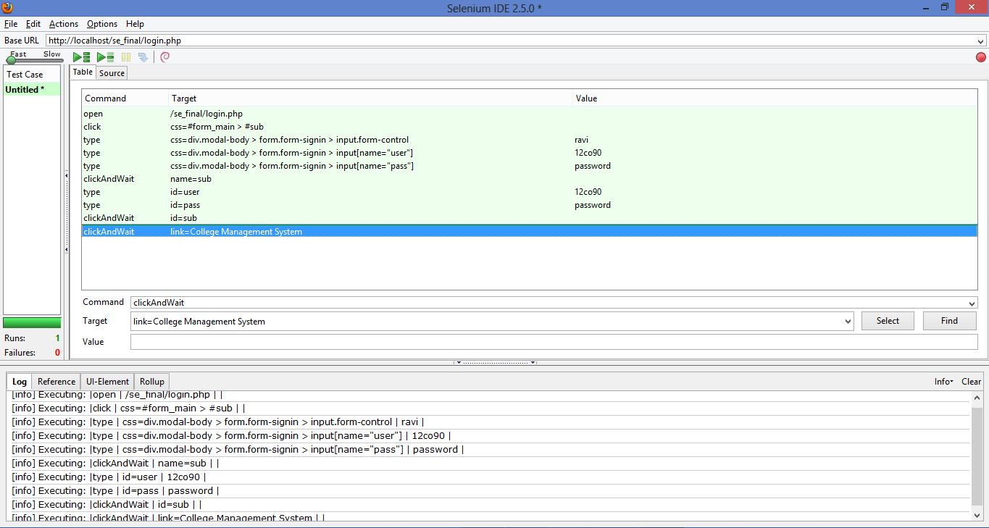
4. Login incorrect:
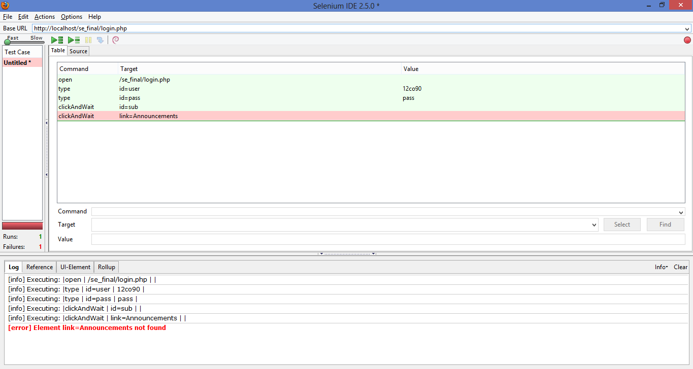
How it helped?
- It supports all modern browsers like Chrome,Firefox, Safari
- Supports all Operating Systems
- Run multiple tests at a time

PROJECT MANAGEMENT TOOLS – PROJECTLIBRE:
ProjectLibre is a project management software system. It intends to be a complete desktop replacement for Microsoft Project. ProjectLibre runs on the Java platform allowing it to run on all operating systems.

SCREENSHOTS:
1.Gnatt Chart showing the various tasks and the timeline

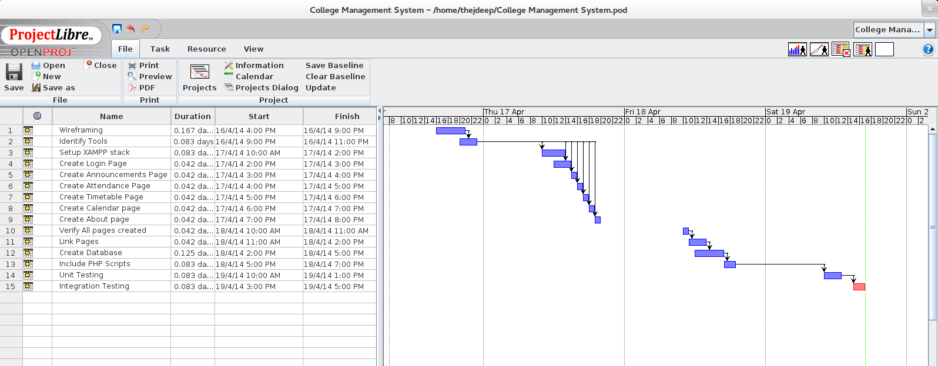
2. Chart showing the task usage
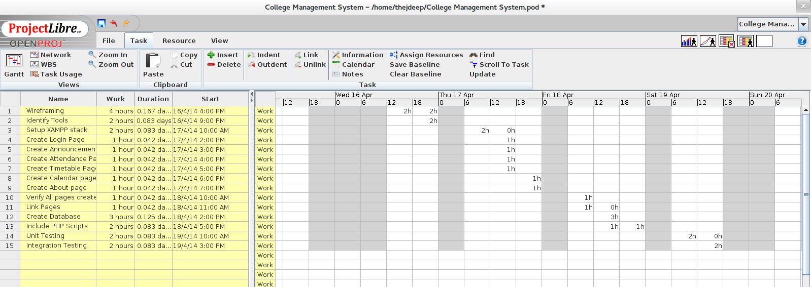
3. Chart showing the network
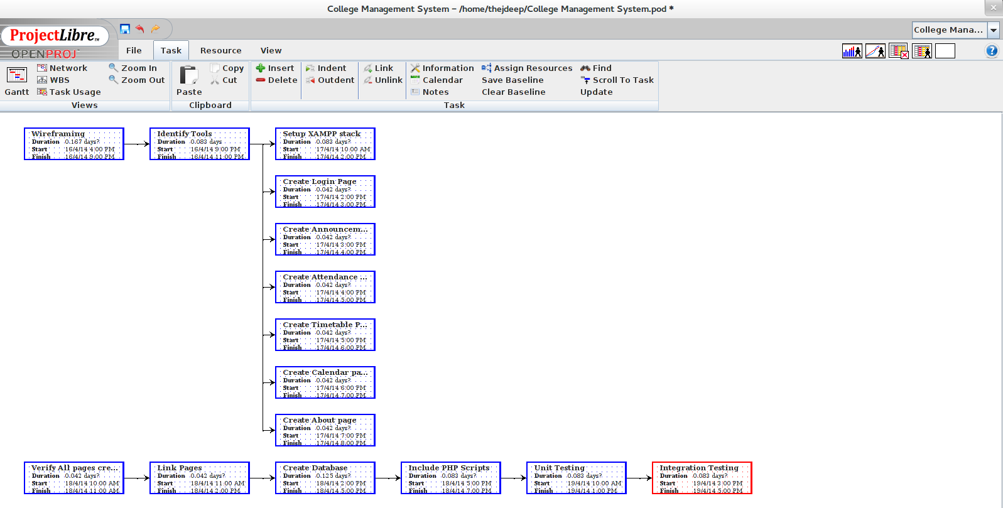

How it helped :
- Ribbon user interface
- Gnatt chart
- Earned value costing
- Task usage reports
- Easy distribution of resources available
- Efficient usage of man hours
- Easy to use intuitive interface
- No manual required to use

PROJECT IMPLEMENTATION :
Using all the above mentioned tools during our software development lifecycle, we were able to successfully implement the software as specified in the requirements stage and design phase. Below are a few screenshots of the final deliverable product :

PROJECT SNAPSHOTS:-
1. Login Page:-
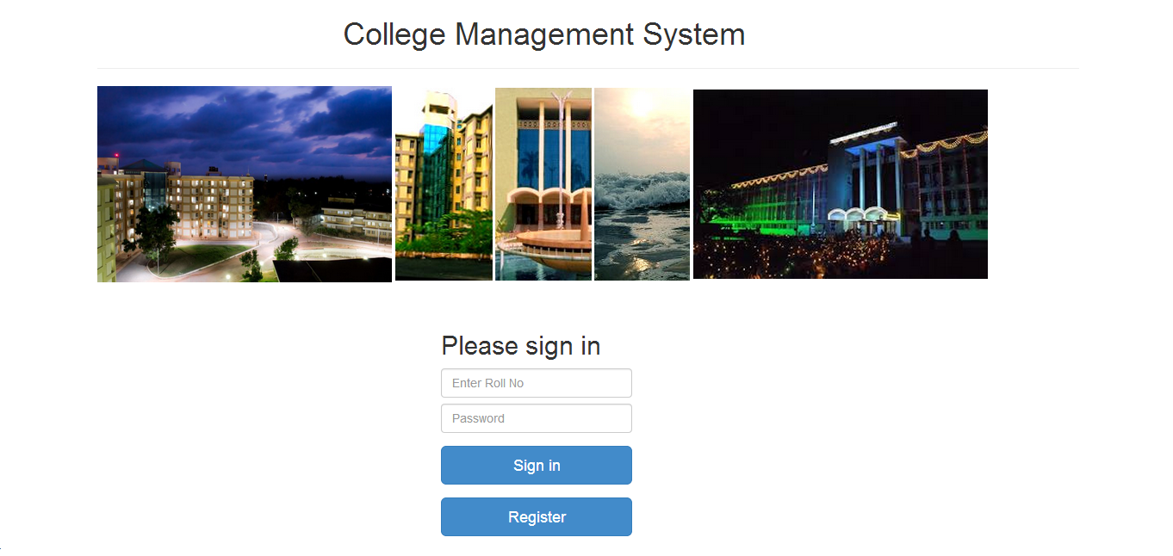
2. ANNOUNCEMENTS:-
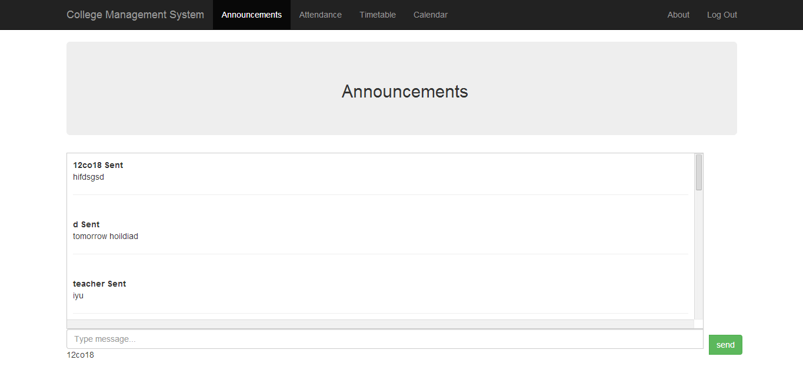

3. ATTANDENCE:-
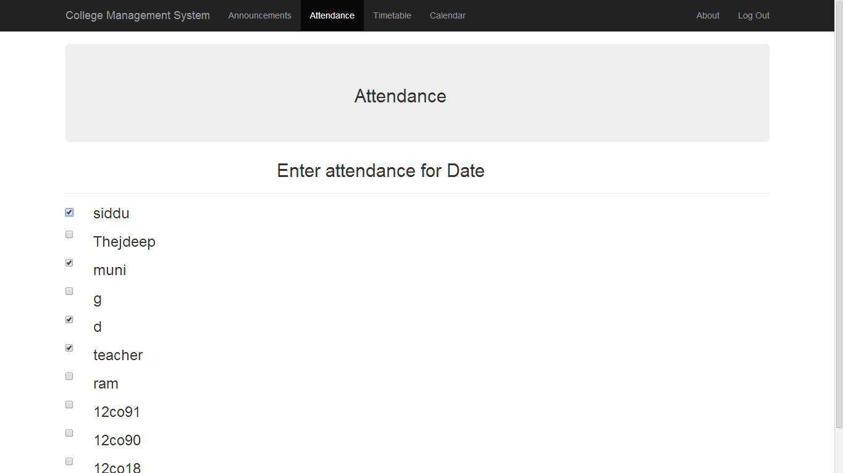
4. TIME-TABLE:-
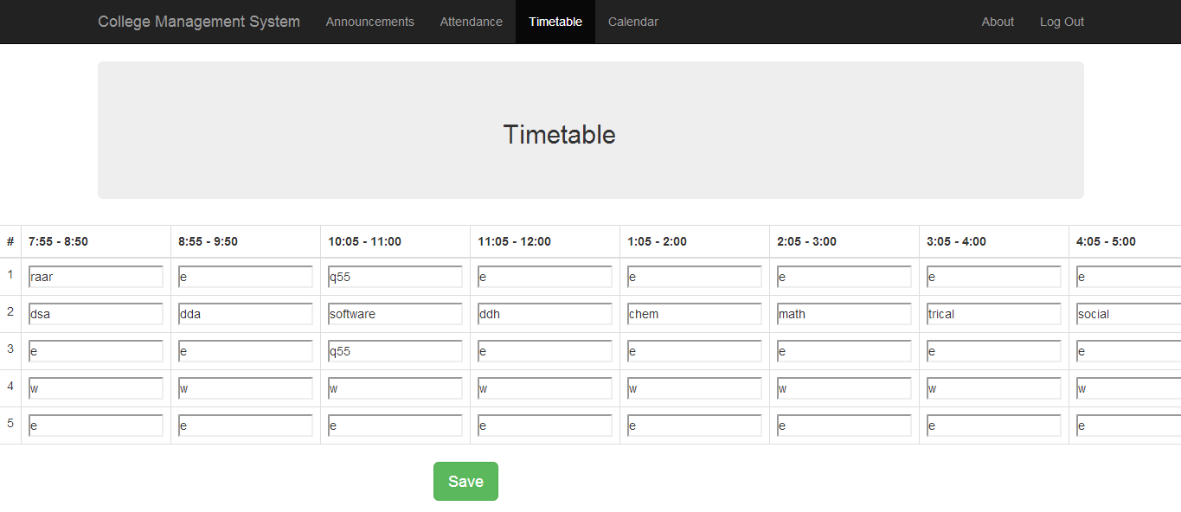

5. CALENDAR:-
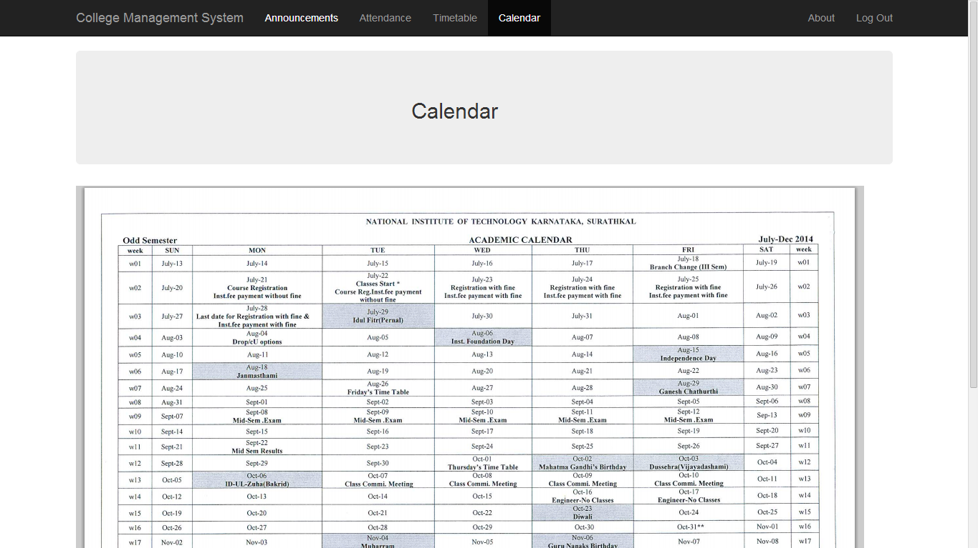
DATABASE SCREENSHOTS:-
1. REGISTRATION TABLE:-
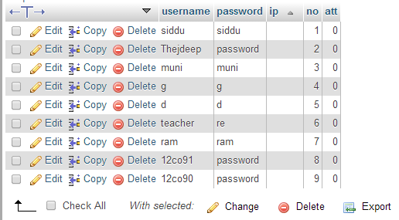
2. ANNOUNCEMENTS TABLE:-
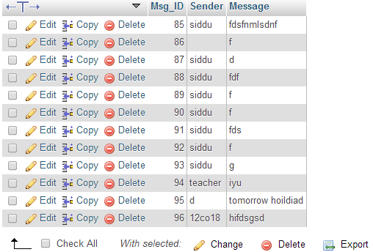
3. TIME-TABLE:-
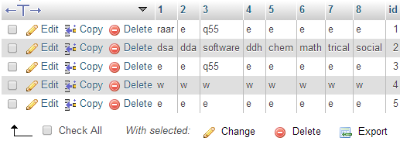

Conclusion :
A school management software that had to meet the current demands and standards of the user base had to be met. A successful implementation of the project was achieved using various tools during the software development lifecycle. The tools proved to be invaluable during the software development phases without which the project would be difficult to either get the requirements right, the design , the implementation or testing the working of the same.

References
www.jquery.com
www.sourceforge.com/rth
www.bootstrap.com
http://argouml.tigris.org
www.selenium.com
www.projectlibre.com

