Test case 1 : only campaign provided by user

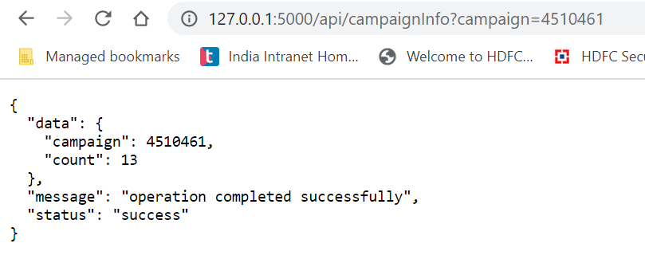

Test case 2: campaign id with proper start date and end date

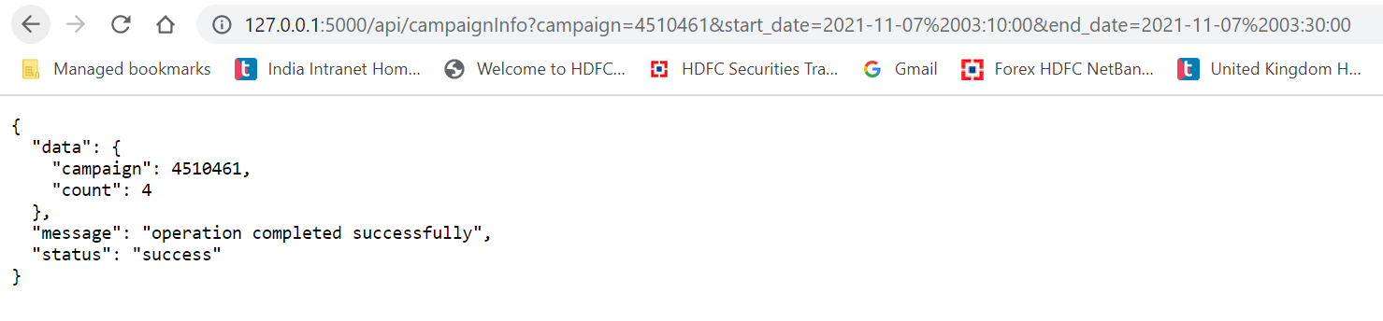

Test case 3 : campaign input blank

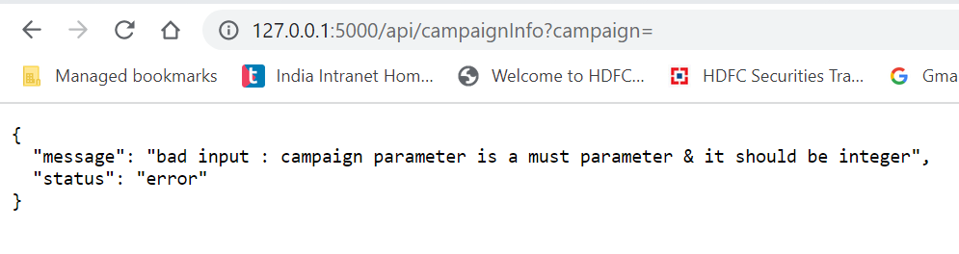

Test case 4 : campaign is not integer

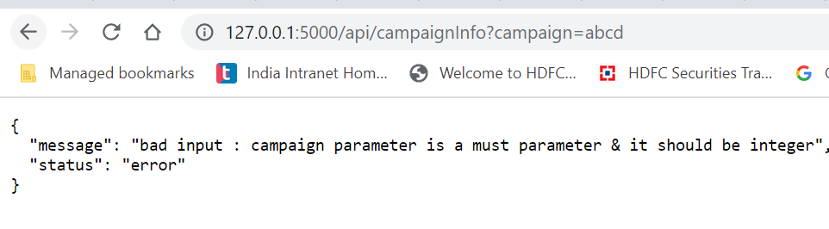

Test case 5: campaign provide but start and end dates not provided correctly

