Employee Management System
30 Business-Oriented SQL Queries
Business Questions Covered
- Q1: Which department has the highest total salary cost?
- Q2: Which department has the lowest total salary cost?
- Q3: Which department has the largest workforce?
- Q4: Which department has the smallest workforce?
- Q5: Which departments have more employees but lower average salary?
- Q6: Which employees are paid more than 20% above the company average?
- Q7: Which employees are earning below their department average?
- Q8: Which employees are earning more than their department average?
- Q9: Which department has the highest average salary?
- Q10: Which department has the lowest average salary?
- Q11: Which managers have the largest teams?
- Q12: Which managers are responsible for more than 4 employees?
- Q13: Which manager controls the highest salary budget?
- Q14: What is the average salary of each manager's team?
- Q15: Which designation creates the highest salary expense?
- Q16: Which designations have the highest average salary?
- Q17: Which departments have a large payroll with only a few employees?
- Q18: Which departments have more than 100000 in salary expense?
- Q19: Which employees belong to high-cost departments?
- Q20: Who are the top 5 salary earners in the company?
- Q21: Which departments have employees earning above 80000?
- Q22: Which department has the largest salary gap between highest and lowest employee?
- Q23: Who is the highest-paid employee under each manager?
- Q24: Who are the top 5 employees by salary?
- Q25: Which departments have more than one employee earning above 70000?
- Q26: What percentage of the company payroll is spent by each department?
- Q27: Which managers have the highest average employee salary?
- Q28: Which departments are above average in both salary and workforce size?
- Q29: Which highest-paid employee represents the largest share of their department payroll?
- Q30: What is the complete department salary and workforce report?

Q1: Which department has the highest total salary cost?
Business purpose: Identifies the department that consumes the largest share of the salary budget.

SQL Query
SELECT
d.department_name,
SUM(e.salary) AS total_salary_cost
FROM employee e
JOIN department d
ON e.department_id = d.department_id
GROUP BY d.department_id, d.department_name
ORDER BY total_salary_cost DESC
LIMIT 1;

Output
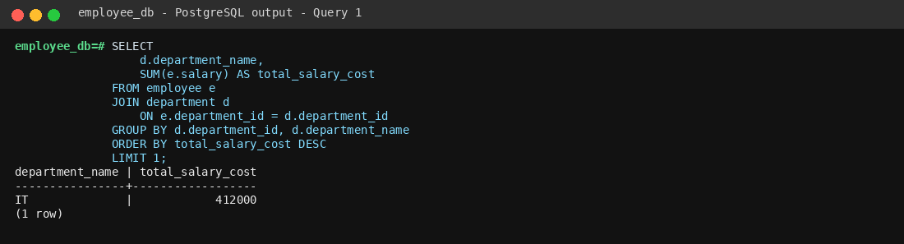
Employee database • Query 1

Q2: Which department has the lowest total salary cost?
Business purpose: Shows the department with the smallest salary expense, useful for budget comparisons.

SQL Query
SELECT
d.department_name,
SUM(e.salary) AS total_salary_cost
FROM employee e
JOIN department d
ON e.department_id = d.department_id
GROUP BY d.department_id, d.department_name
ORDER BY total_salary_cost ASC
LIMIT 1;

Output
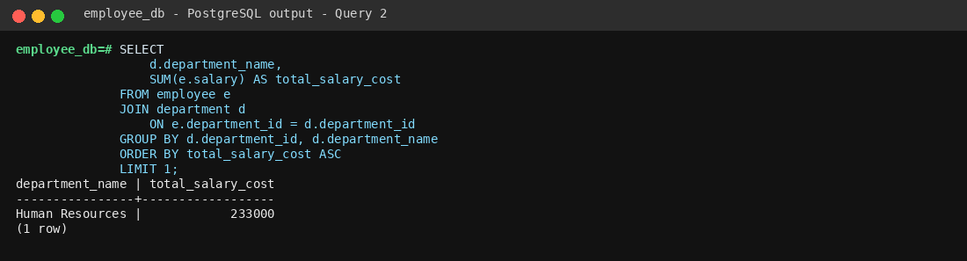
Employee database • Query 2

Q3: Which department has the largest workforce?
Business purpose: Finds the department with the greatest number of employees.

SQL Query
SELECT
d.department_name,
COUNT(e.employee_id) AS employee_count
FROM employee e
JOIN department d
ON e.department_id = d.department_id
GROUP BY d.department_id, d.department_name
ORDER BY employee_count DESC
LIMIT 1;

Output
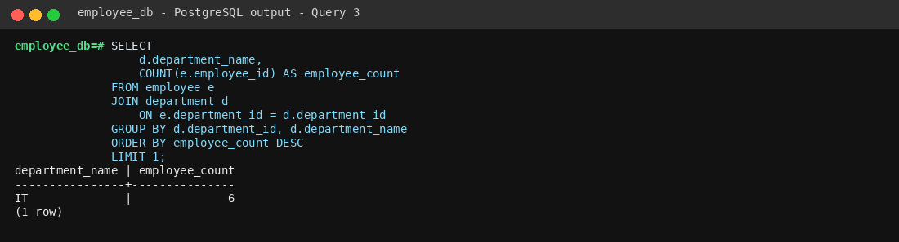
Employee database • Query 3

Q4: Which department has the smallest workforce?
Business purpose: Finds the department with the fewest employees.

SQL Query
SELECT
d.department_name,
COUNT(e.employee_id) AS employee_count
FROM employee e
JOIN department d
ON e.department_id = d.department_id
GROUP BY d.department_id, d.department_name
ORDER BY employee_count ASC
LIMIT 1;

Output
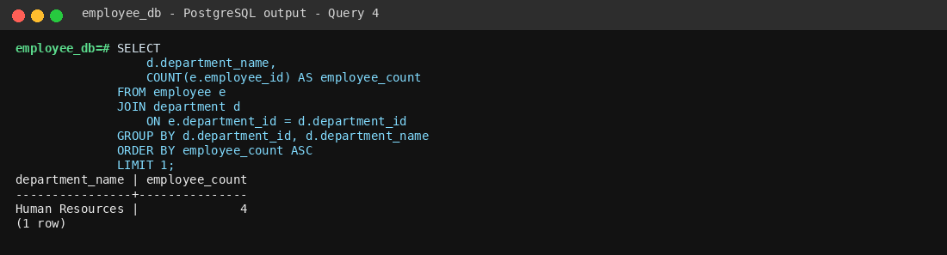
Employee database • Query 4

Q5: Which departments have more employees but lower average salary?
Business purpose: Highlights departments that are larger in size but have comparatively lower average pay.

SQL Query
SELECT
d.department_name,
COUNT(e.employee_id) AS employee_count,
ROUND(AVG(e.salary), 2) AS average_salary
FROM employee e
JOIN department d
ON e.department_id = d.department_id
GROUP BY d.department_id, d.department_name
HAVING COUNT(e.employee_id) > 1
ORDER BY employee_count DESC, average_salary ASC;

Output
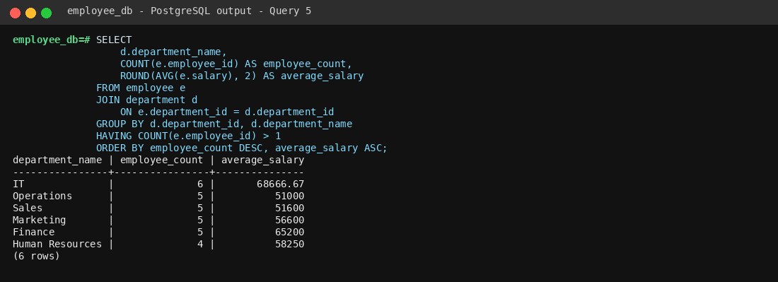
Employee database • Query 5

Q6: Which employees are paid more than 20% above the company average?
Business purpose: Identifies employees whose compensation is significantly above the overall company average.

SQL Query
SELECT
e.first_name || ' ' || e.last_name AS employee_name,
e.salary
FROM employee e
WHERE e.salary > (
SELECT AVG(salary) * 1.20
FROM employee
)
ORDER BY e.salary DESC;

Output
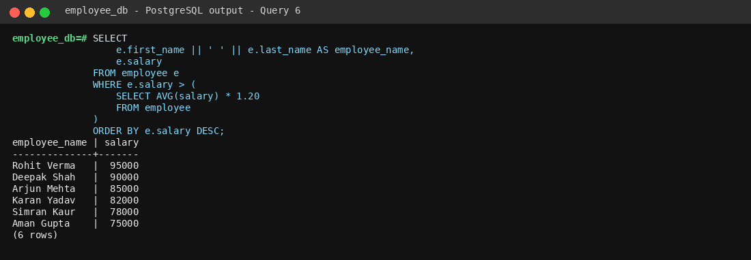
Employee database • Query 6

Q7: Which employees are earning below their department average?
Business purpose: Flags employees whose salary is below the typical pay level in their own department.

SQL Query
SELECT
e.first_name || ' ' || e.last_name AS employee_name,
d.department_name,
e.salary,
ROUND(dept_avg.avg_salary, 2) AS department_average
FROM employee e
JOIN department d
ON e.department_id = d.department_id
JOIN (
SELECT department_id, AVG(salary) AS avg_salary
FROM employee
GROUP BY department_id
) dept_avg
ON e.department_id = dept_avg.department_id
WHERE e.salary < dept_avg.avg_salary
ORDER BY d.department_name, e.salary;

Output
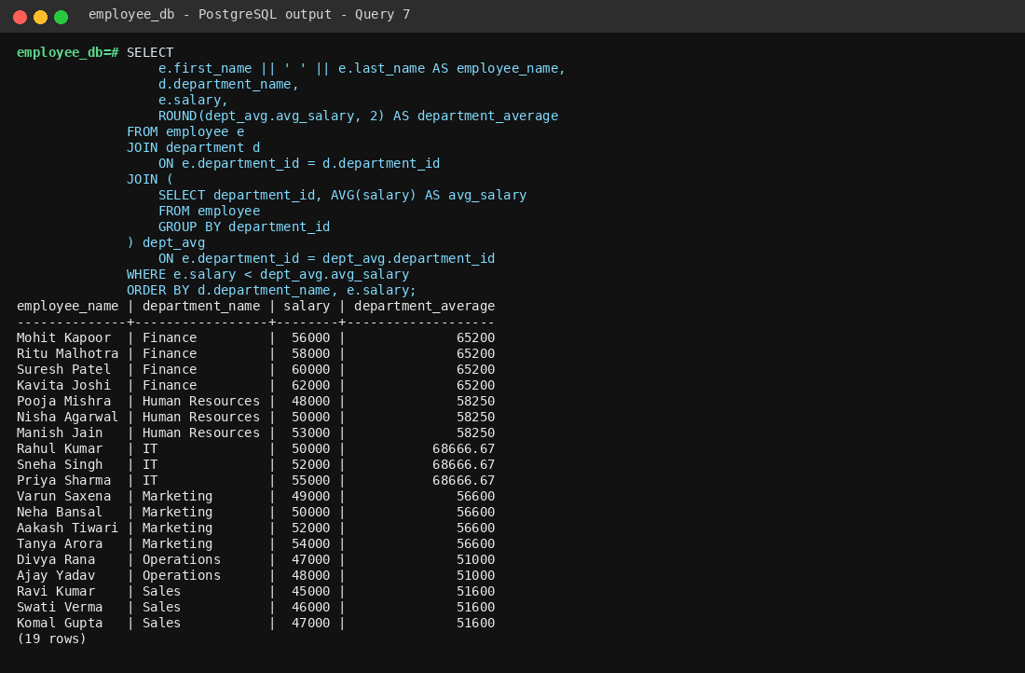
Employee database • Query 7

Q8: Which employees are earning more than their department average?
Business purpose: Identifies employees whose pay is above the normal salary level within their department.

SQL Query
SELECT
e.first_name || ' ' || e.last_name AS employee_name,
d.department_name,
e.salary
FROM employee e
JOIN department d
ON e.department_id = d.department_id
WHERE e.salary > (
SELECT AVG(e2.salary)
FROM employee e2
WHERE e2.department_id = e.department_id
)
ORDER BY e.salary DESC;

Output
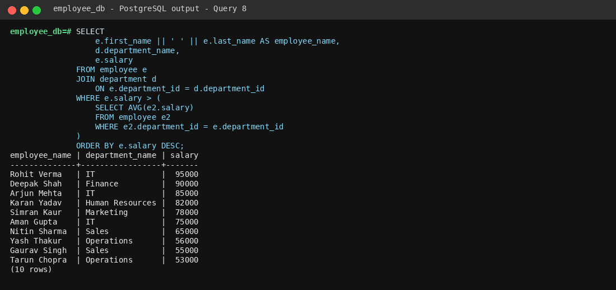
Employee database • Query 8

Q9: Which department has the highest average salary?
Business purpose: Shows where the organization has the highest average employee compensation.

SQL Query
SELECT
d.department_name,
ROUND(AVG(e.salary), 2) AS average_salary
FROM employee e
JOIN department d
ON e.department_id = d.department_id
GROUP BY d.department_id, d.department_name
ORDER BY average_salary DESC
LIMIT 1;

Output
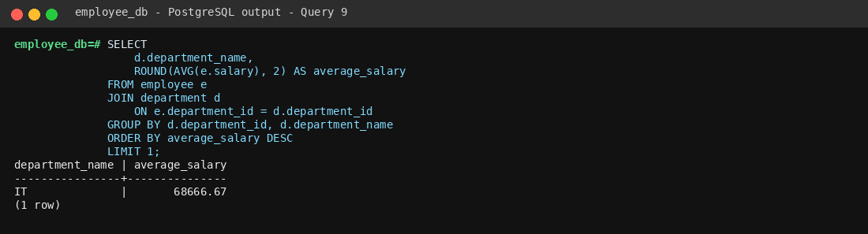
Employee database • Query 9

Q10: Which department has the lowest average salary?
Business purpose: Shows the department with the lowest average employee compensation.

SQL Query
SELECT
d.department_name,
ROUND(AVG(e.salary), 2) AS average_salary
FROM employee e
JOIN department d
ON e.department_id = d.department_id
GROUP BY d.department_id, d.department_name
ORDER BY average_salary ASC
LIMIT 1;

Output
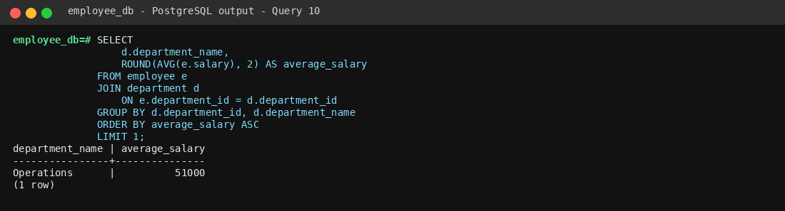
Employee database • Query 10

Q11: Which managers have the largest teams?
Business purpose: Measures manager workload by ranking managers according to team size.

SQL Query
SELECT
m.first_name || ' ' || m.last_name AS manager_name,
COUNT(e.employee_id) AS team_size
FROM manager m
JOIN employee e
ON m.manager_id = e.manager_id
GROUP BY m.manager_id, m.first_name, m.last_name
ORDER BY team_size DESC;

Output

Employee database • Query 11

Q12: Which managers are responsible for more than 4 employees?
Business purpose: Identifies managers with relatively large teams that may require more coordination.

SQL Query
SELECT
m.first_name || ' ' || m.last_name AS manager_name,
COUNT(e.employee_id) AS team_size
FROM manager m
JOIN employee e
ON m.manager_id = e.manager_id
GROUP BY m.manager_id, m.first_name, m.last_name
HAVING COUNT(e.employee_id) > 4;

Output
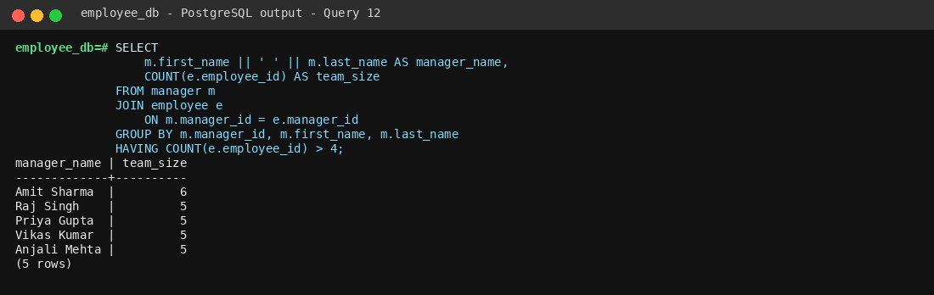
Employee database • Query 12

Q13: Which manager controls the highest salary budget?
Business purpose: Finds the manager whose team represents the largest salary commitment.

SQL Query
SELECT
m.first_name || ' ' || m.last_name AS manager_name,
SUM(e.salary) AS team_salary_budget
FROM manager m
JOIN employee e
ON m.manager_id = e.manager_id
GROUP BY m.manager_id, m.first_name, m.last_name
ORDER BY team_salary_budget DESC
LIMIT 1;

Output
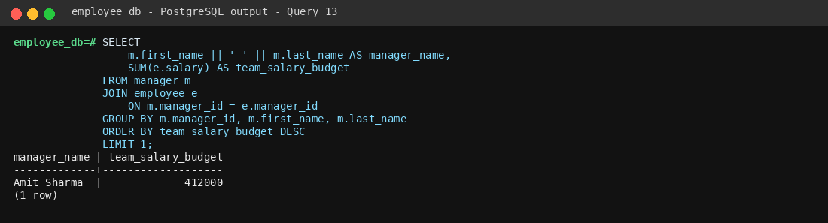
Employee database • Query 13

Q14: What is the average salary of each manager's team?
Business purpose: Compares the average compensation level across different manager-led teams.

SQL Query
SELECT
m.first_name || ' ' || m.last_name AS manager_name,
ROUND(AVG(e.salary), 2) AS average_team_salary
FROM manager m
JOIN employee e
ON m.manager_id = e.manager_id
GROUP BY m.manager_id, m.first_name, m.last_name
ORDER BY average_team_salary DESC;

Output
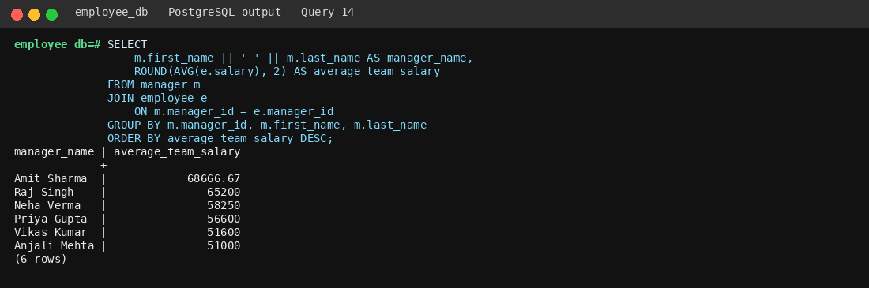
Employee database • Query 14

Q15: Which designation creates the highest salary expense?
Business purpose: Shows which job designation consumes the most total salary budget.

SQL Query
SELECT
ds.designation_name,
COUNT(e.employee_id) AS employee_count,
SUM(e.salary) AS total_salary_cost
FROM employee e
JOIN designation ds
ON e.designation_id = ds.designation_id
GROUP BY ds.designation_id, ds.designation_name
ORDER BY total_salary_cost DESC
LIMIT 1;

Output

Employee database • Query 15

Q16: Which designations have the highest average salary?
Business purpose: Compares average compensation across job roles.

SQL Query
SELECT
ds.designation_name,
ROUND(AVG(e.salary), 2) AS average_salary
FROM employee e
JOIN designation ds
ON e.designation_id = ds.designation_id
GROUP BY ds.designation_id, ds.designation_name
ORDER BY average_salary DESC;

Output
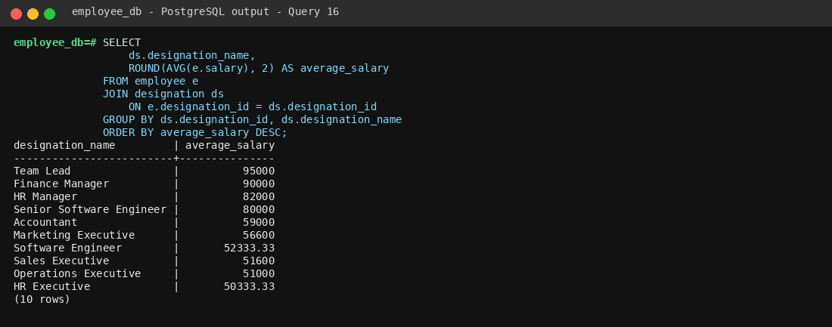
Employee database • Query 16

Q17: Which departments have a large payroll with only a few employees?
Business purpose: Highlights small teams that still represent a relatively large payroll commitment.

SQL Query
SELECT
d.department_name,
COUNT(e.employee_id) AS employee_count,
SUM(e.salary) AS total_payroll
FROM employee e
JOIN department d
ON e.department_id = d.department_id
GROUP BY d.department_id, d.department_name
HAVING COUNT(e.employee_id) <= 3
ORDER BY total_payroll DESC;

Output
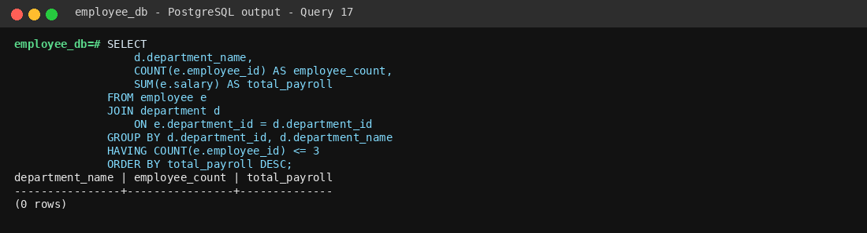
Employee database • Query 17

Q18: Which departments have more than 100000 in salary expense?
Business purpose: Identifies departments whose annual salary cost crosses a budget threshold.

SQL Query
SELECT
d.department_name,
SUM(e.salary) AS total_payroll
FROM employee e
JOIN department d
ON e.department_id = d.department_id
GROUP BY d.department_id, d.department_name
HAVING SUM(e.salary) > 100000
ORDER BY total_payroll DESC;

Output
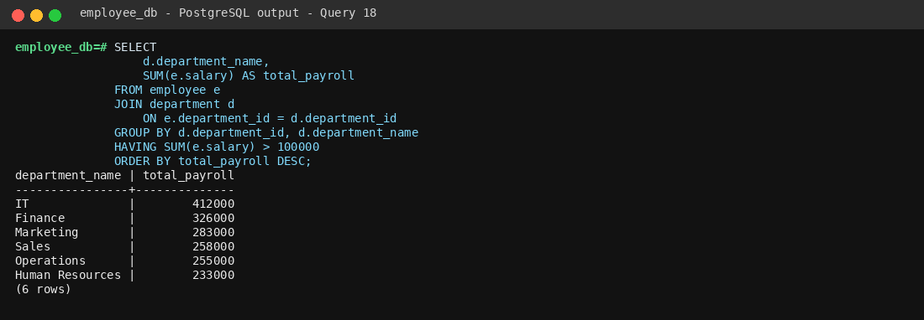
Employee database • Query 18

Q19: Which employees belong to high-cost departments?
Business purpose: Lists employees working in departments whose total payroll exceeds the defined threshold.

SQL Query
SELECT
e.first_name || ' ' || e.last_name AS employee_name,
d.department_name,
e.salary
FROM employee e
JOIN department d
ON e.department_id = d.department_id
WHERE e.department_id IN (
SELECT department_id
FROM employee
GROUP BY department_id
HAVING SUM(salary) > 100000
)
ORDER BY d.department_name, e.salary DESC;

Output
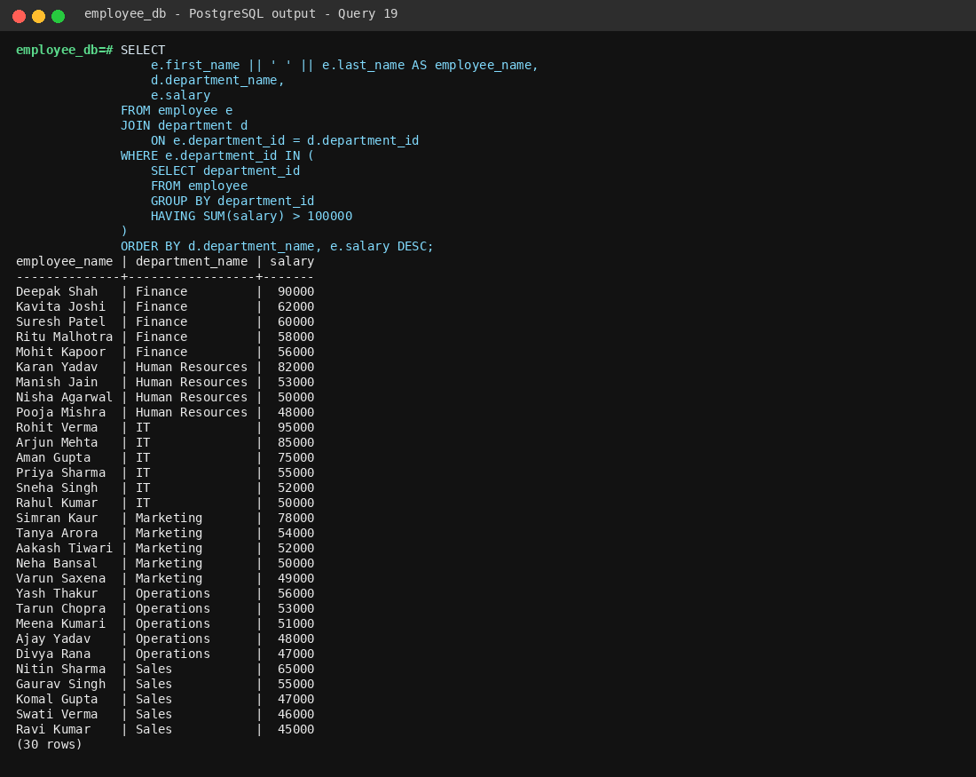
Employee database • Query 19

Q20: Who are the top 5 salary earners in the company?
Business purpose: Shows the five employees with the highest compensation levels.

SQL Query
SELECT
first_name || ' ' || last_name AS employee_name,
salary
FROM employee
ORDER BY salary DESC
LIMIT 5;

Output

Employee database • Query 20

Q21: Which departments have employees earning above 80000?
Business purpose: Measures how many higher-paid employees each department has.

SQL Query
SELECT
d.department_name,
COUNT(e.employee_id) AS high_paid_employees
FROM employee e
JOIN department d
ON e.department_id = d.department_id
WHERE e.salary > 80000
GROUP BY d.department_id, d.department_name
ORDER BY high_paid_employees DESC;

Output
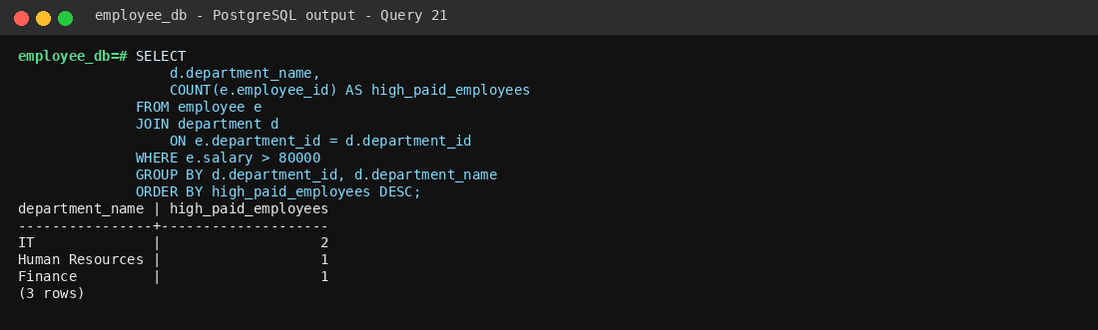
Employee database • Query 21

Q22: Which department has the largest salary gap between highest and lowest employee?
Business purpose: Identifies the department with the widest internal salary spread.

SQL Query
SELECT
d.department_name,
MAX(e.salary) - MIN(e.salary) AS salary_gap
FROM employee e
JOIN department d
ON e.department_id = d.department_id
GROUP BY d.department_id, d.department_name
ORDER BY salary_gap DESC
LIMIT 1;

Output
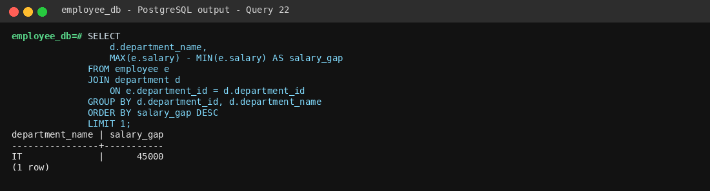
Employee database • Query 22

Q23: Who is the highest-paid employee under each manager?
Business purpose: Shows each manager's highest-paid direct report for compensation review.

SQL Query
SELECT
m.first_name || ' ' || m.last_name AS manager_name,
e.first_name || ' ' || e.last_name AS employee_name,
e.salary
FROM manager m
JOIN employee e
ON m.manager_id = e.manager_id
WHERE e.salary = (
SELECT MAX(e2.salary)
FROM employee e2
WHERE e2.manager_id = e.manager_id
)
ORDER BY e.salary DESC;

Output
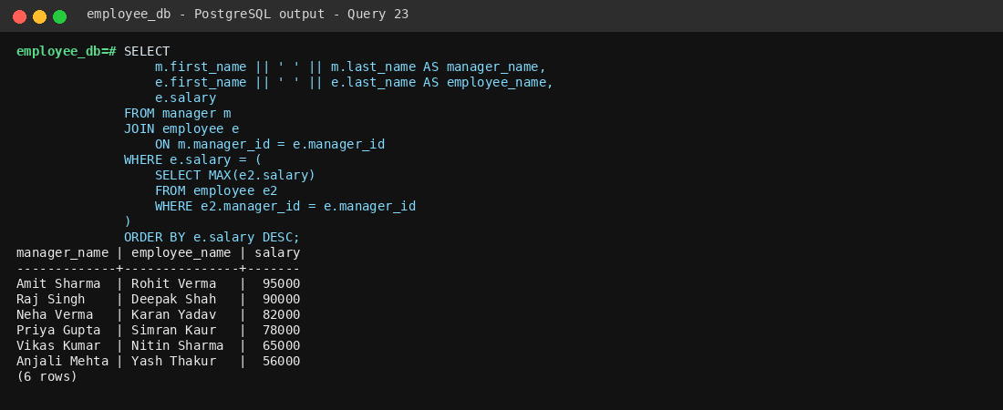
Employee database • Query 23

Q24: Who are the top 5 employees by salary?
Business purpose: Provides a quick view of the highest-paid employees for compensation analysis.

SQL Query
SELECT
first_name || ' ' || last_name AS employee_name,
salary
FROM employee
ORDER BY salary DESC
LIMIT 5;

Output

Employee database • Query 24

Q25: Which departments have more than one employee earning above 70000?
Business purpose: Identifies departments with multiple high-paid employees.

SQL Query
SELECT
d.department_name,
COUNT(e.employee_id) AS high_salary_employees
FROM employee e
JOIN department d
ON e.department_id = d.department_id
WHERE e.salary > 70000
GROUP BY d.department_id, d.department_name
HAVING COUNT(e.employee_id) > 1;

Output
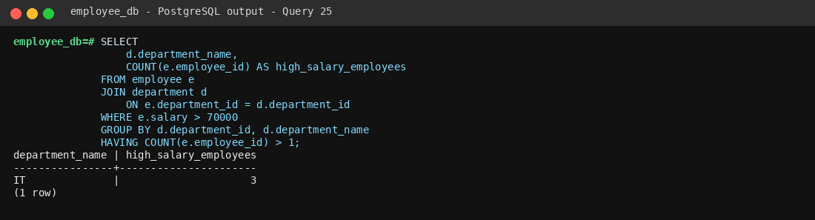
Employee database • Query 25

Q26: What percentage of the company payroll is spent by each department?
Business purpose: Measures each department's share of the overall salary budget.

SQL Query
SELECT
d.department_name,
ROUND(
SUM(e.salary) * 100.0 /
(SELECT SUM(salary) FROM employee),
2
) AS payroll_percentage
FROM employee e
JOIN department d
ON e.department_id = d.department_id
GROUP BY d.department_id, d.department_name
ORDER BY payroll_percentage DESC;

Output
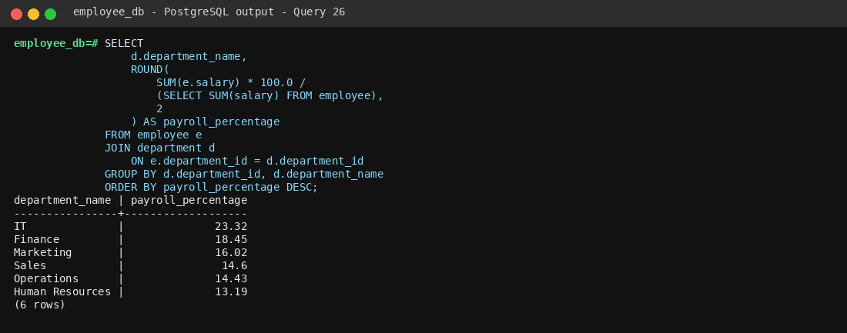
Employee database • Query 26

Q27: Which managers have the highest average employee salary?
Business purpose: Ranks managers by the average compensation of their teams.

SQL Query
SELECT
m.first_name || ' ' || m.last_name AS manager_name,
ROUND(AVG(e.salary), 2) AS average_team_salary
FROM manager m
JOIN employee e
ON m.manager_id = e.manager_id
GROUP BY m.manager_id, m.first_name, m.last_name
ORDER BY average_team_salary DESC;

Output
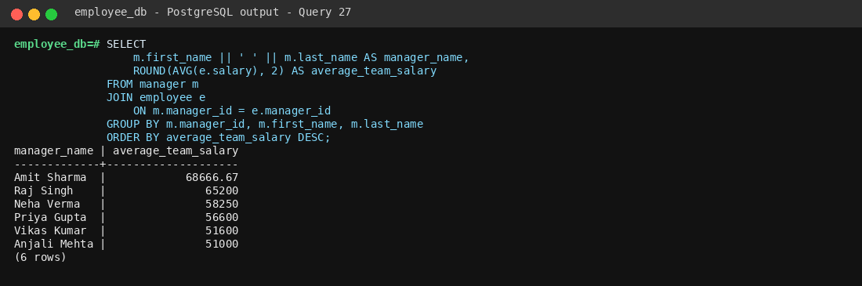
Employee database • Query 27

Q28: Which departments are above average in both salary and workforce size?
Business purpose: Identifies departments that are larger than typical and also pay above the company average.

SQL Query
SELECT
d.department_name,
COUNT(e.employee_id) AS employee_count,
ROUND(AVG(e.salary), 2) AS average_salary
FROM employee e
JOIN department d
ON e.department_id = d.department_id
GROUP BY d.department_id, d.department_name
HAVING COUNT(e.employee_id) > (
SELECT AVG(employee_count)
FROM (
SELECT COUNT(*) AS employee_count
FROM employee
GROUP BY department_id
) x
)
AND AVG(e.salary) > (
SELECT AVG(salary)
FROM employee
);

Output
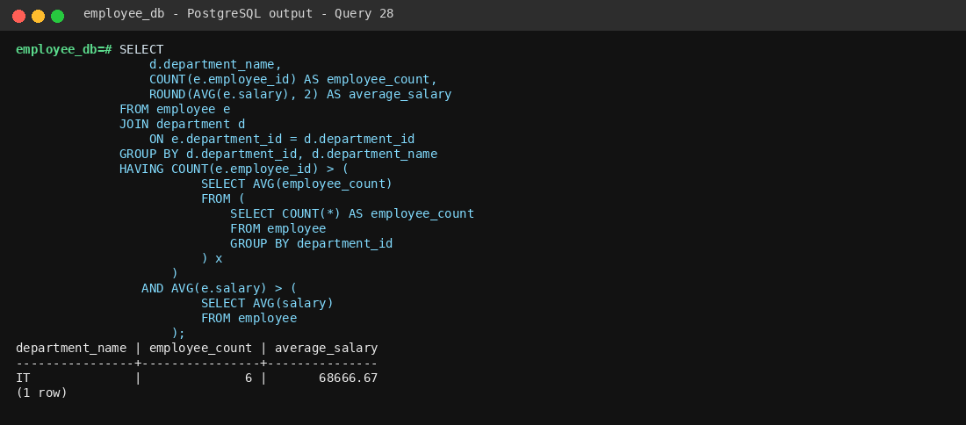
Employee database • Query 28

Q29: Which highest-paid employee represents the largest share of their department payroll?
Business purpose: Measures how concentrated each department's salary budget is around its highest-paid employee.

SQL Query
SELECT
d.department_name,
e.first_name || ' ' || e.last_name AS employee_name,
e.salary,
ROUND(
e.salary * 100.0 /
(
SELECT SUM(e2.salary)
FROM employee e2
WHERE e2.department_id = e.department_id
),
2
) AS salary_cost_percentage
FROM employee e
JOIN department d
ON e.department_id = d.department_id
WHERE e.salary = (
SELECT MAX(e2.salary)
FROM employee e2
WHERE e2.department_id = e.department_id
)
ORDER BY salary_cost_percentage DESC;

Output
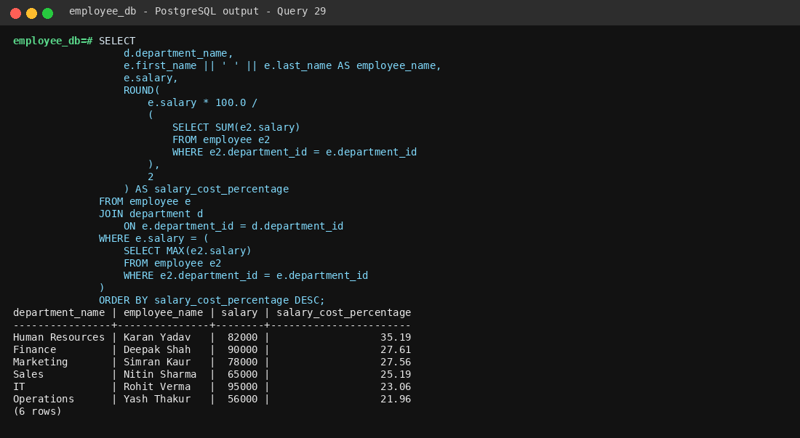
Employee database • Query 29

Q30: What is the complete department salary and workforce report?
Business purpose: Summarizes department size and compensation into one management-ready report.

SQL Query
SELECT
d.department_name,
COUNT(e.employee_id) AS employee_count,
ROUND(AVG(e.salary), 2) AS average_salary,
SUM(e.salary) AS total_payroll,
MAX(e.salary) AS highest_salary,
MIN(e.salary) AS lowest_salary
FROM department d
JOIN employee e
ON d.department_id = e.department_id
GROUP BY d.department_id, d.department_name
ORDER BY total_payroll DESC;

Output
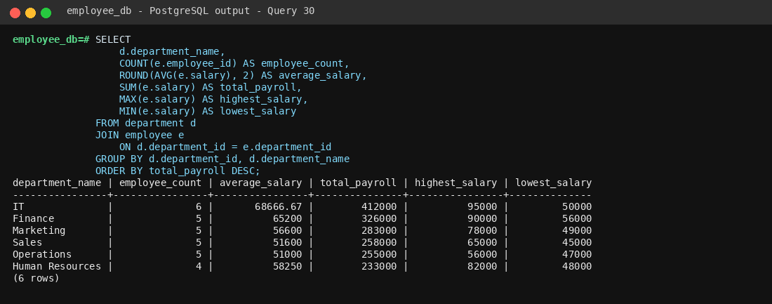
Employee database • Query 30

