Object-Oriented Programming (OOP) in Python

0. What is OOP?
OOP stands for Object-Oriented Programming. It is a way of writing programs by combining data and the functions that work on that data into objects.

1. Class
A class is a blueprint or design used to create objects. It tells Python what data and behavior the objects should have.
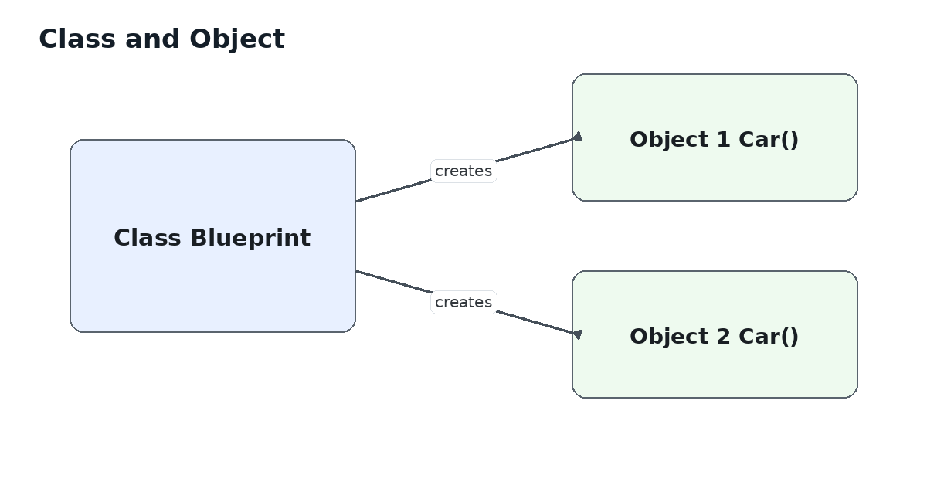
class Car:
brand = "Toyota"
def start(self):
print("Car started")

2. Object
An object is a real instance created from a class. Each object can have its own data.
class Car:
def __init__(self, brand):
self.brand = brand
car1 = Car("Toyota")
car2 = Car("Honda")
print(car1.brand) # Toyota
print(car2.brand) # Honda

3. Constructor
In Python, __init__() is commonly called the constructor. It runs automatically when an object is created. We use it to give the object its initial values.
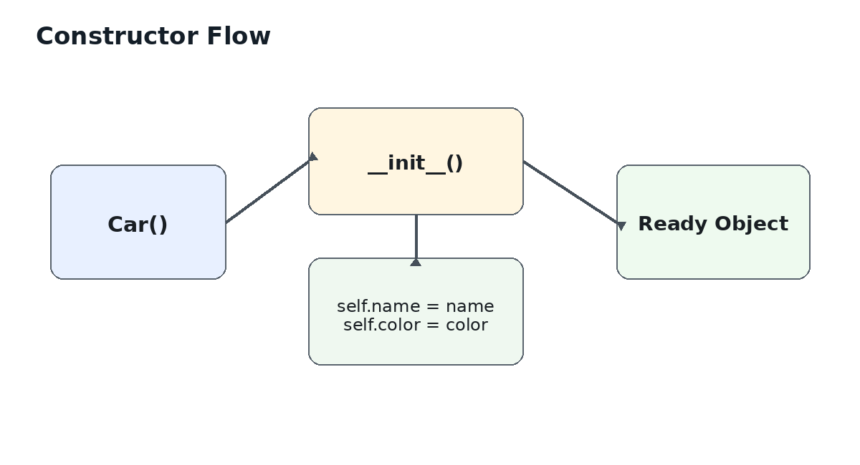
class Student:
def __init__(self, name, age):
self.name = name
self.age = age
student1 = Student("Aman", 21)
- self refers to the current object.
- __init__() runs automatically when Student(...) creates an object.
- It is useful for setting initial attributes.

4. Attributes
Attributes are variables that belong to an object or class. They store the data/state of an object.
class Car:
wheels = 4 # class attribute
def __init__(self, brand, color):
self.brand = brand # instance attribute
self.color = color
car = Car("Toyota", "Black")

Two common types
Instance attribute: usually belongs to one specific object (self.brand).
Class attribute: shared by instances unless an instance overrides it (Car.wheels).

5. Methods
A method is a function written inside a class. Methods describe what an object can do.
class Dog:
def __init__(self, name):
self.name = name
def bark(self):
print(self.name, "says Woof!")
dog = Dog("Bruno")
dog.bark()

Easy Hindi-style memory trick
Attribute = object ka data
Method = object ka action

6. Encapsulation
Encapsulation means keeping data and the methods that control that data together inside a class. It also helps prevent direct misuse of internal data.

class BankAccount:
def __init__(self, balance):
self.__balance = balance
def deposit(self, amount):
if amount > 0:
self.__balance += amount
def get_balance(self):
return self.__balance
account = BankAccount(1000)
account.deposit(500)
print(account.get_balance())

A double underscore such as __balance triggers Python name-mangling. It is a common way to make an attribute harder to access directly. In practice, use methods/properties to control access.

7. Inheritance
Inheritance lets a child class reuse attributes and methods from a parent class. This reduces repeated code.
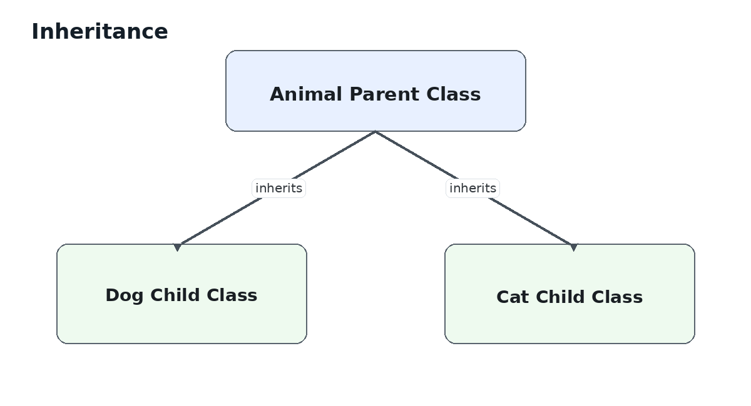
class Animal:
def eat(self):
print("Eating")
class Dog(Animal):
def bark(self):
print("Woof")
d = Dog()
d.eat() # inherited
d.bark() # own method
- Animal = parent/base class
- Dog = child/derived class
- Dog gets access to eat() from Animal

8. Composition
Composition means building a larger object by putting other objects inside it. It represents a strong “has-a” relationship.
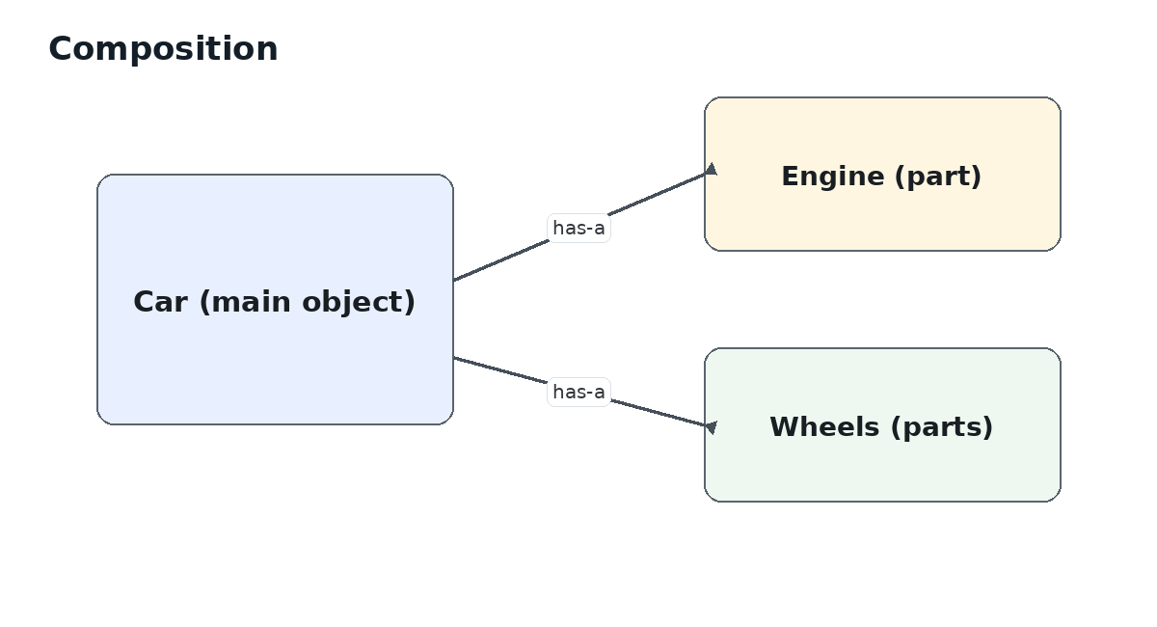
class Engine:
def start(self):
print("Engine started")
class Car:
def __init__(self):
self.engine = Engine()
def start(self):
self.engine.start()
car = Car()
car.start()

9. Class Methods
A class method works with the class itself rather than one particular object. It uses cls as its first parameter and is marked with @classmethod.
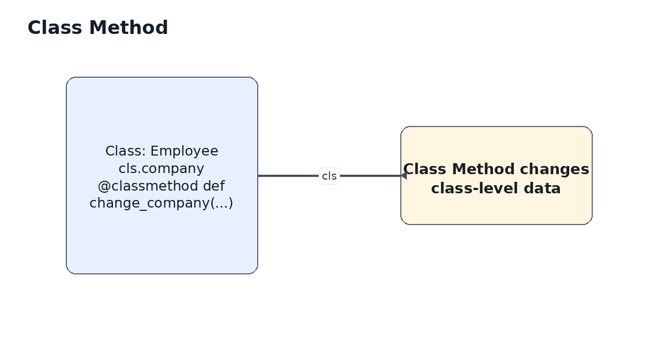
class Employee:
company = "ABC Ltd"
def __init__(self, name):
self.name = name
@classmethod
def change_company(cls, new_name):
cls.company = new_name
Employee.change_company("XYZ Ltd")

Use @classmethod when the method needs to read or change class-level data, or when providing an alternative way to create objects.

10. Static Methods
A static method is a utility method placed inside a class because it is logically related to that class. It does not receive self or cls automatically.
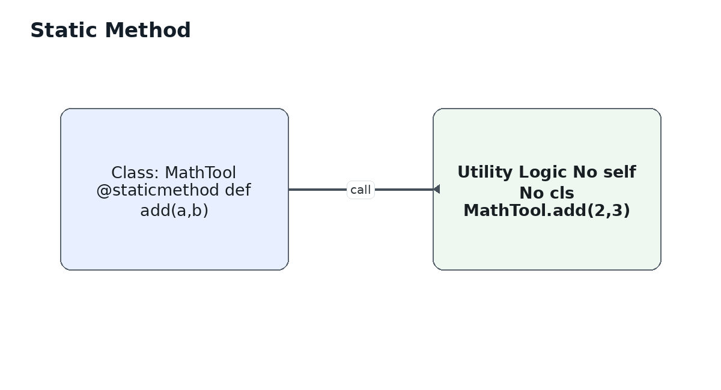
class MathTool:
@staticmethod
def add(a, b):
return a + b
result = MathTool.add(10, 20)
print(result) # 30

Static method = related utility logic that does not need object data or class data.

11. Quick Revision
- Class -> blueprint/design
- Object -> instance created from a class
- Constructor (__init__) -> initializes an object
- Attributes -> data/state
- Methods -> actions/behavior
- Encapsulation -> control and organize data access
- Inheritance -> child reuses parent features
- Composition -> one object contains/uses other objects
- Class method -> works with class-level data using cls
- Static method -> utility method with no self/cls

