

School Management System

Java Project



**Project Group Members:**

Gautam Giri

Kisan Tamang

Kiran Sing Katuwal

Sagar Lama

# **Abstract**

Majority of schools keep record of student/parents/staff’s information manually. This process is both tedious and unproductive. Although many software attempts to solve this problem, either they are too expensive or very difficult to operate. **School Management System(SMS)** is developed to simplify the process of collection/storing of student/parents/staff data digitally and a reasonable cost. **SMS** is also able to generate bills and process result for the students saving the staffs from extremely tedious work of calculating grades and percentage.

# **Acknowledgement**

We have put a lot of effort in this project but it wouldn’t have been possible without the help of Mr. Prakash Ranabhat. We are grateful for his supervision and guidance. We would like to thank Mr. Som Shrestha for his guidance in the project.

We would also like the thank Ms. Simoli Desi for her valuable time and support in this project.

We would like to extend our gratitude towards the Sunway Int’l Business School and the technical support team for providing us with the opportunity and the resources needed for the completion of the project.

**Below is a list of additional people we would like to thank.**

Mr. Prakash Ranabhat

Mr. Kiran Rana

Support Staffs

Academic Director

Senior Students

Family of all the project members

Friends

We would like to extend our gratitude and apologies if anyone who has helped us directly or indirectly if we have missed to include your name. This project wouldn’t have been possible without your support.

# **Table of Contents**

**1** **Abstract** ii

**2** **Acknowledgement** iii

**3** **Table of Contents** iii

**4** **List of Figures** v

**1** **Introduction** 1

**1.1** **Background** 1

**1.2** **Objectives** 1

**1.3** **Scope** 1

**1.3.1** **User Scope** 1

**1.3.2** **Admin scope** 1

**1.4** **Problem statement** 1

**1.5** **Rationale** 2

**2** **Literature Review** 3

**2.1** Background 3

2.2 Significance and Drawbacks of existing system 3

2.2.1 Record Filing: 3

2.2.2 Record of books: 3

2.2.3 drawbacks of exiting system 3

**3** **Methodology** 4

**3.1** **Requirement Gathering and Analysis Phase:** 4

**3.2** **Design Phase:** 4

**3.3** **Implement Phase:** 5

**3.4** **Test Phase:** 5

**3.5** **Deploy Phase:** 5

**3.6** **Maintenance Phase:** 5

**4** **Design** 6

**4.1** **Tools and Techniques** 6

**4.2** **Algorithms and flowchart** 7

**4.2.1** **Login** 7

**5** **Conclusion** 7

**6** **References** 7

https://www.nap.edu/read/1397/chapter/4 7

# **List of Figures**

Figure 3‑1 Water Fall Model 4

Figure 4‑1 Login Flowchart 7

# **Introduction**

## **Background**

Almost every sector of today’s world is digitalized. Papers are being replaced by digital devices. The technology is improving at an exponential rate. It is a must for all the educational institutions to be update with the technology in order to provide the best education for the students. **SMS** is developedto aid the school and colleges to accomplish such tasks easily so the schools can focus on the real tasks. The schools are taking records of students manually and extremely tedious manner. The purpose of these proposal is to propose a management system software development that manages all the different activities takes place in the schools.

## **Objectives**

* To speed up the billing process
* Enable users to view student details categorized into different subscription groups
* Enable users to generate receipt within few clicks.
* Enable users to view pending bills

## **Scope**

### **User Scope**

* User is able to view details of each student
* User is able to view due bills for students
* User is able to view marks/ grades of students

### **Admin scope**

* Admin is able to view/edit details of each student
* Admin is able to generate/ print bill for each student.
* Admin is able to make changes on student fees
* Admin is able to offer scholarships to students
* Admin is able to store marks obtained by each students and generate result/grade

## **Problem statement**

1. The existing practice requires keeping records manually. There is digital backup of the data. If lost or theft, then the school loses all the information.
2. The existing practice is unproductive and consumes excessive amount of time and effort which will hold back the full potential of the service that the school can give

## **Rationale**

The fundamental reasons for this proposal is to develop an effective School Management System that allows the school to gather and store required information without having to put a huge effort in the course. This software overcomes the difficulties in the following ways:

**Digitalization:** Since the computers used to store and generate bills it will replace paper and move towards digitalization.

**Saves Time:** This project helps to save time and effort of the schools to gather information and generate bills and grade/result of the students.

**Cost:** This project aims to create system that helps the schools to get the job done at a minimal cost.

# **Literature Review**

## Background

Education sector accessed by almost 74% population of the world, is one of the oldest and densest sectors in human history. The school management system is expected to come into existence in late 385 BC, specifically in ancient India, ancient China, ancient Greece, and ancient Rome. However, the curriculum of schools is updated every decade but there have not been much major change operations of schools. In contrast, there have been some major improvements in the methods of teaching. This change was brought by YouTube and many Ed-Tech startups as they have digitalized the learning process. So this system is commonly used from ancient time in school that’s why we choose this system.

## Significance and Drawbacks of existing system

These are the significance of exiting system nowadays:

### Record Filing:

Collecting, storing, fetching & altering the records can be done very efficiently and in real-time with the help of this management software. It helps in keeping data centralized and only authorized people can access the data from the database.

### Record of books:

This is very important software it comes to books. Librarians can make use of this software completely. They can keep track of all the study material flowing in & out. This helps in organising data very efficiently.

### drawbacks of exiting system

These are the drawbacks of exiting system:

* Application is slow as it’s having large database
* Very Difficult to use

# **Methodology**

This project is developed using **waterfall** model as software development life cycle. This is a classic model of SDLC. Each process requires the previous one to be completed before it to be started. It is a steady model. It is easy and understandable way to develop the system. This model is selected mainly due to the following reasons.

* This model is simple and easy to understand and use
* It is easy to manage due to the rigidity of the model –each phase has specific deliverables and a review process
* In this model phases are processed and completed one at a time. Phases do not overlap. Hence this model is not complicated
* Waterfall model works for small projects where requirements are very well understood.

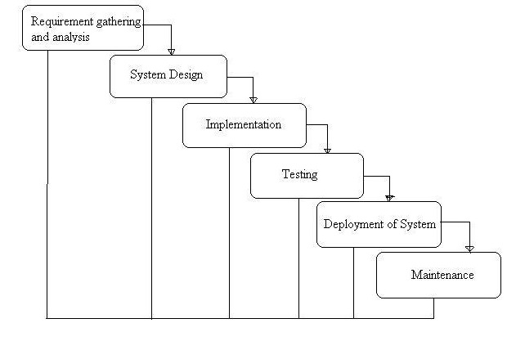

Figure 3‑1 Water Fall Model

The waterfall model has the following phases.

## **Requirement Gathering and Analysis Phase:**

This is the first phase where requirements to produce a product are gathered and analyzed.

This is the phase which involves customer. All information about the entire process are

identified to be designed and delivered here.

## **Design Phase:**

The requirements from the earlier phase are documented and converted into technical

design. Like what hardware, system software, technology, language is used etc. are

specified.

## **Implement Phase:**

Output from Design phase are used and implemented to achieve the goal. They are split in

program units. These program units are developed independently and functionally tested.

This is called Unit Testing.

## **Test Phase:**

Here all program units which are developed in implement phase are integrated and tested

together to see end product has all desired functionalities required.

## **Deploy Phase:**

Once Test phase is successfully completed, it is deployed in customer environments and

product is released.

## **Maintenance Phase:**

If any changes are required in client environments, then they are upgraded and released as

patches to fix any issues that come up after deployment.

# **Design**

The design and development of project will be carried step by step following waterfall model. A general use case diagram for the project is given below.

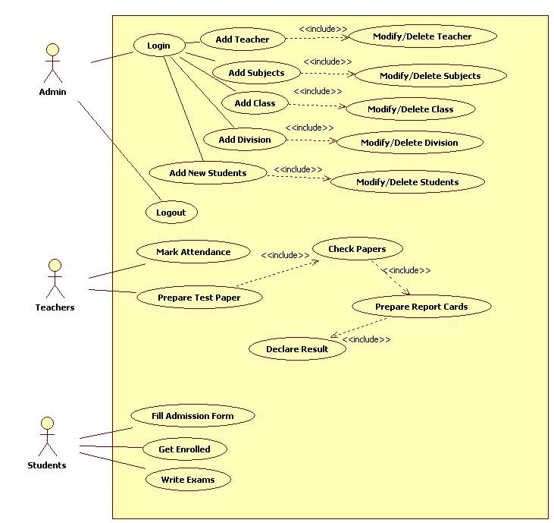

## **Tools and Techniques**

Tools that will be used in this project are:

1. MS Visio: This is used to create algorithms and flowcharts and any project related diagrams.
2. Project 2016: It is Microsoft product that helps us to make a project plan and keep track of the projects schedule, define project duration, dependencies, resources etc. It helps to keep track of the mile stones of the projects and monitor the project.
3. IDE: This project will require IDE for the coding section. IDE helps to build the application efficiently and helps us to be more productive.
4. SQL workbench: It is a tool to write SQL scripts efficiently.

## **Algorithms and flowchart**

### **Login**

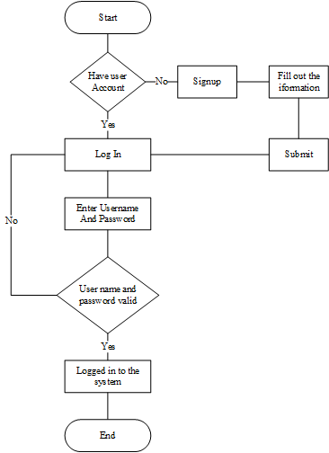

Figure 4‑1 Login Flowchart

# **Conclusion**

This project developed to manage the school activities. It can collect, store students’ records, generate students bill, keep track of student’s marks and generate grade/mark sheet of each term.

# **References**

# <https://www.nap.edu/read/1397/chapter/4>

<http://tryqa.com/what-is-waterfall-model-advantages-disadvantages-and-when-to-use-it/>

Internet site: <https://www.experts-exchange.com/articles/17441/Waterfall-Model-pros-andcons.html>

<https://creately.com/diagram/example/gy2h2rov2/login%20process>