1. Write a shell script(create_file.sh) to perform the following.

i. Prompt "no of records" and "no of lines" from the user (as an integer input)

ii. Generate sequence of random numbers(from 1 to 100) and write it into the file as a csv(output.csv). Records should be comma separated.

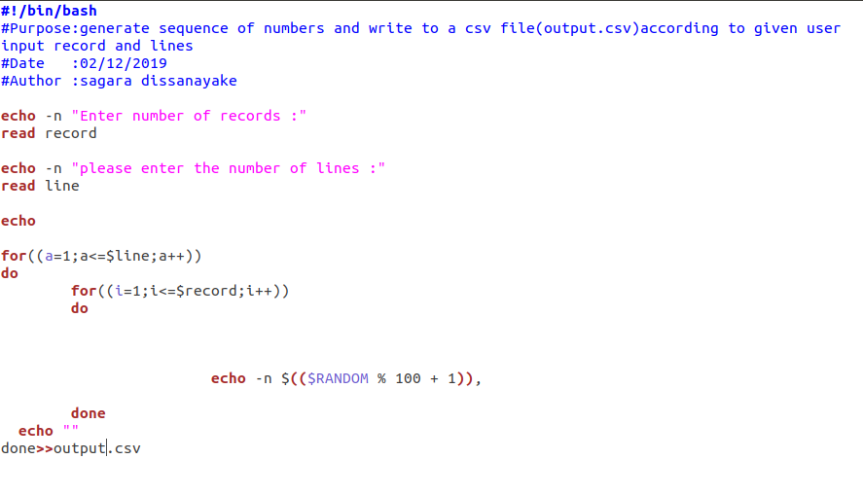

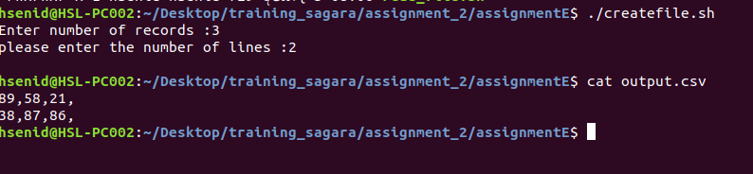

2. Write another shell script(read_file.sh) to perform the following

i. Read the above generated file(output.csv) and write the following to another file(processed.csv).

Row number, Total, Max and Min value of each row

eg:
1, 63, 50, 3
2, 123, 89, 1
