The included file(OPTPF.csv) contains an auto-generated csv file of 100000 records. Read the appendix 2 of the attached document to understand about the fields.

1. Prepare a shell script to get number of records per each merchant (utility company). Write the output into a file.

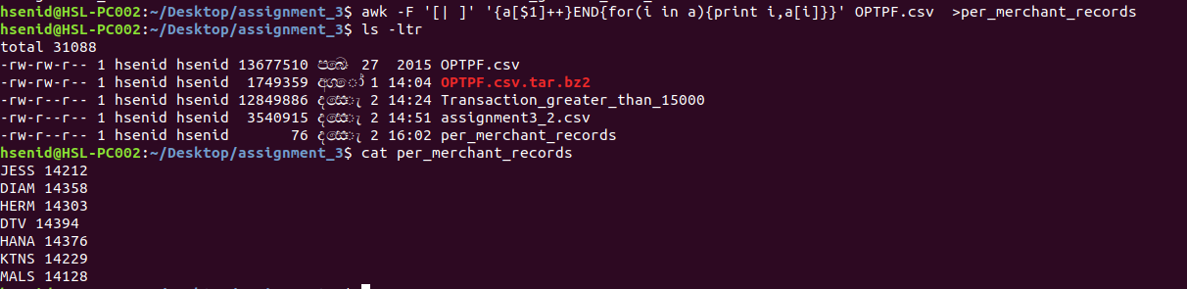

2. Write only following fields as a csv to a new file.
utility company code, utility account number, transaction date, transaction amount.

awk -F '[| ]' 'BEGIN {OFS=","}{print $1,$2,$4,$9}' OPTF.csv

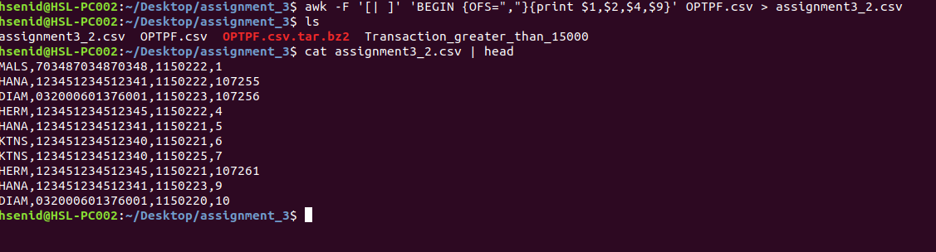

3. Get the number of credit transactions(eg: CREDIT) where amount(use Transaction amount) is higher than LKR 15000. Write the output into a file.
