
CI/CD LAB
LAB EXERCISE 1
Managing Jenkins Freestyle Jobs

Name | SAGAR
SAP ID | 500125475
Batch | DevOps-3
Subject | CI/CD Lab
University of Petroleum and Energy Studies (UPES)

Lab Exercise 1
Managing Jenkins Freestyle Jobs
Objective: To manage Jenkins job by creating, renaming, and deleting freestyle job, facilitating streamlined job configuration and maintenance within the Jenkins environment.
Tools required: Jenkins
Prerequisites: None
Steps to be followed:
- Create a new Freestyle Job
- Rename and delete the Freestyle Job

Step 1: Create a new Freestyle Job
1.1 Open Jenkins Dashboard in the browser. The performed lab instance is running at localhost:8081.
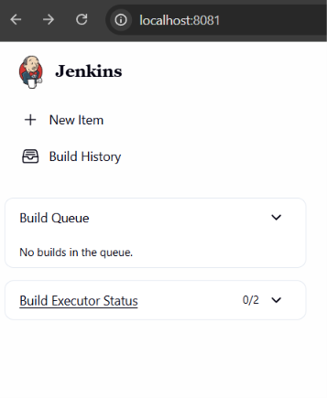
Figure 1: Jenkins Dashboard
1.2 Click on New Item in the Jenkins Dashboard.
1.3 Enter the project name Lab1-Freestyle, select Freestyle project, and click OK.
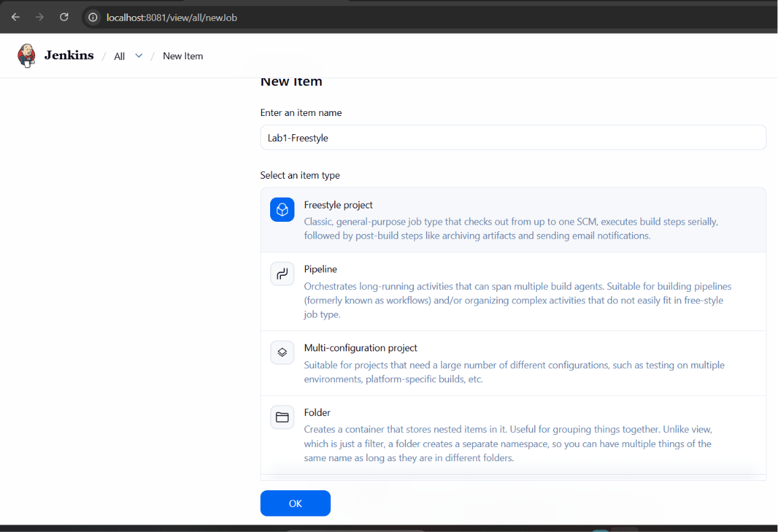
Figure 2: Creating the Lab1-Freestyle job
1.4 On the Configure page, click Save to save the Freestyle job configuration.
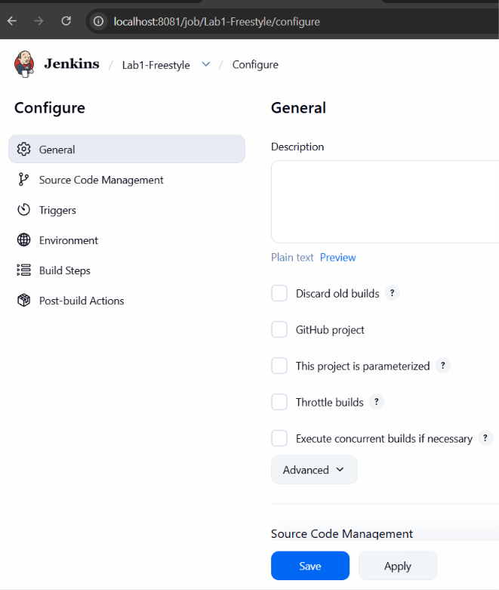
Figure 3: Freestyle job configuration page

Step 2: Rename and Delete the Freestyle Job
2.1 Open the created project and select the Rename option.
2.2 Enter the new name Lab1Freestyle-Renamed and click Rename.
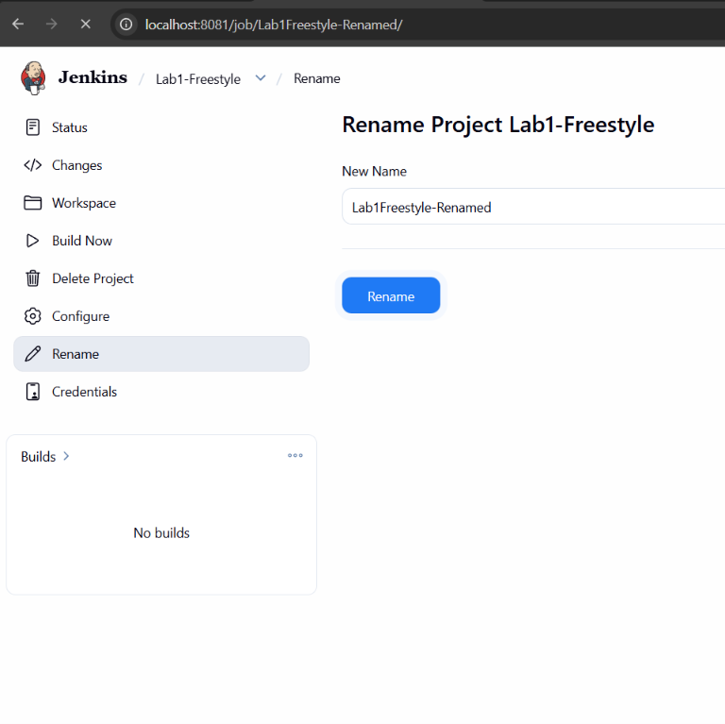
Figure 4: Renaming the Freestyle project
2.3 Choose Delete Project for the renamed job and confirm the deletion by clicking Yes.
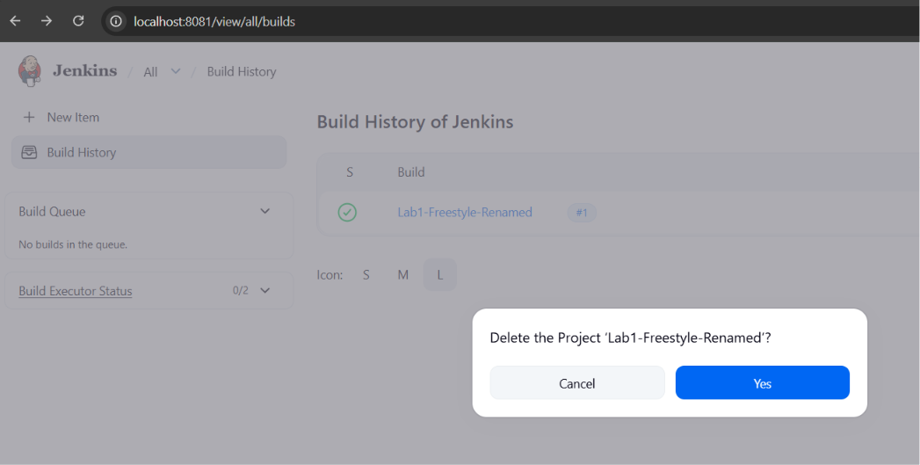
Figure 5: Delete Project confirmation
2.4 Return to the Jenkins Dashboard and verify the available jobs after performing the lab operations.
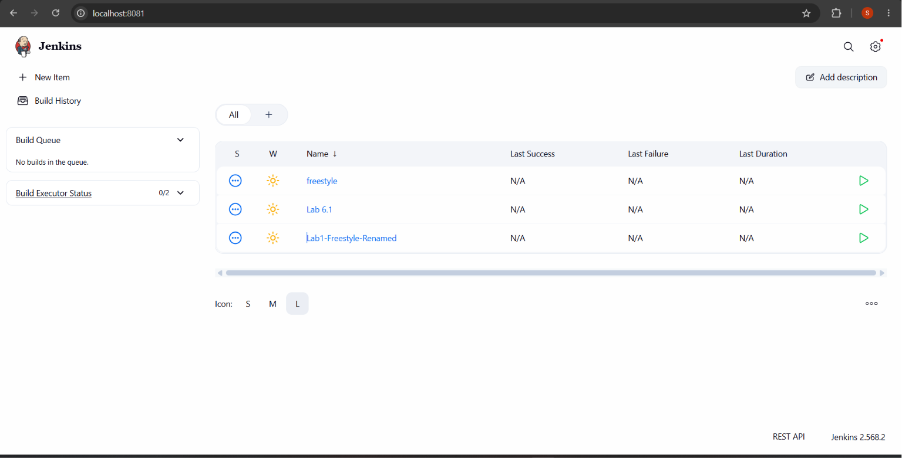
Figure 6: Jenkins Dashboard after the lab operations

Result
The Jenkins Freestyle job was successfully created, configured, renamed, and the delete operation was performed/verified using the Jenkins interface. This demonstrates basic Jenkins job management and maintenance.

