
CI/CD LAB
LAB EXERCISE 2
Creating a New Jenkins Job to Checkout Source Code

Name | SAGAR
SAP ID | 500125475
Batch | DevOps-3
Subject | CI/CD Lab
University of Petroleum and Energy Studies (UPES)

Lab Exercise 2
Creating a New Jenkins Job to Checkout Source Code
Objective: To set up a Jenkins job to manage source code, specifically by configuring the Source Code Management section to check out code from a Git repository.
Tools required: Jenkins
Prerequisites: Jenkins must be operational.
Steps to be followed:
- Log in and create a Jenkins job
- Configure source code management

Step 1: Log in and Create a Jenkins Job
1.1-1.3 Open Jenkins, create a new Freestyle project, and save the job. The performed job is named Demo-Job.
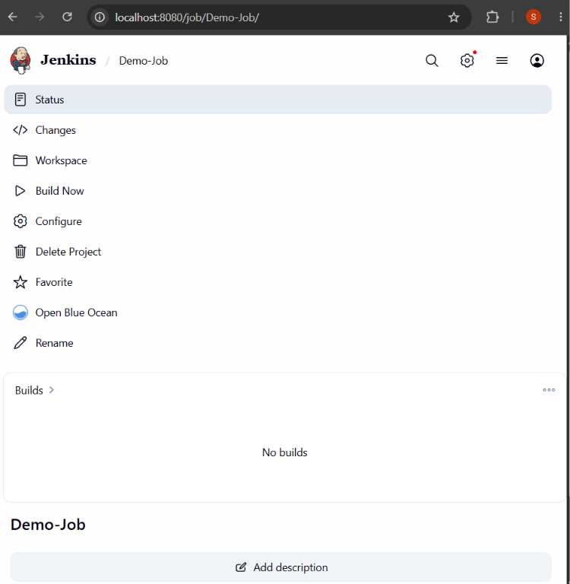
Figure 1: Demo-Job created in Jenkins

Step 2: Configure Source Code Management
2.1-2.2 Open Configure, select Git under Source Code Management, and set the repository URL to https://github.com/hkshitesh/DEVSECOPS-MAVEN-REPO.git. Save the configuration.
2.3-2.5 Click Build Now and open Console Output to verify the source-code checkout process.
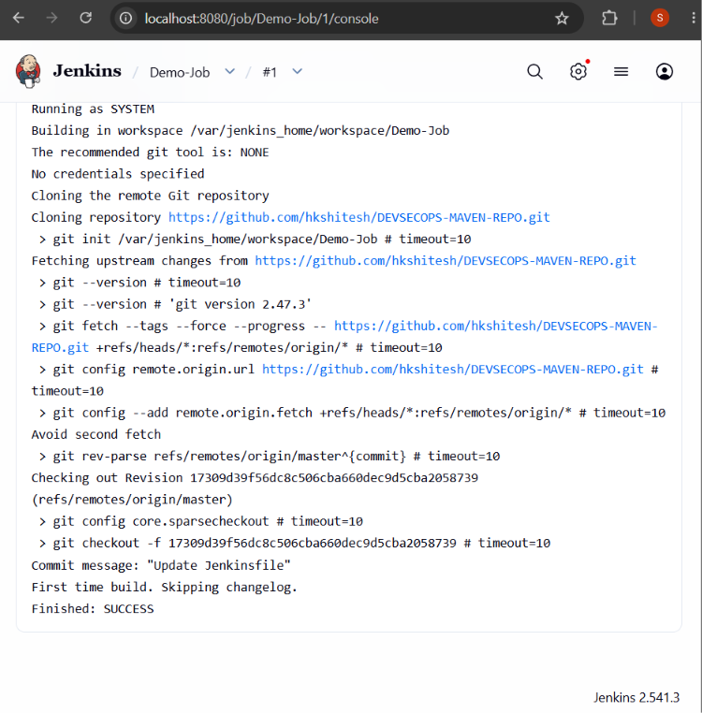
Figure 2: Console Output showing successful Git checkout

Result
The Jenkins job successfully checked out the source code from the configured Git repository. The Console Output confirms the repository clone/checkout and shows Finished: SUCCESS.

