
CI/CD LAB
LAB EXERCISE 3
Integrating Maven with Jenkins

Name | SAGAR
SAP ID | 500125475
Batch | DevOps-3
Subject | CI/CD Lab
University of Petroleum and Energy Studies (UPES)

Lab Exercise 3
Integrating Maven with Jenkins
Objective: To install the Maven plugin in Jenkins for smooth integration and automation of Maven-based build processes within the Jenkins environment.
Tools required: Git, GitHub, and Jenkins
Prerequisites: None
Steps to be followed:
- Install the Maven plugin
- Set up Global Tool Configuration
- Fork a sample repository
- Integrate Maven with Jenkins

Step 1: Install the Maven Plugin
1.1-1.4 Open Jenkins, go to Manage Jenkins > Plugins, and install or verify the Maven Integration plugin. The installation progress below shows the Maven Integration plugin and its dependencies completed successfully.
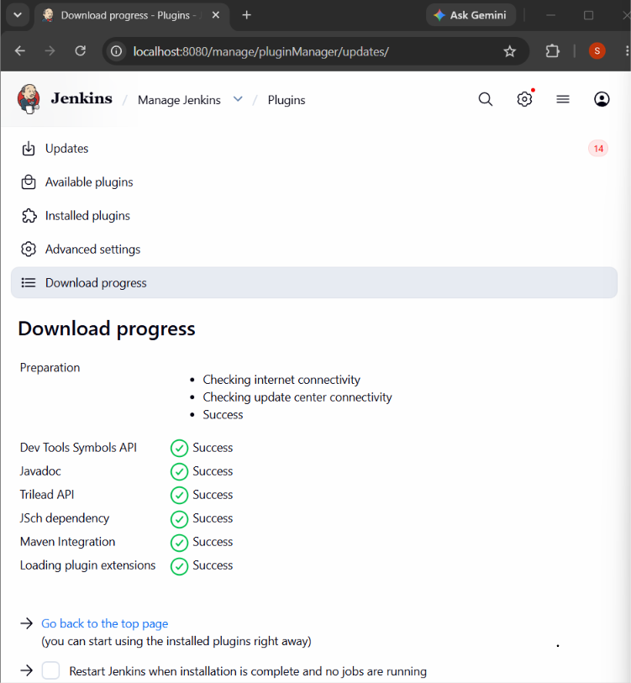
Figure 1: Maven Integration plugin installation completed successfully

Step 2: Set up Global Tool Configuration
2.1-2.2 Go to Manage Jenkins > Tools. Under Maven installations, add a Maven installation, enter MAVEN_HOME as the name, enable Install automatically, select the required Apache Maven version, and save the configuration.
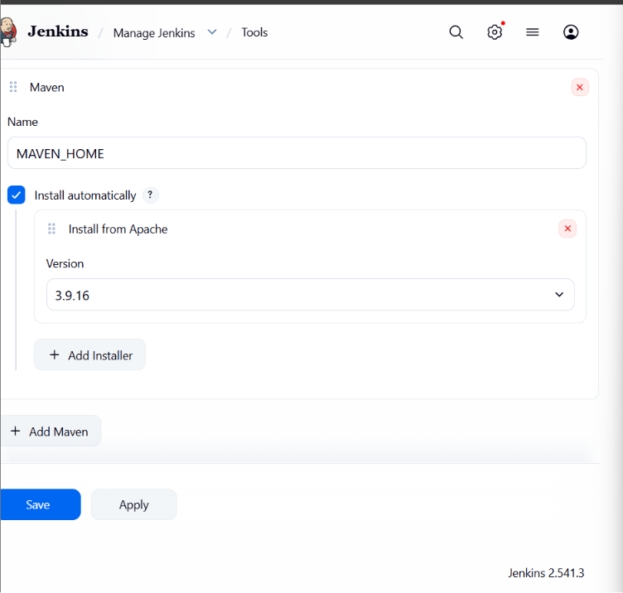
Figure 2: Maven configured in Jenkins Tools as MAVEN_HOME (version 3.9.16)

Result
The Maven Integration plugin was installed successfully and Maven was configured in Jenkins under Global Tool Configuration. Jenkins is now prepared to use Maven for Maven-based build processes.

