
CI/CD LAB
LAB EXERCISE 4
Setting up Maven Build Job in Jenkins
Name | SAGAR
SAP ID | 500125475
Batch | DevOps-3
Subject | CI/CD Lab

University of Petroleum and Energy Studies (UPES)

Lab Exercise 4
Setting up Maven Build Job in Jenkins
Objective: To set up Maven build job in Jenkins for automating the build process, enabling continuous integration to enhance the software development lifecycle
Tools required: Jenkins
Prerequisites: You need to have a Jenkins up and running.

Steps to be followed:
1. Log in to Jenkins CI tool and configure Maven freestyle job

Step 1: Log in to Jenkins CI tool and configure Maven freestyle job
1.1 Create/open the Maven-Build-Job and navigate to the Configure page in Jenkins.
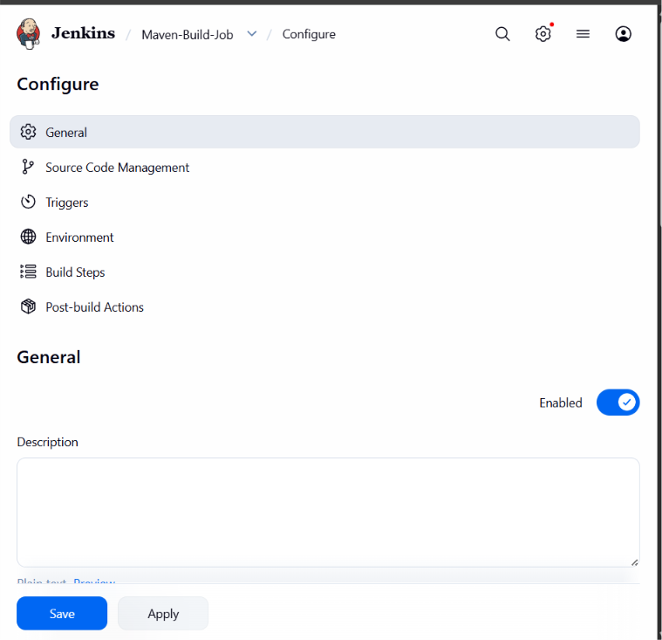
1.2 In the Configure page, navigate to Source Code Management, select Git, and provide the Git repository URL: https://github.com/hkshitesh/DEVOPS-MAVEN-PROJECT.git
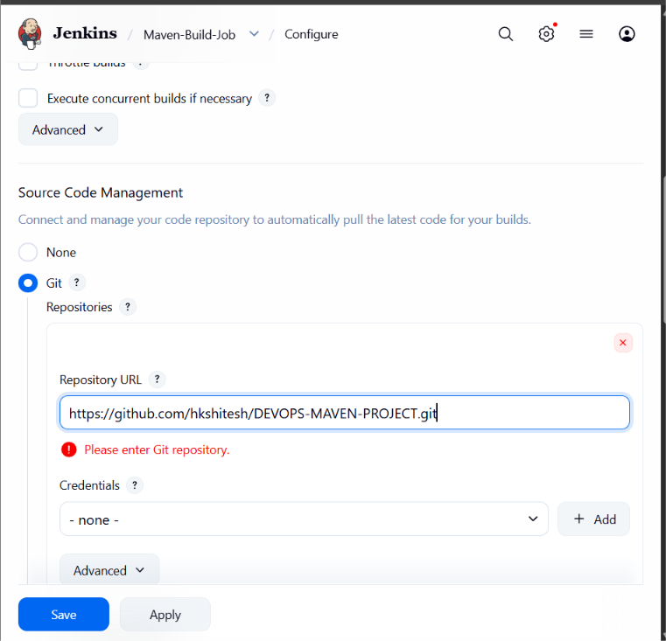
1.3 Navigate to Build Steps and configure Invoke top-level Maven targets. Select MAVEN_HOME and provide clean install under Goals, then save the configuration.
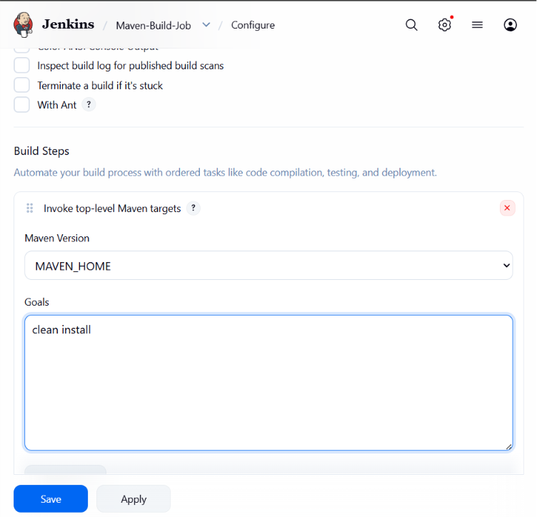
1.4 Click Build Now to initiate the Maven build. Open the build output to verify the result.
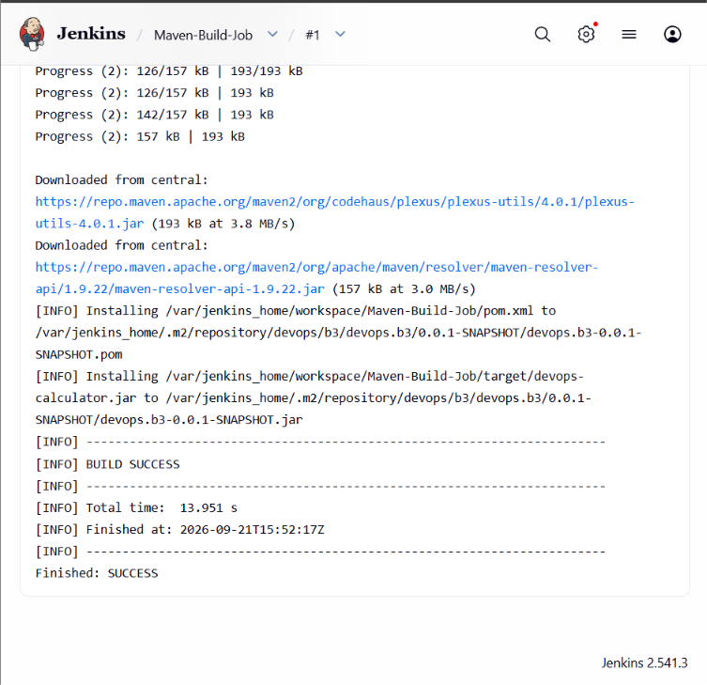
Result: The Maven build job was configured and executed successfully. The console output shows BUILD SUCCESS and Finished: SUCCESS.
By following these steps, the Maven build job in Jenkins was successfully configured to automate the build process and support continuous integration.

