
CI/CD LAB
LAB EXERCISE 5
Setting up Poll SCM Configuration in Jenkins
Name | SAGAR
SAP ID | 500125475
Batch | DevOps-3
Subject | CI/CD Lab

University of Petroleum and Energy Studies (UPES)

Lab Exercise 5
Setting up Poll SCM Configuration in Jenkins
Objective: To set up poll SCM configuration in Jenkins for automating build triggering and optimizing resource usage on Jenkins servers.
Tools required: Jenkins
Prerequisites: You need to have a Jenkins up and running.
Steps to be followed:
1. Create a Freestyle project for Poll SCM
2. Configure Git repository
3. Configure Poll SCM schedule
4. Verify Git Polling Log and successful build
Step 1: Create the Poll SCM Freestyle Job
Create a new Jenkins job named poll_scm and select Freestyle project.
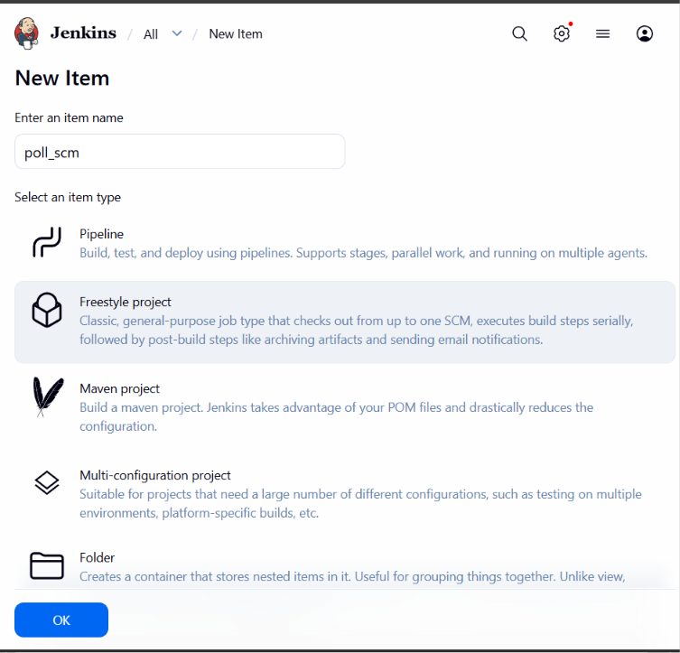
Step 2: Configure Source Code Management
Select Git under Source Code Management and provide the repository URL: https://github.com/hkshitesh/DEVOPS-MAVEN-PROJECT.git
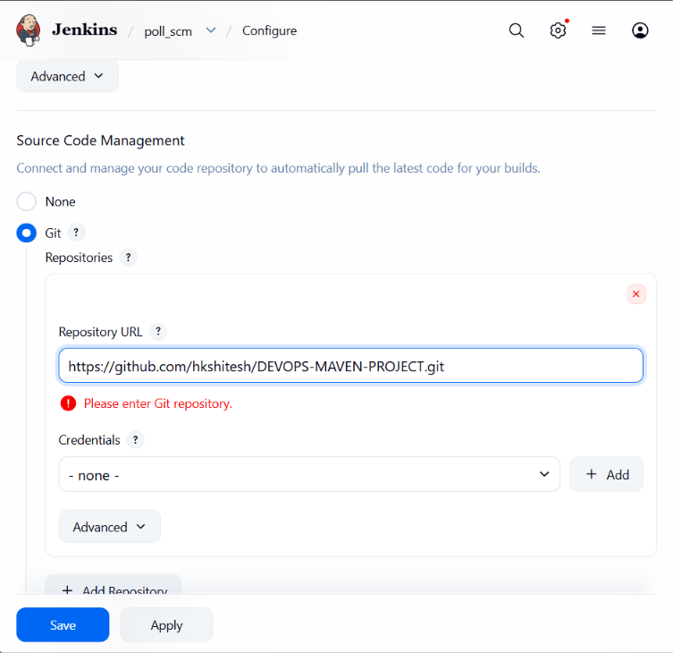
Step 3: Configure Poll SCM
Under Triggers, enable Poll SCM and set the schedule to * * * * * as specified in the lab exercise.
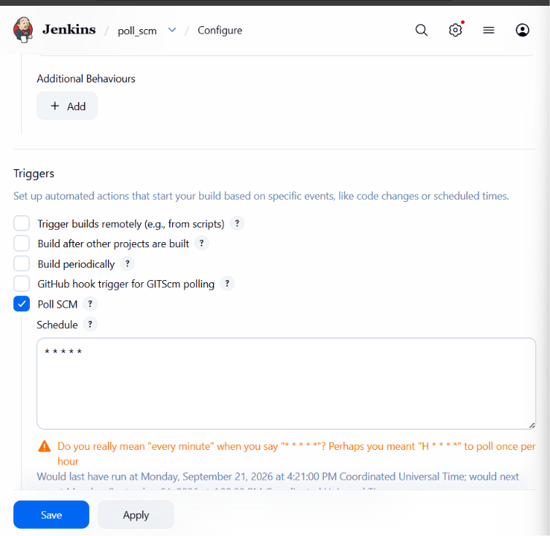
Step 4: Verify Git Polling Log
Open Git Polling Log to verify that Jenkins is polling the configured repository.
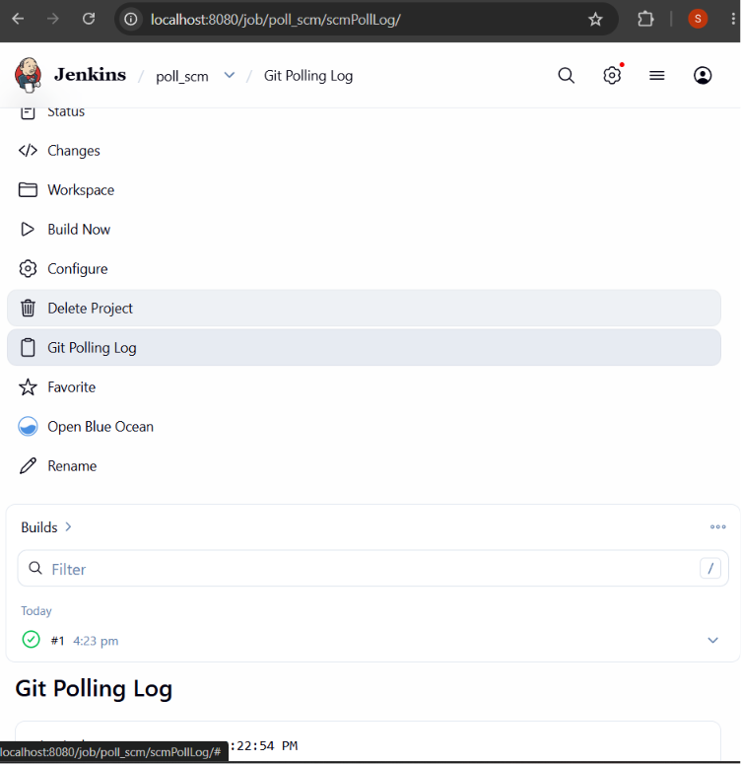
Step 5: Verify Successful Build
Check the build console output. The repository is fetched successfully and the output ends with Finished: SUCCESS.
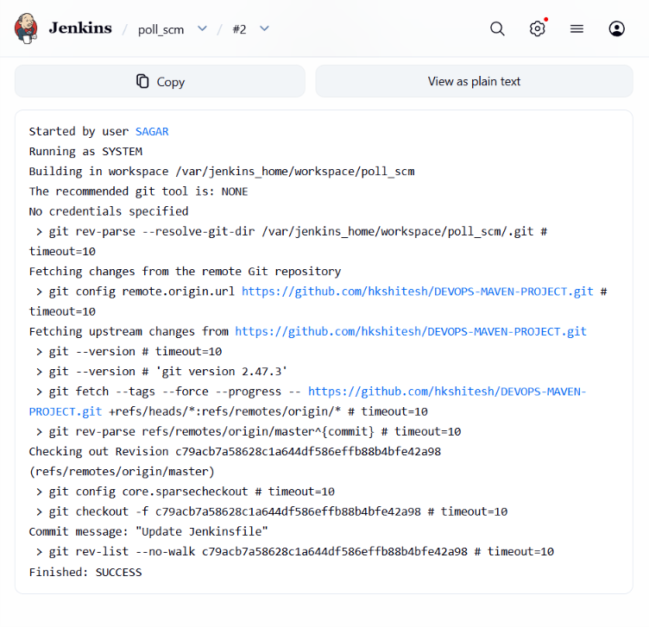
Result: Poll SCM configuration was set up successfully in Jenkins, and the build completed successfully after fetching changes from the Git repository.

