CI/CD LAB
LAB EXERCISE 6
Creating a Pipeline Script
Name | SAGAR
SAP ID | 500125475
Batch | DevOps-3
Subject | CI/CD Lab

University of Petroleum and Energy Studies (UPES)

Lab Exercise 6
Creating a Pipeline Script
Objective: To create a pipeline script for automating build processes in Jenkins.
Tools required: Jenkins
Prerequisites: None
Steps to be followed:
1. Log in to the Jenkins CI tool and create a pipeline script
Step 1: Create a Pipeline Job
Create a new Jenkins item named new_demo_pipeline, select Pipeline, and click OK.
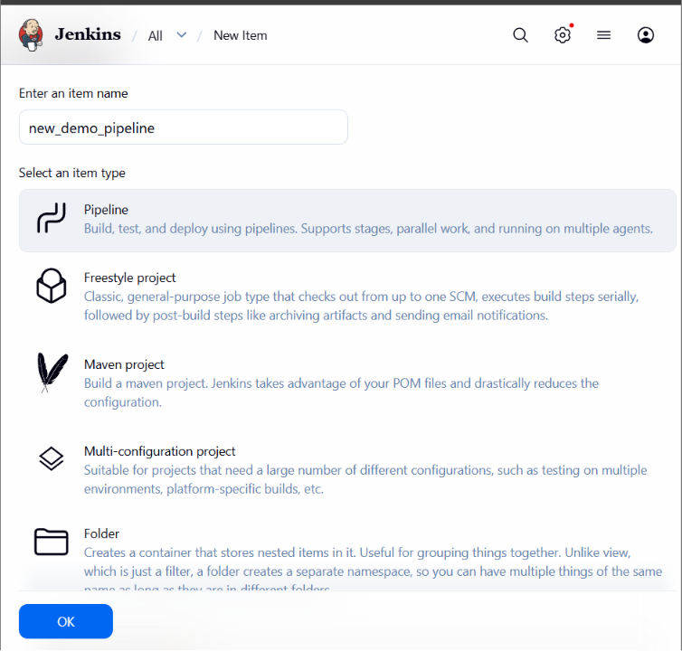
Step 2: Enter the Pipeline Script
In the Pipeline section, enter the script containing Stage 1, Stage 2, and Stage 3, then save the configuration.
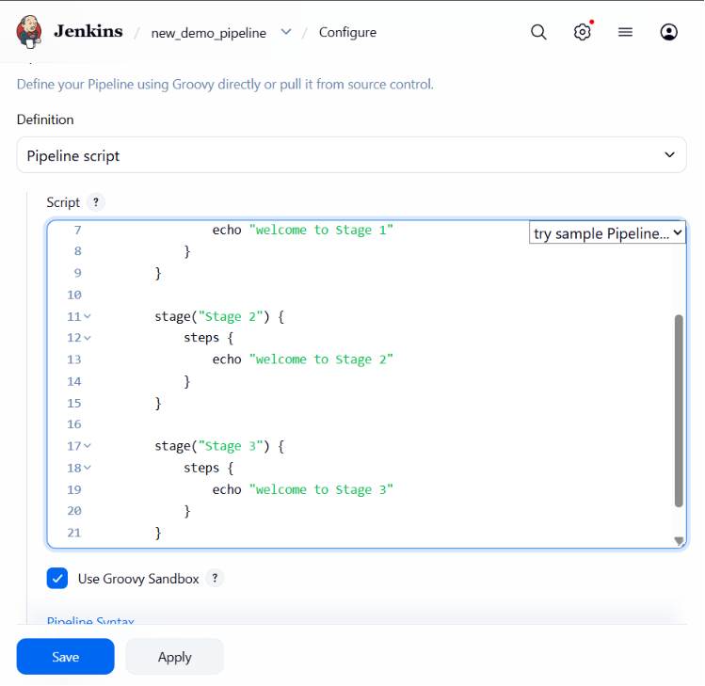
Step 3: Run the Pipeline
Run the pipeline and verify that the pipeline stages complete successfully.
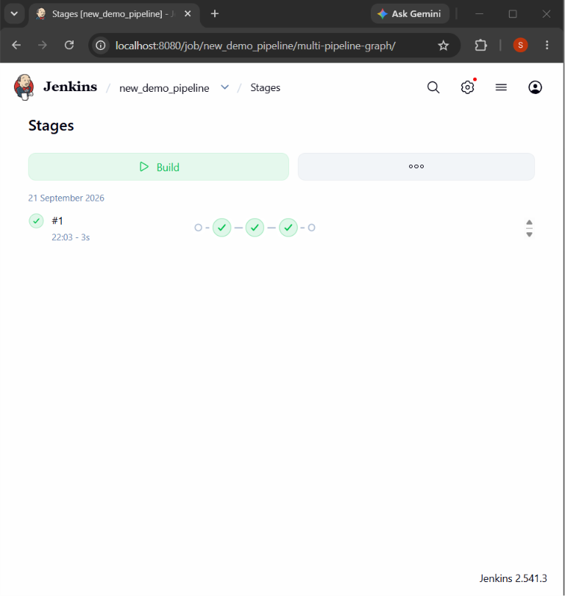
Step 4: Verify Stage Execution
Open the build stage view. Stage 1, Stage 2, and Stage 3 are shown in green, confirming successful execution.
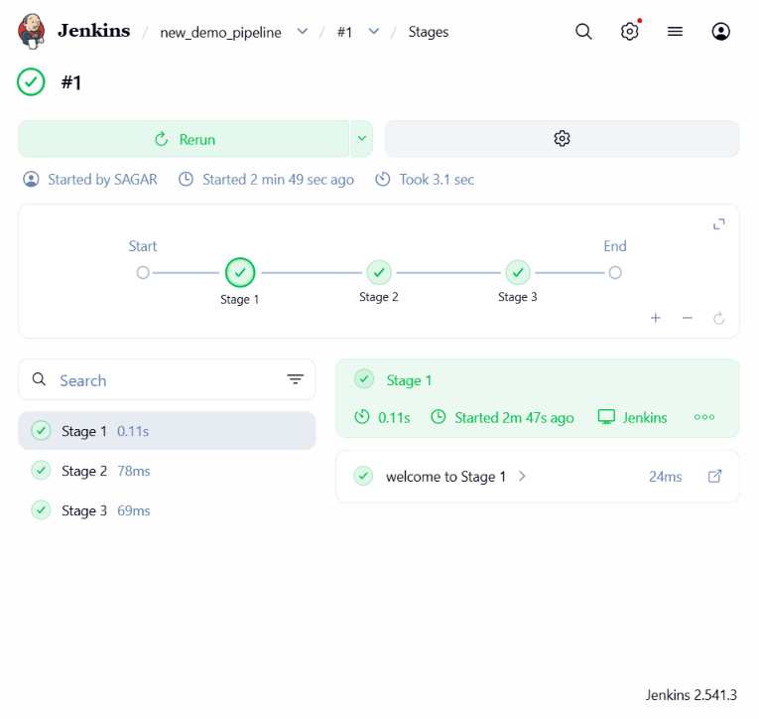
Result: The Jenkins pipeline script was created and executed successfully. All three configured stages completed successfully.

