CI/CD LAB
LAB EXERCISE 7
Setting up Jenkins Pipeline Job from Git
Name | SAGAR
SAP ID | 500125475
Batch | DevOps-3
Subject | CI/CD Lab

University of Petroleum and Energy Studies (UPES)

Lab Exercise 7
Setting up Jenkins Pipeline Job from Git
Objective: To set up a Jenkins pipeline job from Git version control system to enable automated CI for building, testing, and potentially deploying software upon code changes.
Tools required: Jenkins, Git and Linux
Prerequisites: None
Steps to be followed:
1. Create a Git repository
2. Push the pipeline script into the Git repository
3. Create a pipeline script-based freestyle job
Step 1: Create a Git Repository
Create a public GitHub repository named Maven and initialize it with a README file.
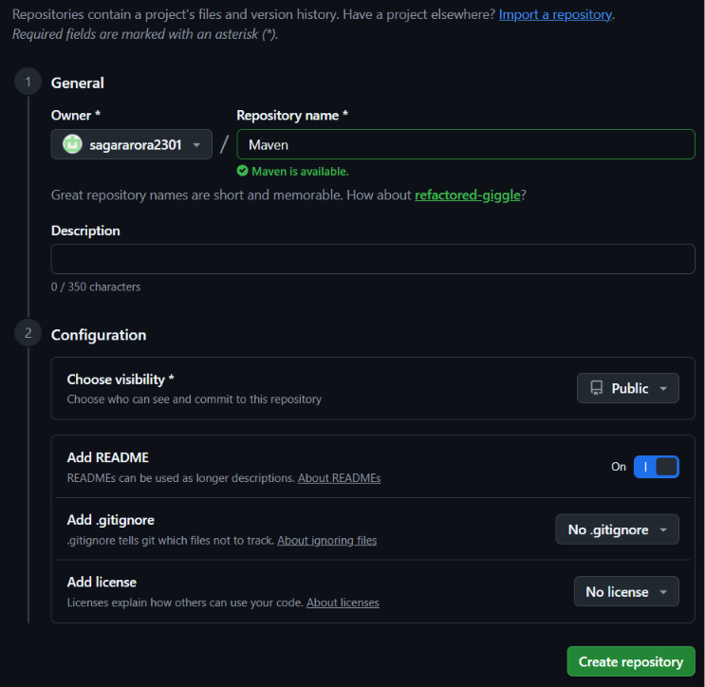
Step 2: Copy the Repository URL
Open the repository Code menu and copy the HTTPS repository URL for use with Git.
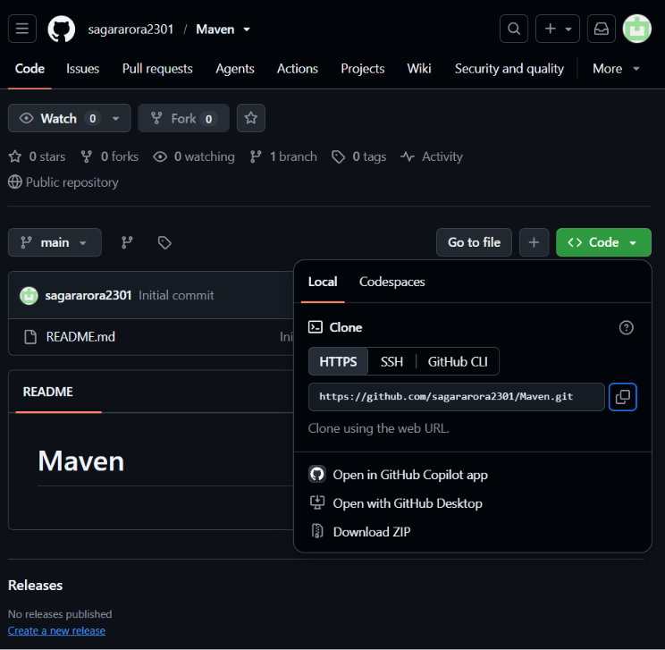
Step 3: Create the Jenkinsfile
Create a Jenkinsfile containing the Maven tool configuration and pipeline stages for Welcome, Clean, Build, Build Success, and Final Success.
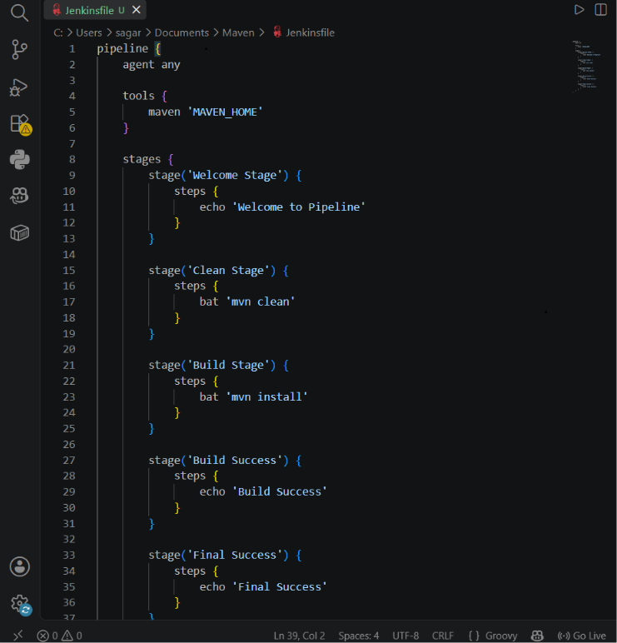
Step 4: Verify Jenkinsfile in GitHub
Push the Jenkinsfile to the Maven repository and verify that it appears in the repository along with README.md.
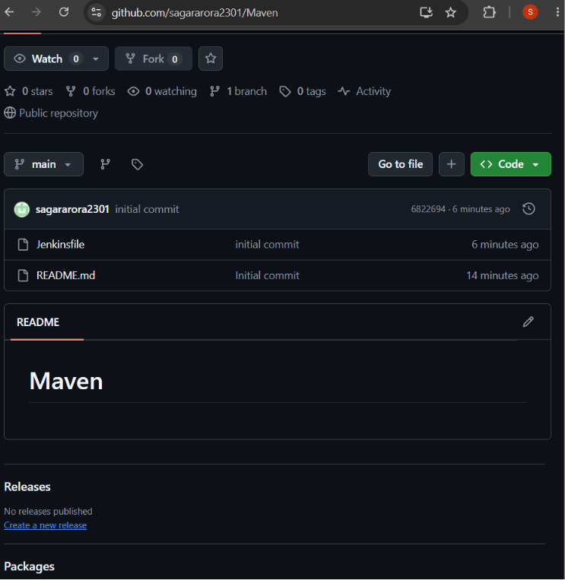
Result: The Git repository was created, the Jenkins pipeline script was prepared in a Jenkinsfile, and the Jenkinsfile was successfully pushed to the GitHub repository.

