CI/CD LAB
LAB EXERCISE 8
Configuring Multibranch Jenkins Pipeline Job
Name | SAGAR
SAP ID | 500125475
Batch | DevOps-3
Subject | CI/CD Lab

University of Petroleum and Energy Studies (UPES)

Lab Exercise 8
Configuring Multibranch Jenkins Pipeline Job
Objective: To configure a Multibranch Jenkins pipeline job to facilitate managing multiple projects within a single job setup.
Tools required: Jenkins, Git, and GitHub
Prerequisites: None
Steps to be followed:
1. Create a Git repository
2. Push the code file into the Git repository
3. Create a Multibranch Pipeline
Step 1: Create a Git Repository
Create a public GitHub repository named Multibranch-Pipeline and initialize it with a README file.
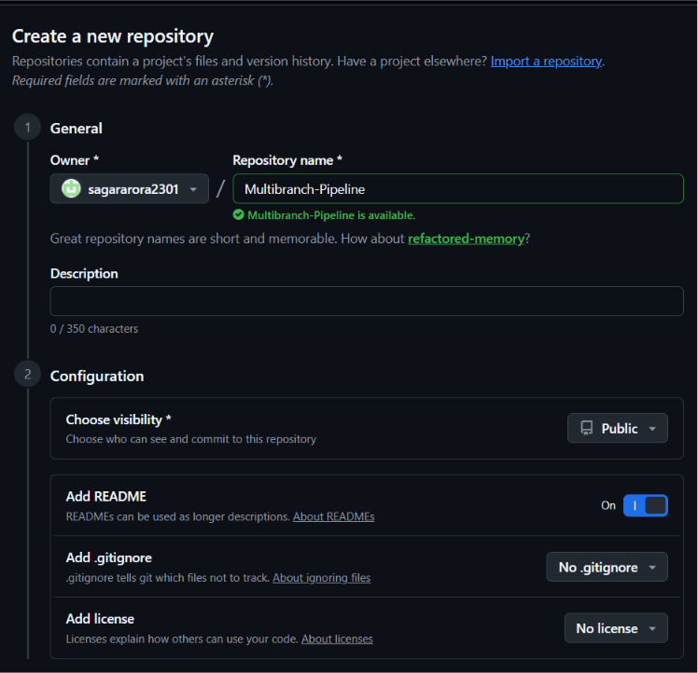
Step 2: Copy the Repository URL
Open the repository Code menu and copy the HTTPS repository URL.
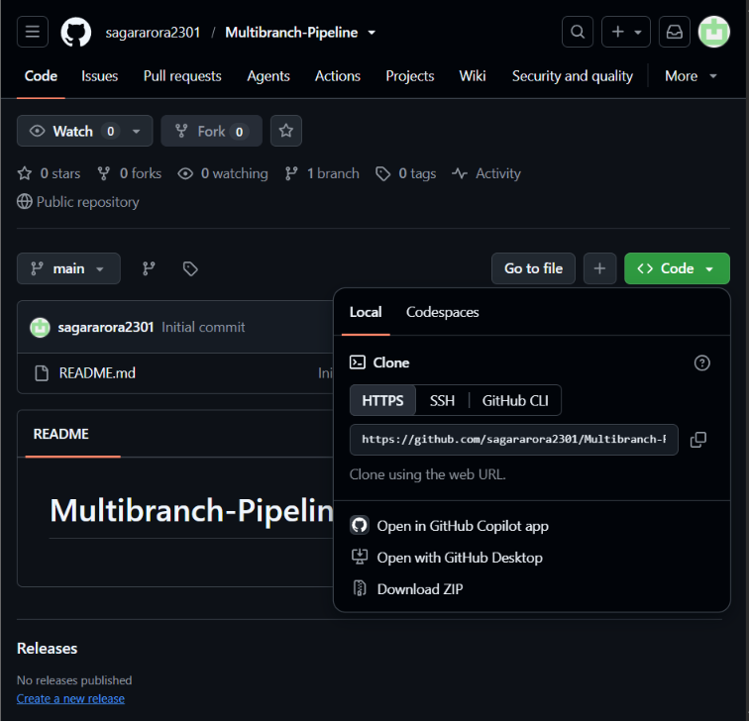
Step 3: Create the Pipeline Code File
Create the pipeline code file containing Build, Test, Deploy, and post success/failure logic.
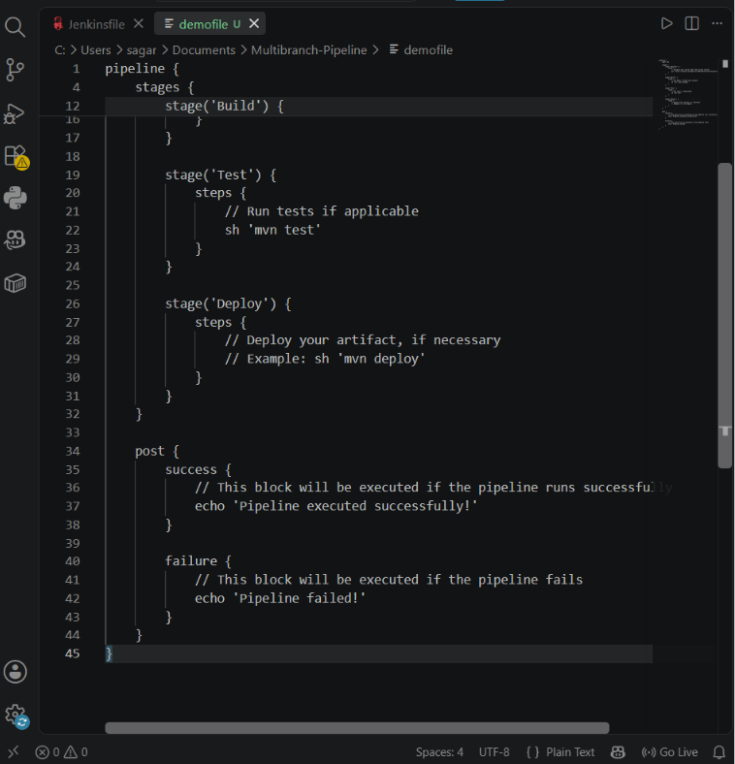
Step 4: Verify the File in GitHub
Push the code file to the Multibranch-Pipeline repository and verify it appears with README.md.
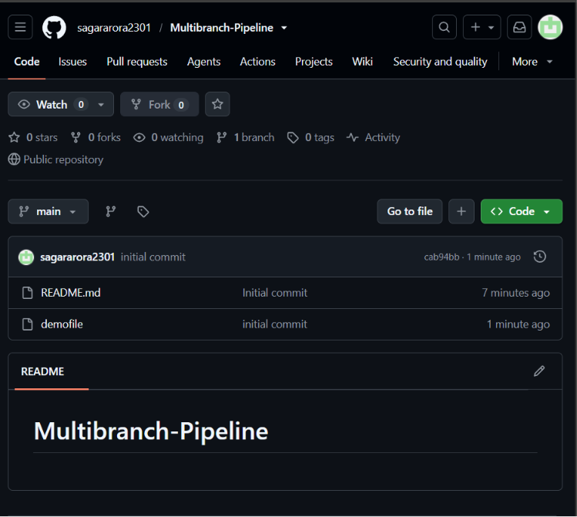
Step 5: Create a Multibranch Pipeline in Jenkins
Create a new Jenkins item and select Multibranch Pipeline as the project type.
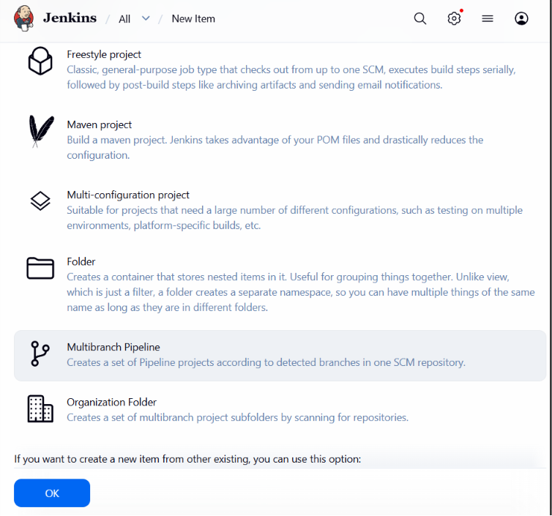
Step 6: Scan the Repository and Verify Success
Scan the configured repository. Jenkins detects the main branch and Jenkinsfile, meets the criteria, schedules the build, and finishes branch indexing successfully.
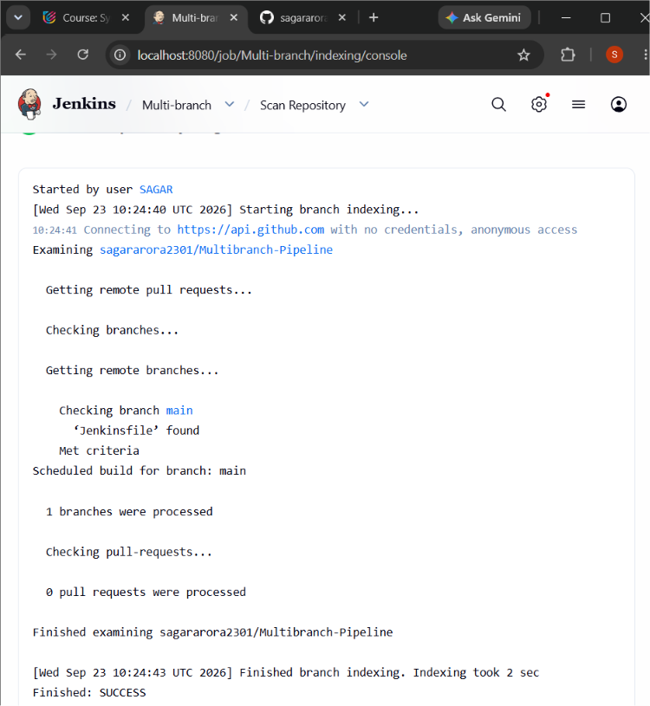
Result: The Multibranch Jenkins Pipeline job was configured successfully. Jenkins detected the main branch and Jenkinsfile and completed repository scanning with SUCCESS.

