DEVOPS PROJECT

SUBMITTED BY: SAGARA SASIKUMAR|sagara-sasikumar@mail.nissan.co.jp

1. Initialized a maven repository for building a desktop application.

//This would create a folder named my-devops_project in the desired location.

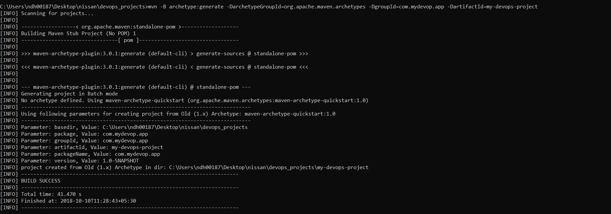

1. Start the maven life cycle //mvn validate (Command)

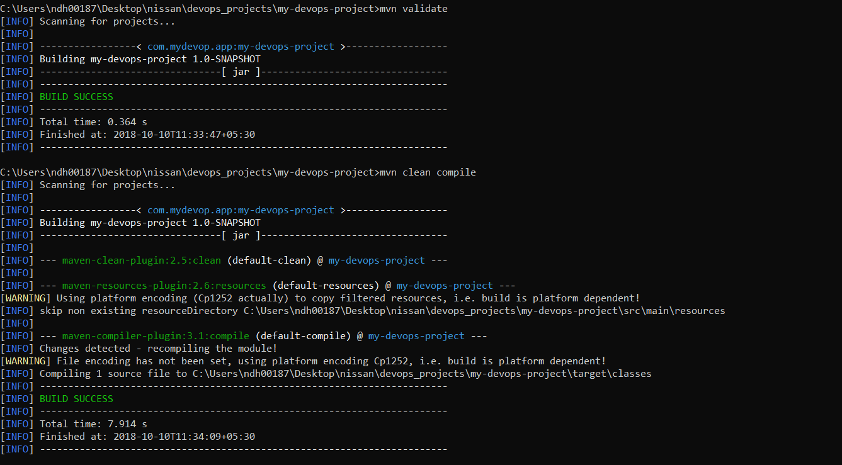

1. Edit the App.java class and AppTest.java class formed in the main test subfolder inside the src folder of my-devops-project subfolder.

* Write the program for number to word conversion and compile the same to verify the results for the given input.

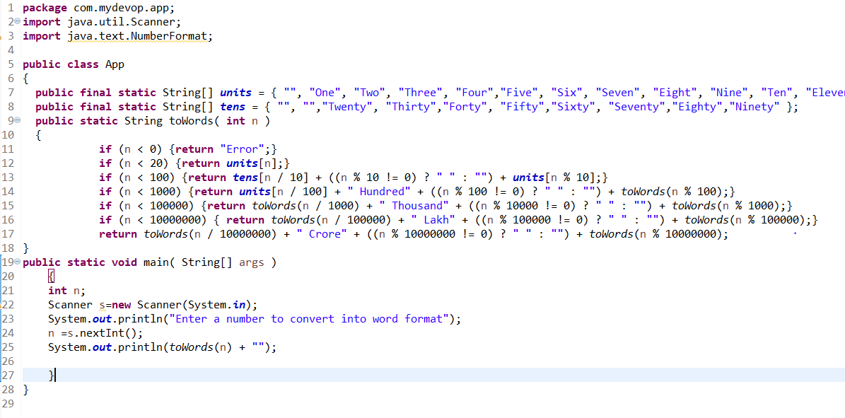

* Console Output:

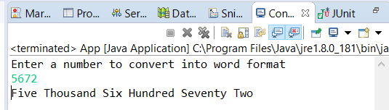

* Write the Test Cases in AppTest.java class and test those with the help of Junit
* 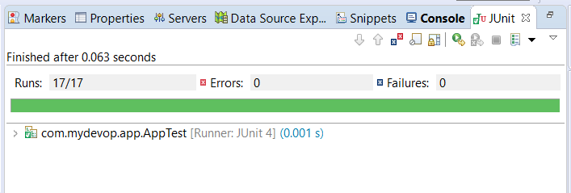
* Test cases:
* 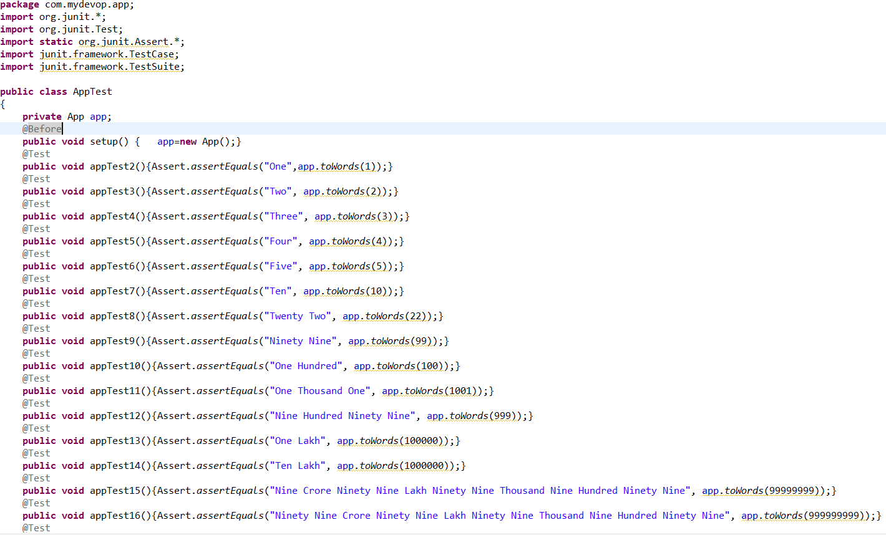

1. Edit the pom.xml file to configure the nexus properly.

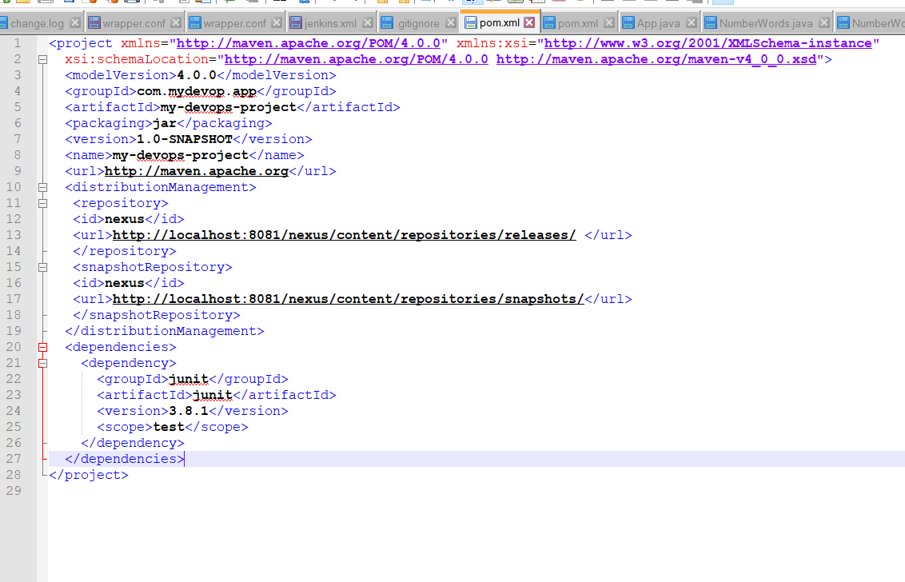

1. Complete the maven lifecycle

* mvn clean compile

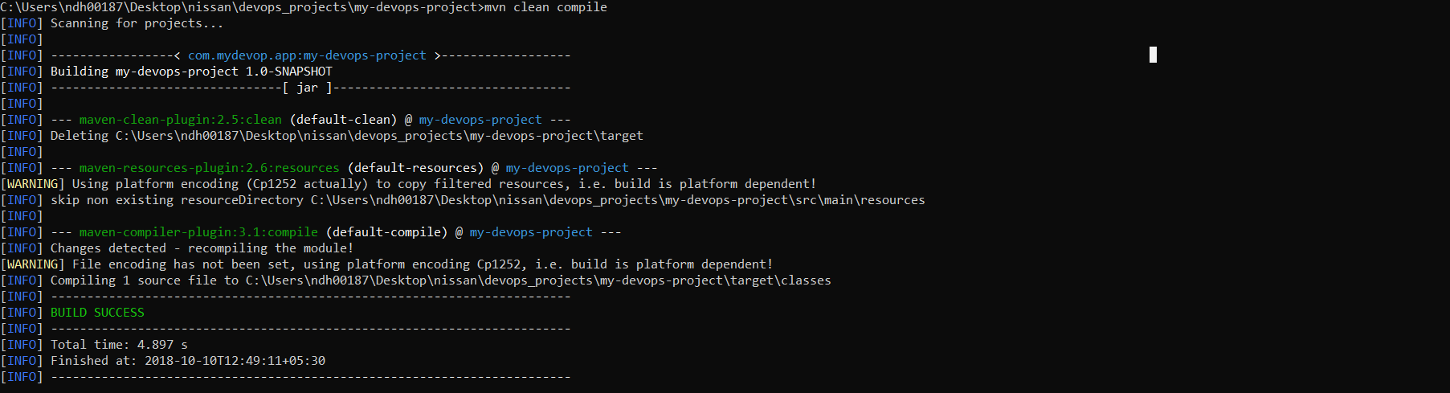

* mvn clean test

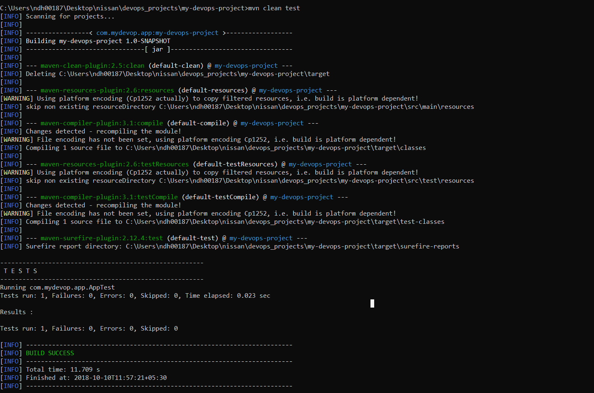

* mvn clean package
* 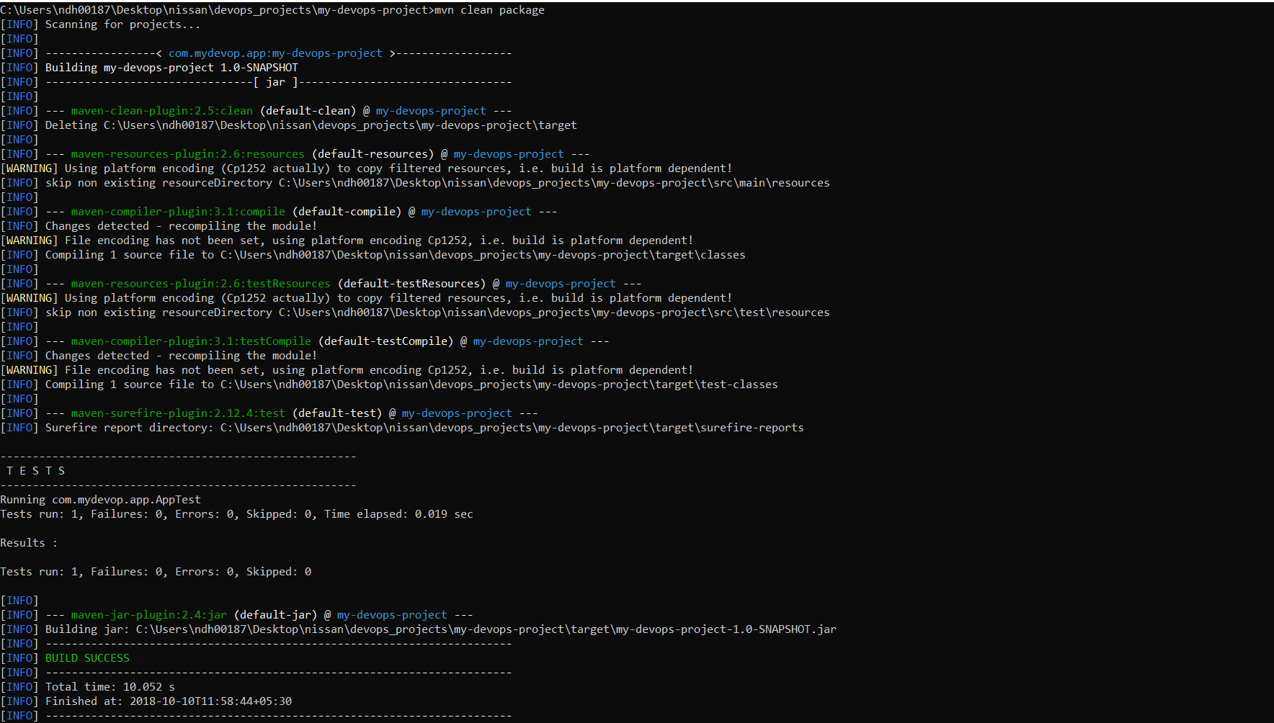
* mvn install

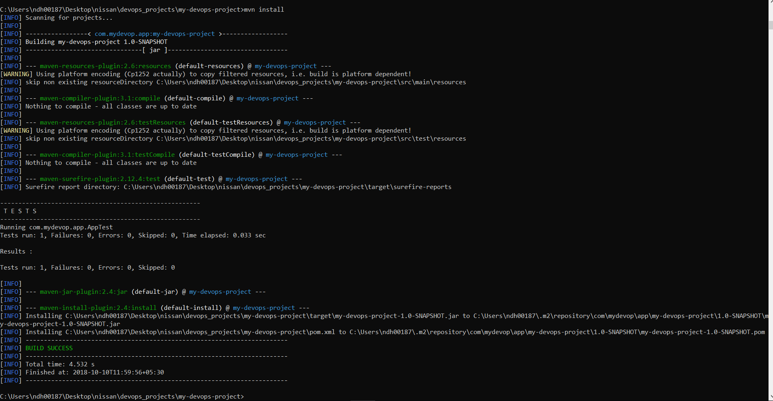

* mvn deploy

1. After the deployment we can see the app being deployed at localhost:8081/nexus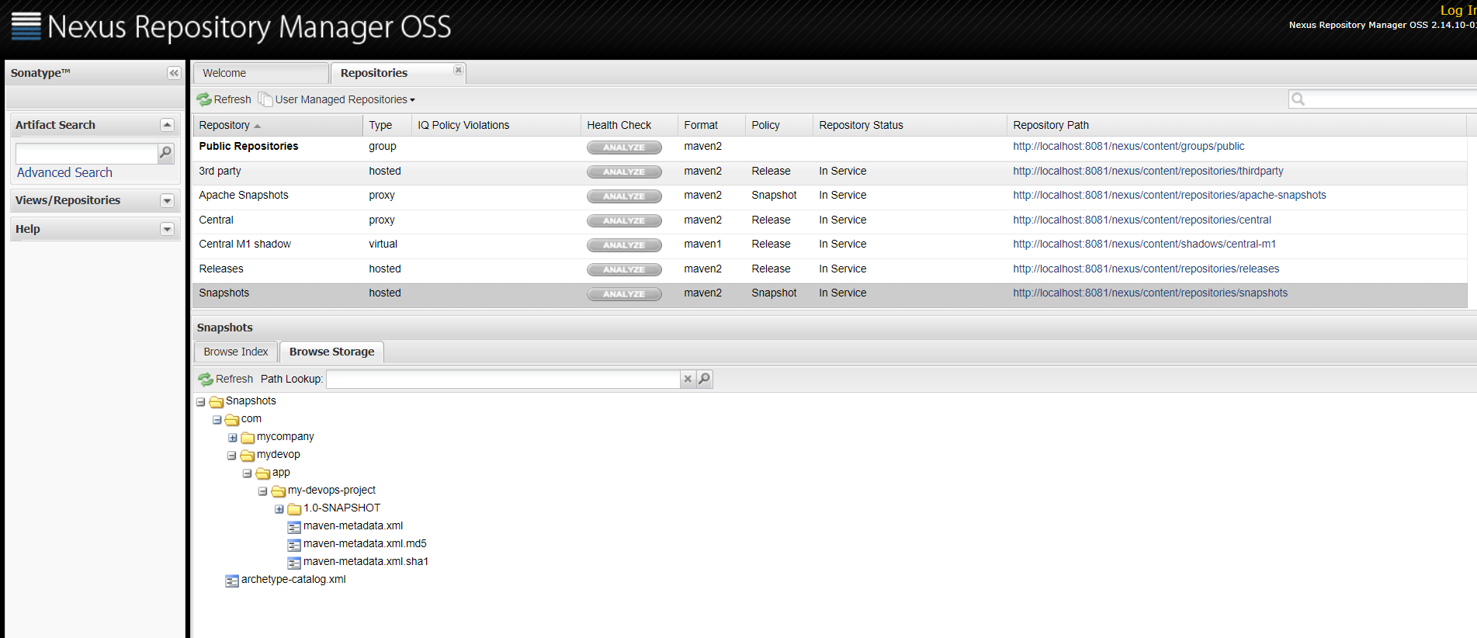
2. Open Jenkins (localhost/809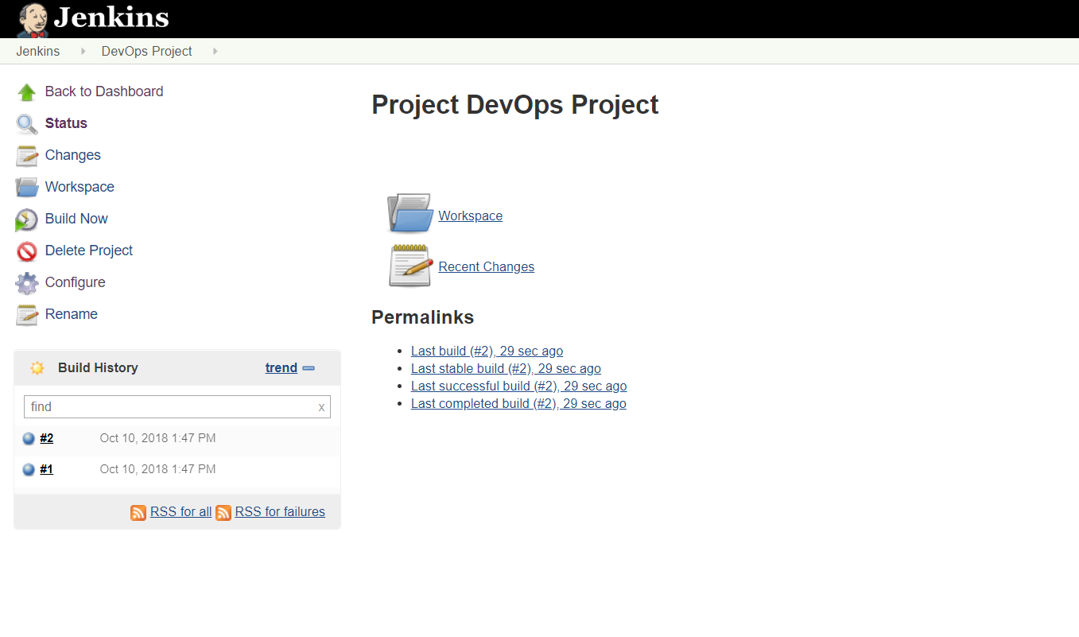 create a new repository and build the project there.
3. Create a git repository and push the project:

* git init
* git add .
* git commit –m “Commiting the poject”
* git remote –v
* git remote add origin <https://github.com/sagarasasikumar/DevOps-Project-Nissan-Training.git>
* git push origin master

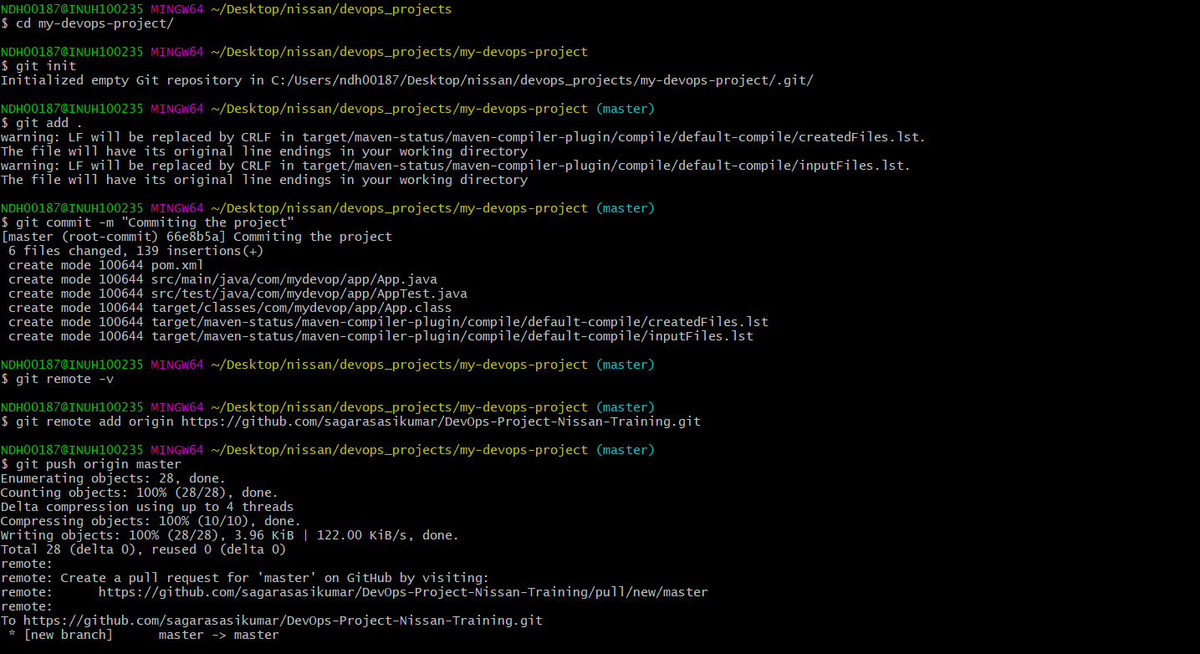

9. For any further changes to be added in code, push it to the github and configure build trigger settings in Jenkins to automatically trigger the build for any update happening in corresponding github repository.

Thankyou