**Methodology For Case Study Airbnb**



**Submitted By:**

Sagar Barge,

1. **Understanding problem, data, objective:**

Airbnb has experienced a significant decline in revenue over recent months, likely due to reduced travel demand.

1. **Understanding the Data-**

This data includes all Airbnb listings in New York city. Contains details such as host information, property type, price, location, availability, and customer reviews.

Data Dictionary

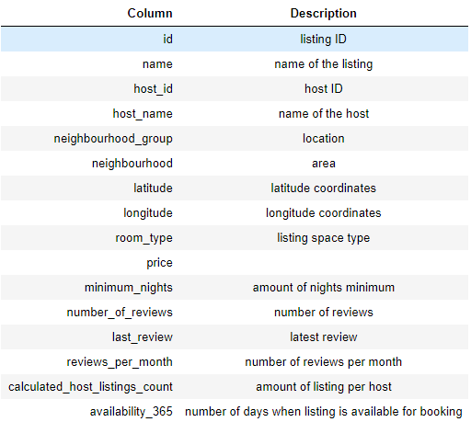

1. **Discussing about Tools required:**

* After discussion with team member we decided to different software to achieve this objective.
* Tools: Python, Excel, PowerBI, Tableau, QGIS.

1. **Import required libraries-**



1. **Checking data type, basic statistics to getting overview of data:**

* *.shape, df.info(), df.describe()*

1. **Checking duplicate values:**

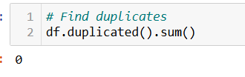

1. **Checking null values :**

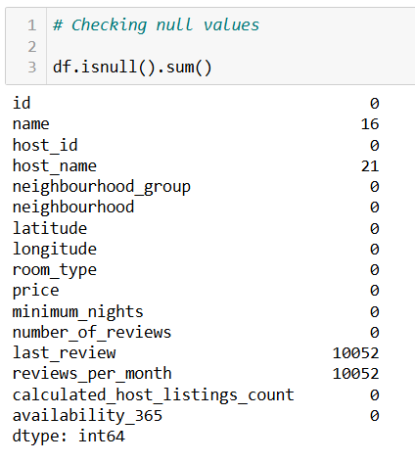

1. **Filled Null values :**
   * Filled 'name', 'host_name' as ‘Unknown’. This column usefull for finding top listing names.
   * Filled Null values as 0 >> Because number_of_reviews column having 0 value, so reviews_per_month will be 0.
   * Changing data format to date

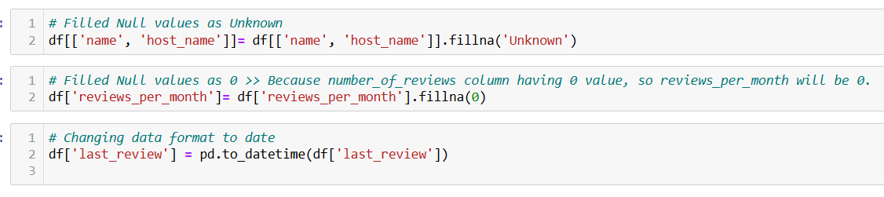

1. **Checking outlier, if it outlier filled with the appropriate value.**

* For checking this used box plot, value count

Example-

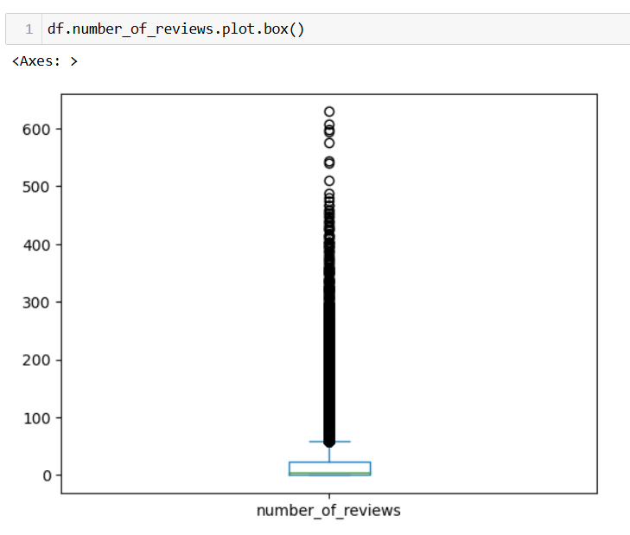

* minimum_nights capping at 500, because after 500, there were only a few values.

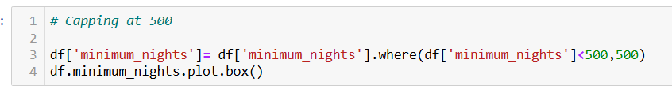

1. **Dropping Unnecessary columns**

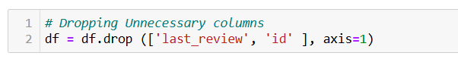

1. **Creating new Column with Low review (0), to understand unpopular listings**

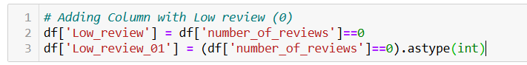

1. **Export final dataframe to .csv for more analysis work >>>>>>>>>>>**

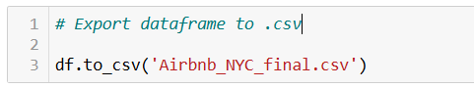

1. Hotspot map created using geopandas

* Created a GeoDataFrame from .csv (lat long to point)

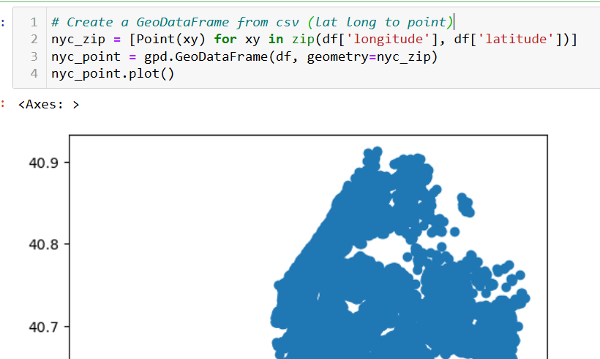

* Loaded NYC map shapefile over listing point

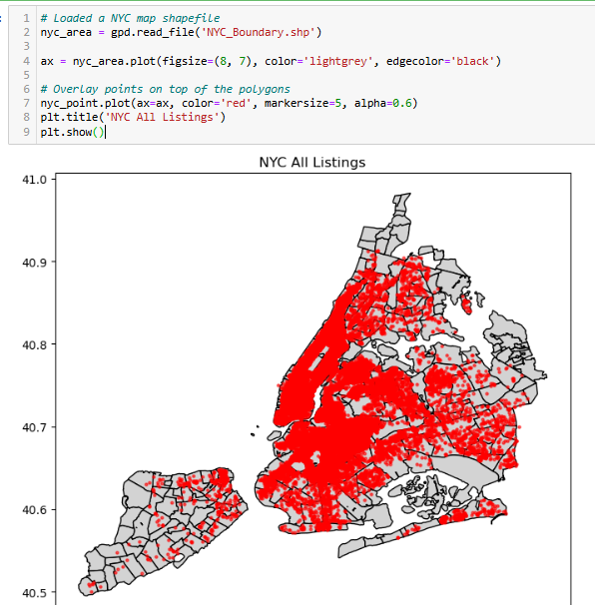

* Number of Days Booking Available

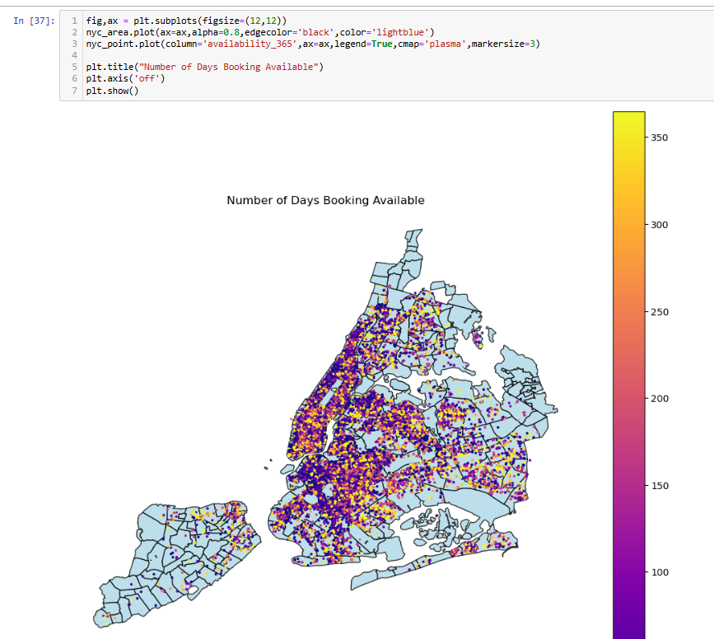

**Power BI, Tableau**

1. Importing data in Power BI, Tableau

* To Analyze Which type of host to acquire more and where, we analyzed the Top 10 neighborhoods with the type of rooms to count of listings. the following chart shows which listings are available and where they are.

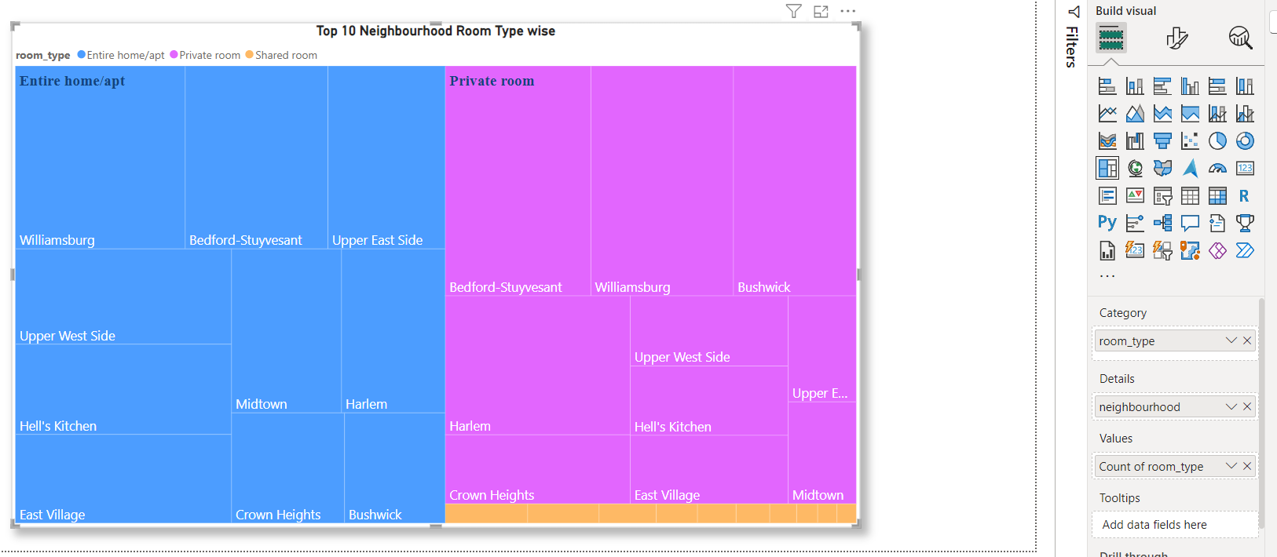

* Neighborhoods group by count of listings, Here we understand listing count with their size of shape.

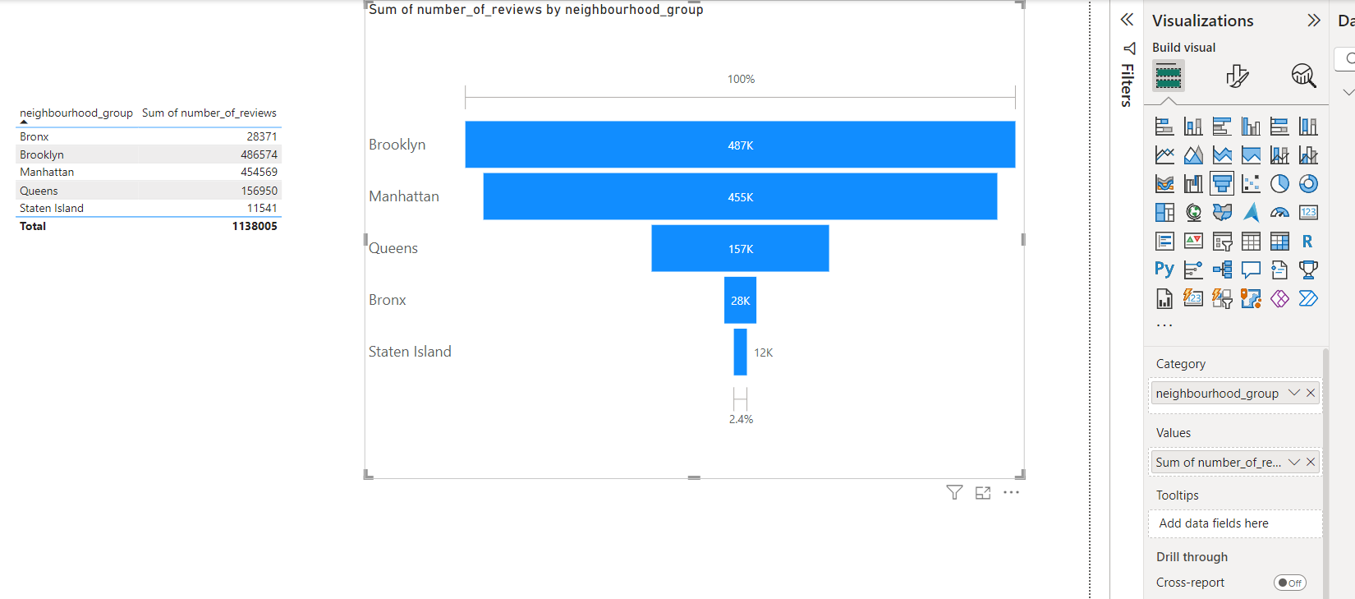

Top 10 Neighborhoods by Sum of No. of reviews

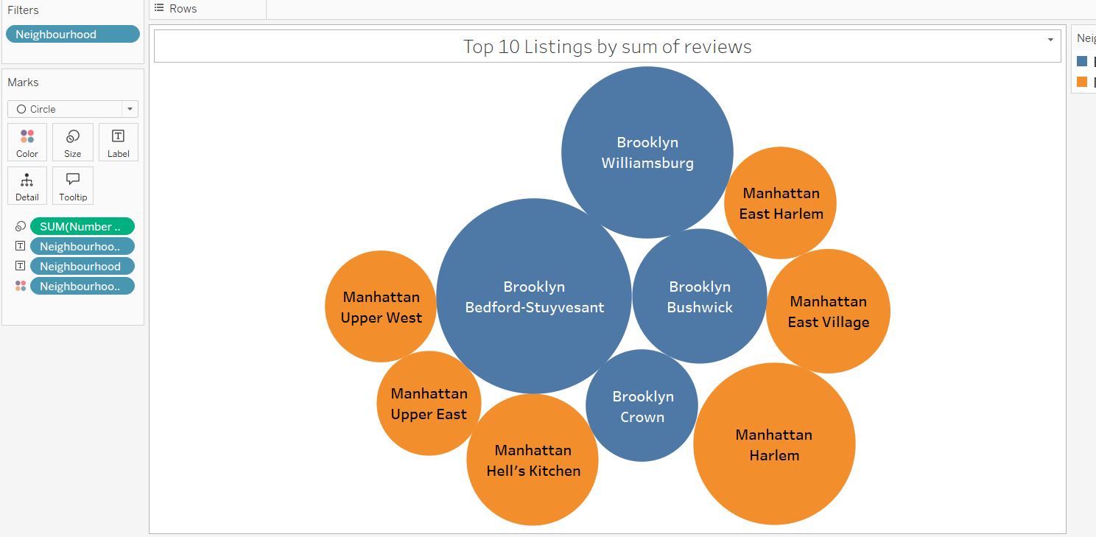

* To know the categorization of customers based on their preferences we created bins of price ranges & to know preferred stay for days. There was an outlier in the data so filtered as top 10 price ranges to easily visualize price ranges.

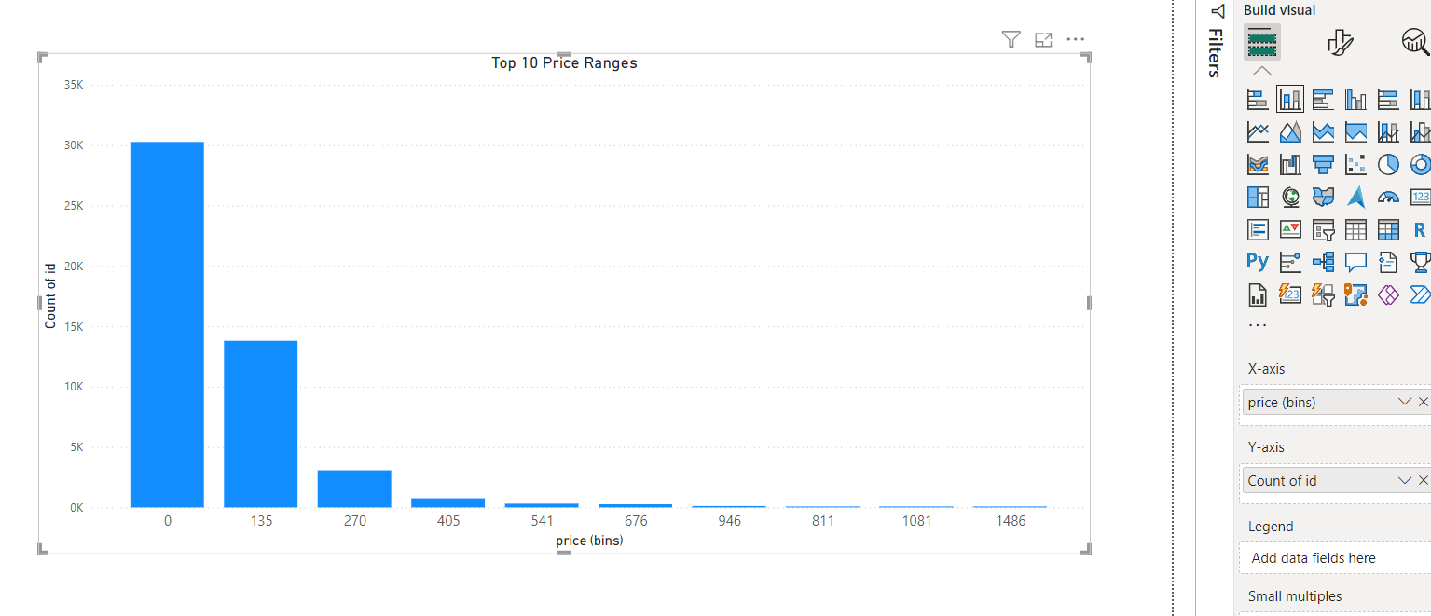

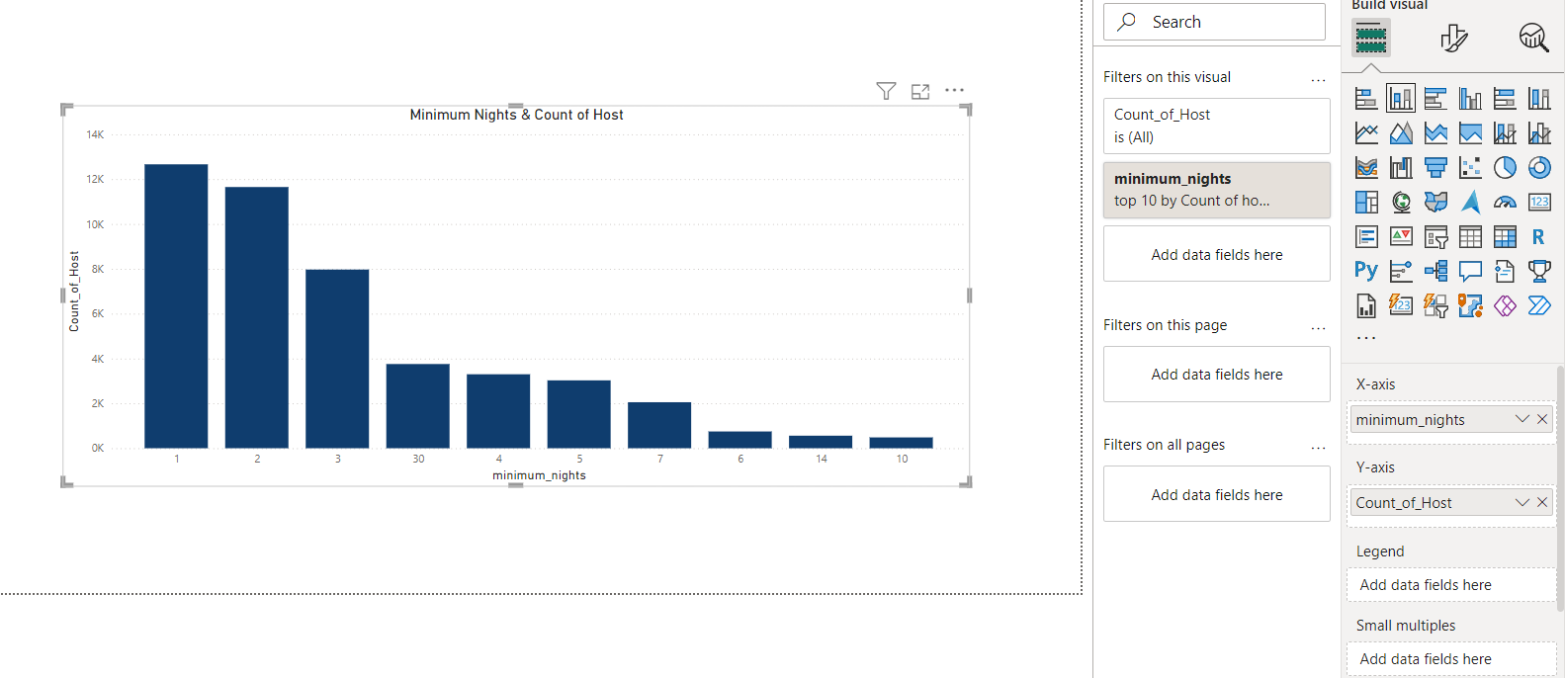

* To know The various kinds of properties that exist w.r.t. customer preferences, we calculated count of host by room type & Average review room type

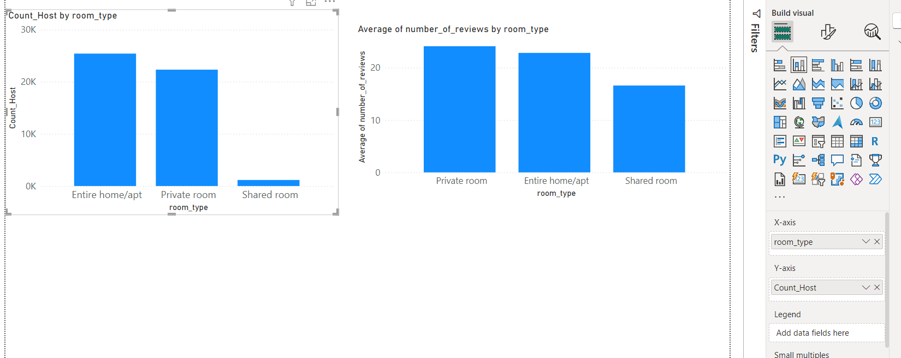

* To know adjustments in the existing properties to make it more customer-oriented in the first pie-chart share of different room type presented. In second plot bar chart created with room type in x axis, sum of number of reviews on y axis, the average availability given to text labels to bars & color shades according to average availability.

