1. **Which are the top three variables in your model which contribute most towards the probability of a lead getting converted?**

**Answer:** The following are the top 3 variables in our model that contribute most towards the probability of a lead getting converted:

* 1. Last Source
  2. Lead Origin
  3. Lead Notable Activity

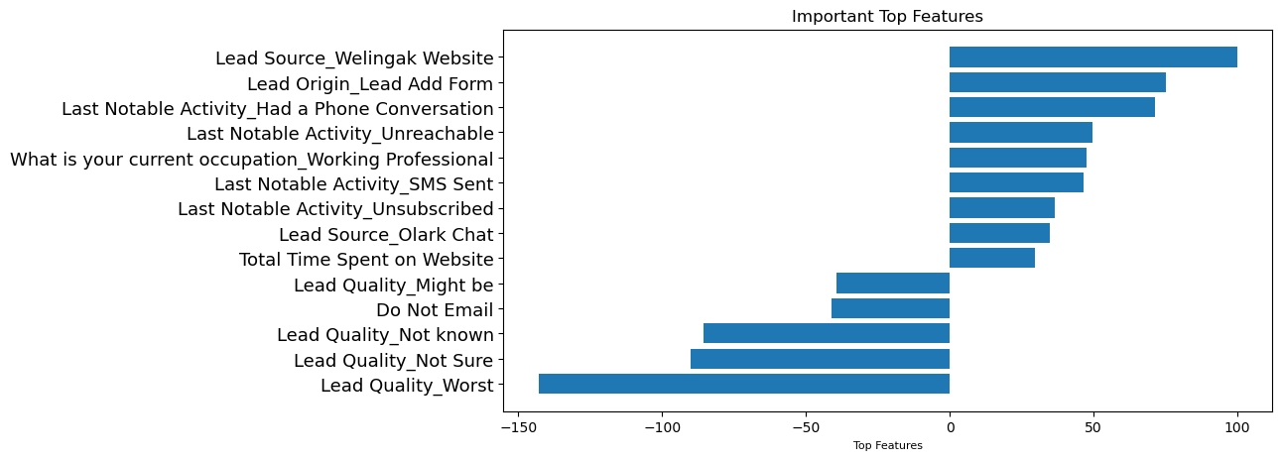

1. **What are the top 3 categorical/dummy variables in the model which should be focused the most on in order to increase the probability of lead conversion?**

**Answer:**

1. Lead Source_Welingak Website: The Company can focus more on the Welingak website to get more leads.
2. Lead Origin_Lead Add Form: Obtaining more leads from leads who have engaged with the "Lead Add Form," since they have a better likelihood of converting.
3. Last Notable Activity_Had a Phone Conversation: Most recent action was via phone conversation could lead to business.
4. **X Education has a period of 2 months every year during which they hire some interns. The sales team, in particular, has around 10 interns allotted to them. So during this phase, they wish to make the lead conversion more aggressive. So they want almost all of the potential leads (i.e. the customers who have been predicted as 1 by the model) to be converted and hence, want to make phone calls to as much of such people as possible. Suggest a good strategy they should employ at this stage.**

**Answer:** Following Strategy can be used:

* + Target customers with high sensitivity.
  + Utilize the 'Lead Score' column generated by the logistic regression model, sorting it in descending order. A higher lead score indicates a higher probability of lead conversion.
  + Prioritize engaging with customers ranked highest in the lead score, ensuring all customers predicted as potential conversions by the model are covered.

1. **Similarly, at times, the company reaches its target for a quarter before the deadline. During this time, the company wants the sales team to focus on some new work as well. So, during this time, the company’s aim is to not make phone calls unless it’s extremely necessary, i.e. they want to minimize the rate of useless phone calls. Suggest a strategy they should employ at this stage.**

**Answer:** When company reaches its target before the deadline, the time company should apply following strategy:

* + Focus on high-specificity customers.
  + Since the company has reached its target ahead of the deadline, it can now shift its focus to new tasks while continuing to engage with leads.
  + Resume engagement from where the lead scoring left off, targeting high-sensitivity customers.
  + This approach ensures that follow-up calls are made only to those customers with a high probability of conversion.