**Docker Commads:**

**1. docker –version**

This command is used to get the currently installed version of docker

 2.**docker pull**

**Usage: docker pull <image name>**

This command is used to pull images from the **docker repository**(hub.docker.com)

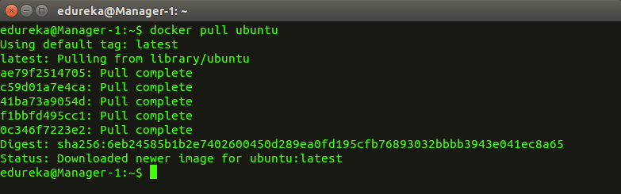  
  
3. **docker run**

**Usage: docker run -it -d <image name>**

This command is used to create a container from an image

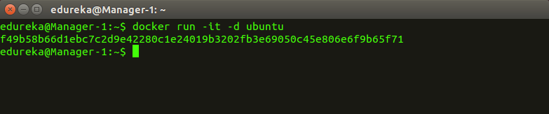  
  
4. **docker ps**

This command is used to list the running containers

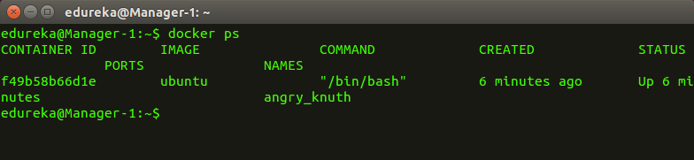  
  
5. **docker ps -a**

This command is used to show all the running and exited containers

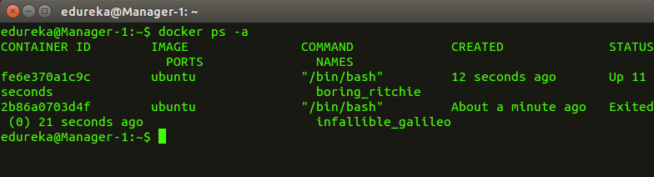  
  
6. **docker exec**

**Usage: docker exec -it <container id> bash**

This command is used to access the running container

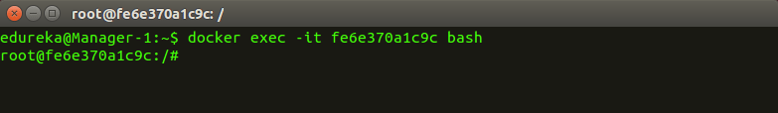  
  
7. **docker stop**

**Usage: docker stop <container id>**

This command stops a running container

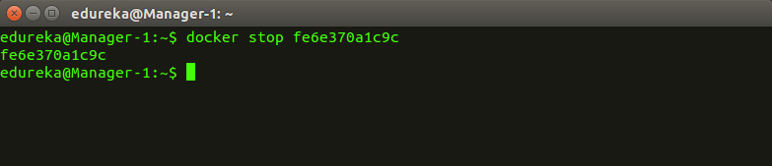  
  
8. **docker kill**

**Usage: docker kill <container id>**

This command kills the container by stopping its execution immediately. The difference between ‘docker kill’ and ‘docker stop’ is that ‘docker stop’ gives the container time to shutdown gracefully, in situations when it is taking too much time for getting the container to stop, one can opt to kill it

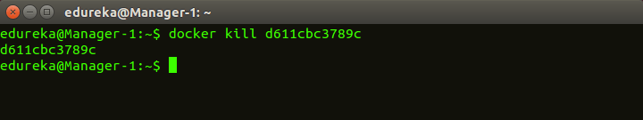  
  
9. **docker commit**

**Usage: docker commit <conatainer id> <username/imagename>**

This command creates a new image of an edited container on the local system

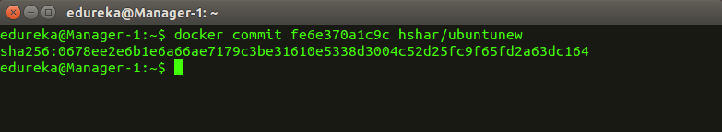  
  
10. **docker login**

This command is used to login to the docker hub repository

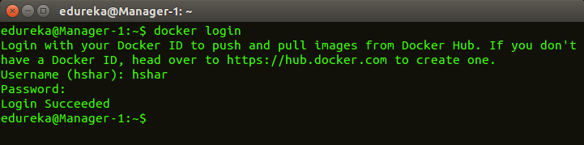  
  
11.**docker push**

**Usage: docker push <username/image name>**

This command is used to push an image to the docker hub repository

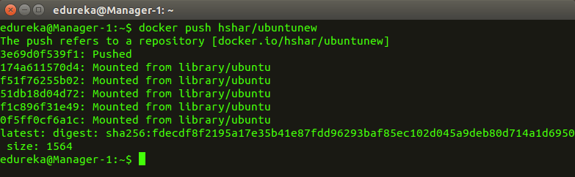  
  
12. **docker images**

This command lists all the locally stored docker images

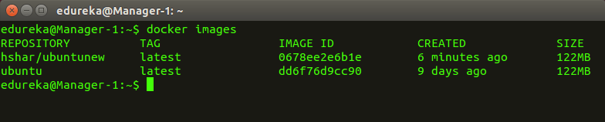  
  
13. **docker rm**

**Usage: docker rm <container id>**

This command is used to delete a stopped container

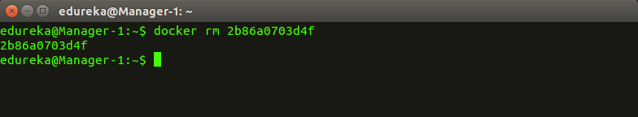  
  
14. **docker rmi**

**Usage: docker rmi <image-id>**

This command is used to delete an image from local storage

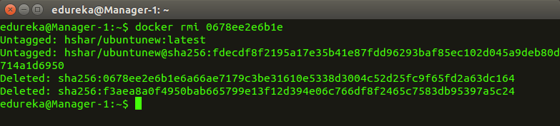  
  
15. **docker build**

**Usage: docker build <path to docker file>**

This command is used to build an image from a specified docker file

