Monitoring project POC:

1. **Create a docker-compose.yml file:**

version: '3'

services:

elasticsearch:

image: docker.elastic.co/elasticsearch/elasticsearch:6.2.4

container_name: elasticsearch

environment:

cluster.name: "docker-cluster"

bootstrap.memory_lock: "true"

ES_JAVA_OPTS: "-Xms512m -Xmx512m"

TAKE_FILE_OWNERSHIP: "true"

ulimits:

memlock:

soft: -1

hard: -1

volumes:

- ./data/esdata1:/usr/share/elasticsearch/data

ports:

- 9200:9200

- 9300:9300

grafana:

image: grafana/grafana:5.1.0

container_name: grafana

volumes:

- ./data/grafana:/var/lib/grafana

ports:

- 3000:3000

user: "0”

1. **run command: docker-compose up**
2. **then launch Elasticsearch and Grafana**

**Grafana URL:** [http://localhost:3000](http://localhost:3000/)

**Elasticsearch URL:** <http://localhost:9200/>

1. **Create ES Index through Postman:**

**Mapping:**

**{**

**"mappings": {**

**"data": {**

**"properties": {**

**"timestamp": {**

**"type": "date"**

**}**

**}**

**}**

**}**

**}**

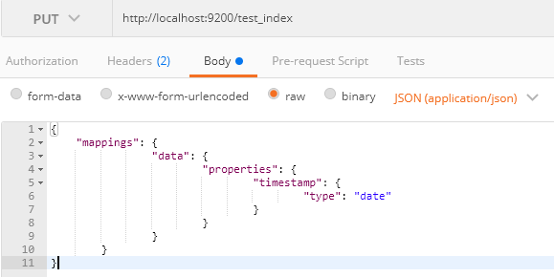

1. **Post data into ES index**

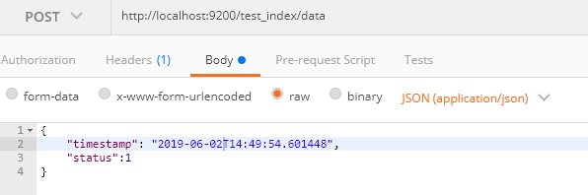

1. **Configure Data source for ES:**

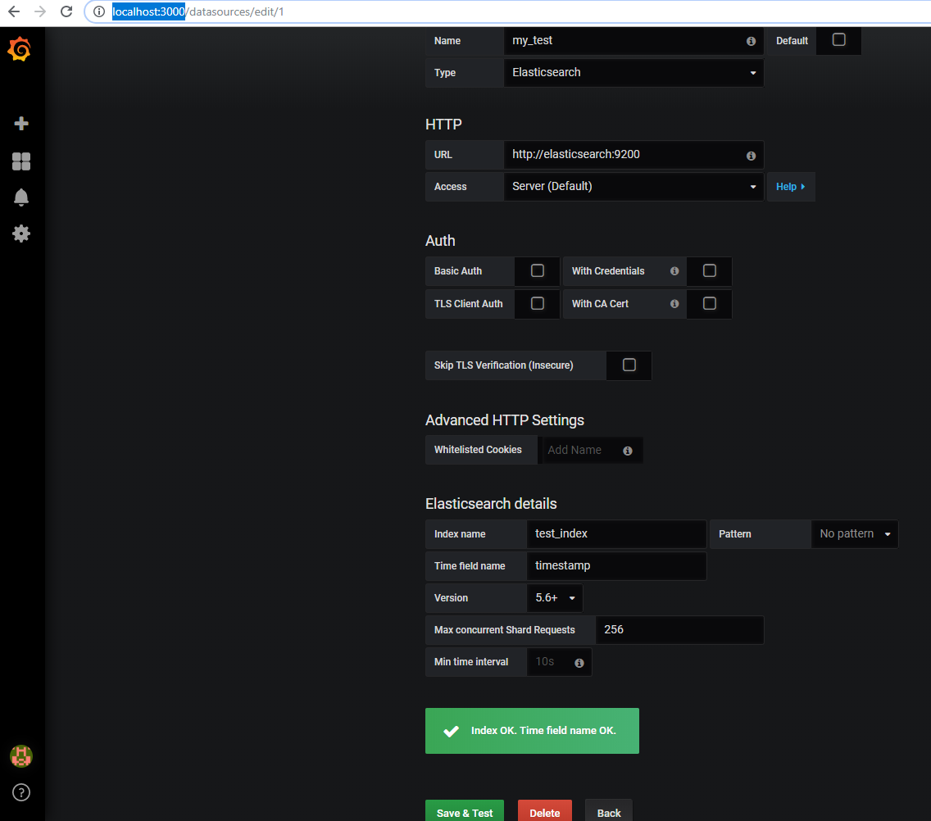

**Example:**

