Read Me

URL for Live Application: <http://ec2-35-163-2-175.us-west-2.compute.amazonaws.com:5000/>

**Screen shots:**

Login Page:

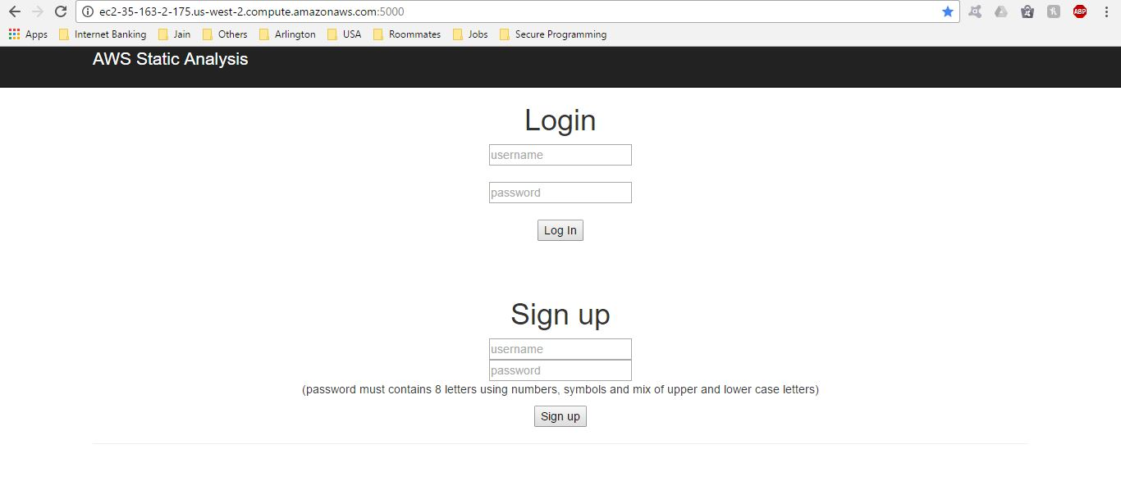

Home Page:

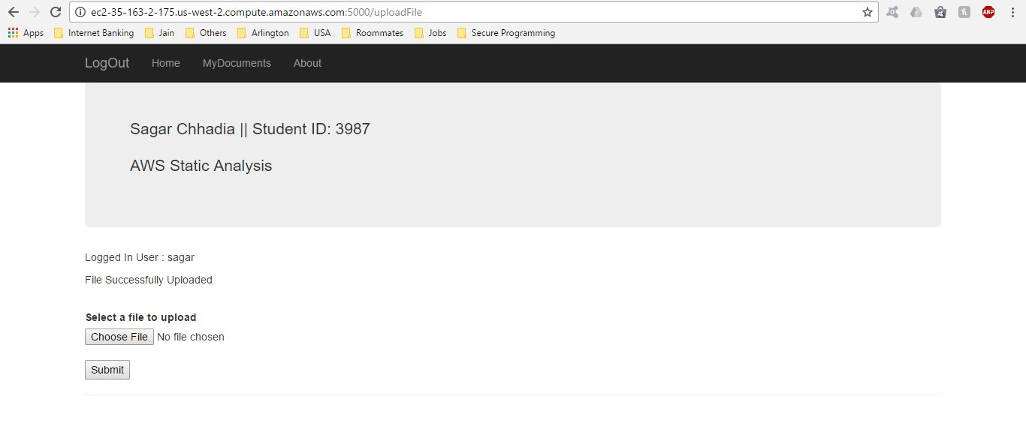

My Documents Page:

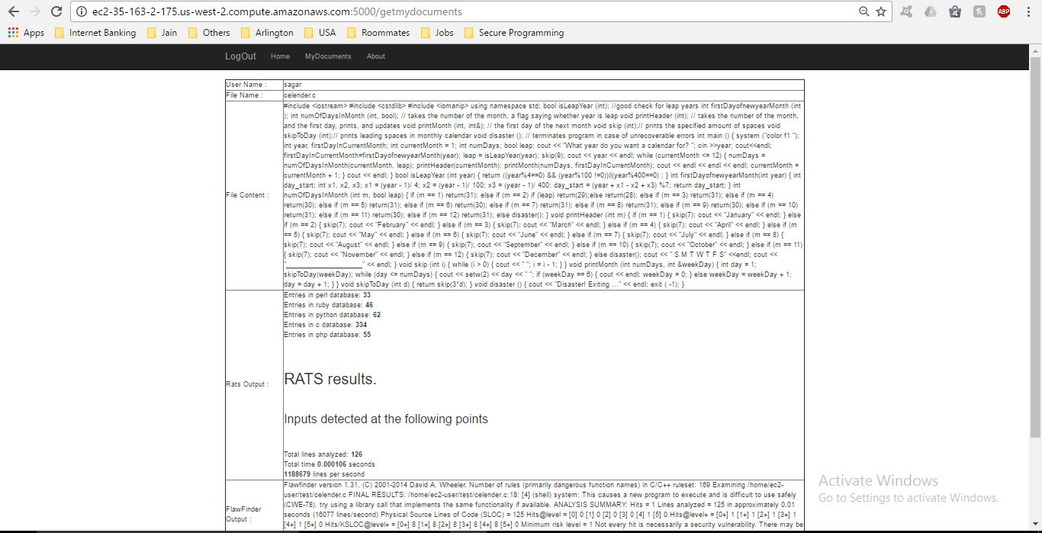

Rats Analysis:

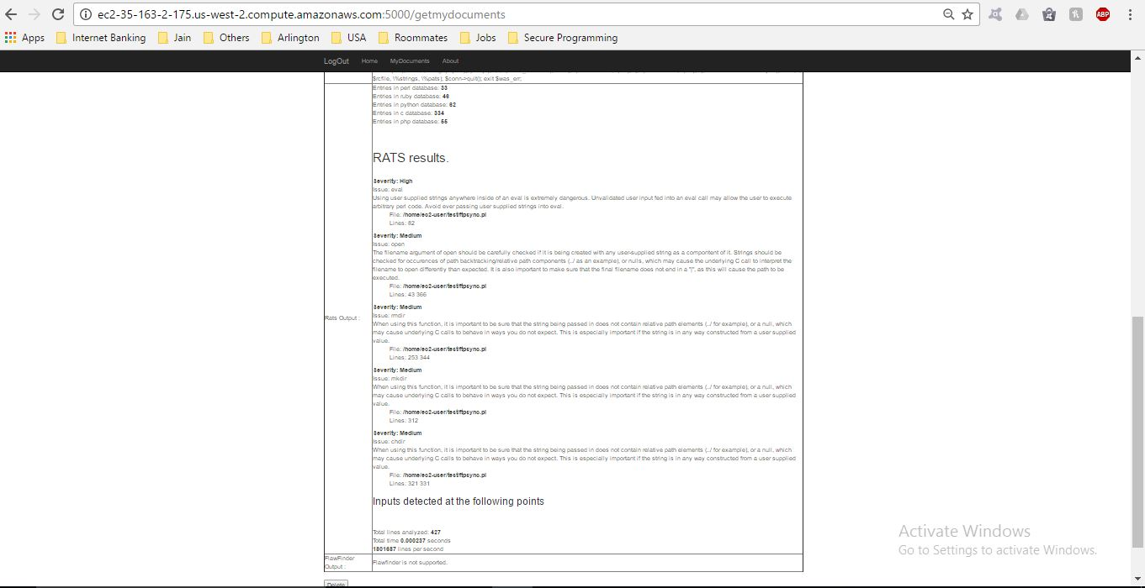

FlawFinder Analysis:

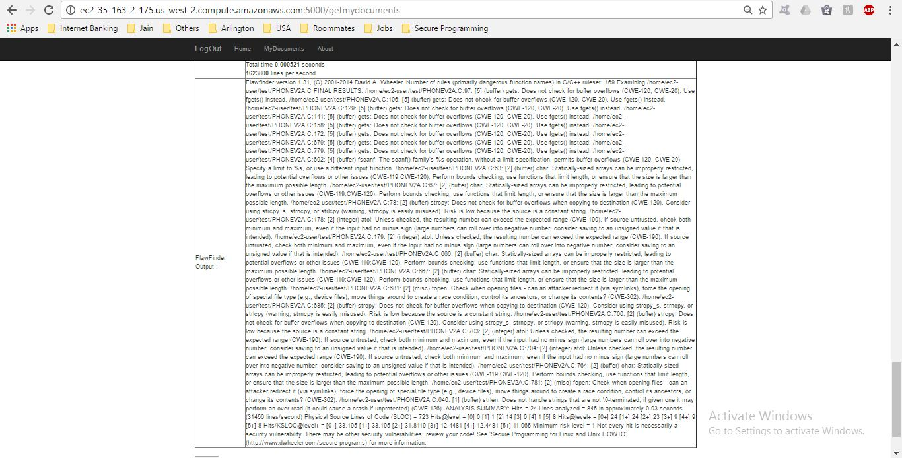

About Page:

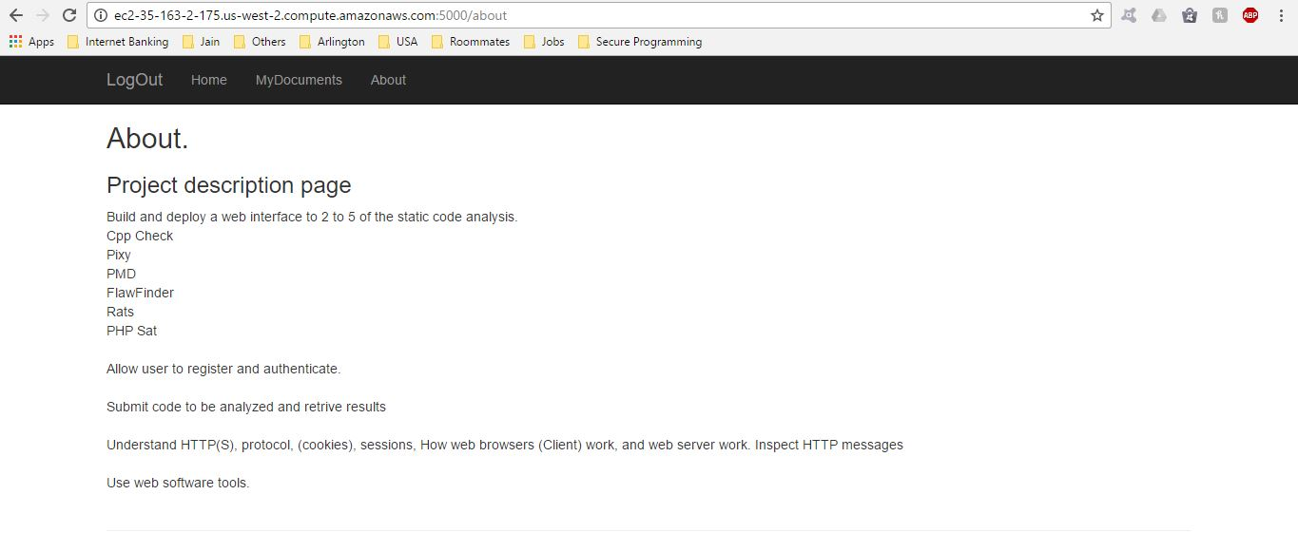

Logout Page:

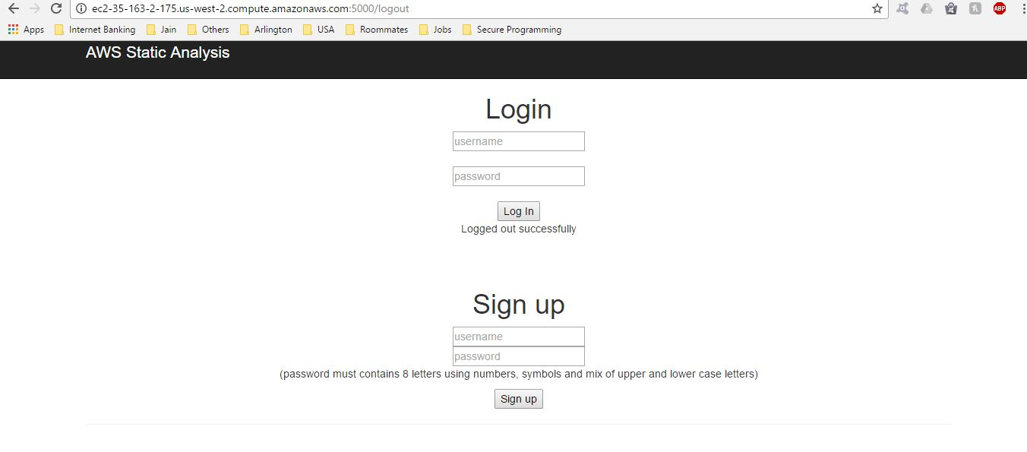

**References:**

* <http://stackoverflow.com/questions/1221985/how-to-validate-a-user-name-with-regex>
* <http://stackoverflow.com/questions/23432478/flask-generate-password-hash-not-constant-output>
* <http://stackoverflow.com/questions/2502833/store-output-of-subprocess-popen-call-in-a-string>
* <https://security.web.cern.ch/security/recommendations/en/codetools/rats.shtml>
* <https://security.web.cern.ch/security/recommendations/en/codetools/flawfinder.shtml>