## Using UDP sockets, write a client-server program to make client sending the file name and the server to send back the contents of the requested file if present

Server.py

from socket import * serverPort = 12000

serverSocket = socket(AF_INET, SOCK_DGRAM) serverSocket.bind(("127.0.0.1", serverPort)) print ("The server is ready to receive") while 1:

sentence, clientAddress = serverSocket.recvfrom(2048) sentence = sentence.decode("utf-8") file=open(sentence,"r")

con=file.read(2048) serverSocket.sendto(bytes(con,"utf-8"),clientAddress)

print ('\nSent contents of ', end = ' ') print (sentence)

# for i in sentence:

# print (str(i), end = '') file.close()

## Client.py

from socket import * serverName = "127.0.0.1"

serverPort = 12000

clientSocket = socket(AF_INET, SOCK_DGRAM) sentence = input("\nEnter file name: ")

clientSocket.sendto(bytes(sentence,"utf-8"),(serverName, serverPort))

filecontents,serverAddress = clientSocket.recvfrom(2048) print ('\nReply from Server:\n')

print (filecontents.decode("utf-8")) # for i in filecontents:

# print(str(i), end = '') clientSocket.close() clientSocket.close()

## Sentence.txt

Hi, this is sagar

# Output

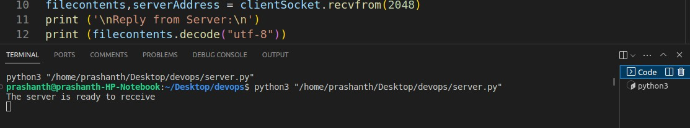Server.py

# Client.py