***WEEK- 7***

**DBMS LAB Supplier Database**

**create database Supplier_d1;**

**use Supplier_d1;**

**create table suppliers**

**(**

**sid int primary key,**

**sname varchar(20),**

**city varchar(20)**

**);**

**create table parts**

**(**

**pid int primary key,**

**pname varchar(20),**

**color varchar(10)**

**);**

**create table catalog**

**(**

**sid int,**

**pid int,**

**foreign key(sid)references suppliers(sid) on delete cascade,**

**foreign key(pid) references parts(pid) on delete cascade,**

**cost float,**

**primary key(sid, pid)**

**);**

**insert into suppliers values(10001, "Acme Widget","Bangalore"), (10002, "Johns","Kolkata"),**

**(10003,"Vimal","Mumbai"), (10004,"Reliance","Delhi"), (10005,"Mahindra","Mumbai");**

**select *from suppliers;**

**insert into parts values(20001,"Book","Red"),**

**(20002,"Pen","Red"), (20003,"Pencil","Green"),**

**(20004,"Mobile","Green"), (20005,"Charger","Black");**

**select *from parts;**

**insert into catalog values(10001, 20001,10),**

**(10001, 20002,10), (10001, 20003,30),**

**(10001, 20004,10), (10001, 20005,10),**

**(10002, 20001,10), (10002, 20002,20),**

**(10003, 20003,30), (10004, 20003,40);**

**select *from catalog;**

query 1

Find the pnames of parts for which there is some supplier .

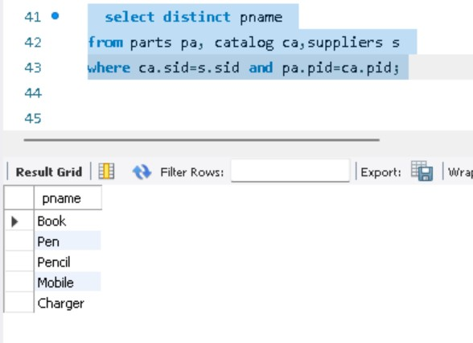query 2

Find the snames of suppliers who supply every part.

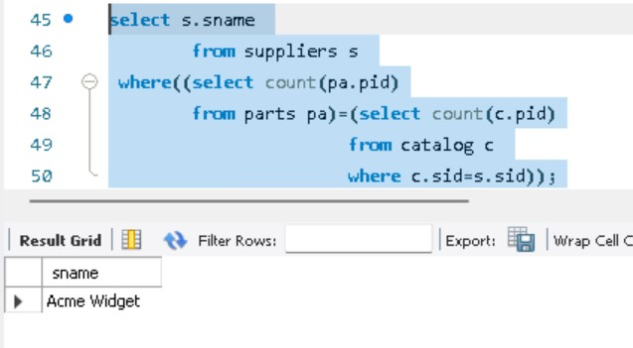

query 3

Find the snames of suppliers who supply every red part.

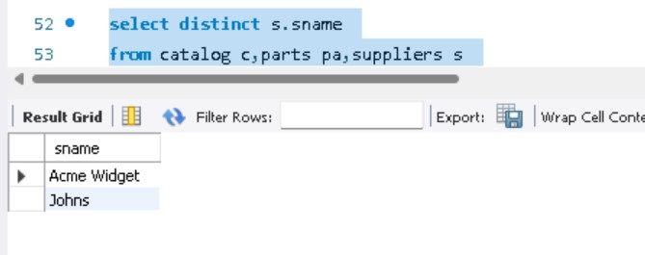

query 4

Find the pnames of parts supplied by Acme Widget Suppliers and by no

one else.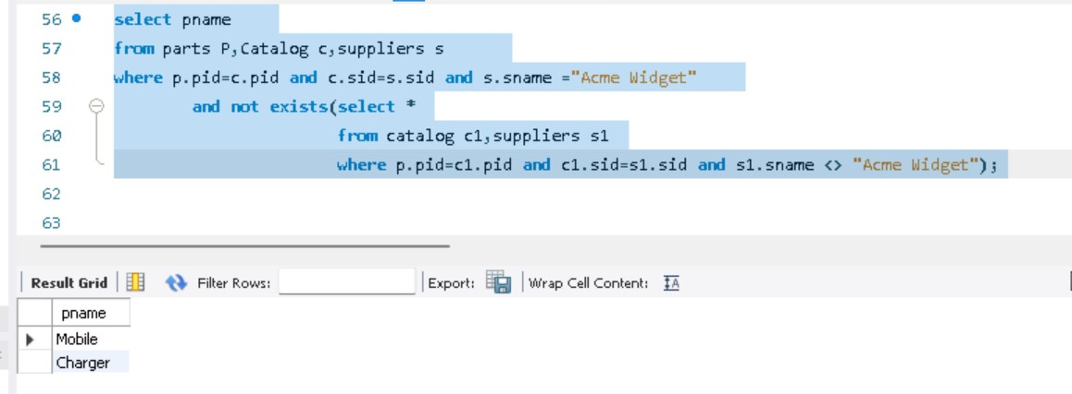

query 5

Find the sids of suppliers who charge more for some part than the average cost of that part (averaged over all the suppliers who supply that part).

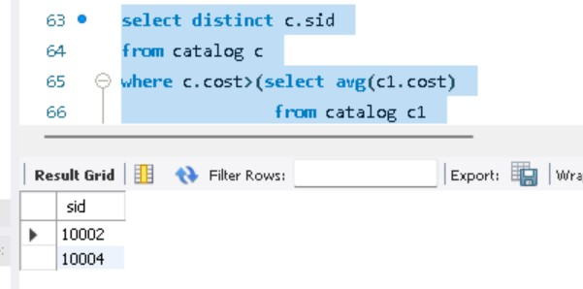

query 6

For each part, find the sname of the supplier who charges the most for that part.

