Query 1

Find all the customers who have an account at all the branches located in a specific city (Ex. Delhi).

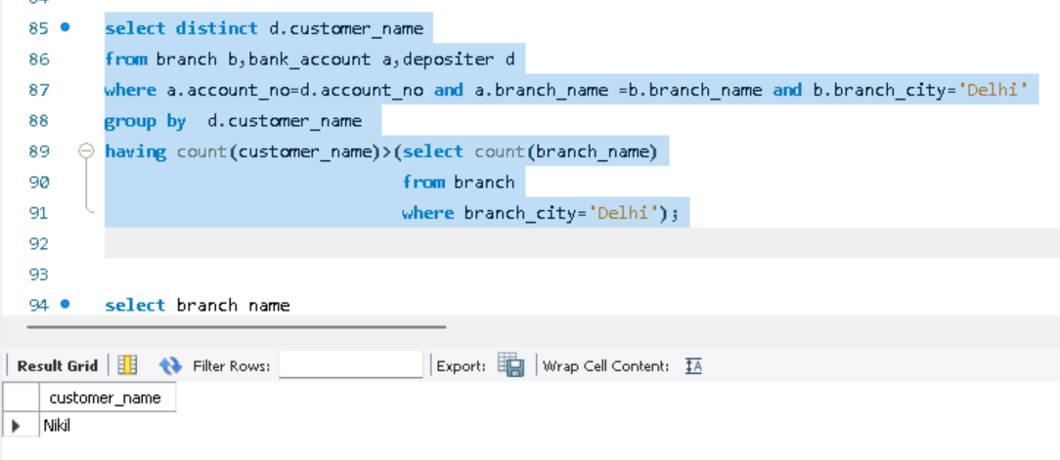

Query 2

Find all customers who have a loan at the bank but do not have an account.

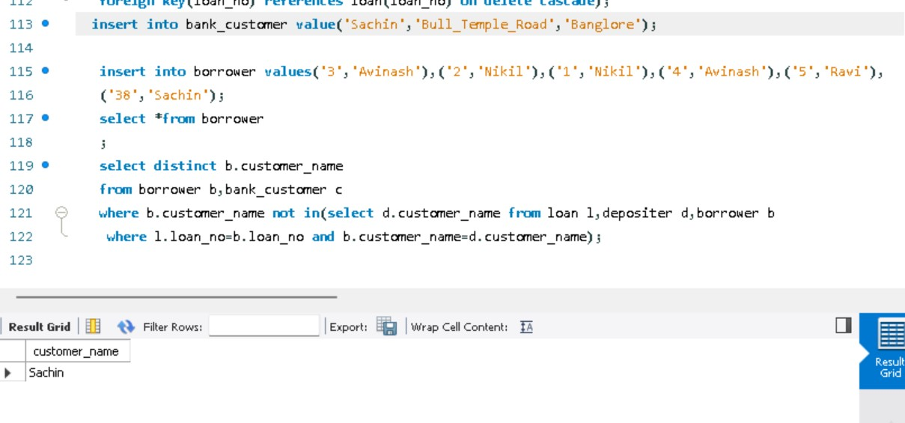

Query 3

Find all customers who have both an account and a loan at the Bangalore branch

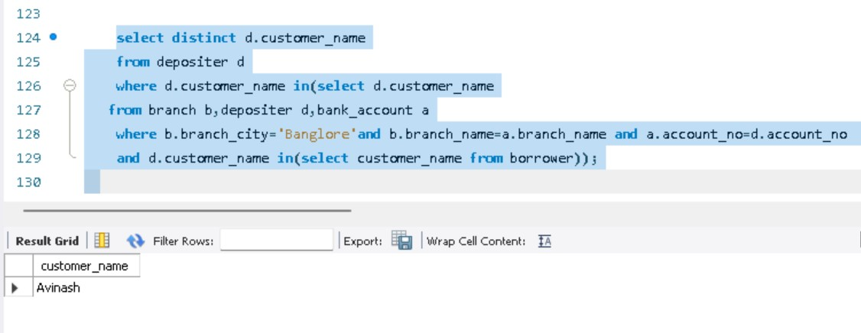

Query 4

Find the names of all branches that have greater assets than all branches located in Bangalore.

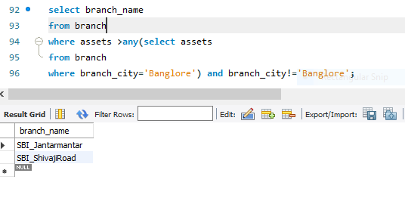

Query 5

Demonstrate how you delete all account tuples at every branch located in a specific city (Ex. Bombay).

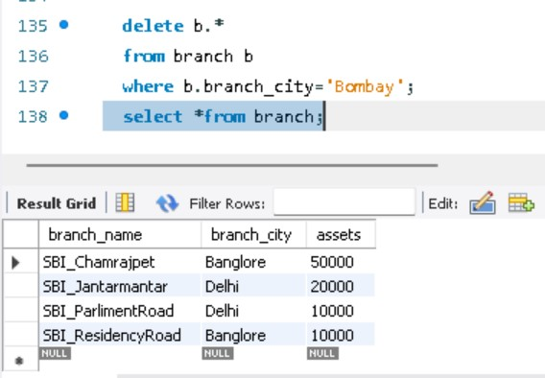

Query 6

Update the Balance of all accounts by 5%

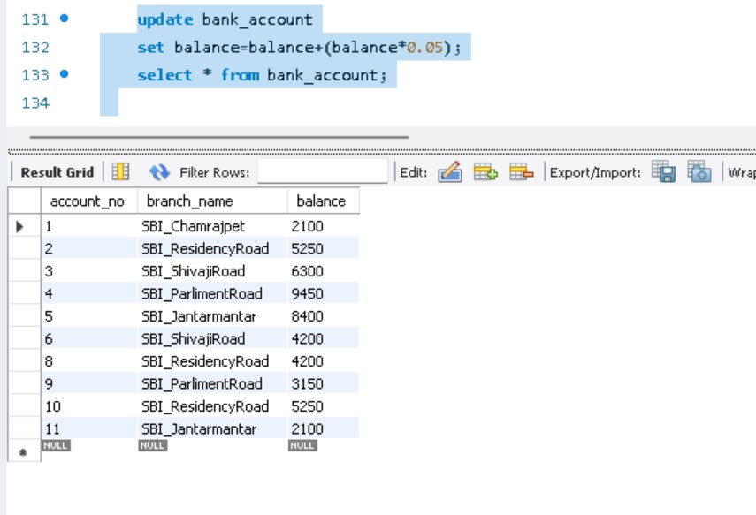

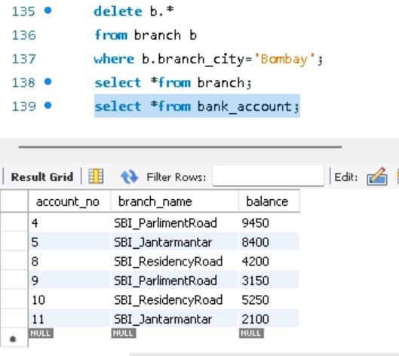

Spot Query

Find the names of all branches that have greater assets than total assets of all branches located in Bangalore.

