Query 1

List the name of the managers with the maximum employees

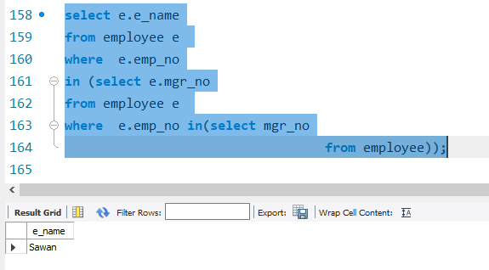

Query 2

Display those managers name whose salary is more than average salary of his

employee.

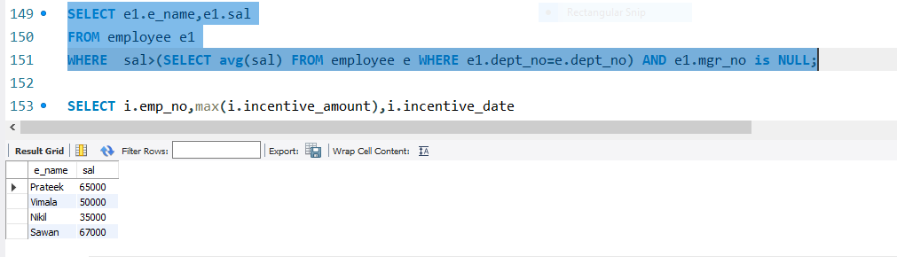

Query 3

Find the name of the second top level managers of each department.



Query 4

Find the employee details who got second maximum incentive in January 2019.

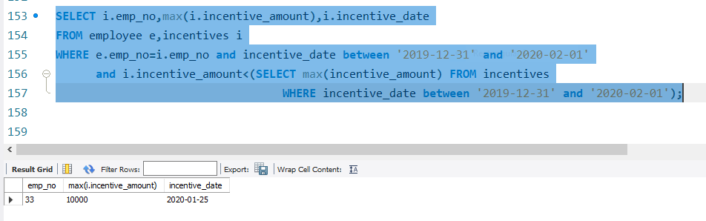

Query 5

Display those employees who are working in the same department where his

manager is working.

