Assignment

Module: 1 SE – Overview of IT Industry

**1 What is software? What is software engineering?**

➢ Software is a set of instructions, data or programs used to operate computers and execute specific tasks. It is the opposite of hardware, which describes the physical aspects of a computer. Software is a generic term used to refer to applications, scripts and programs that run on a device.

* Software engineering is defined as a process of analyzing user requirements and then designing, building, and testing software application which will satisfy those requirements.

**2 Explain types of software**

* **1>system software:** These software programs are designed to run a computer's application programs and hardware. System software coordinates the activities and functions of the hardware and software**.**
* **2>Application software :** The most common type of software, application software is a computer software package that performs a specific function for a user, or in some cases, for another application. An application can be self-contained, or it can be a group of programs that run the application for the user.
* **3>Driver software :** this software is often considered a type of system software. Device drivers control the devices and peripherals connected to a computer, enabling them to perform their specific tasks.
* **4>Middleware :** The term middleware describes software that mediates between application and system software or between two different kinds of application software.
* **5>Programming software** **:** Computer programmers use programming software to write code. Programming software and programming tools enable developers to develop, write, test and other software programs.

# 3 What is SDLC? Explain each phase of SDLC

* The software development life cycle (SDLC)refar to a methodology with clearly defined processes for creating high-quality software
* Planning
* analysis
* design
* implementation
* testing
* maintenance

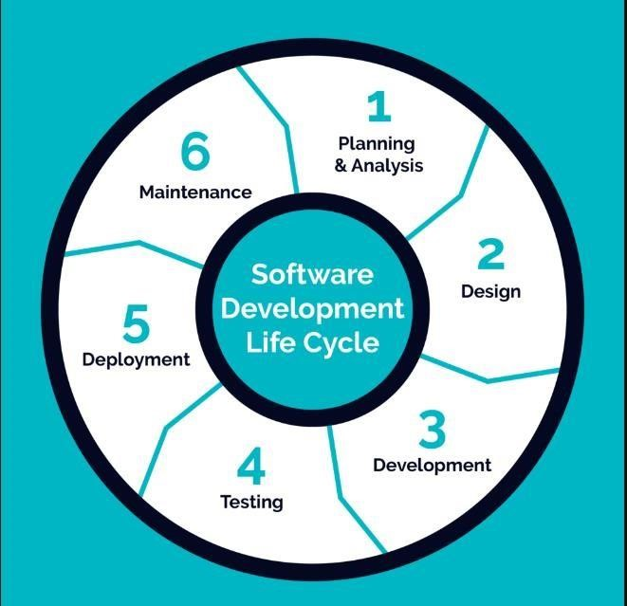

* **Planning :** the planning stage where you are gathering requirements from your client or stakeholders and the requirement analysis stage where you’re looking into the feasibility of creating the product, revenue potential, the cost of production, the needs of the users etc.

* **Analysis :** The analysis stage includes gathering all the specific details required for a new system as well as determining the first ideas for prototypes. Developers may: Define any prototype system requirements.

* **Design :** The design phase is where you put pen to paper—so to speak. The original plan and vision is elaborated into the basic structure of the software, including the system design, programming language, templates, platform to use, and application security measures. This is also where you can flowchart how the software responds to user actions.

* Implementation : During implementation, the project team creates the actual product. Product implementation can be an exciting phase for the customer, because their idea for the project becomes something tangible. Project developers begin building and coding the software.
  + **Example :** a customer wants a new gaming application, the project developers must program the

application to perform the customer's gaming requirements. As the team develops the code, the team must follow specific coding requirements. Customer requirements may call for specific computer programming languages or upgrades, and developers need to run the applications to ensure they function properly

.

* **Testing :** Before getting the software product out the door, it’s important to have your quality assurance team test it to make sure it is functioning properly and does what it’s meant to do. The testing process can also help hash out any major user experience issues and security issues. In some cases, software testing can be done in a simulated environment. Other simpler tests can also be automated.

* + **The types of testing phase:** 
    1. performance testing
    2. functional testing
    3. security testing
    4. unit-testing
    5. usability testing

**maintenance :** The maintenance stage is the final stage of the SDLC

if you’re following the waterfall structure of the software development process. However, the industry is moving towards a more agile software development approach where maintenance is only a stage for further improvement.

* In the maintenance stage, users may find bugs and errors that were missed in the earlier testing phase. These bugs need to be fixed for better user experience and retention. In some cases, these can lead to going back to the first step of the software development life cycle.
* The SDLC phases can also restart for any new features .

# 4. What is DFD? Create a DFD diagram on Flipkart

***DFD:***

* DFD stand of “Data Flow Diagram “. It is also known as a “Bubble Chart”.
* Through which we can represent the flow of data graphically on an Information system.
* By using DFD we can easily understand the overall functionality of system because diagram represents the incoming data flow, outgoing data flow and store data in a graphically form.
* It describe how data is processed in a system in term of input and output.

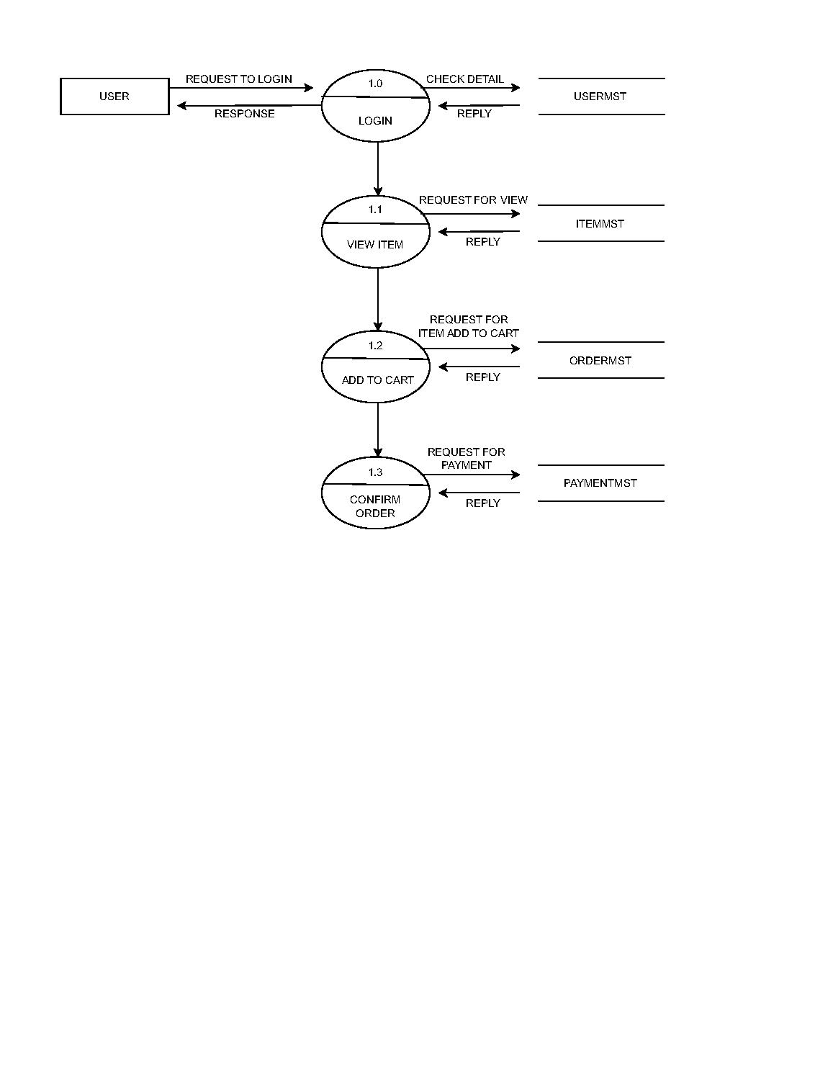

# 5. What is Flow chart? Create a flowchart to make addition of two numbers

➢ A flowchart is a picture of the separate steps of a process in sequential order. It is a generic tool that can be adapted for a wide variety of purposes, and can be used to describe various processes, such as a manufacturing process, an administrative or service process, or a project plan.

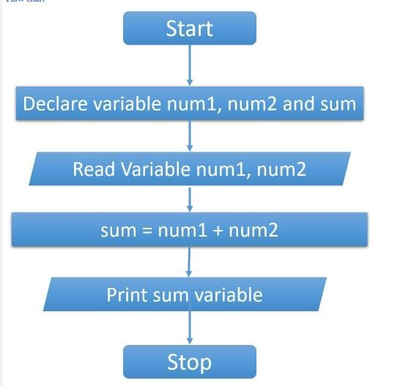

# 6.What is Use case Diagram? Create a use-case on bill payment on paytm

➢ A use case is a methodology used in system analysis to identify, clarify and organize system requirements. The use case is made up of a set of possible sequences of interactions between systems and users in a particular environment and related to a particular goal. The method creates a document that describes all the steps taken by a user to complete an activity

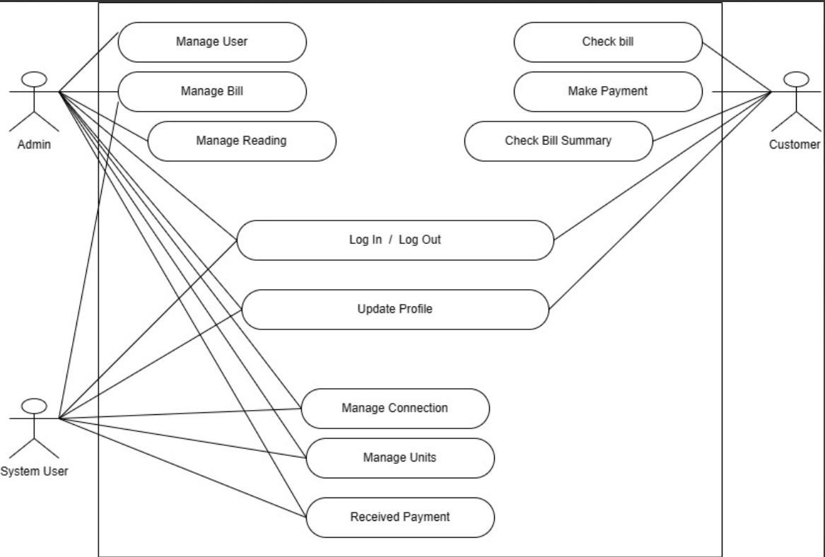

Created by : SAGAR DADHANIYA