SOP VOICE

The following SOP is only for the operation of the **Voice Operated Image Processing cell** at **BSDU**’s premises.

Table of Contents

1. Scope 3

2. Notes 3

3. Equipment pre-check 3

4. Procedure 4

5. Error and Warning Messages 6

5.1 Communication Error 6

5.2 Insufficient Air Pressure 6

5.3 System Fault 6

5.4 Emergency Stop 6

5.5 No Objects Detected 6

5.6 Homing not done 6

5.7 Image Processing Error 6

5.8 No Camera Detected Error 6

5.9 Teach Pendant Error 6

6. Recalibrating the system 7

6.1 Color recalibration 7

6.2 Size Recalibration 7

7. Troubleshooting 8

7.1 Connection Error 8

7.2 Insufficient air pressure 8

7.3 Emergency Stop 8

7.4 System Fault 8

7.5 No camera detected 9

7.6 No objects detected/ Number of objects incorrectly detected 9

7.7 Image processing error 9

7.8 Robot not picking the objects 9

7.9 Unresponsiveness of GUI buttons 9

7.10 Robot behaving weirdly(moving randomly) 10

7.11 Voice commands not detecting correctly 10

# 1. Scope:

The provided SOP is concerned with the operation of the cell only. All issues and other procedures have been discussed in documents mentioned in the reference section.

# 2. Notes:

1. Opening a default terminal: Press Alt+ Ctrl+T
2. Opening a terminal in the said folder: right click anywhere inside the folder and click on ‘Open in terminal’.
3. Opening the file explorer : Press Alt+ Ctrl+F
4. Application folder: On desktop, “**Gui-Voice**” folder exists inside a folder named “**Brabo**”

# 3. Equipment pre-check:

Kindly ensure the following are present and available before hand to avoid any complications

* Ensure that **camera** is present at the default port and is working.
  + To check this open the **GTK app** on the desktop, if the logitech camera starts up, the camera is ready to use. If the laptop camera starts up or a message is shown displaying no device found, then open Video Controls and under Device select ‘C922 Pro Stream Webcam’.
  + Then reconnect the camera and restart the laptop keeping the camera USB cable connected to the laptop. If restarting the laptop doesn’t work, go inside the Brabo folder located on the desktop. Open a terminal in the said folder and type the following command:

**./cam_set**

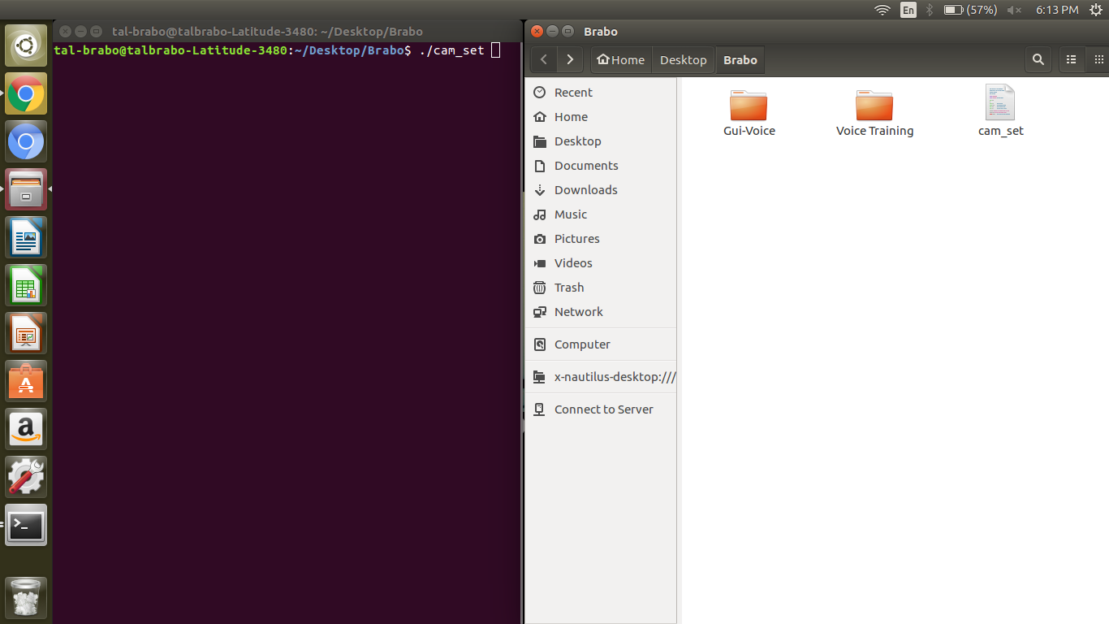

* Ensure the **connection** between the laptop and robot.
  + After connecting the ethernet cable, open a default terminal and execute the following **ping 192.168.0.250**, if the above command generates a successful result i.e. 0% packet loss, then the connection is stable and good. If any issues occur here, restart laptop and reconnect to network.
* Ensure that the room is noise free.
* Ensure that the room is evenly lit.
* Ensure that the pieces are placed in the view area.

# 4. Procedure:

### Step 0:

### This step involves starting the robot and running the teach pendant program.

* Refer **Robot operating procedure** document for starting the robot.
* After Homing, turn the knob on teach pendant to auto mode. Go to “program” window on teach pendant and click on “open program” button. Select the teach pendant program named **tal-brabo.** Click on “run” button in the command window.
* After the robot moves on to the point saved as **safe**, proceed to the next step.

### Step 1:

Open “Brabo” folder located on the desktop. Go to “GUI Voice” folder. Right click inside the folder and select “open in terminal”. Now, type the following command to open the GUI:

**python final.py**

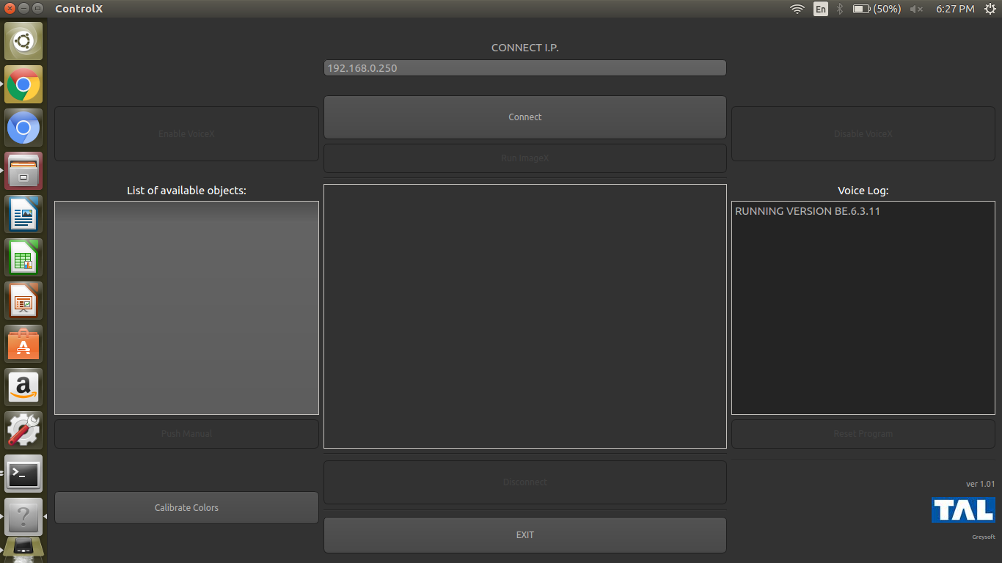

Description of GUI

* The following buttons are present on the GUI
  + Connect
  + Run ImageX
  + Enable VoiceX
  + Disable Voice X
  + Disconnect
  + Exit
  + Reset Program
  + Push Manual
  + Calibrate Colors
* The Following “non-button” elements are present on the GUI
  + List of available objects: (here-on referred to as **object list**)
  + Voice Log: (here-on referred to as **log**)

### Step 2:

Press the **Connect** button on the GUI. The GUI may become irresponsive during the connecting process. However if there is any problem in establishing the communication, an error message is displayed. In case of an error, go to the Trouble shooting section of the SOP.

### Step 3:

Stop and run the teach pendant problem again to bring robot at the safe position. Click on the **Run ImageX** button. This runs the camera and image processing scripts, wait for a few seconds until the application loads the list of objects. Any error in the process will generate an appropriate pop-up whose description is given in the troubleshooting section.

NOTE: If after pressing Run ImageX, error message ‘Robot not at Safe’ pops up, then stop and run the teach pendant problem to bring robot at the safe position.

### Step 4:

Once the object list is populated and the image is loaded in the central space, check the number of objects in the list and actual objects. If the objects detected are equal, the cell is ready to operate. However, if wrong number of objects are detected refer to the trouble shooting section.

**NOTE:** Look for a red boundary on the purple index strip. If the boundary is incomplete or deformed, click on the **Reset** button and then **Run ImageX** again. If the problem keeps repeating, recalibrate for purple color (refer section 6.1).

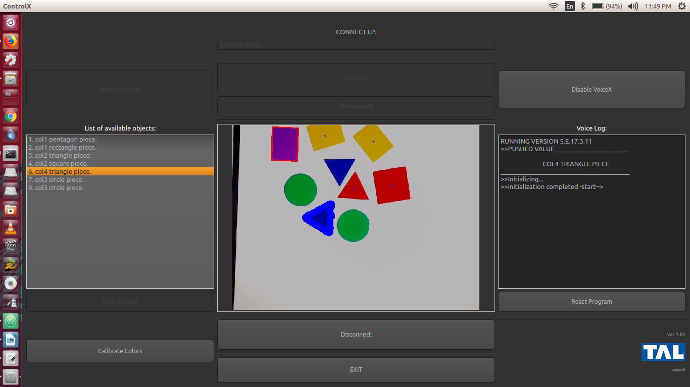

### Step 5:

The Enable VoiceX and the Push Manual buttons are enabled. Proceed by doing any of the following,

1. For using **Voice Control**:
   * Click on the **Enable VoiceX** button.
   * Observe the log area, we can see that once the voice module is ready to use, an initialized message is displayed.
   * Use the voice commands as mentioned below:
     1. PICK RED PIECE
     2. PICK BLUE PIECE
     3. PICK YELLOW PIECE
     4. PICK GREEN PIECE
   * The said words appear continuously on the log.
   * The log will show “PUSHED” keyword for the object that have been selected by the voice commands. The same object will be reflected in the image with a blue border. The robot will move the selected piece from the view area to the corresponding sorting area.

**NOTE:** Once a voice command is given it is recommended that the operator should mute the headset mic**,** as the module listens continuously and sometimes may process background noise as valid commands.

**NOTE:** Give next voice command only when the previous pick and place operation has been completed and the robot is at Index point.

* + Once Voice Control is done, click on the **Disable VoiceX** button to stop the Voice module.
  + If Voice commands are not detected properly, refer to the trouble-shooting section of the manual.

1. For using **Manual Control**:

* From the object list **select the object** that needs to be picked by the robot.
* After clicking on the desired object click on the **Push Manual** button.
  + The log will show “PUSHED” keyword for the object that have been selected by the voice commands. The same object will be reflected in the image with a blue border. The robot will move the selected piece from the view area to the corresponding sorting area.

**NOTE:** Push next object only when the previous pick and place operation has been completed.

* The Push Manual button is disabled and after the data is sent to the robot, the button is enabled again, if this doesn’t happen, Exit application and restart the system.

1. If the robot is unable to pick the piece correctly then refer to the troubleshooting section of the manual.

### Step 6:

Once all objects are emptied from the list, wait for the robot to completely sort all the objects and click on the **Reset** button to reset the system for next cycle.

**NOTE:** The reset button can be pressed at any time to reset the system, However if there are any objects in the object list, the GUI may become unresponsive for a while.

### Step 7:

Restart from **Step 1** to continue cycle. To stop the cell,

* Click on the **Disconnect** button followed by the **Exit** button.
* **Stop** the teach pendant program.

NOTE:

* The application can be reset at any point by clicking on the **Reset** button on the GUI during the operation cycle.
* The execution of the cycle can be Paused, Resumed or Stopped at any stage from the teach pendant or their respective buttons on the operator box.

# 5. Error and Warning Messages:

### 5.1 Communication Error:

This error occurs if there are any problems in establishing connection as mentioned in the step 2 of the procedure. The trouble shooting section deals with this error.

### 5.2 Insufficient Air Pressure

This error occurs when the supplied pressure drops below the pressure value set in the pressure switch on the FR-Unit of the pneumatic assembly.

### 5.3 System Fault

This error occurs when the robot goes into fault due to internal errors.

### 5.4 Emergency Stop

This message occurs every time the emergency stop button is pressed either on teach pendant, controller or the operator box.

### 5.5 No Objects Detected

When no objects are detected after clicking on the Run ImageX button, this error pops up. More information about how to resolve this can be found in the troubleshooting section of this manual.

### 5.6 Homing not done

This error occurs when the Run ImageX button is clicked without doing homing of the robot. Kindly do homing for the robot and run again.

### 5.7 Image Processing Error

Sometimes Image processing errors occur in the scripts. This is due to various factors and detailed resolution of the problem is given in the troubleshooting section.

### 5.8 No Camera Detected Error

This error is given if no camera is detected on clicking the Run ImageX button. Refer section 7.5 for information on resolving this error.

### 5.9 Teach Pendant Program stopped

This error occurs when the teach pendant program is stopped mid operation of the cell.

# 6. Recalibrating the system:

### 6.1 Color recalibration

1. Run the application from the application folder and on the GUI click the **Connect** button.
2. Once the GUI is connected, click on the **Calibrate Colors** button. This will open a Recalibrate Colors webpage.
3. On the page **zoom** into the color you want to calibrate until the selection box is **evenly filled** with the same color.
   * To zoom, place the mouse on the area where you wish to zoom. Press and hold the **Ctrl** key and on the trackpad perform the scroll up gesture.

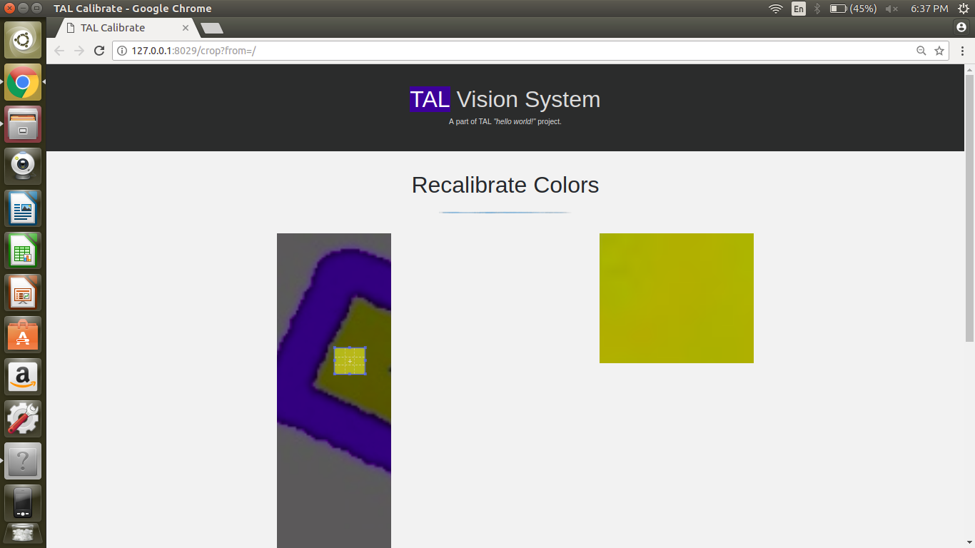

1. After making the selection make sure that the **X1 and Y1** values in the boxes are **greater** than the **X2 and Y2** values respectively.

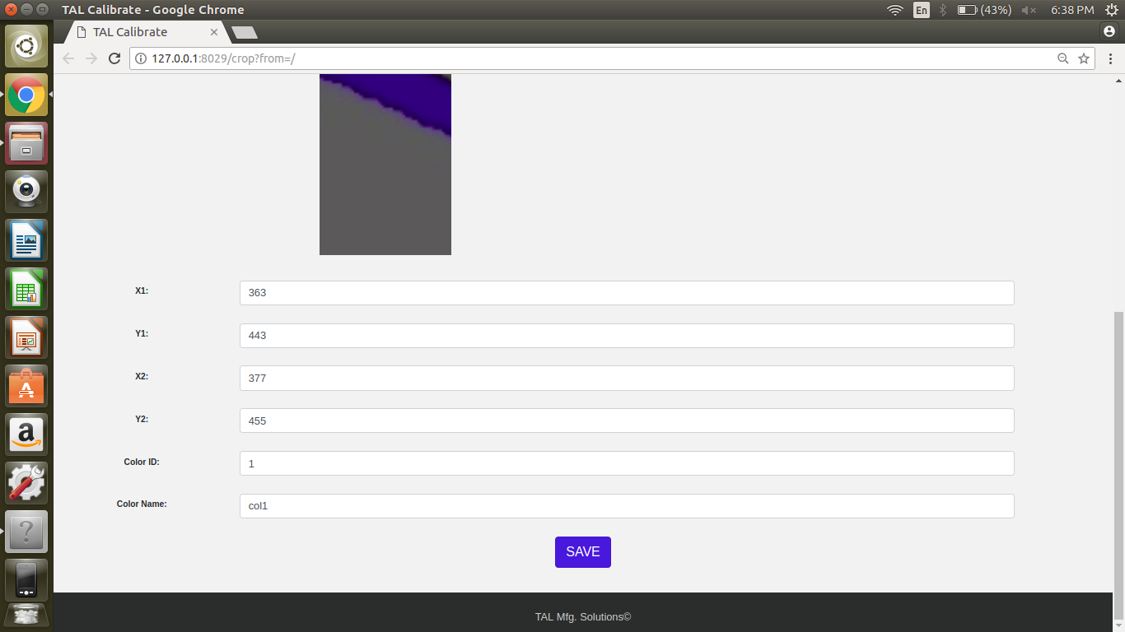

1. Type in the color **name and color id** with **reference** to the data given below.
2. Click on the **Save** button.
3. The System is now recalibrated. Exit the application for the changes to take effect.

### 6.2 Size Recalibration

1. On the color recalibration page **clear all** the data fields.
2. In the **X1 and Y1** fields measure and type in the actual **width and length** of the index strip.
3. In the **X2 and Y2** fields type in **0**
4. In the **name** field type in **size**.
5. In the **ID** field type in **99.**
6. Click on the **Save** button.
7. The System is now recalibrated. Exit the application for the changes to take effect.

REFERENCE TABLE FOR COLOR NAMES AND COLOR IDs

|  |  |  |
| --- | --- | --- |
| **COLOR** | **COLOR NAME** | **COLOR ID** |
| YELLOW | col1 | 1 |
| RED | col2 | 2 |
| GREEN | col3 | 3 |
| BLUE | col4 | 4 |
| PURPLE | col0 | 0 |
| SIZE | Size | 99 |

# 7. Troubleshooting:

### 7.1 Connection Error:

This error occurs when the laptop is not able to establish communication with the robot:

1. After connecting the ethernet cable, Open a default terminal and execute the following command **ping 192.168.0.250**, if the above command generates a successful result i.e. 0% packet loss, then the connection is stable and good.
2. If any issues occur here, restart laptop and reconnect to the network.

### 7.2 Insufficient air pressure

This error occurs when the pressure input at the FR-Unit drops below a threshold value set in the pressure switch.

1. Increase the input pressure to the system or wait for the pressure to build in the compressor.
2. If the error keeps repeating itself, on the Pressure switch reduce the threshold value,
   1. To do this, Press the middle button once to read **S1** on the Pressure Switch.
   2. Press the button on the left to reduce the threshold pressure.
   3. Once the threshold pressure is below the actual pressure the error will be resolved.

### 7.3 Emergency Stop:

This error occurs when Emergency Stop is pressed on the teach pendant, operator box and the controller while the cell is operational. To resolve this,

1. Release the emergency stop switch and press the Enable Controller button,
2. Press the Reset button. The robot will make a sound when the drive brakes disengage and engage again.
3. Once the Robot is reset, Jog the robot to the pre-home position in joint mode and do Homing (Procedure given in the robot SOP.)

### 7.4 System Fault:

This error occurs when the robot drives go into fault state due to internal errors. This is indicated by the fault lamp present on the controller. To resolve this,

1. Press and release the emergency stop on the teach pendant, operator box and the controller switch and press the Controller On button,
2. Press the Reset button, the robot will make a sound when the drive brakes disengage and engage again.

**NOTE:** If the fault persists after following the above mentioned steps, then press the emergency stop button and open the controller. Switch off MCB Q7 & Q8 to clear the fault. Then switch it on to operate normally and repeat the steps mentioned above.

1. Once the Robot is reset, Jog the robot to the pre-home (in joint mode) position and do Homing (Procedure given in the robot SOP.)

### 7.5 No camera detected:

To resolve this error,

* Ensure that **camera** is present at the default port and is working.
  + To check this open the **GTK app** on the desktop, if the logitech camera starts up, the camera is ready to use. If the laptop camera starts up or a message is shown displaying no device found, then open Video Controls and under Device select ‘C922 Pro Stream Webcam’.
  + Then reconnect the camera and restart the laptop keeping the camera USB cable connected to the laptop. If restarting the laptop doesn’t work, go inside the Brabo folder located on the desktop. Open a terminal in the said folder and type the following command: **./cam_set**



Icon of GTK App

### 7.6 No objects detected/ Number of objects incorrectly detected:

This error is raised when the ImageX script does not detect any objects in the view area once the Run ImageX button is pressed. The possible resolution for this error are,

1. Check if there are objects in the view area, if no objects are present then place the objects in the view area and click on reset, then click on Run ImageX again.
2. If Objects are not detected or are detected incorrectly, then recalibrate the image processing script using the method for color recalibration mentioned earlier.

NOTE: If the error keeps occurring after multiple recalibrations, try the solution for Image Processing Error.

### 7.7 Image processing error:

This error occurs in the image processing script and can be resolved by referring the document named “Image processing- Quick fix”.

### 7.8 Robot not picking the objects (too much offset from center of objects)

This error occurs whenever there is a mismatch in actual size of the indexed region (purple colored strip) with the calibrated size. For correction in the size,

1. Check whether robot base, camera and work table are parallel too each other.
2. If robot is not parallel to worktable then reteach the index point such that the gripper is in the center of the purple strip.
3. If even after this problem persists, refer size recalibration procedure.

### 7.9 Unresponsiveness of GUI buttons:

If GUI buttons become unresponsive, i.e., they stop getting enabled/ disabled then:

1. Click the **Reset** button, **Disconnect** and **Exit** the application.
2. Restart the application.
3. If problem persists, restart the laptop and try again.

### 7.10 Robot behaving weirdly (moving randomly):

When robot performs unnecessary moves in between a cycle then:

1. Click the **Reset** button, **Disconnect** and **Exit** the application.
2. **Stop** the teach pendant program.
3. Restart the application. **Run** the teach pendant program again.
4. If problem persists, restart the laptop and try again.

### 7.11 Voice commands not detecting correctly:

1. Check whether the headset is properly connected to laptop.
2. The headset volume on the top right corner of the screen should be exactly in the middle.
3. If voice commands are still not detected properly then refer “Voice Training” document.