**ScreenShots of System**

1. **Upload featureFile into Weka**

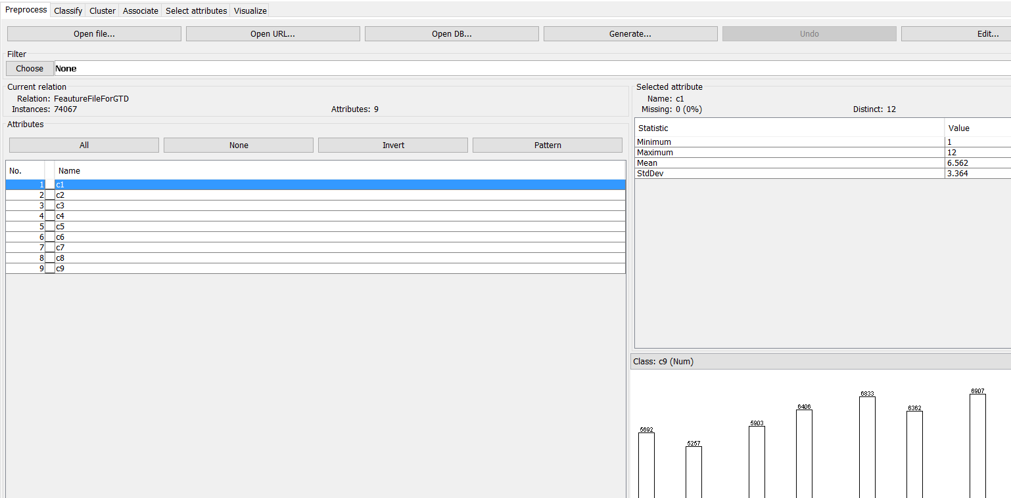

**2) Apply Filter on DataSet**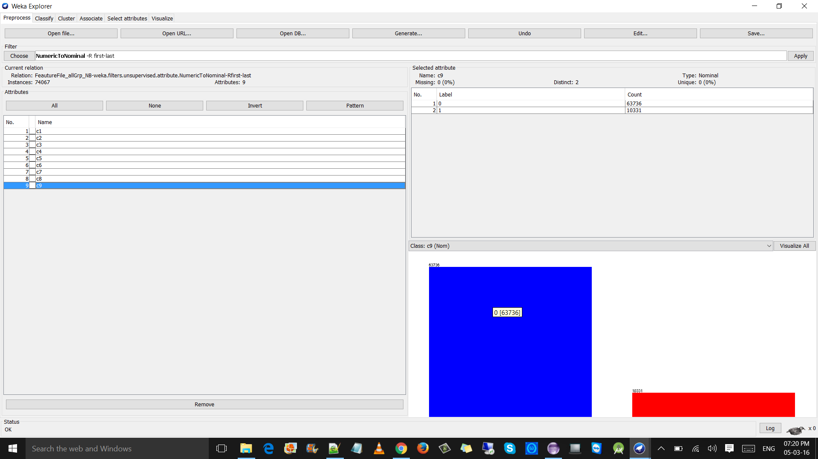

**3) Naive Bayes Accuracy**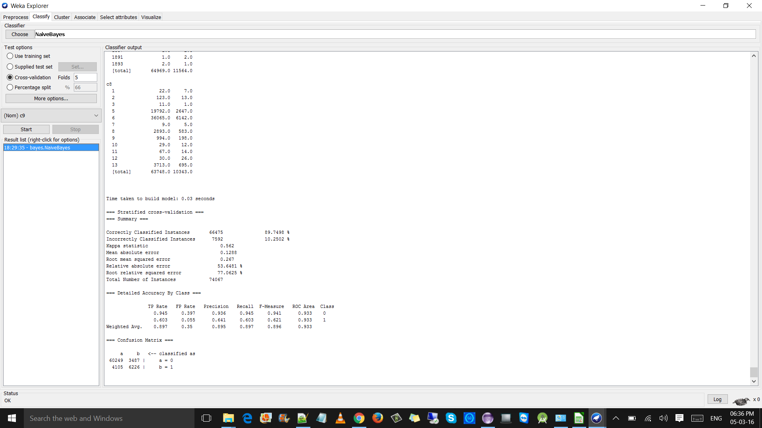

**4)Random Forest Accuracy**

