Discrete Cosine Transform

Original Image:

sagar

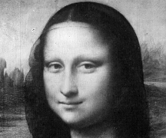

DCT of an image:

