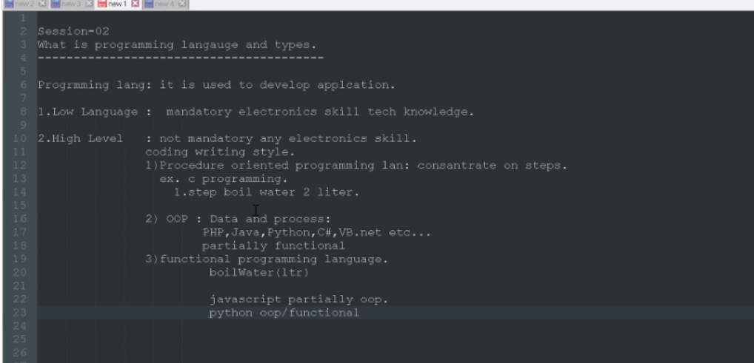

1)github.com – go to site

2)signup then enter email

3)enter git on google and search it ….click on 1st link and download software

Git Configuration :

Step 01 : github account

a)<https://github.com>

b)signup n create account then sign in

c) login

step 02 :create repository using new or +

enter Repository_name

public

Add a readme file (tick)

Add gitignore (tick) ---enter java

---we can write any message in readme file and commit changes

Step 03 : git Integration (remote)

1. Remote repo -> local repo
2. click on repository and clone the url (copy)
3. where you want to clone it

--open command prompt

1)f:/>git clone (paste url)

step 04 : git add .commit , push

1)add one new file there

2)f:/file_floder>git status

--read file

3) git add *

---git status ---green

4)git commit –m”this is my file”

5)git push

step 05: will check repo on cloud (refresh repo)

