

Predicting Loan Amount Using Regression Techniques

University ID : 2548866
Name : Sagar Shah
Assignment: Final Portfolio Project (5CS037)
Submission Date : 10 February 2026
Dataset link : https://www.kaggle.com/datasets/wordsforthewise/lending-club
SDG Relevant to Dataset : SDG 8 (Decent Work and Economic Growth)

Abstract
This project investigates a regression-based machine learning approach to predict loan amounts using a real-world financial dataset. The study includes data preprocessing, exploratory data analysis, neural network modeling, classical regression models, hyperparameter optimization, feature selection, and final comparative analysis. Model performance is evaluated using standard regression metrics to identify the most suitable approach. Both neural network–based and classical regression techniques were applied.
The study aims not only to achieve accurate predictions but also to ensure model reliability, interpretability, and robustness suitable for real-world financial decision-making.

Introduction
Regression analysis is widely used in financial applications to model relationships between variables and predict continuous outcomes. In this project, the objective is to predict the loan amount using borrower and loan-related attributes. Understanding these relationships can assist financial institutions in risk assessment and loan planning. Regression analysis plays a vital role in financial analytics, particularly in loan assessment and credit risk evaluation. Financial institutions rely on historical borrower and loan characteristics to determine suitable loan amounts. The objective of this project is to develop regression models capable of predicting the loan amount (loan_amnt)based on applicant financial information, credit history, and loan attributes. This work emphasizes correct data handling, prevention of data leakage, and fair model evaluation. Rather than focusing solely on performance metrics, the project prioritizes methodological correctness and model interpretability, which are critical in regulated financial environments.

Dataset Description
The dataset used in this project is a structured CSV dataset from Kaggle containing a mix of numerical and categorical attributes. The dataset was loaded using Pandas and inspected to understand its structure, feature types, and target variable. The dataset used in this study consists of loan records containing borrower demographic details, employment information, credit history, and loan-related variables. The dataset includes both numerical and categorical features, with varying levels of missing values. Due to the real-world nature of the data, preprocessing was required to address inconsistencies, missing entries, and redundant or outcome-related variables. The target variable for this regression task is loan_amnt, representing the approved loan amount. The dataset enables analysis of how borrower characteristics and credit factors influence

Data Preprocessing
Data preprocessing was a critical stage of this project.
Columns with more than 40% missing values were removed to maintain data quality and reduce noise. Several features stored numerical information as strings (e.g., loan term, interest rate percentages, and employment length) and were converted into appropriate numerical formats. Special attention was given to preventing data leakage.
Outcome-related variables such as repayment amounts, recovery values, and loan status indicators were removed because they contain information that would not be available at prediction time. Additionally, the `installment` feature was excluded as it is mathematically derived from the target variable, which could lead to inflated model performance. Missing numerical values were handled using median imputation, while categorical variables were imputed using the most frequent category. A preprocessing pipeline using `ColumnTransformer` was implemented to ensure consistent and leakage-free data transformation.

Exploratory Data Analysis
Exploratory Data Analysis (EDA) was performed to understand the characteristics of the dataset. A histogram of the target variable showed the distribution and range of loan amounts, highlighting concentration around common loan values.
Boxplots were used to detect the presence of extreme values and assess variability.
Correlation analysis among numerical features provided insight into relationships between financial attributes. Scatter plots were also used to observe the relationship between interest rates and loan amounts. These analyses informed feature selection decisions and helped validate modeling assumptions.
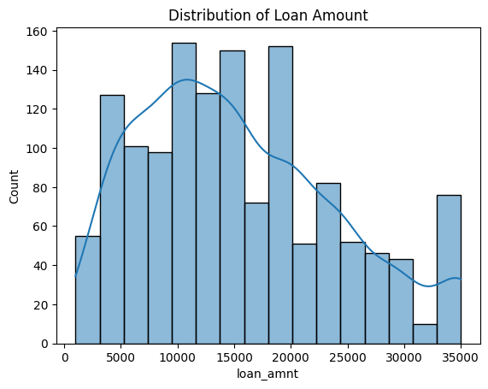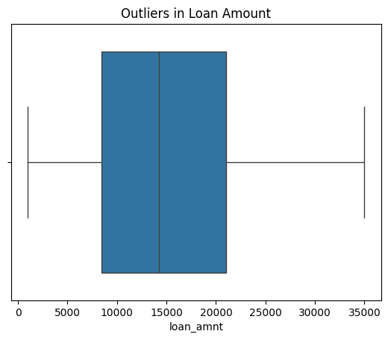
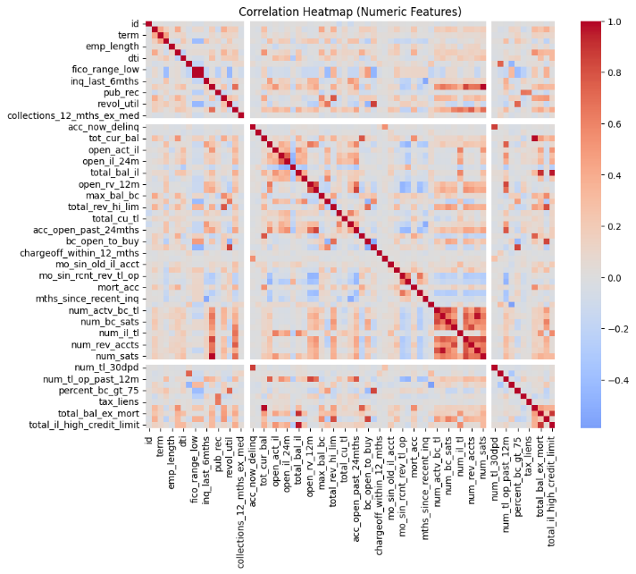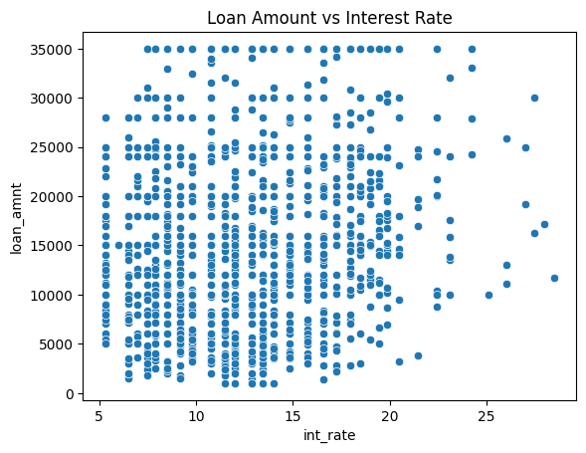

Neural Network Regression Model
A neural network regression model was implemented using a Multilayer Perceptron (MLP).
The architecture consisted of two hidden layers with 64 and 32 neurons respectively,
using the ReLU activation function. The output layer contained a single neuron to produce continuous predictions. The model was trained using the Adam optimizer and minimized a mean squared error–based loss function. Early stopping was applied to prevent overfitting by halting training when validation performance stopped improving. Model performance was evaluated on both training and testing datasets using RMSE and R-squared metrics. The neural network demonstrated the ability to capture non-linear patterns in the data.

Classical Machine Learning Models
Two classical regression models were developed for comparison: Ridge Regression and K-Nearest Neighbors (KNN) Regression. Ridge Regression was chosen due to its ability to handle multicollinearity and high-dimensional feature spaces through L2 regularization. KNN Regression was included as a non-parametric method that predicts values based on similarity between data points. Both models were trained using the same preprocessing pipeline to ensure a fair comparison. Performance evaluation highlighted the strengths and limitations of each approach, particularly in handling high-dimensional data produced by one-hot encoding.

Hyperparameter Optimization
Hyperparameter tuning was performed using GridSearchCV with five-fold cross-validation.
For Ridge Regression, the regularization parameter was optimized. For KNN Regression, the number of neighbors and weighting strategy were tuned. Root Mean Squared Error (RMSE) was used as the scoring metric during cross-validation, as it provides an interpretable measure of prediction error in the same units as the target variable. Cross-validation ensured that model performance estimates were robust and not dependent on a single data split.

Feature Selection
Feature selection was carried out using an embedded method based on Lasso regression.
Lasso applies L1 regularization, which shrinks less important feature coefficients to zero,
effectively selecting a subset of relevant features. This approach was particularly useful due to the high dimensionality introduced by one-hot encoding. The selected features were used to retrain both Ridge and KNN regression models, allowing for improved stability and reduced noise while maintaining predictive performance.

Final Models and Comparative Analysis
Final models were rebuilt using the optimal hyperparameters identified through cross-validation and the selected feature subset. Performance was evaluated on the test dataset using RMSE and R-squared metrics. Ridge Regression significantly outperformed KNN Regression. This result indicates that the underlying relationships in the dataset are largely linear and benefit from regularization in high-dimensional spaces. The weaker performance of KNN can be attributed to the curse of dimensionality, which affects distance-based models.
Both models were rebuilt using the optimal hyperparameters obtained from GridSearchCV and the selected features identified using Lasso regression. Ridge Regression showed stable performance with good generalization, while KNN Regression was more sensitive to feature dimensionality but captured local patterns.
 | Model | Features Used | CV RMSE | Test RMSE | Test R²
0 | Ridge Regression | Selected (1370) | 6845.643075 | 6775.277973 | 0.402881
1 | KNN Regression | Selected (1370) | 7180.245296 | 7514.739099 | 0.265428

Ridge Regression performs better than KNN on this dataset. It has lower RMSE values in both cross-validation and test results, and a higher R² score, which means it explains more of the data. KNN shows higher error and lower accuracy, so Ridge is the more reliable model here.

Conclusion and Reflection
This project demonstrated a complete and well-structured regression modeling workflow.
Careful preprocessing, leakage prevention, and systematic evaluation contributed to reliable model performance. Among the models tested, Ridge Regression provided the best balance between accuracy and generalization. The project reinforced the importance of understanding data characteristics and selecting models accordingly. Future work could explore dimensionality reduction techniques or tree-based models to further improve performance and interpretability.

Appendix



