Week 5 Workshop Task – PHP Basics (Part 2)

Git hub link :

Student Portfolio Manager
Build a PHP application that demonstrates functions, arrays, string handling, file handling,
error handling, include/require usage, and a validated file upload feature.
PART 1 — Homepage (index.php)
• Display a welcome message.
• Use include/require to load header and footer.
• Show links to:
– Add Student Info
– Upload Portfolio File
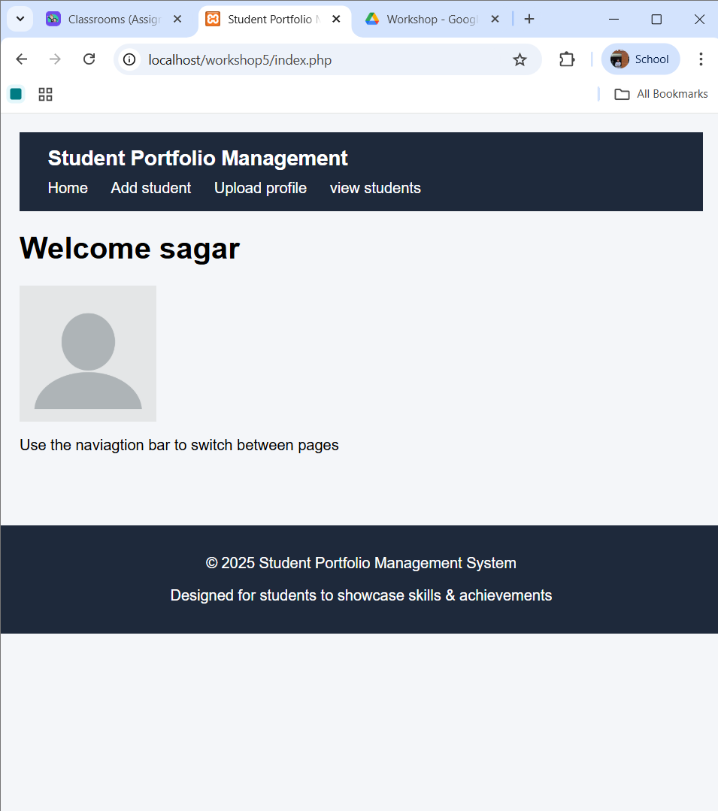

PART 2 — Add Student Info Page (add_student.php)
Tasks:
1. Create a form: Name, Email, Skills (comma-separated).
2. Handle submission using string functions and validation.
3. Convert skills string into an array using explode().
4. Save student info into students.txt.
5. Implement error handling with try/catch.
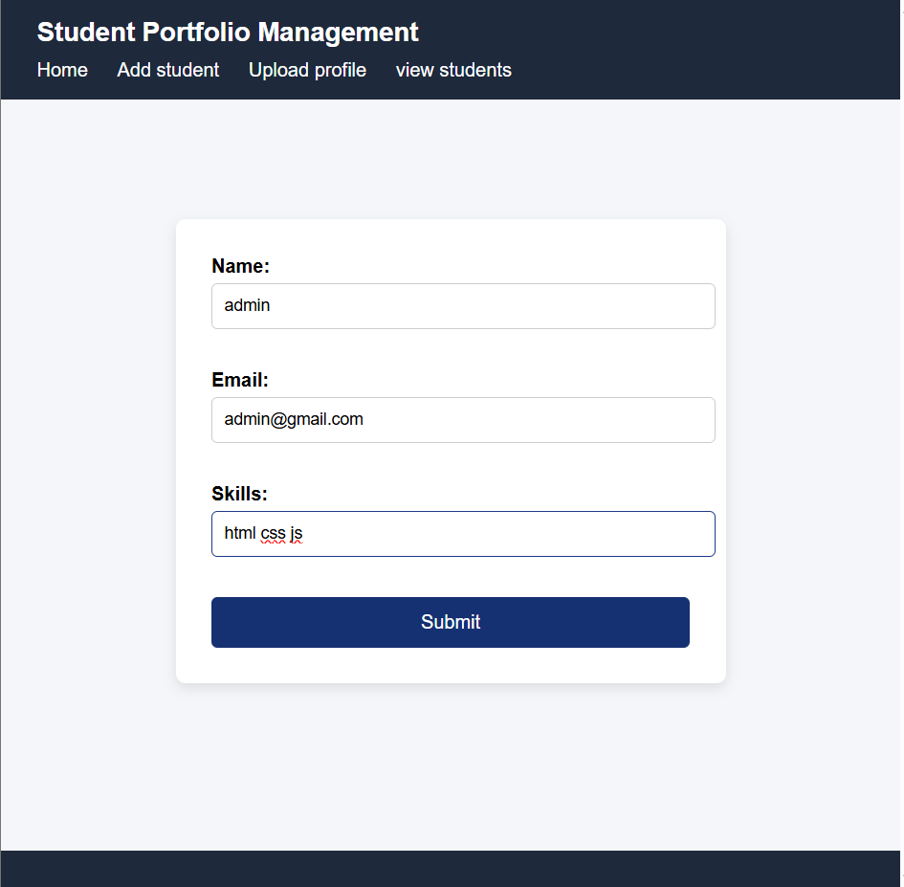
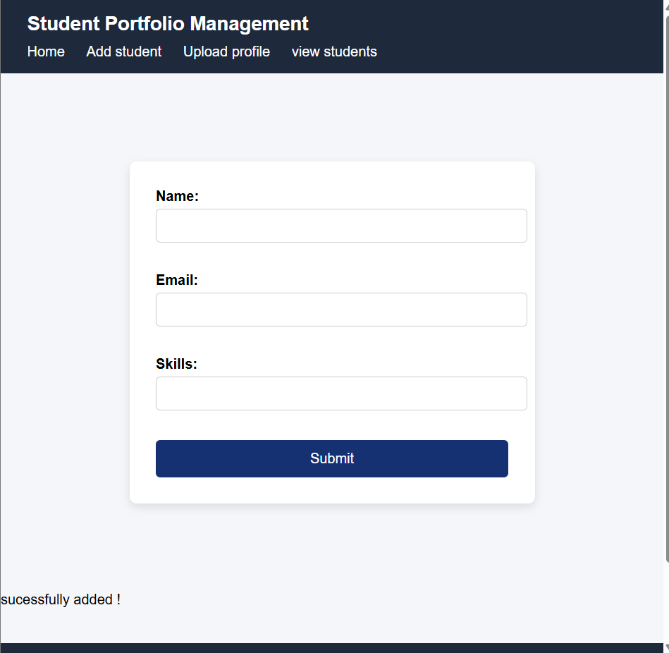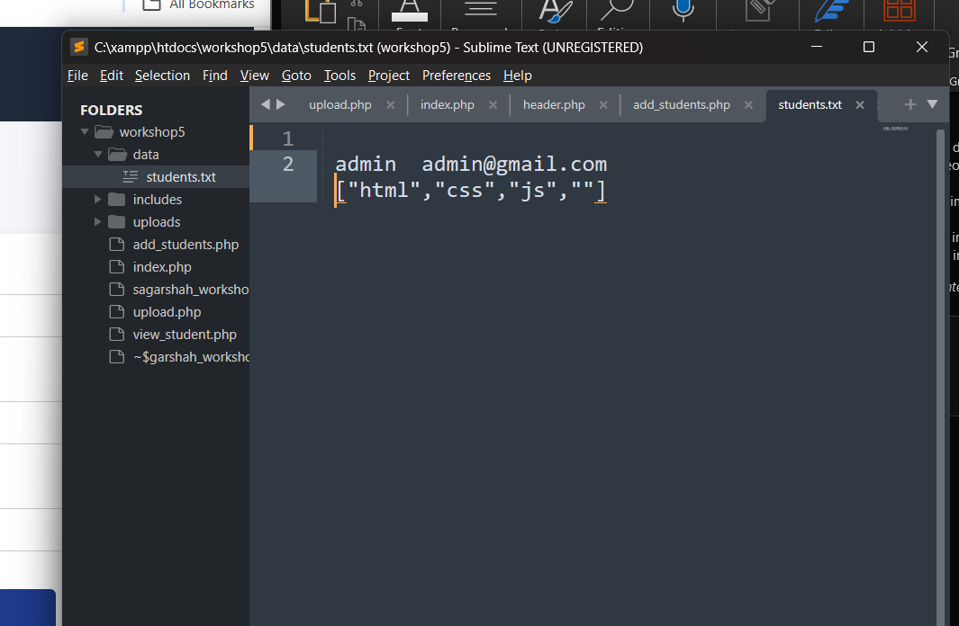

PART 3 — Upload Portfolio File (upload.php)
Requirements:
• Accept only PDF, JPG, PNG
• Max size: 2MB
• Rename file using string functions
• Store file inside /uploads/
• Use error handling for invalid format, directory errors, etc.
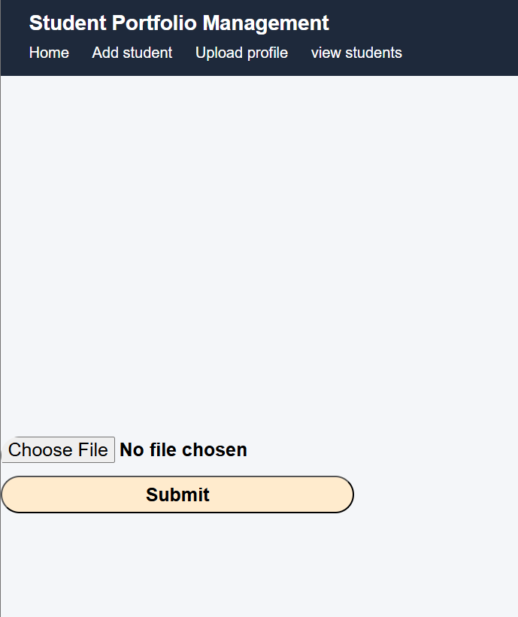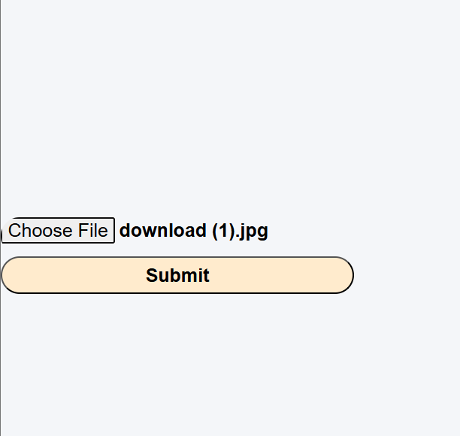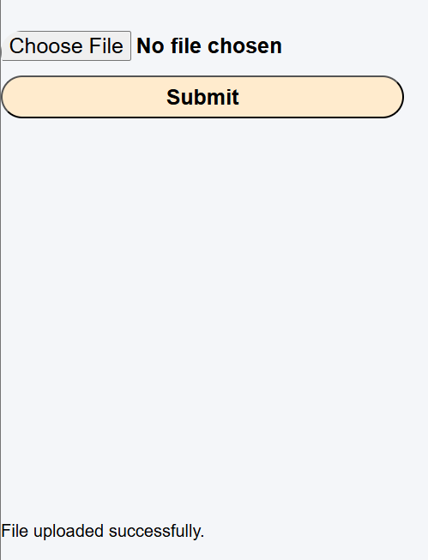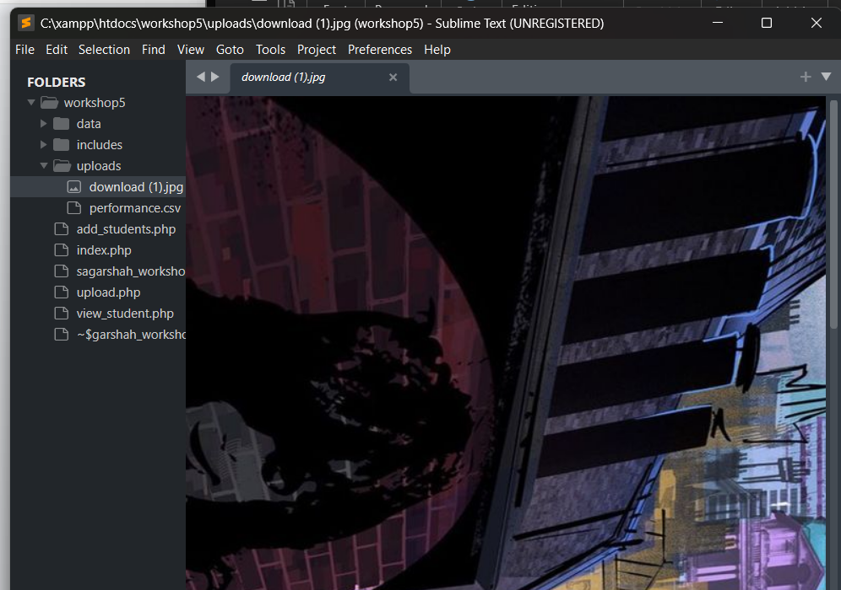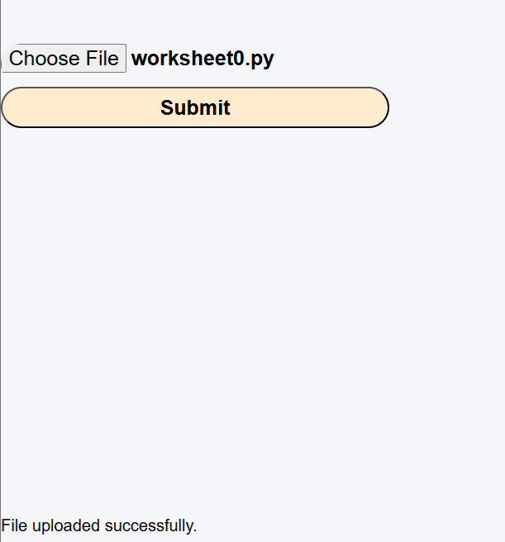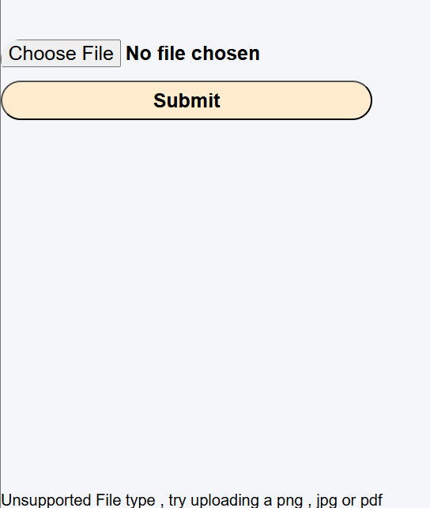

PART 4 — View Students Page (students.php)
• Read students.txt and display:
– Name
– Email
– Skills (as an array)
• Use include/require for header/footer.
