- What is the dependency inversion principle? Explain how it contributes to the more testable code.
Ans: High-level modules should not depend on low-level modules. Both should depend on abstractions (interfaces).

- Describe the scenario where applying the Open-Closed Principle leads to improved code quality.

Ans: it simply refers to being open for extension but closed for modification. Suppose if a payment system is integrated in a program and to add a new payment gateway we should be creating a class that implements the interface rather than adding in more conditions or sophisticated class.

- Explain the scenario where the Interface Segregation Principle was beneficial.
Ans: Clients should not be forced to depend on methods they don’t use. For example if u have :

interface Workable {
void code();
void cook();
}
Here the cook() method is not applicable as If implementing the Workable interface Developer needs to override the cook() method even it doesn’t have to any work. And a chef would be forced to override the code() method even he don’t need it.

- Examine the following code.
public class Report {
public void generateReport() {
// generate report logic
}

public void exportToPDF() {
// export report to PDF logic
}

public void exportToExcel() {
// export report to Excel logic
}
}

Which principle is violated in the code among Single Responsibility, Open Closed, Interface Segregation, and Dependency Inversion Principles? Explain in detail.
Ans: The first principle Single Responsible Principle (SRP) is violated in this example where the methods like exportTOPdf() and exportToExcel() might be related to Report class but not fully belongs to that class . Rather it should belongs to different Export class.
- Can you provide an example of how to design an online payment processing system while adhering to the SOLID principles? Please explain how each principle can be applied in the context of this system and illustrate with code or a conceptual overview. Let’s assume we have payment types like CreditCardPayment, PayPalPayment, Esewa, and Khalti. Each of these payments should have a method of transferring the amount.
Ans: S — Single Responsibility
Each payment class handles only one thing: processing its own payment type.
O — Open Closed
You should add new payment types without modifying existing code.
L — Liskov Substitution
Any payment type should be usable wherever a PaymentMethod is expected.
I — Interface Segregation
Have a clean interface with only what is necessary.
D — Dependency Inversion
High-level service depends on interface, not concrete types.

- Examine the following code.
public class Shape {
public void drawCircle() {
// drawing circle logic
}

public void drawSquare() {
// drawing square logic
}
}

You want to add more shapes (e.g., triangles, rectangles) without modifying the existing Shape class. Which design change would adhere to the Open-Closed Principle?
Ans: According to the Open-Closed Principle creating small Interface is more applicable ten creating classes for example to show above code in the OC principle it would be :
interface Shape {
void draw();
}
class Circle implements Shape {
public void draw() { }
}
class Square implements Shape {
public void draw() { }
}
class Triangle implements Shape {
public void draw() { }
}

- Examine the following code.
public class Duck {
public void swim() {
System.out.println("Swimming");
}
public void quack() {
System.out.println("Quacking");
}
}

public class WoodenDuck extends Duck {
@Override
public void quack() {
throw new UnsupportedOperationException("Wooden ducks don't quack");
}
}

Which principle is violated in the above code among Open Closed, Single Responsibility, Liskov, and Interface Segregation Principle? Explain in detail. Also, update the above code base to resolve the issue.
Ans: Liskov substitute Principles Is violated since a subclass should be replaceable with its parent without breaking behavior. In this example Quack() methods breaks the parent method so the quake() should be an another class of Quakeable .

- Examine the following code.
public interface PaymentMethod {
void processPayment();
}

public class PaypalPayment implements PaymentMethod {
@Override
public void processPayment() {
System.out.println("Processing PayPal payment");
}
}

public class OrderService {

private PaymentMethod paymentMethod;

public OrderService(PaymentMethod paymentMethod) {
this.paymentMethod = paymentMethod;
}

public void makePayment() {
paymentMethod.processPayment();
}
}

Which solid principle is being used in above? Explain in detail.
Ans: The codes uses Dependency Inversion Principle (DIP) since the oderservice class in depends on PaymentMethod interfact . It follows bigl module should depend upon small module.

COMPOSITION IN OOPD
- Write classes Team and Player where the Team class creates all Player objects internally (e.g., in constructor or method).
Demonstrate in main() that once the Team object is set to null, the Player objects become inaccessible because they only exist through the Team.
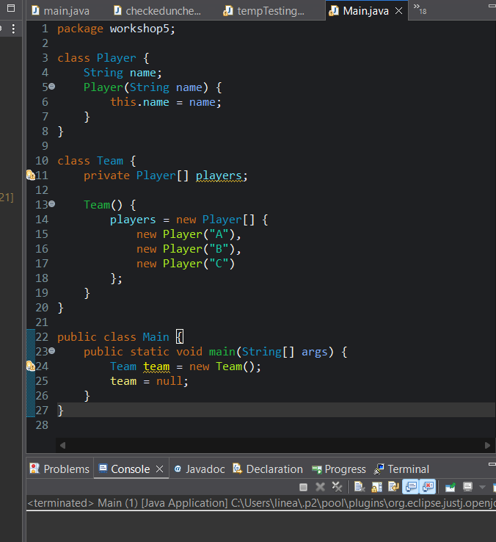
Ans:

10. Create two classes Computer and Processor.
Modify the Computer class so that it instantiates a new Processor object inside its constructor.
In main(), create only a Computer object and show that you cannot create or access a Processor independently.
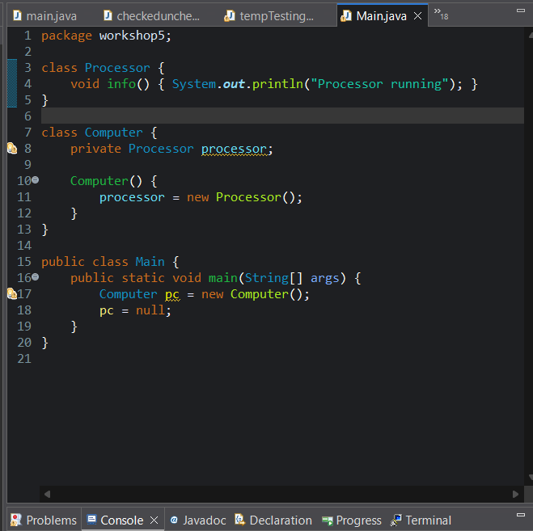
AGGREGATION IN OOPD
11. Create two classes: Library and Book.
Write code where:
- Book objects are created independently
- A Library holds a list of existing Book objects
- After removing or nullifying the Library, the Book objects can still be accessed and printed.
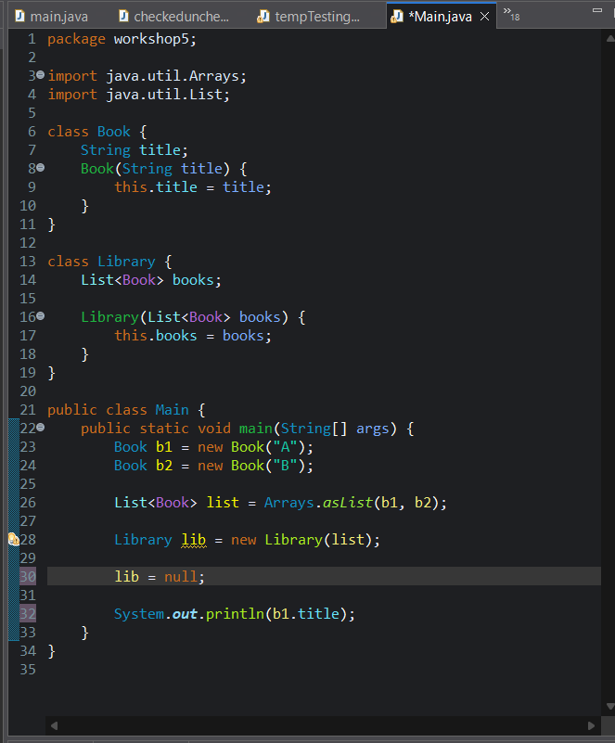

12. Given the following classes:

class Engine {}
class Car {
private Engine engine;
}

Update the code so that Engine objects are created outside the Car class and passed into it. Demonstrate in main() that the Engine object still exists even after the Car object is set to null.

