Version Control System

GitHub link : https://github.com/sagardonut/OOPs/tree/feature-grade-calculator

Project Scenario
You are tasked with creating a simple Java-based Student Management System for week 8 practice. The system will include basic functionality for adding student information, displaying student records, and calculating average grades. Your Git repository will store these files, and you will be working on the repository to practice Git commands.
- Initializing a Git Repository:
- Scenario: You’ve started a Java project for the Student Management System. The first thing you need to do is initialize a Git repository.
- Task: Write the Git command to initialize a new repository. You should also create a file called Main.java with the following code:
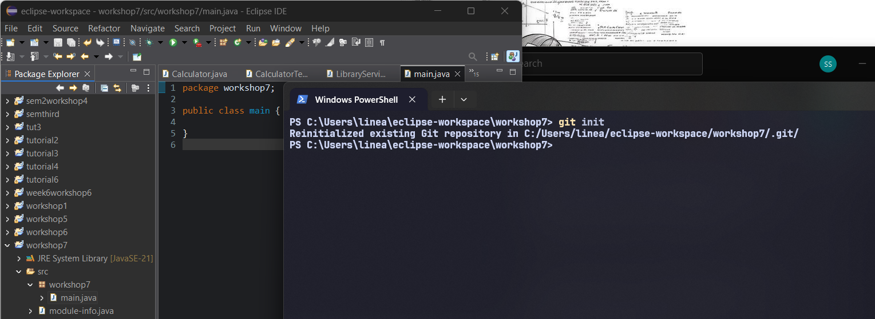
- Staging Files for Commit:
- Scenario: You’ve created a new Java file Student.java that contains the class definition for a student. The class has a name and age attribute, along with a constructor.
- Task: Write the Git command to stage the Student.java file.
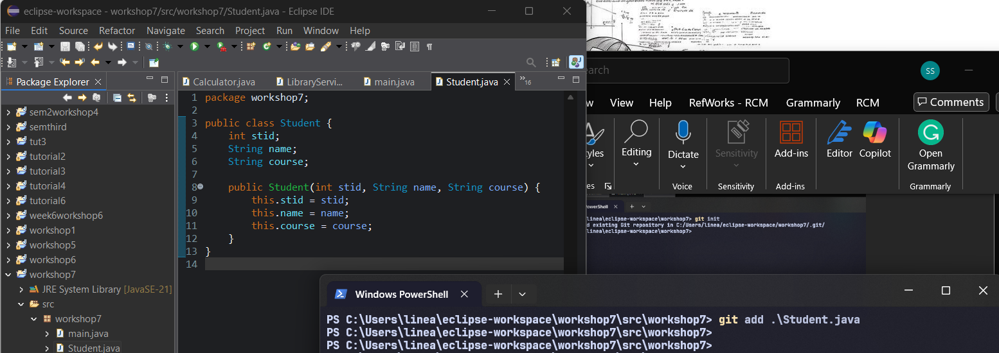
- Committing Changes:
- Scenario: You made changes to Student.java, adding getter methods for name and age. Now, you are ready to commit these changes.
- Task: Write the Git commands to commit the changes to Student.java with the message “Added getter methods to Student class.”
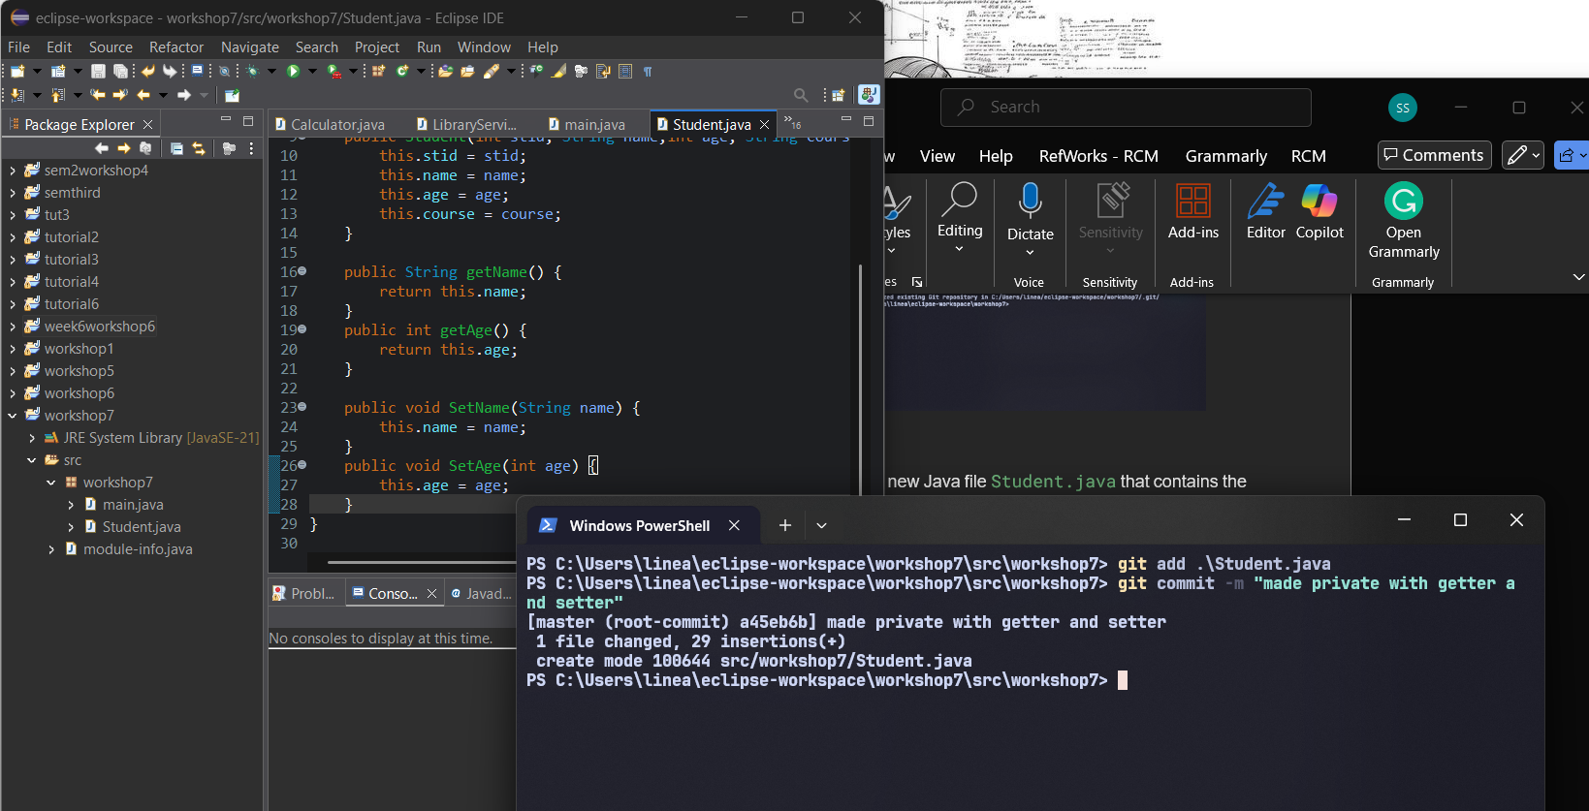
- Creating and Switching Branches:
- Scenario: You want to add a new feature for calculating student grades in a new class GradeCalculator.java. To avoid interfering with the main branch, you decide to create a new branch.
- Task: Write the Git commands to create a new branch named feature-grade-calculator and switch to it.
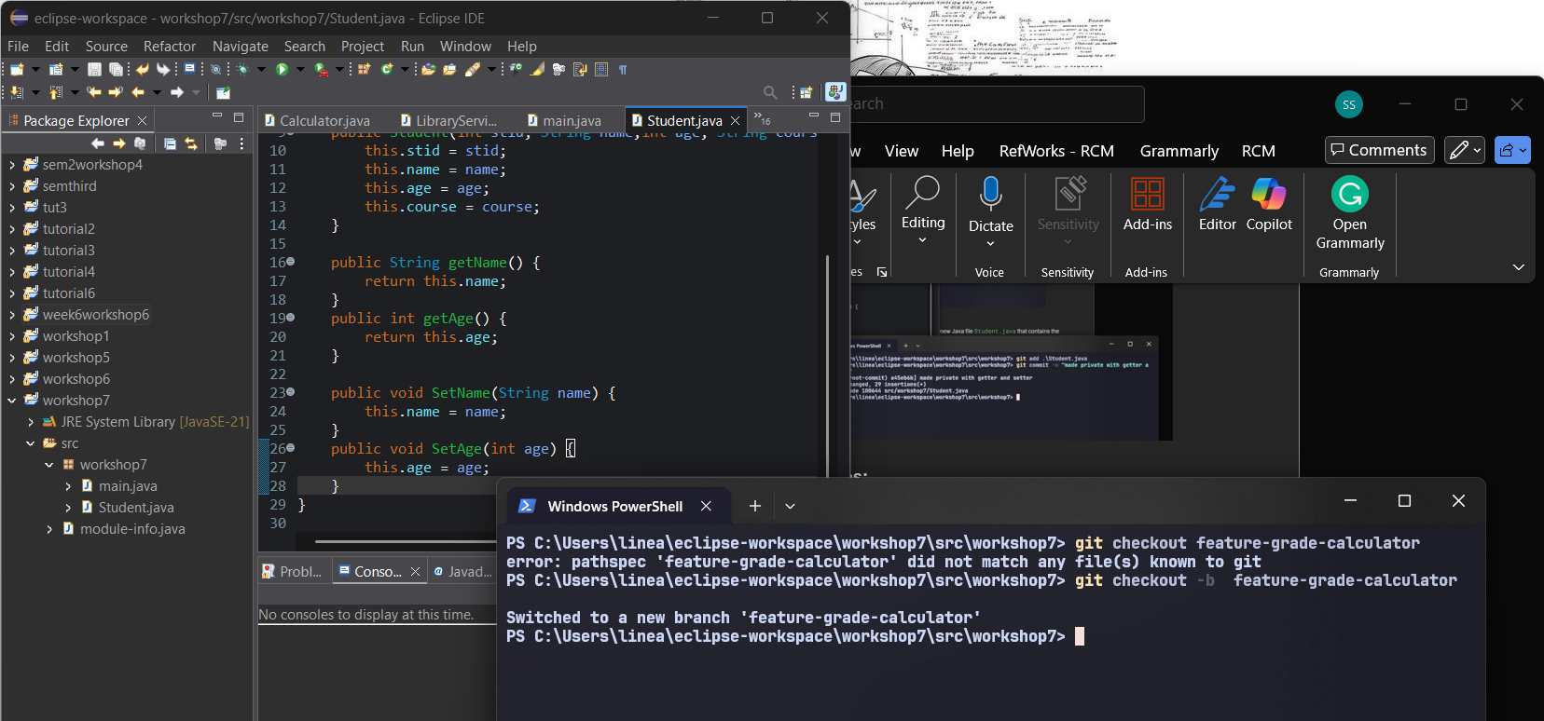
- Pushing Changes to GitHub:
- Scenario: After making changes to GradeCalculator.java, you want to push your branch to GitHub.
- Task: Write the Git command to push the feature-grade-calculator branch to your GitHub repository.
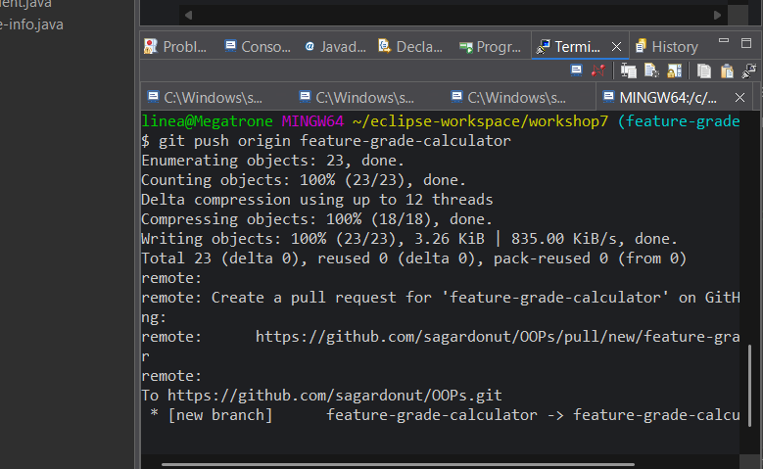
- Cloning a Repository:
- Scenario: Your friend from another group project has created a similar Java project and you want to contribute to it. They have shared the repository URL with you.
- Task: Write the Git command to clone their repository to your local machine. Assume the URL is https://github.com/ramlal/hck-w7
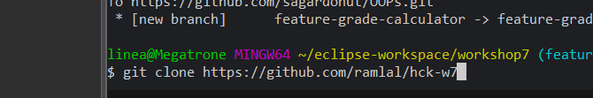

Software Development and UML Diagrams

Case Study One: Hospital Management System
A hospital needs a system to manage its operations, which include managing patients, doctors, appointments, and treatments. Patients can book appointments with doctors, and doctors can prescribe treatments.
Design a class diagram representing the system and generate Javadocs for classes and methods. Also, implement the following functionalities:
Requirements:
- Patients: Patients can book appointments with doctors.
- Appointments: Appoitments record the date, time, and patient details.
- Doctors: Doctors can prescribe treatments/medications for patients during an appointment.
Classes, Attributes and their Relationships:
- Person(Parent Class)
  - Attributes: personID, name, age, gender, address, contactDetails
  - Methods:viewPersonalDetails()
- Patient(Child Class)
  - Attributes: patientID
  - Methods: bookAppointment()
- Doctor(Child Class)
  - Attributes: doctorID, department
  - Methods: seePatientDetails(), prescribeTreatment()
- Appointment
  - Attributes: appointmentID, appointmentDate, appointmentTime
  - Methods: rescheduleAppointment(), cancelAppointment(), viewAppointmentDetails()
- Treatment
  - Attributes: treatmentID, type, description
  - Methods: updateDescription(), viewTreatmentDetails()

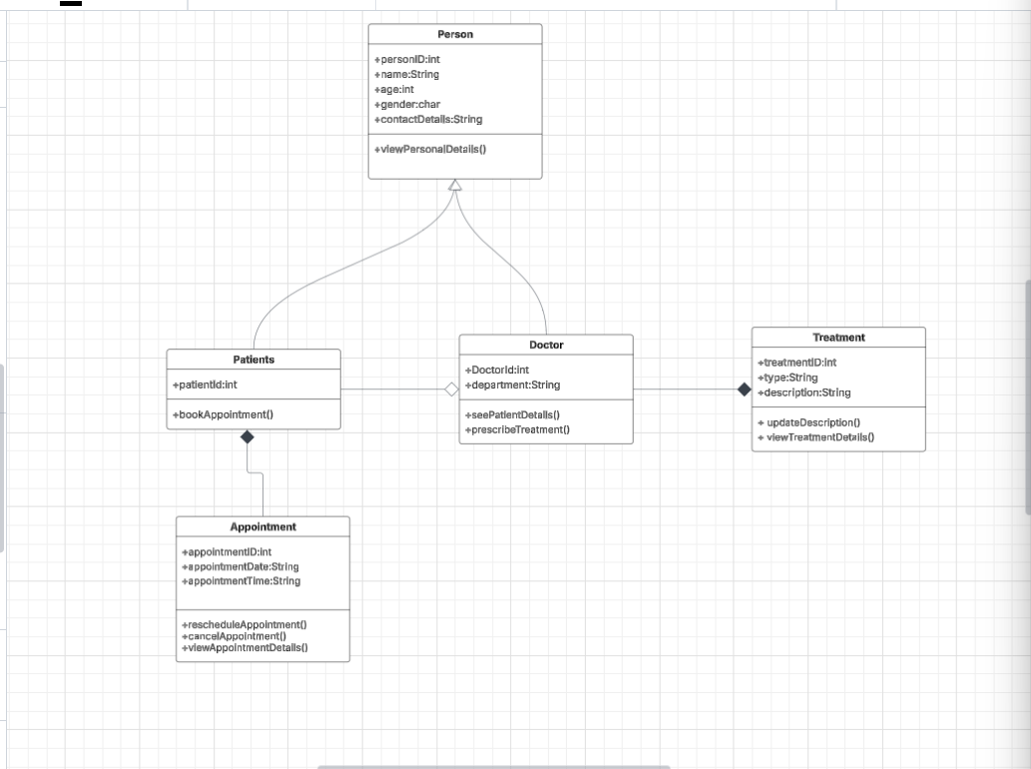

Case Study Two: E-Commerce Shopping Cart System
You are developing a system that should allow customers to browse products, add products to a shopping cart, and proceed with the checkout.
Design a class diagram representing the system and generate Javadocs for classes and methods. Also, implement the following functionalities:
Requirements:
- Customer: A customer can create an account, log in, and view products. A customer can also add products to their cart and proceed to checkout.
- Product: The system should manage a list of products with details like name, price, and stock availability.
- Shopping Cart: A customer can add products to the shopping cart, remove products, and view the total price of the cart. The cart should keep track of the quantities for each product.
Classes:
- Customer
  - Attributes: customerId, name, email, password
  - Methods: register(), login(), viewProducts(), addToCart(), checkout()
- Product
  - Attributes: productId, name, price, stockQuantity
  - Methods: getDetails(), checkAvailability()
- ShoppingCart
  - Attributes: cartItems (a list of products with their quantities), totalPrice
  - Methods: addProduct(), removeProduct(), calculateTotalPrice(), viewCartItems()
