- Write a program to get the following output.
Hey there,
I am “some data”! (assign a variable and print the variable data)
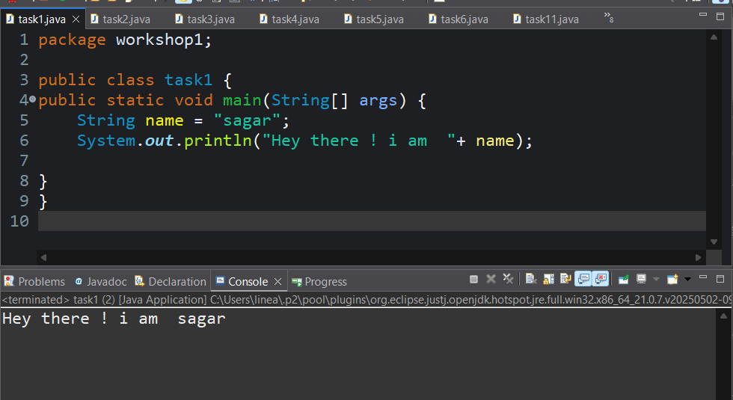
- Write a program to print the difference and product of numbers 45 and 32.
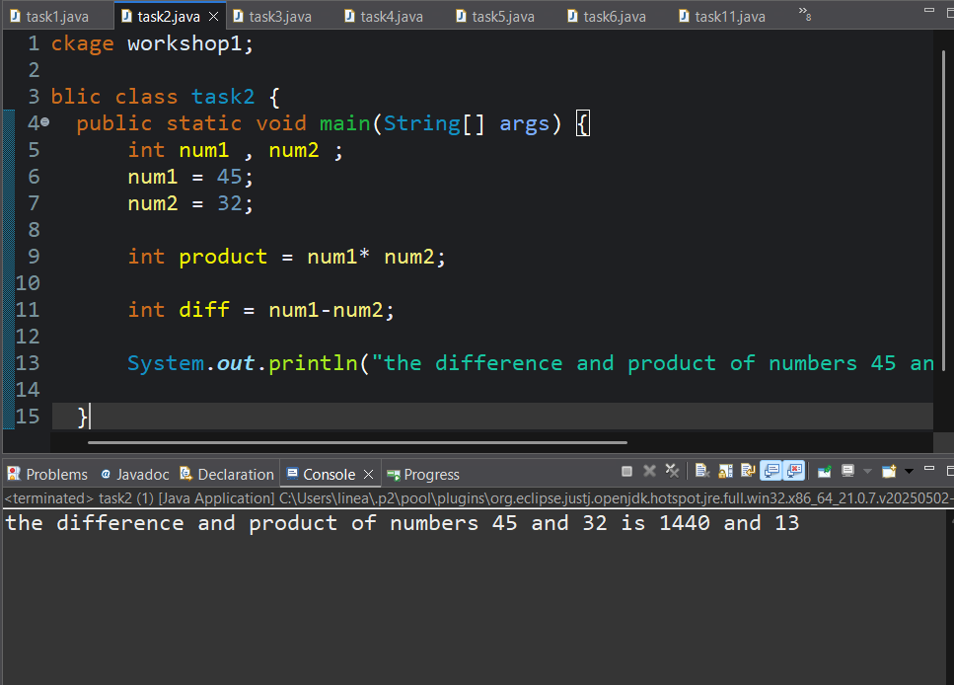

- Write a Java program to print an int, a double, and a char on the screen.
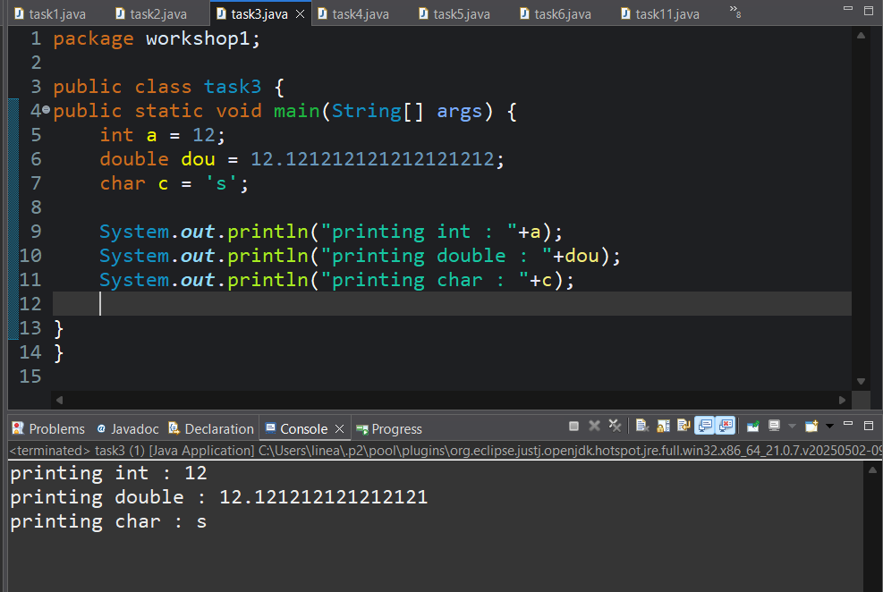

- Write a program to calculate the area of a triangle.
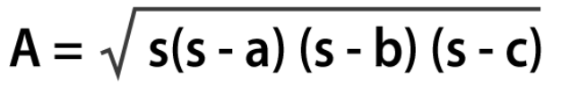
Where s is the semi-perimeter of the triangle s = (a+b+c)/
2
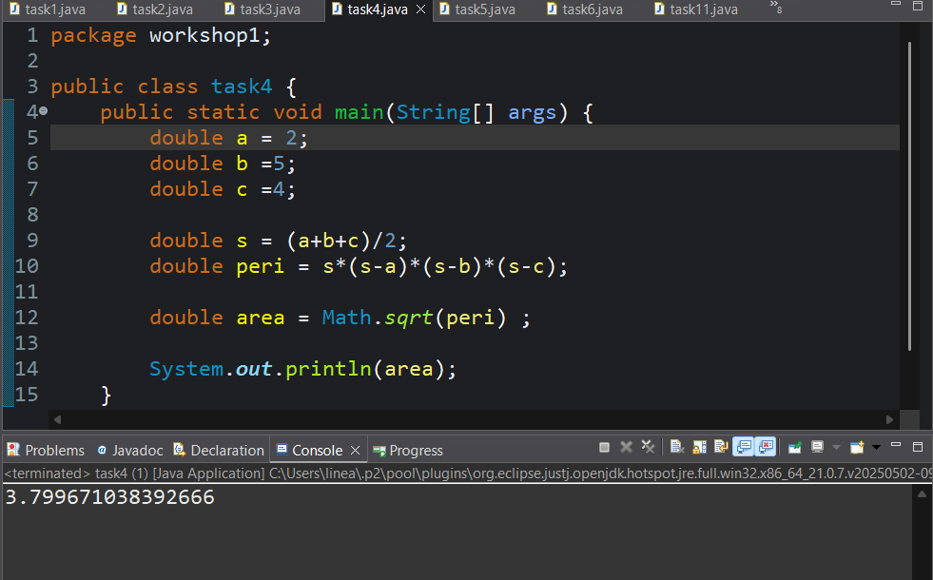

- Write a Java program to calculate the area of a square. Prompt the user to enter the length of one side and then display the result. Ensure that the program handles user input as a double data type.
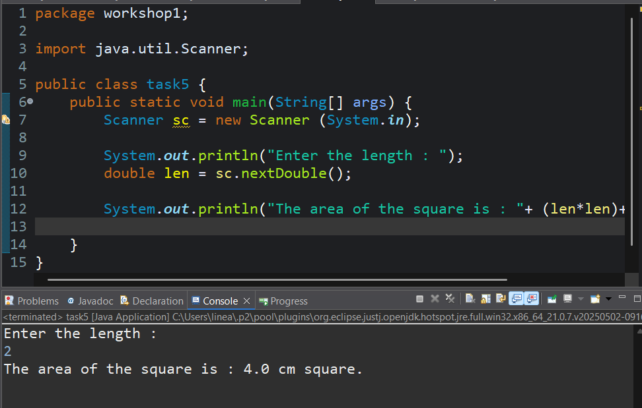

- Create a Java program that converts a temperature in Celsius to Fahrenheit. Prompt the user to enter the temperature in Celsius, perform the conversion using the formula (F = C * 9/5 + 32), and display the result as a double.
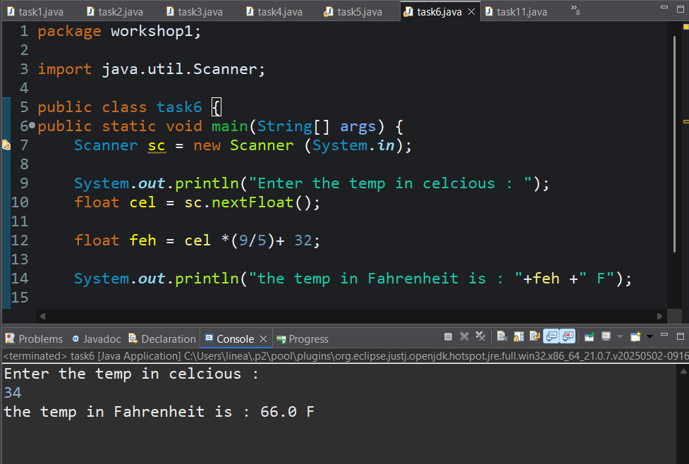

- Write a Java program that calculates the simple interest on a loan. Prompt the user to enter the principal amount, the rate of interest, and the time period. Calculate and display the interest amount as a double.
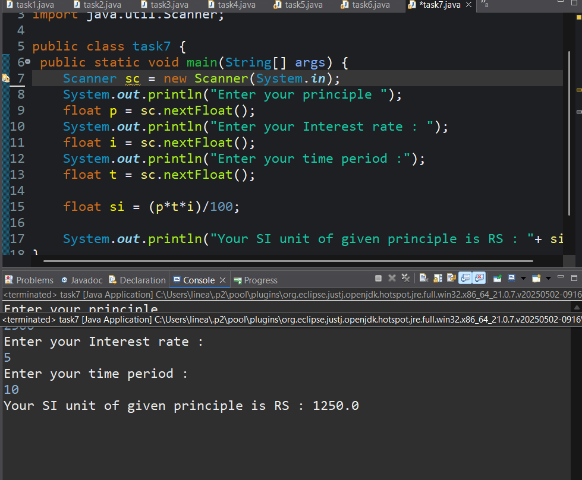

- Create a Java program that takes two integer inputs from the user, performs all basic arithmetic operations (addition, subtraction, multiplication, and division) on these numbers, and displays the results.
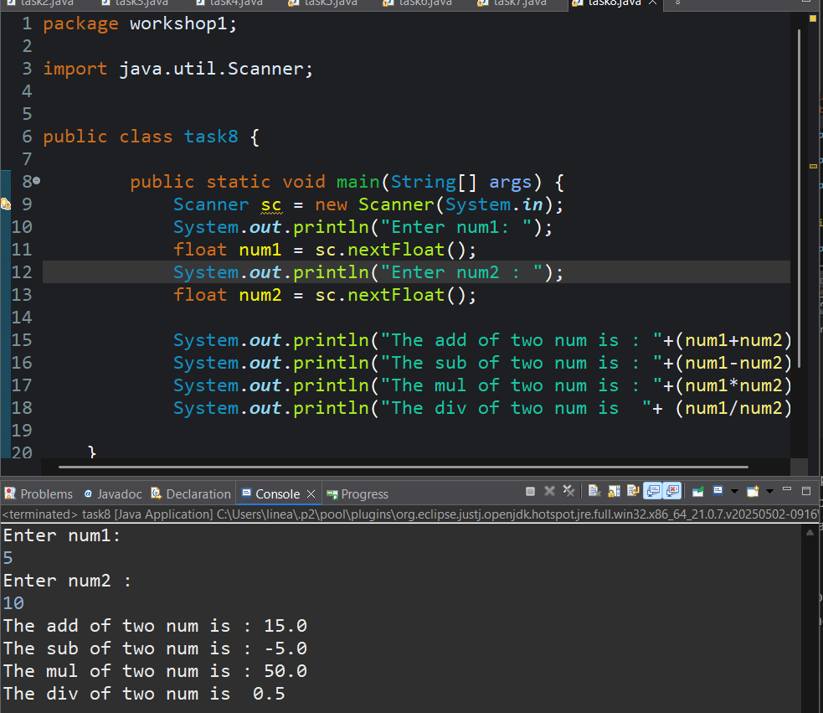
- Create a Java program that computes the area of a circle. Prompt the user to enter the radius and display the result as a double. Use the formula (Area = π * r * r) for the calculation.
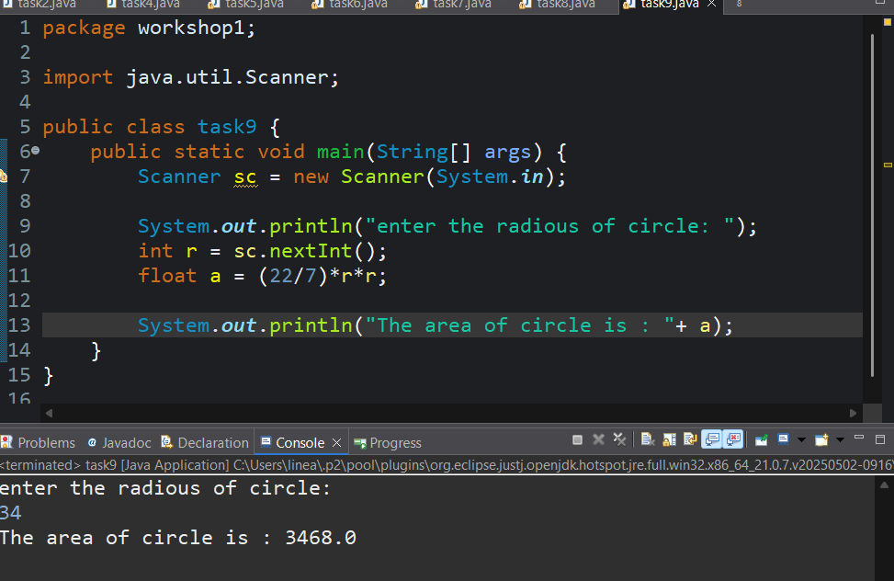

- Develop a Java program that calculates the total cost of purchasing a given quantity of items at a certain price per item. Prompt the user to enter the quantity and price, and display the total cost as a double.
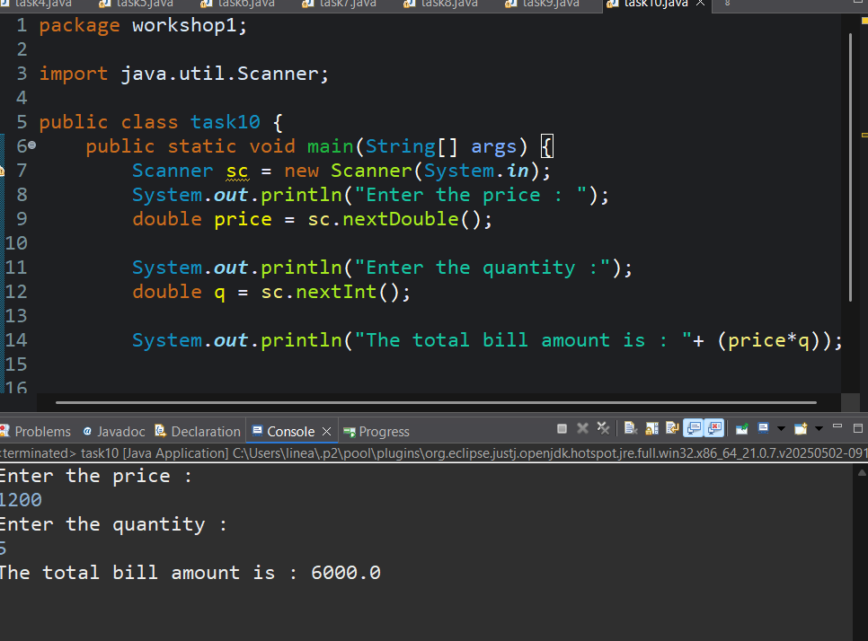

- Create a Book class with fields title, author, and year. Override the toString() method to return a formatted string representation of a Book object.
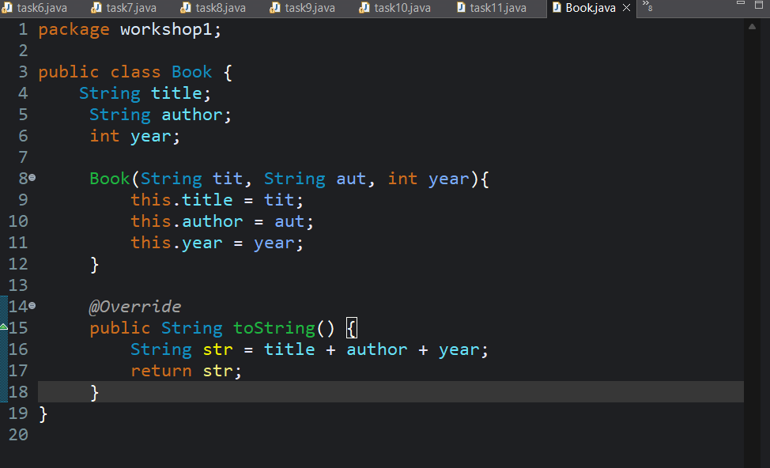
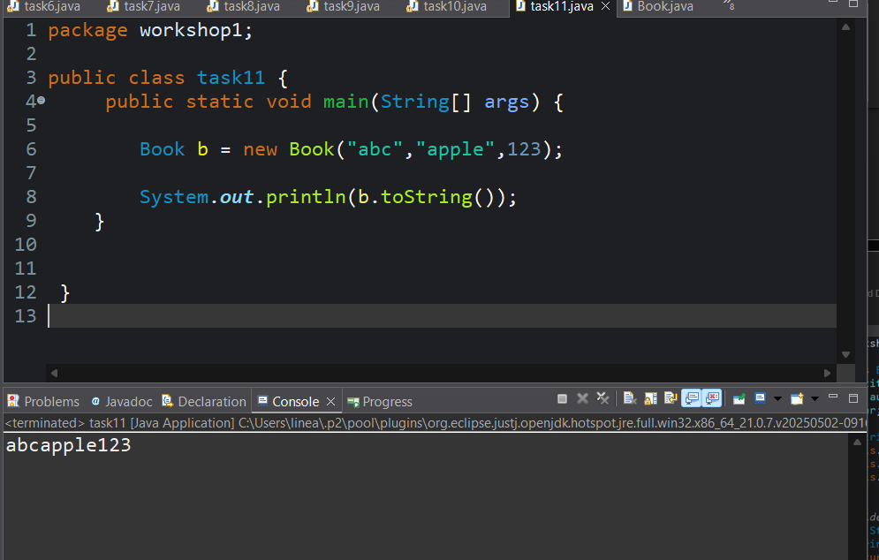
- Create a class Rectangle with fields for width and height. Add a constructor to initialize these fields. Override the toString() method to return the rectangle's dimensions in a readable format.
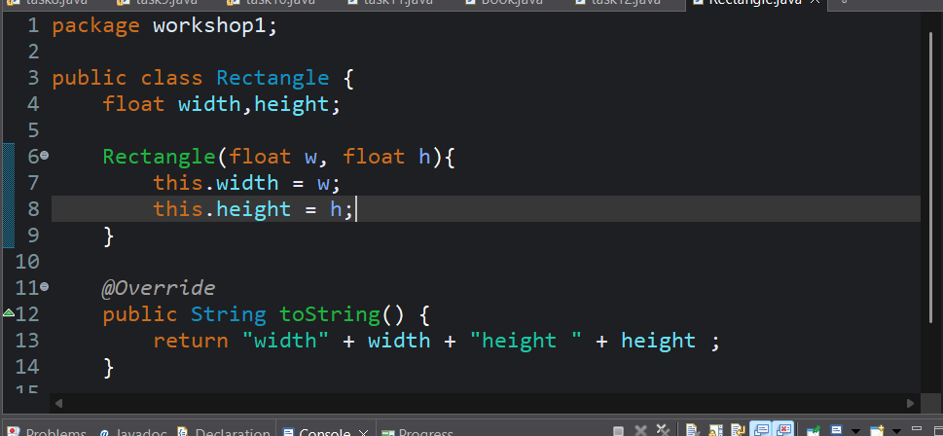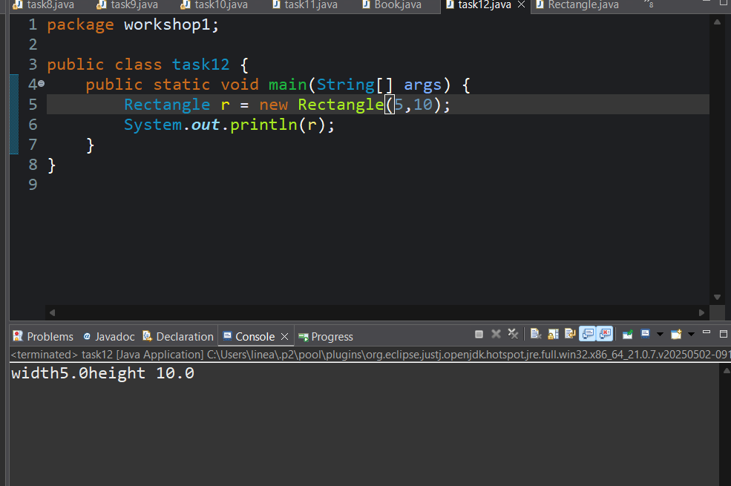
- Write Javadoc comments for the following Java method:
