Types of Inheritance
[1] Single Inheritance:
Create two classes: Vehicle (with a method start()) and Car (which inherits from Vehicle). In the Car class, override the start() method to print "Car started." Create an object of the Car class and call the start() method.
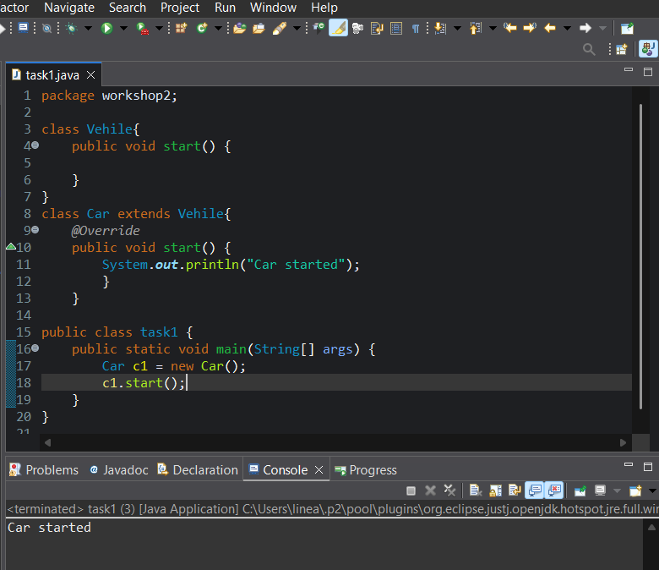

[2] Multilevel Inheritance:
Create a class Person with a method displayInfo(). Create a class Employee that extends Person and adds a method displayRole(). Then, create a class Manager that extends Employee and adds a method displayDepartment(). Instantiate an object of the Manager class and call all three methods.
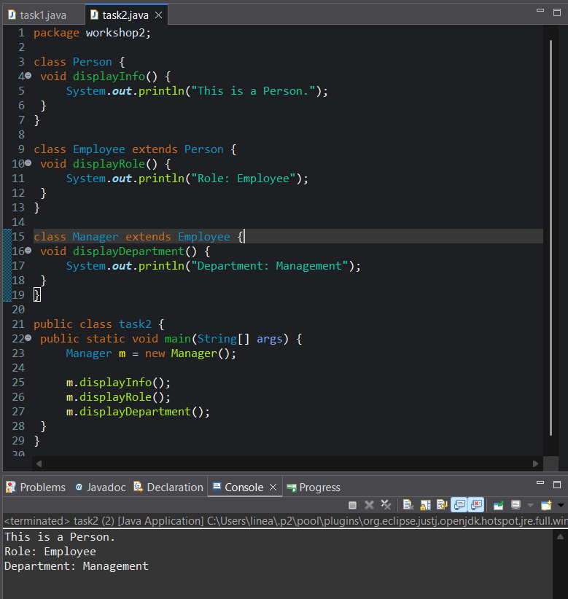
[3] Hierarchical Inheritance:
Create a class Animal with a method sound(). Create two classes Dog and Cat that extend Animal and override the sound() method to print "Bark" and "Meow," respectively. Instantiate objects of both classes and call their sound() methods.
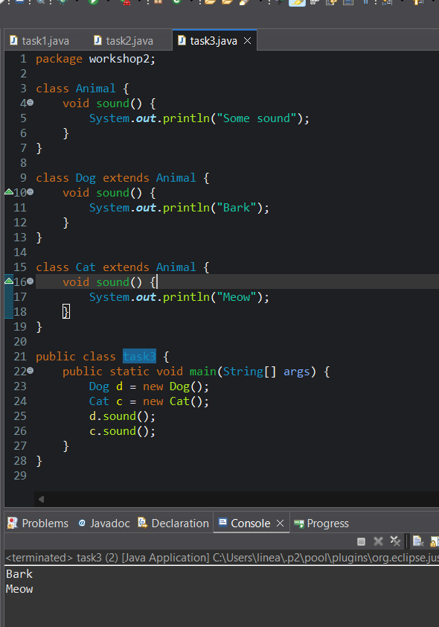
[4] Hybrid Inheritance:
Create an interface Flyable with a method fly(). Then create a class Bird that implements Flyable and another class Animal with a method eat(). Create a class Eagle that extends Animal and implements Flyable. Instantiate an object of Eagle and call both eat() and fly() methods.

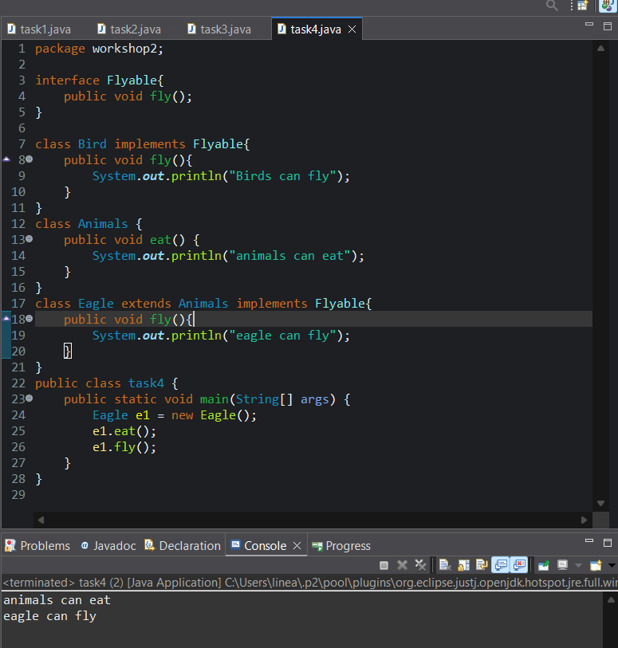

Super Keyword
[5] Access Parent Class Constructor:
Create a class Animal with a constructor that prints "Animal created". Create a subclass Dog that calls the Animal constructor using the super() keyword and adds a constructor to print "Dog created". Instantiate an object of Dog and observe the output.
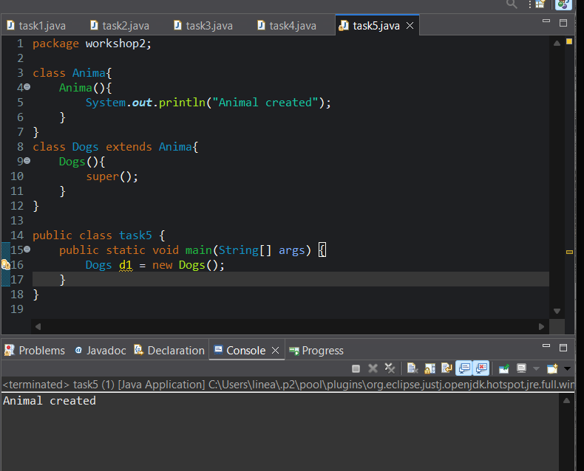

[6] Access Parent Class Methods:
Create a class Vehicle with a method start(). Create a class Car that extends Vehicle and overrides the start() method. In the Car class, use super.start() to call the parent class's start() method. Instantiate a Car object and call the start() method.
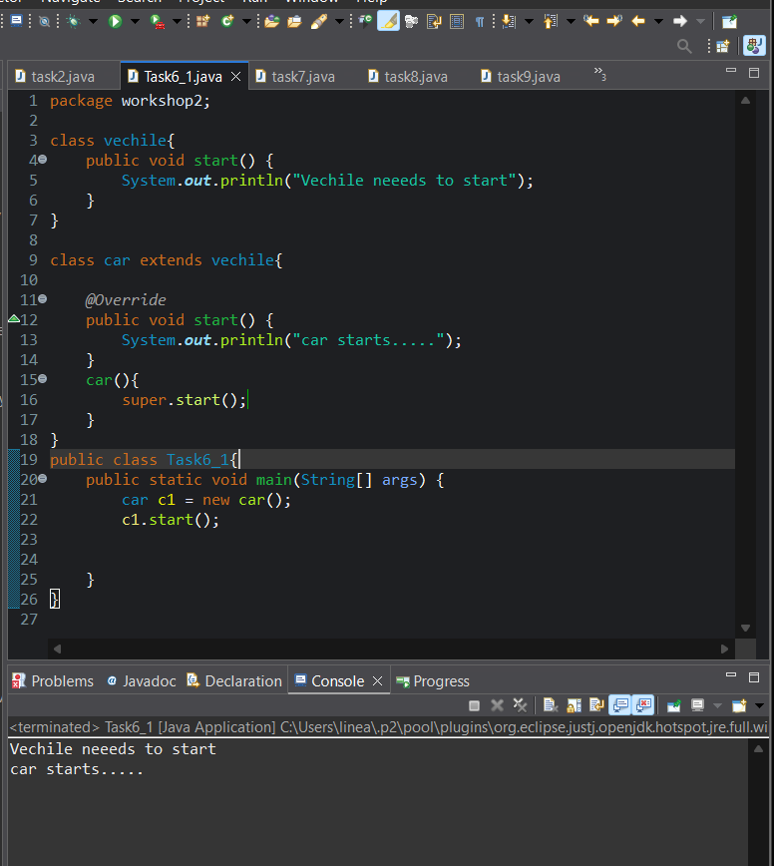

Abstract Classes and Methods
[7] Abstract Class with Abstract Method:
Create an abstract class Shape with an abstract method area(). Create two subclasses Circle and Rectangle that implement the area() method. Instantiate objects of both subclasses and print their areas.
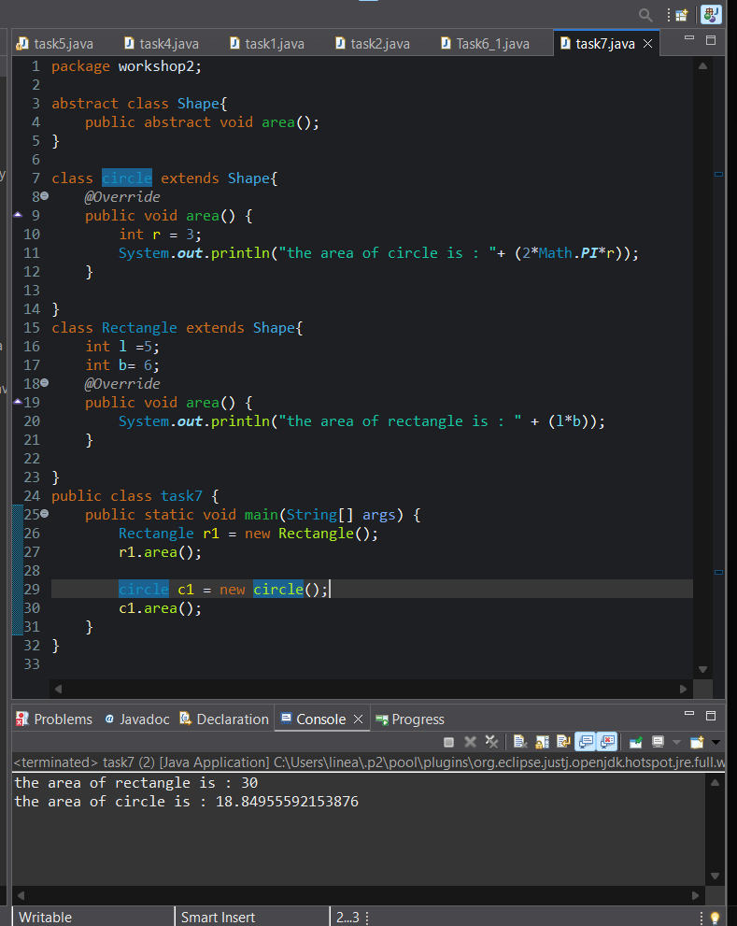

[8] Abstract Class with Concrete Methods:
Create an abstract class Appliance with a concrete method turnOn() and an abstract method operate(). Create a subclass WashingMachine that implements the abstract method operate(). Instantiate the WashingMachine and call both turnOn() and operate() methods. 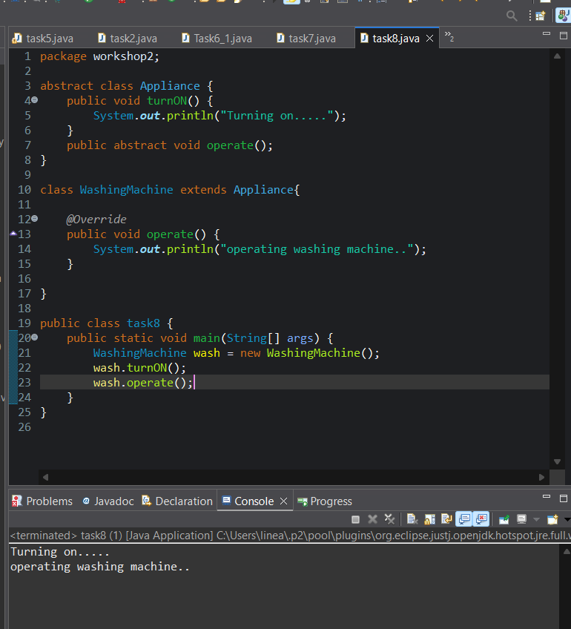

Interfaces
[9] Basic Interface Implementation:
Create an interface Runnable with a method run(). Create a class Car that implements Runnable and overrides the run() method to print "Car is running." Instantiate a Car object and call the run() method.
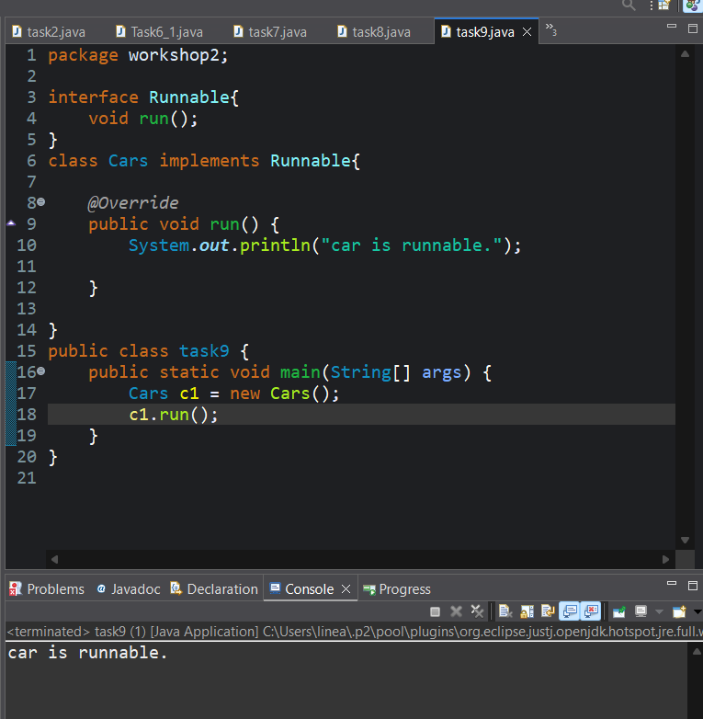

[10] Multiple Interfaces Implementation:
Create two interfaces: Swimable (with a method swim()) and Flyable (with a method fly()). Create a class Duck that implements both interfaces. Instantiate a Duck object and call both swim() and fly() methods.
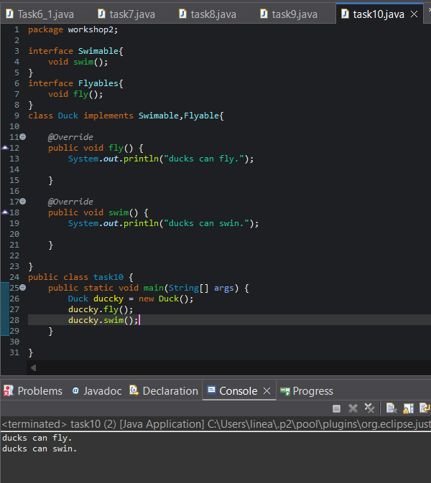

Multiple Inheritance
[11] Using Interfaces:
Create two interfaces Readable (with a method read()) and Writable (with a method write()). Create a class Book that implements both interfaces. Instantiate a Book object and call both methods.
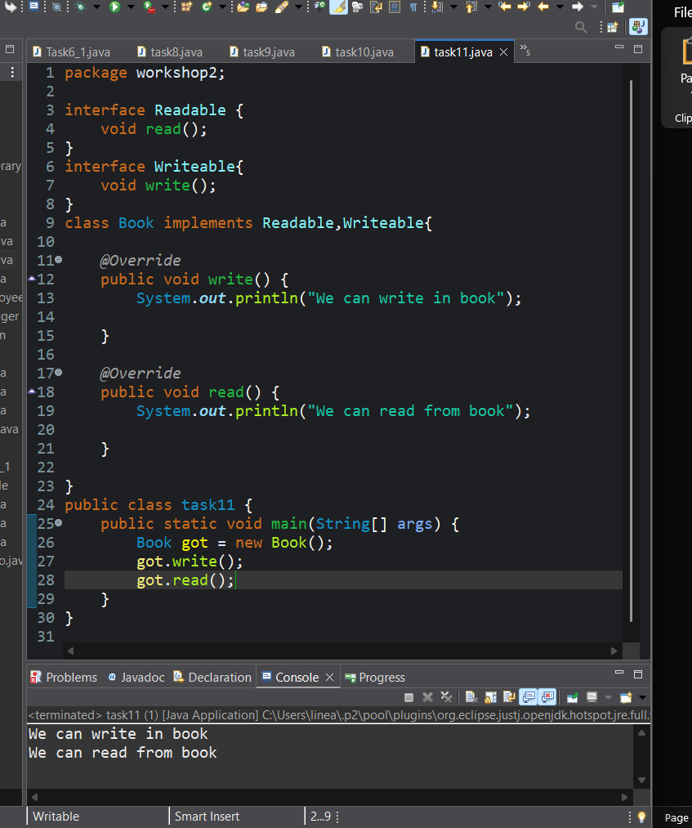

[12] Handling Default Method Conflicts:
Create two interfaces A and B, both with a default method show(). Create a class C that implements both interfaces and resolves the conflict using super.
