Dependencies for Routing:

* Install 🡪 “react-router-dom”

Simple Navigation is as follow:

import React from 'react';

import { BrowserRouter, Switch, Route } from 'react-router-dom';

import Nav from './views/Nav';

import Home from './views/Home';

import About from './views/About';

import Contact from './views/Contact';

import Error from './views/Error';

function App() {

return (

<BrowserRouter>

<div>

<Nav />

<Switch>

<Route path="/" exact component={Home}/>

<Route path="/about" exact component={About}/>

<Route path="/contact" exact component={Contact}/>

<Route exact component={Error}/>

</Switch>

</div>

</BrowserRouter>

);

}

export default App;

import React from 'react';

import { NavLink, Link } from 'react-router-dom';

const Nav = () =>{

return(

<div>

<NavLink to="/" activeClassName="nav-active">Home</NavLink>

<NavLink to="/about" activeClassName="nav-active">About</NavLink>

<Link to={{

pathname:'/contact/2000',

search:'?id=1',

hash:'#hash',

state: { isAdmin:true }

}} activeClassName="nav-active">User</Link>

</div>

);

}

export default Nav;

* We can use “Link” or “NavLink” (But NavLink provides :hover, :active, :visited type of features)

// Home.js

import React from 'react';

const Home = () =>{

return(

<p>Home</p>

);

}

export default Home;

// About.js

import React from 'react';

const About = () => {

return(

<p>About</p>

);

}

export default About;

// Contact.js

import React from 'react';

const Contact = () =>{

return(

<p>Contact</p>

);

}

export default Contact;

// Error.js

import React from 'react';

const Error = () =>{

return(

<p>Error</p>

);

}

export default Error;

To get details related to route:

* We can get from “props”
* If routing is set, we can access them using “props”
* List of objects can be accessed as following
  + History
  + Location
  + Match

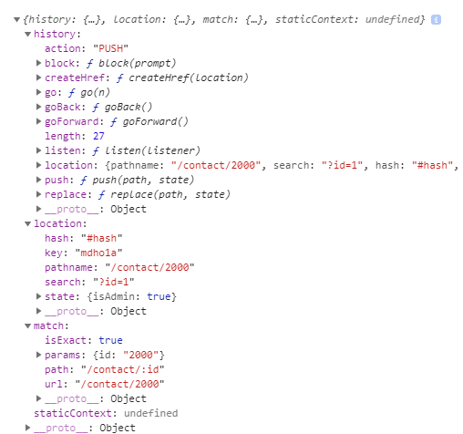

To pass router props to child component:

* import { withRouter } from 'react-router-dom';
* export default withRouter(HomeChild);
* Refer below example:

import React from 'react';

import HomeChild from './Home-Child';

const Home = (props) =>{

console.log(props);

return(

<div>

<p>Home</p>

<HomeChild />

</div>

);

}

export default Home;

import React from 'react';

import { withRouter } from 'react-router-dom';

const HomeChild = (props) =>{

console.log(props);

return(

<p>HomeChild</p>

);

}

export default withRouter(HomeChild);

Styling the active rout:

* By default for active link class=”active” is going to add
* What if you need some other class name, Use below logic:
* <NavLink to="/" activeClassName="nav-active">Home</NavLink>