**Role of Information Asymmetry in a Public Goods Game for Climate Change**

*A Project Submitted in partial fulfillment of the requirements*

*for the degree of*

**MASTER OF TECHNOLOGY**

**in**

**Information and Communication Technology**

*Submitted by*

**Rohit Chouhan**

*Under the guidance of*

**Dr. Varun Dutt**



**SCHOOL OF COMPUTING AND ELECTRICAL ENGINEERING**  
**INDIAN INSTITUTE OF TECHNOLOGY, MANDI**

MANDI, HIMACHAL PRADESH, INDIA

*Submitted to*

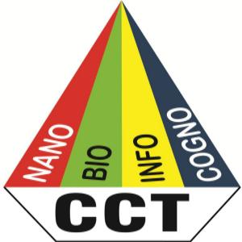



**CENTRE FOR CONVERGING TECHNOLOGIES,**

**UNIVERSITY OF RAJASTHAN**

JAIPUR, RAJASTHAN, INDIA

FEBRUARY, 2015

**APPROVAL SHEET**

**Project entitled:** Role of Information Asymmetry in a Public Goods Game for Climate Change

**By:** Rohit Chouhan

is approved for the degree of Master of Technology (Information and Communication Technology).

**Examiners:**

**Supervisors:**

**Date: Chairman:**

**Place:** Jaipur

**DECLARATION**

I, Rohit Chouhan, hereby declare that the project work entitled **“*Role of Information Asymmetry in a Public Goods Game for Climate Change*”** submitted to the Centre for Converging Technologies, University of Rajasthan, Jaipur in partial fulfillment requirements for the degree of Master of Technology in Information and Communication Technology, has been done by me under the supervision and valuable guidance of **Dr. Varun Dutt**, School of Computing and Electrical Engineering and School of Humanities and Social Sciences, Indian Institute of Technology, Mandi, India.

Rohit Chouhan

Centre for Converging Technologies,

University of Rajasthan,

Jaipur

Counter Sign By

Dr. Varun Dutt

School of Computing and Electrical Engineering

School of Humanities and Social Sciences

Indian Institute of Technology, Mandi

Mandi

**CERTIFICATE**

This is to certify that the research project entitled, “***Role of Information Asymmetry in a Public Goods Game for Climate Change***” submitted by Master Rohit Chouhan in fulfillments for the requirements for the award of Master of Technology degree in Information and Communication Technologies, University of Rajasthan, Jaipur is an authentic work carried out by him under my supervision and guidance. To the best of my knowledge, the matter embodied in this work has not been submitted to any other University/  
Institute for the award of any Degree or Diploma.

Date: 04/02/2015 **Dr. Varun Dutt**

Place: Mandi School of Computing and Electrical Engineering

School of Humanities and Social Sciences

Indian Institute of Technology, Mandi

# 

# **Copyright Notice**

Copyright © Rohit Chouhan 2015

All rights reserved. All material in this document is, unless otherwise stated, the property of Rohit Chouhan and Prof. Varun Dutt. Copyright and other intellectual property laws protect this material. Unauthorized reproduction or retransmission of the materials, in whole or in part, in any manner, without the prior written consent of the copyright holder, is a violation of copyright law.

Rohit Chouhan  
Centre for Converging Technologies  
University of Rajasthan  
Jaipur, India

Prof. Varun Dutt  
Indian Institute of Technology, Mandi, India

February 04, 2015

# **ACKNOWLEDGEMENTS**

I would like to express my sincere gratitude to my principle advisor Dr. Varun Dutt for the continuous support of my M. Tech. study and research, for his patience, motivation, enthusiasm, and immense knowledge. I am greatly thankful for his sincere and diligent effort as a guide, mentor, and inspiration, during all times, good or bad. His advice on both research as well as on my career have been priceless.

I express my sincere gratitude to Prof. Deepak Bhatanagar, HOD, Centre for Converging Technologies, University of Rajasthan, Jaipur who allowed me to undergo and complete the dissertation work.

Furthermore, I would like to acknowledge and convey my special thanks to Medha Kumar research scholar, who has greatly helped me by providing a critical review of my research work and helping me collect data, manuscript submission, proof reading and valuable advice and helped me in writing of this project.

A special thanks to my family. Words cannot express how grateful I am to my mother, father and brother for all of the sacrifices that you’ve made on my behalf. Your prayer for me was what sustained me thus far. I would also like to thank all of my friends (Shailendra, Navid, Aayushi, Sachin, Hitankshi) who supported me in writing, and incented me to strive towards my goal.

I really appreciate all your help and I am really thankful to all who have helped me make this research possible!

**Abstract**

The continued increase in the atmospheric concentration of carbon dioxide due to anthropogenic emissions like (burning fossil fuel) is predicated to lead to significant changes in Earth’s climate like temperature change and melting of polar icecaps. Although atmospheric carbon-dioxide concentration is increasing at an alarming rate, currently little is known on how information asymmetry among world players, who make monetary contributions against climate change, would influence the emergence of cooperation against climate change. In this project, I investigate the role of information asymmetry among human players about monetary investments using a modified form of a repeated public goods game for the environment, called the climate game. In the climate game, a group of four human players (representing different world economies) play repeatedly against each other where in each round a player decides how much money to contribute to a green fund (the money not invested in the green fund accrues interest as a private investment for a player). In an experiment, six 4-player groups played the climate game across two between-subjects conditions: Info-NoInfo and NoInfo-Info. In Info-NoInfo condition, 3 randomly selected groups first played the climate game for 50 rounds where information on opponents’ contribution to green fund was known to all players. This play was followed by a game where information on opponents’ contribution to green fund was not known to players. The information presentation was reversed in the NoInfo-Info condition. Results revealed that contribution to the green fund decreased rapidly across repeated rounds in both conditions. However, possessing information about contributions decreased the contributions made much less compared to not possessing this information. Also, experiencing information in the first game had lesser effect in the subsequent game compared to not experiencing information in the first game. I discuss implications of our findings for emergence of cooperation against climate change.

**Table of Contents**

**Approval Sheet** i

**Declaration** ii

**Certificate** iii

**Copyright Notice** iv

**Acknowledgements** v

**Abstract** vi

**Table of Content** viii

**List of Tables** x

**List of Figures** xi

**Chapter 1: Introduction** 1

**1.1 Introduction** 1

**1.2 Variants** 4

**1.2.1 Iterated public goods games** 4

**1.2.2 Open public goods game(Transparency)** 5

**1.2.3 Public goods games with punishment and/or reward** 6

**1.2.4 Asymmetric costs and/or benefits** 7

**1.2.5 Income variation** 8

**1.2.6 Framing** 9

**1.3 Project Contributions** 11

**Chapter 2: Development of Public Goods Game** 13

**2.1 Opening z-Tree** 17

**2.2 Setting the General Background Parameters** 18

**2.3 Set Non-General Background Parameters for the Experiment** 19

**2.4 Ask Players for Contributions** 22

**2.5 Calculate Public Good** 29

**2.6 Display Outcomes** 30

**2.7 Easy Networking** 32

**Chapter 3: Methodology** 35

**3.1 Hypothesis** 35

**3.2 Experiment Design** 36

**3.3 Participants** 38

**3.4 Procedure** 39

**3.5 Results** 39

**3.5.1 Payoff differences between Information and No-Information Condition** 39

**3.5.2 Learning effect of Information and No-Information Condition** 40

**Chapter 4: Discussion, Conclusions and Future Directions** 44

**References** 47

**List of Tables**

|  |  |  |
| --- | --- | --- |
| **Table Number** | **Name of Table** | **Page Number** |
| **Table 2-1.** | Values of return on investments on the amounts contributed to the green fund by respective players and investment contributed to private fund by high, upper middle, middle and low income economies respectively. | 14 |

**List of Figures**

|  |  |  |  |  |
| --- | --- | --- | --- | --- |
| **Figure Number** | | **Name of Figure** | **Page Number** | |
| **Figure 1-1.** | | The Public Goods Game | 4 | |
| **Figure 2-1.** | | Client/Server architecture of z-Tree. | 16 | |
| **Figure 2-1.** | | Opening z-Tree. | 17 | |
| **Figure 2-2.** | | Setting the General Background Parameters. | 18 | |
| **Figure 2-3.** | | Create a Program to Store the Variables. | 19 | |
| **Figure 2-4.** | | Creating a New Program for Global Variable. | 20 | |
| **Figure 2-5.** | | Creating a New Program for Subject Variable. | 21 | |
| **Figure 2-6.** | | Creating a New Program. | 22 | |
| **Figure 2-7.** | | Creating a New Stage. | 23 | |
| **Figure 2-8.** | | Creating a New Stage. | 25 | |
| **Figure 2-9.** | | Creating a Screen for Players to Enter Contribution. | 25 | |
| **Figure 2-10.** | | Creating a New Box. | 26 | |
| **Figure 2-11.** | | Putting an Item into the Box. | 27 | |
| **Figure 2-12.** | | Showing the Endowment. | 27 | |
| **Figure 2-13.** | | An Input Box for Contribution. | 28 | |
| **Figure 2-14.** | | Set the button. | 29 | |
| **Figure 2-15.** | | Contribution Stage completed. | 30 | |
| **Figure 2-16.** | | Calculating Public Goods Stage completed. | 31 | |
| **Figure 2-17.** | | Final Structure of Public Goods Game. | 32 | |
| **Figure 2-19.** | | Starting z-Leaf. | | | 33 | |
| **Figure 2-20.** | | Starting the Treatment. | | | 34 | |
| **Figure 3-1.** | | The game uses a fictitious currency EC. Each player get yearly income of 10 million EC each. All players decide to invest a part of this income (X, X’, X’’, or X’’’ million EC) in a green fund for averting climate change. The remaining money is stored in a bank account and it accrues a simple interest. The money contributed by all players in the green fund is multiplied by certain multipliers and then summed together. This sum is then equally divided among all players. All players payoff at the end of a year is the sum of the return on investments all players obtain from the bank and the green fund. | | | 37 | |
| **Figure 3-2.** | | Average contributions to the green fund in information and no-information conditions across 50 rounds. | | | 40 | |
| **Figure 3-3.** | | Average contributions to the green fund in no-information condition played after and before information conditions across 50 rounds. | | | 41 | |
| **Figure 3-4.** | | Average contributions to the green fund in information condition played after and before no-information condition across 50 rounds. | | | 42 | |

**Chapter 1: Introduction**

* 1. **Introduction**

Now a days, climate change is a worldwide phenomenon with disastrous consequences like melting of ice-caps and sea-level rise (IPCC, 2007). Each year, several countries meet in the Conference of Parties (COP) meetings to discuss and negotiate monetary investments for averting climate change (UNFCCC, 2014). Although the COPs are a regular event, these negotiations have not resulted in concrete measures against climate change. For example, at COPs there is always speculation among negotiating parties on how much a country or a block of countries is willing to contribute in public funds to avert climate change (Dutt, 2014; 2015). An important aspect of this speculation is how much information a country has about the binding promises of monetary contribution of other countries to public funds (Dutt, 2014). According to Dutt (2014), sometimes countries possess information about the promises of their opponents in advance and sometimes these promises are speculative and hidden from the public.

Although negotiations are an important part of COPs in the real world, very little research has taken place to understand the resulting negotiation behavior in a controlled laboratory environment. Furthermore, prior research has seldom investigated how information asymmetries about contributions made among players influences cooperation against climate change. In this research study, I use a modified form of the classic public goods game (Axelrod, 1997), called “climate game”, in order to overcome the limitations of prior research.

In the climate game, just like in the public goods game, players play a game with each other by making yearly monetary investments to a private (personal) fund and a public (green) fund. The end point of the game is not known to players. The money put in green fund is multiplied by a factor and the return generated is equally divided among all players. In contrast, the money not invested in the green fund is put in a private fund and it earns interest at a constant rate of return. The game takes into account four players, which represent four economic blocks in the world, namely, high income, middle income, upper-middle income and low income economies. The economic classification of players into four blocks is provided by World Bank (World Bank, 2015). The goal of each player in the game is to earn as much money as possible by making investments in the private and green funds.

The classical public goods game is an economic game. In this game, each player secretly decides his/her own contribution from the initial endowment to a public fund. The amount in this public fund is multiplied by a factor (greater than one and less than the number of players, *N*) and the resulting payoff is evenly divided among players. Each player gets to keep the amount privately that she/he did not contribute to the public fund. The public goods game describes group interactions. The group’s total payoff is maximized when everyone contributes all of their endowment to the public pool. However, the Nash Equilibrium in this game is simply zero contribution by all. Nash Equilibrium is a stable stage of a system that involves several interacting participants in which no participant can gain by a change of strategy as long as all the other participants remain unchanged. Simply put, a Nash Equilibrium is a set of best-response strategies for rational agents. Depending on the experiment’s design, those who contribute below average or nothing are called “free riders” or “defectors”, as opposed to the contributors or above average contributors who are called “cooperators”. The Nash equilibrium is rarely seen in experiments involving public-goods games; people, behaving non-rationally, almost always add something into the pool in a round (U & Li, 2010). The average contribution typically depends on the size of the multiplication factor with larger multipliers for the same number of participants producing higher contributions compared to smaller multipliers (Gunnthorsdottir, Houser & McCabe, 2007). Next, I discuss different variations in the public goods game and certain aspects that I have borrowed from these variations as part of the climate game.

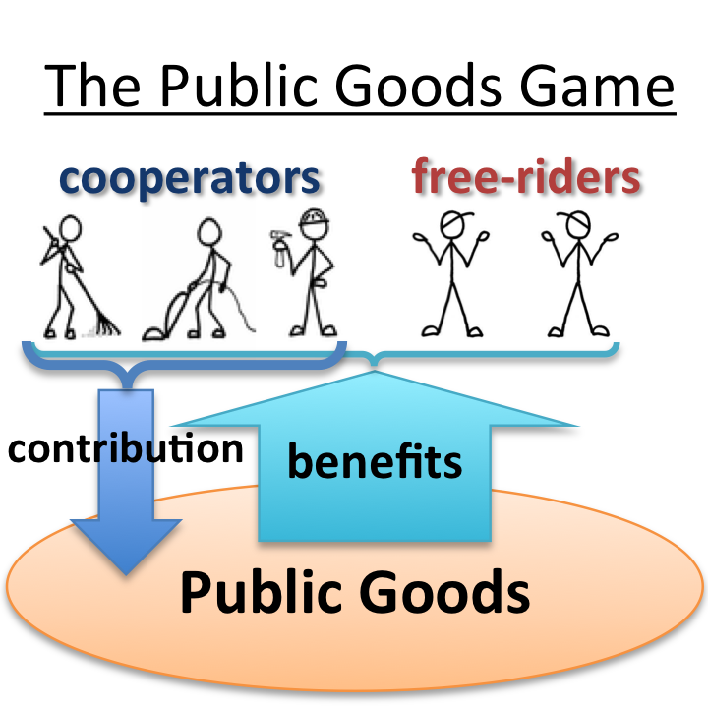

Figure 1-1. The Public Goods Game (Allen, 2011)

**1.2 VARIANTS**

**1.2.1 Iterated public goods games**

Public goods games involve the same group of players playing the game for several rounds. When contributors see that not everyone is investing in public fund as much as they do so in the following round they reduce their investing amount to public fund (Levitt & John, 2007). If this dynamics is again repeated but from a lower base, so that the amount contributed to the public fund is reduced again. However, the amount contributed to the public fund rarely drops to zero when rounds of the game are iterated, because there tend to remain a hard core of ‘givers’ (U & Li, 2010).

During a repeated game, players learn their co-player’s inequality aversion in previous rounds on which future beliefs can be based. If players receive a bigger share for a smaller contribution, the sharing members may react against the perceived injustice (even though the identity of the “free riders” are unknown, and it’s only a game) (Fehr & Schmidt, 1999). Those who contribute nothing in one round, rarely contribute something in later rounds, even after discovering that others are contributing.

**1.2.2** **Open public goods games (Transparency)**

In open public goods game, players are aware of the contributions made by other players to the public fund after each round of play. That means that each player does not hide his/her own contribution to the public account. In open public goods game, free riders may feel shame and contribute something in later rounds (Rege & Telle, 2004). While in the no transparency condition, players do not know about the contributions to the public fund made by other players. Thus, in open public goods game, participants can see how much others contribute to the green fund and this knowledge causes them to reduce or increase their contribution to public fund depending on the contribution of all participants.

Information asymmetries can be created in the climate game by making available the manipulative information to players about investments made by their opponents in each round. For example, Tavoni et al. (2011) have manipulated information in a public goods game for climate change, where players decided whether to contribute €0, €2, or €4 to a climate account (a form or public fund) in each of the 10 rounds. After each round, a player was provided information on individual contributions made by other players as well as the aggregate contribution of the group. In the information manipulation condition it was found that contributions to green fund is more in presence of availability of other player’s contribution as compared to the absence of information.

Similarly, Gonzalez et al. (2014) have reported influence of information asymmetry in decisions making in the Prisoner’s Dilemma (PD) game (Rapoport & Chammah, 1965). In this study, as information about opponent actions increased in a repeated PD game, the amount of cooperation across repetitions of play increased as well.

In this project, I manipulate the information available to players and consider the influence of information asymmetry on emergence of cooperation to avert climate change.

**1.2.3 Public goods games with punishment and/or reward**

Punishments and rewards are powerful means for building collaboration in social issues. The option to punish non-contributors and to reward the highest contributors after a round of the public goods game has been the issue of many experiments. Findings strongly suggest that non-rewarding is not seen as authorization, while rewards don’t substitute punishment. Rather they are utilized distinctively as a means to enforce cooperation and higher payoffs.

Various studies by Helbing (2010), Szolnoki (2010) and Brandt (2003) reveal the threat of punishments and rewards. The combination seems to yield both a higher level of cooperation and payoffs. This holds for iterated games in changing gatherings and in indistinguishable gatherings (David, Dreber, Ellingsen, Fudenberg & Martin, 2009). Although it is interesting, I plan to consider such punishment and reward manipulations as part of future research.

**1.2.4 Asymmetric costs and/or benefits**

Asymmetric cost and benefit functions have direct influence in the behaviour of contribution players. Economic theory predicts that individuals will free-ride, providing sub-optimal Nash equilibrium quantities of public goods. However, 25 years of experimental evidence indicates that individuals’ behavior often differs from the Nash prediction (McGinty & Milam, 2012). McGinty and Milam (2012) have examined the context of asymmetric benefits and asymmetric costs of providing a public good with declining marginal benefits and increasing marginal costs. Their research involves voluntary environmental agreements, under which players commit to costly abatement activities. Such agreements range in scale from local community-based organization to efforts to abate global emissions of greenhouse gases by countries. Generally, players receive different benefits from abatement, and there are vast differences in the cost of abatement. Nations that use a relatively clean mix of fuels, such as Japan, face a much steeper marginal cost curve than nations that have a more carbon intensive mix of fuels (Ellerman, 1998). These asymmetries alter the incentives to free-ride on the abatement of others in important ways. McGinty (2007) models the impact of such asymmetry on Nash equilibrium and optimal abatement, showing that asymmetry can increase both the Nash and optimal levels of public good contribution.

Palfrey & Prisbrey (1997) assign players different rates of return for their private accounts and find that the greater the return to the private good, and the higher the opportunity cost of public contribution, the lower the cooperation rates. Fisher et al. (1995) examine heterogeneity by varying the marginal per capita return (MPCR) within groups. They find that high-MPCR players contribute more to public good provision relative to low-MPCR players.

In this research, asymmetry is introduced among players in terms of return on investments. These players represent different economic blocks in the world. We expect that such asymmetries will allow us to account for dynamics of climate change benefits and costs in the real world.

**1.2.5 Income variation**

The effect of income heterogeneity on contributions has been examined by varying players’ endowments: the results of such studies are mixed. Some authors find endowment asymmetry increases cooperation (Chan et al. 1996, 1999; Buckley & Croson, 2006), and others conclude that cooperation is diminished (Anderson et al. 2008, Cherry et al. 2005).

Bergstrom, Blume, & Varian (1986) showed that redistribution of income from rich to poor individuals may lead to a decrease in the amount of public good. These predictions are counter-intuitive, and seem at odds with experimental findings about inequality aversion and reciprocal behavior (Rabin 1993, Fehr and Schmidt 1999, Fischbacher 2001). For example, Chan et al. (1996) found that more inequality leads to more public good provision, in contrast to Bergstrom et al. (1986). Furthermore, at the individual level, in contrast to inequality aversion theories, Chan et al. (1996) observed that the poor tend to over-contribute while the rich tend to under-contribute.

In the current study, as we have different economic blocks represented by players, one could assume that the income levels differ between rich and poor blocks. However, as income variability can have additional effects on the players’ investments beyond those due to information asymmetry, I have assumed the income of different players to be the same in this study. As part of future research, I do plan to create income variation among players and evaluate the effects of this variation.

**1.2.6 Framing**

A different framing of the original public goods game may induce players to act differently because they associate different real-life situations. For example, a public goods experiment could be presented as a climate game, which involves public contributions by private parties. This climate framing has been adopted as part of the study in this project.

Various studies have shown that adding context (framing) to experimental instructions significantly alters the results (Eckel & Grossman 1996; Lieberman et al. 2004; Burnham et al. 2000). Eckel & Grossman (1996) use a double-anonymous dictator game but frame the instructions by replacing the anonymous recipient with a well-known charity. Altruistic giving is significantly increased. Lieberman et al. (2004) conduct a repeated public good game with undergraduate students and Israeli pilots. The game is labeled as the Wall Street Game for half the participants and the Community Game for the other half. Cooperation was significantly less in the Wall Street Game. In a two-person trust game, Burnham et al. (2000) substitute either the word partner or opponent into the instructions. Across pooled data, the authors find partners are significantly more trusting than opponents.

These studies indicate that experimental results can be affected by context. Eckel & Grossman (1996) argue that, in order to introduce the social and psychological factors that affect economic decision making, abstraction needs to be abandoned to some extent. Lowenstein (1999) argues that the external validity of experimental results can be enhanced when appropriate context is added.

**1.3 Project Contributions**

In this project, I study the role of information asymmetry on monetary investments among human players using a modified form of a repeated public goods game for the environment (called, climate game). In the climate game, a group of four human players (representing different world economies) play repeatedly against each other where in each round a player decides how much money to contribute to a green fund (the money not invested in the green fund accrues interest as private investment for a player). In an experiment, several groups of 4-players each participated in the climate game across two between-subjects conditions: Info-NoInfo and NoInfo-Info. In Info-NoInfo condition, groups first played the climate game for 50 rounds where information on opponents’ contribution to green fund was known to all players. This play was followed by a game where information on opponents’ contribution to green fund was not known to players. The information presentation was reversed in the NoInfo-Info condition.

Although prior research has manipulated information availability in abstract 2x2 games (Gonzalez et al., 2014), research that manipulates information availability in an applied domain (e.g., climate context) is scarce. This research overcomes this scarcity by evaluating the effects of information manipulation in the applied context of climate change using the climate game. For this purpose, I designed the climate game for two conditions described above. I use these two conditions in a human experiment reported ahead in this project.

In what follows, first I illustrate the model that is used for developing the climate game. Next, I explain the development of climate game through z-Tree. Next, I report an experiment where we manipulated information asymmetry among human players playing the climate game. I report the results from my experiment and highlight the implications of our findings for negotiation behavior against climate change.

**Chapter 2: Development of Public Goods Game**

The climate game contains four players, which represent four economic blocks, namely, high income, middle income, upper-middle income and low income economies. This classification of economic blocks into four categories is based upon World Bank data (World Bank, 2015). I use a modified public goods game in a climatic change setting, where the payoff is calculated by solving a function. I designed different models of game.

1. Information (Info) Condition

2. No-Information (NoInfo) Condition

In information condition (Info), players are aware of the contributions made by their opponents to the green fund after each round of play. That mean each player didn’t hide his/her own contribution to the public account from the endowment. While in the no information condition (NoInfo), players do not know about their opponents’ contributions to the green fund. That mean each player secretly decides his/her own contribution to the public account from the endowment. The payoff for each of these players is defined by the following equation:



where i = 1, 2, 3 and 4 for the four different economic blocks respectively; *t* = rounds from 1 to 50; *et* is yearly endowment (income) given in form of GDP; *C1, C2, C3* and *C4* are contributions of 4 players to their respective green fund in each round *t*; *k1, k2, k3* and *k4* are the return on investments on the amounts contributed to green fund by players 1, 2, 3 and 4; *k’i* is the investment contributed to private fund by different players; and *πi* is the payoff for different players.

**Table 2-1. *Values of return on investments on the amounts contributed to the green fund by respective players and investment contributed to private fund by high, upper middle, middle and low income economies respectively.***

|  |  |  |  |
| --- | --- | --- | --- |
| Coefficients for the return on investments on the amounts contributed to green fund by players | Value of the return on investments on the amounts contributed to green fund by players | Coefficients for the tokens contributed to private fund by different players | Values of the tokens contributed to private fund by different players |
| k1 | 2 | k’1 | 1.05 |
| k2 | 1 | k’2 | 1.02 |
| k3 | 0.8 | k’3 | 1.06 |
| k4 | 0.2 | k’4 | 1.03 |

The different k values contributed to green fund is derived based on social dilemma condition (Hoven, 2013)



The different k’ values are obtained from the saving bank interest rates of four economies, which is based on World Bank data (World Bank, 2015). Social dilemmas are situations in which an individual profits from selfishness unless everyone chooses the selfish alternative, in which case the whole group loses. It is a challenging situation as acting in one’s immediate self-interest is tempting to everyone involved, even though everybody benefits from acting in the longer term collective interest.

This game has been coded using z-Tree (Fischbacher, 2007). In this chapter, I list how I develop the Public Goods Game in z-Tree. The z-Tree (Zurich Toolbox for Readymade Experiments) is software for experimental economics designed by Urs Fischbacher. The z-Tree program was developed at the University of Zurich. It was specially designed to develop and to carry out economic experiments. On one hand it consists of z-Tree, the “Zurich Toolbox for Readymade Experiments”, a server, and on the other hand z-Leaf, the client program used by the players. The researcher writes the code in z-Tree and players will connect to the program via z-Leaf. In a computerized experiment, the experimenter and a number of players need to communicate with one another. It includes several features that are needed in most experiments:

* communication between the computers;
* data saving;
* display time;
* calculate profit
* flexible screen layout;

In a computerized experiment this communication takes place through the computer. The computer operated by the experimenter is called the experimenter PC. The computers operated by the players are called subject PCs. The program the experimenter works with is called “z-Tree”. It is the server programmer in short, the server. The program the players work with is called “z-Leaf”. It is the client programmer in short, the client.

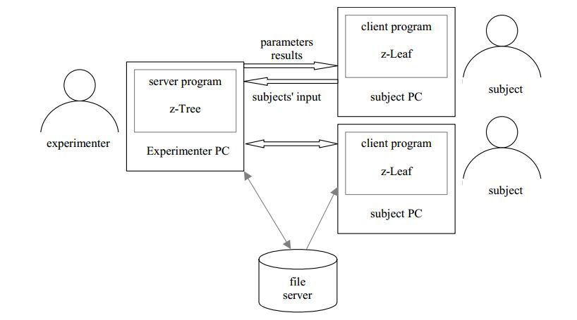

Figure 2.1 Client/Server architecture of z-Tree.

Some terms related to z-Tree:-

* Stage: In an experiment, a 1-screen display on which a subject can take one or many actions.
* Treatment: A related series of stages through which players pass; can be repeating.
* Session or Period: A series of treatments all performed on the same players in sequence.
* Item: An item is the representation of a variable.

**Step 2.1 Opening z-Tree**

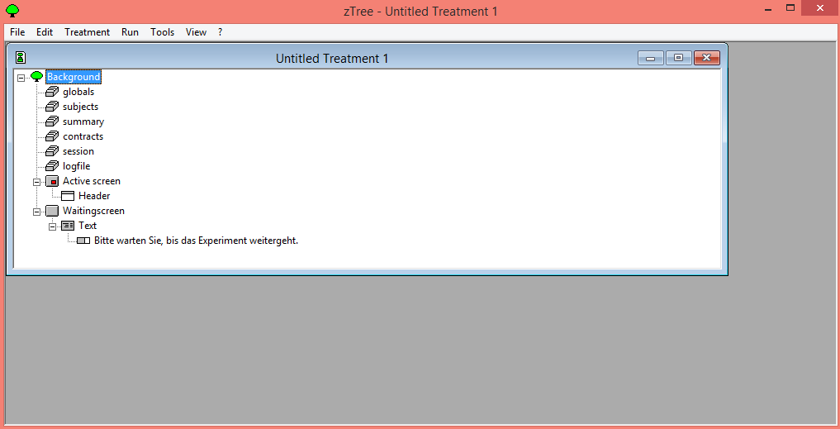

Figure 2-2.Opening z-Tree

**Step 2.2 Setting the General Background Parameters**

* Double-click on Background to show the General Parameters dialog
* Set Number of Players to the right size (in this case, 4)
* Set Number of Groups to the right size (in this case, 1)
* Set Practice Periods to 0
* Set Paying Periods to 50

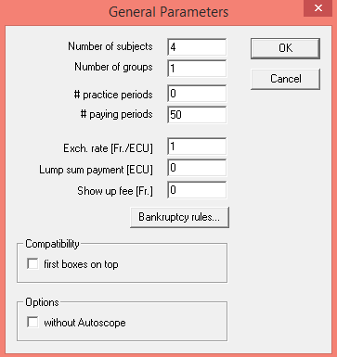

Figure 2-3.Setting the General Background Parameters

**Step 2.3 Set Non-General Background Parameters for the Experiment**

Create a Program to Store the Global and Subject Variables

* + Players – holds variables that may be different between players and between periods.
  + Globals – holds variables that will be the same for all players but may differ between periods.
* Place cursor on **Logfile**
* Select **New Program** from the **Treatment**

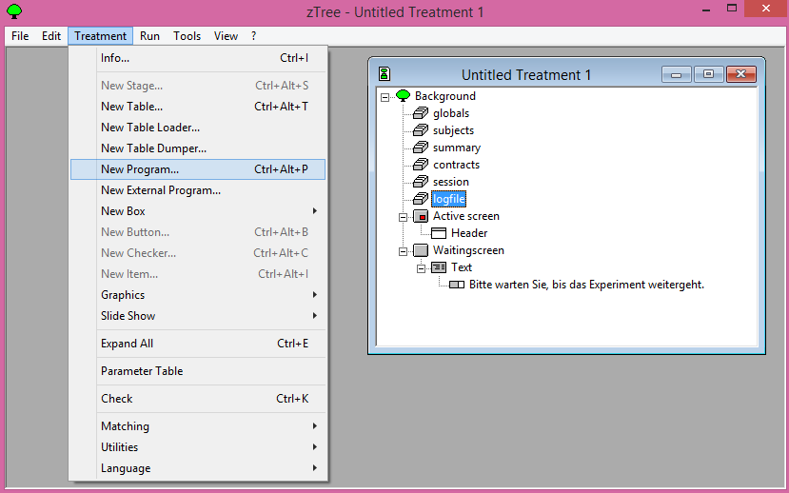

Figure 2-4. Create a Program to Store the Variables

**Creating a New Program for Global variable**

* Under **Table** select **Globals**
* Create a variable names for the Endowment
* Syntax:

variablename = {number};

* Press **OK**

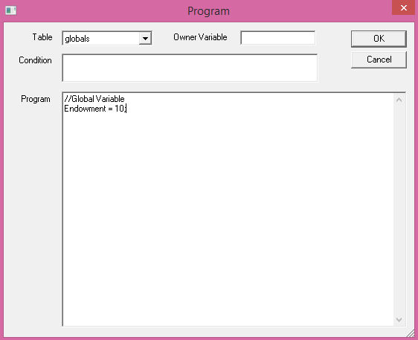

Figure 2-5. Creating a New Program for Global Variable

**Creating a New Program for Subject Variable**

* Under **Table** select **Players**
* Create two variable names for k and a
* Syntax:

variablename = {number};

* Press **OK**

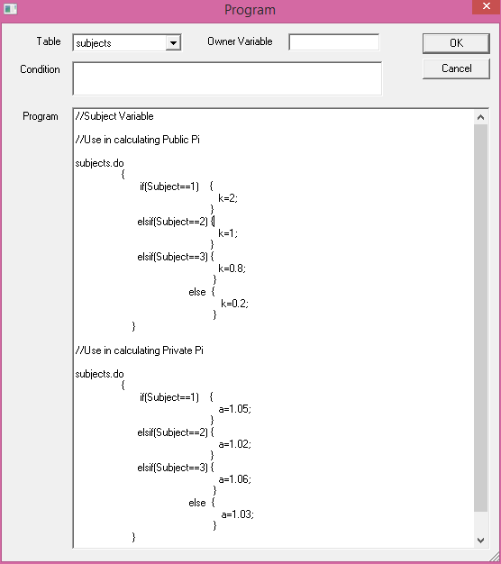

Figure 2-6. Creating a New Program for Subject Variable

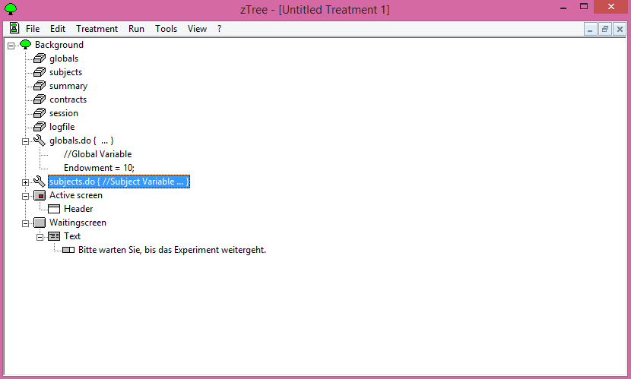

Figure 2-7. Creating a New Program

**Step 2.4 Ask Players for Contributions**

* Place cursor on Background
* Select New Stage from the Treatment menu

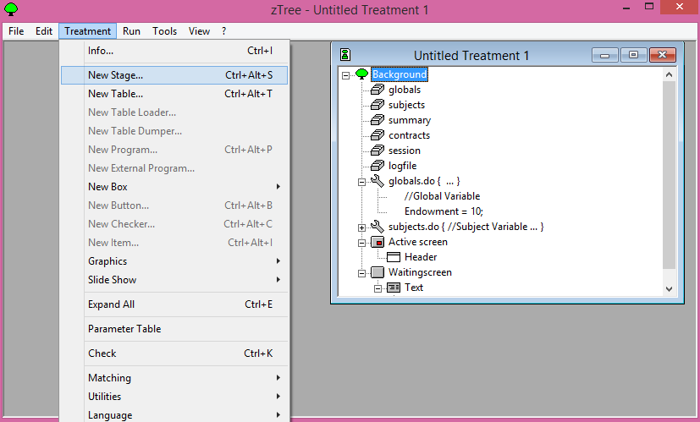

Figure 2-8. Creating a New Stage

**Creating a New Stage**

* Give the stage a name, like “Contribution”
* Under the Start menu, select Wait for all (so that all players enter stage together)
* Leave At most one… unchecked (used to make choices sequential)
* Under Leave stage after timeout, select No (makes time limit non-binding)
* Under Timeout, select 10 (seconds)

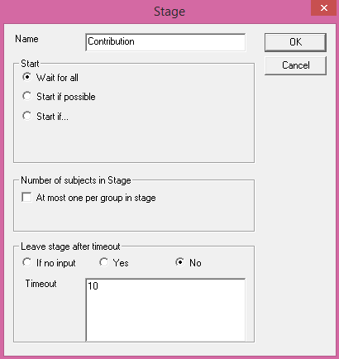

Figure 2-9. Creating a New Stage

**Creating a Screen for Players to Enter Contribution**

* Place cursor on Active Screen
* Select New Box→Standard Box from the Treatment menu

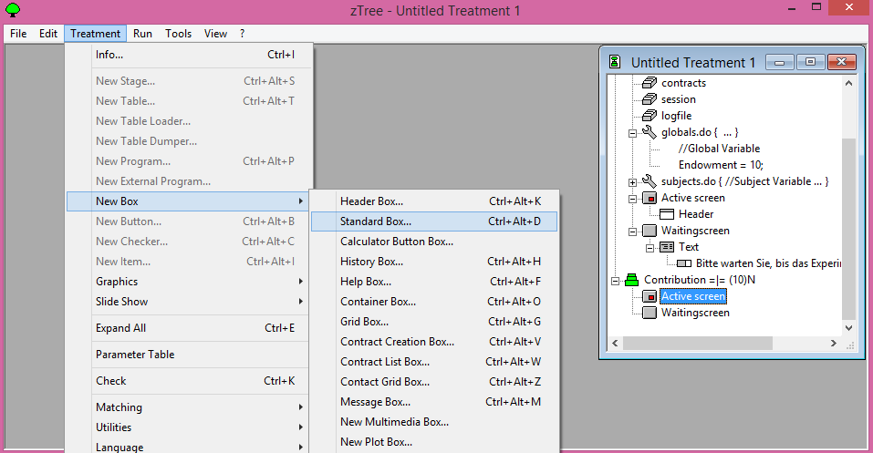

Figure 2-10. Creating a Screen for Players to Enter Contribution

**Creating a New Box**

* Box: A container in which text displays and entry buttons are placed on the Active Screen

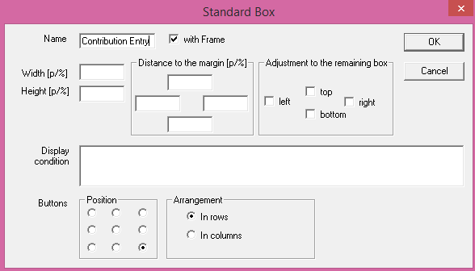

Figure 2.11 Creating a New Box

**Putting an Item into the Box**

* Place cursor on Contribution Entry
* Select New Item from the Treatment menu

**Item**: An item is the representation of a variable.

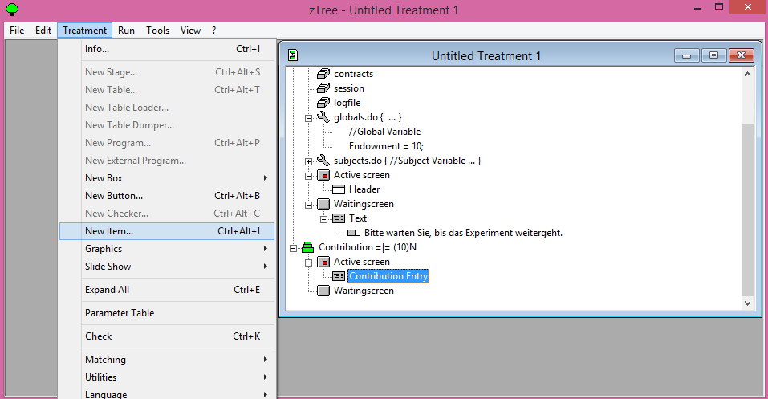

Figure 2-12. Putting an Item into the Box

**A New Item: Showing the Endowment**

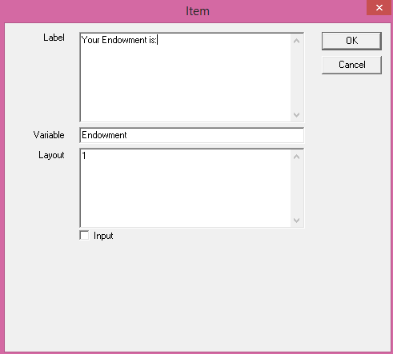

Figure 2-13. Showing the Endowment

**The Final Item: An Input Box for Contribution**

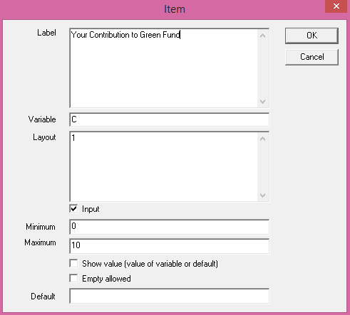

Figure 2-14. An Input Box for Contribution

**A Button to End the Stage**

* Place cursor on the last item under Active Screen
* Select New Button from the Treatment menu
* Set the button as shown

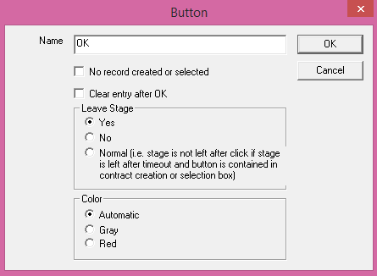

Figure 2-15. Set the button

**Contribution Stage completed**

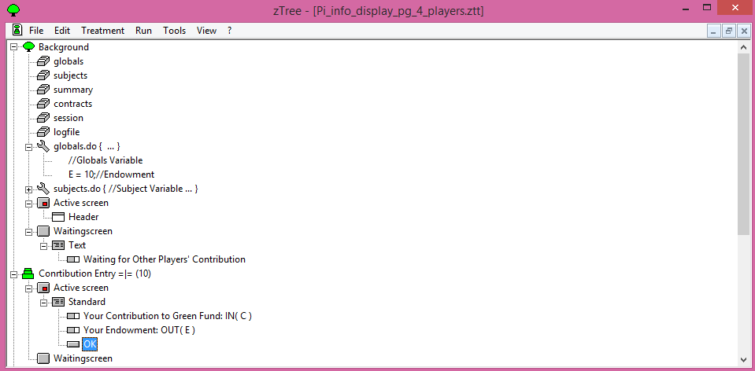

**Figure 2-16. Contribution Stage completed**

**Step 2.5 Calculate Public Good**

* Create a new stage, call it “Display Outcomes”
* Highlight the new stage, then create a new program
* Enter this code into the program:
  + Return on investment from green fund = 1/4 * ( sum ( C* k ) );
  + Return on investment from private fund = a*(E-C);
  + Contribution of other player = find (same(Group) and Subject == 1,C);

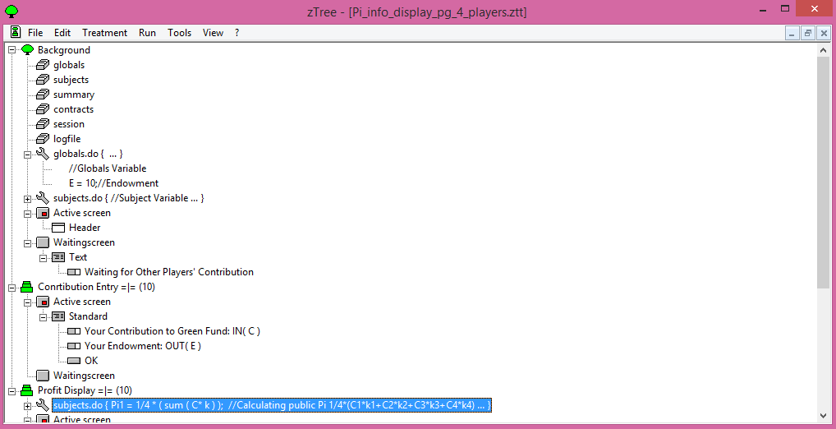

Figure 2-17. Calculating Public Goods Stage completed

**Step 2.6 Display Outcomes**

* Create a new Standard box, call it “Final Outcome”
  + Set the box to take up the entire screen

Add items to the box:

* + Display the amount of contribution invested by all subject to Green Fund.
  + Display return on investment from Green Fund
  + Display return on investment from Private Fund
  + Display sum of return on investments from green and private fund
  + Display the final earnings of the subject
  + Put a button in to leave the stage

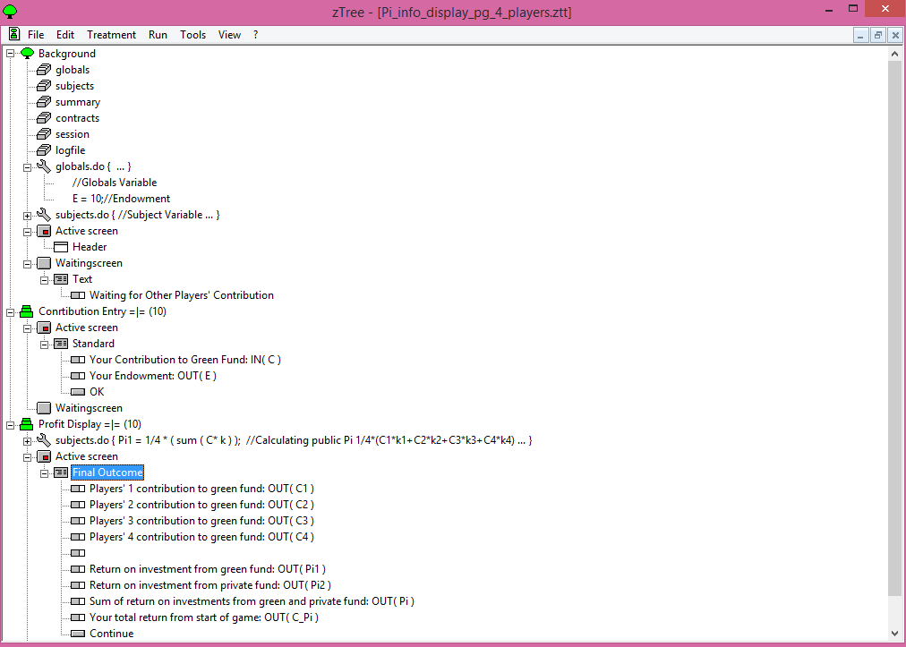

Figure 2-18. Final Structure of Public Goods Game

* Save the file using File→Save
* We are now ready to run an experiment.

**More Terminology:-**

* Program: A set of procedures used to assign variables, calculate payoffs, store information, etc.
* Active Screen: The screen on which players see information and make decisions.
* Waiting Screen: A “placeholder” screen that players see after they make decisions in a stage and are waiting for other players to finish the stage.

**Step 2.7 Easy Networking**

* All you need to do is open z-Tree on the experimenter PC first, then open z-Leaf on each client PC.
* Make sure that, in the same directory as z-Leaf, there is a notepad file called server.eec with the IP address of the server computer on it.



Figure 2-19. Networking

**Starting z-Leaf**

* Create a shortcut to the z-Leaf on each Subject client
* In the Target blank, put in:

/Name <the desired name>

* Put in a different name for each Subject client computer so that you can tell them apart

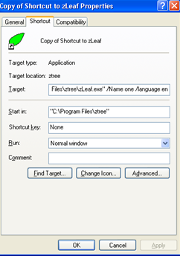

Figure 2-20. Starting z-Leaf

**Starting the Treatment**

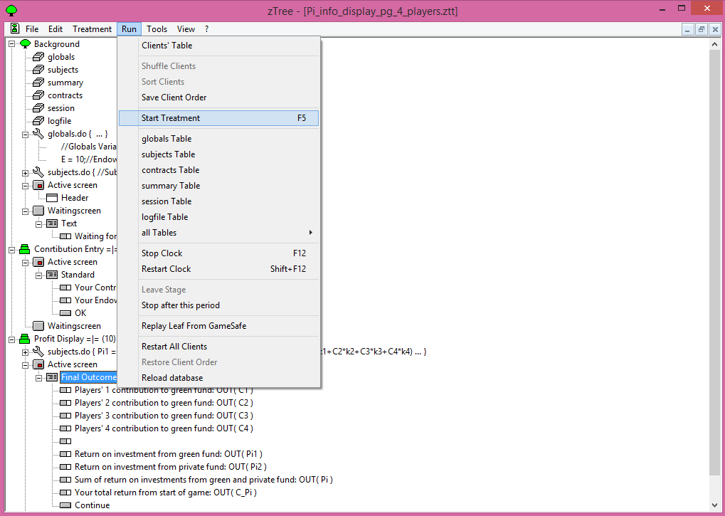

Figure 2-21. Starting the Treatment

**Chapter 3: Methodology**

In this chapter, I discuss how the Public Goods Game was used in a research study where we manipulated information asymmetry among opponents.

**3.1 HYPOTHESIS**

In the information condition (Info), players are aware of the contributions made by their opponents to the green fund after each round of play. While in the no information condition (NoInfo), players do not know about their opponents’ contributions to the green fund. Logically, hypothesis H1 states that in the Info condition, players’ contribution will be more than that in the NoInfo condition. This happens because in the Info condition, participants can see how much others contribute to the green fund and this knowledge does not causes them to stop or reduce their contribution to the green fund, overtime; however, such knowledge is not there for the participants in the NoInfo condition and thus they do decrease their contribution to green fund as they have no basis for trusting opponents. Also, this expectation is supported by the results by Gonzalez et al. (2014) and (Rege & Telle, 2004). Hypothesis H2 states that information condition causes people not to stop contributing over rounds of play and no information condition does so. Thus, when people have no prior exposure to information, they tend to decrease their contribution rapidly; rather, the contribution is very small across rounds. That is because the lack of information causes people not to care about their opponents and rather act selfishly on their own. Furthermore, when people have prior exposure to information, they tend not to decrease their contributions due to the presence of information itself (the information makes these players care about their opponents).

**3.2** **Experimental Design**

In the experiment, 24 participants were divided into 6 groups, where each group consisted of 4 participants. The climate game was played across two between-subjects scenarios: Info-NoInfo and NoInfo-Info. Out of 6 groups, 3 randomly selected groups played Info-NoInfo scenario in which the Info condition was played first and it was followed by play in the NoInfo condition. In the Info condition, contributions to the green fund were known to all players in each round; whereas, in NoInfo condition, contributions to the green fund were not known to players across all rounds. Similarly, three randomly selected groups played NoInfo-Info scenario, where the order of presentation of the Info and NoInfo conditions was reversed. As shown in Figure 3-1, in all conditions, players would receive certain yearly income and they had to decide as to how much of that income players want to invest in the green fund for averting climate change. The amount not invested in the green fund is players’ private income. This private income could be invested in a bank account and this income may accrue certain simple interest.

Player 1

10-X’’’ 10 X’’’

Player 2

10-X’’ X’’

Green Fund for averting climate change

Bank Account (Private income)

10

10-X’ X’

Player 3

10-X 10 X

**Player 4**

10

Figure 3-1. *The game uses a fictitious currency EC. Each player gets yearly income of 10 million EC. All players decide to invest a part of this income (X, X’, X’’, or X’’’ million EC) in a green fund for averting climate change. The remaining money is stored in a bank account and it accrues a simple interest. The money contributed by all players in the green fund is multiplied by certain multipliers and then summed together. This sum is then equally divided among all players. Each player payoff at the end of a round is the sum of the return on investments obtains from the bank and the green fund.*

Total payoff at the end of each round is the sum of return on investments from the green fund and that from the money invested in private fund. The goal is to maximize total payoff in the climate game by making investments in the green and private funds. Both Info and NoInfo conditions of climate game in each of the two scenarios were run for 50 rounds.

**3.3 Participants**

Twenty-four graduate and undergraduate students from diverse fields of study participated in this experiment, comprising 14 females and 10 males. Ages of the participants range from 18 to 44 years. In self-reports, 56% of participants indicated having heard of public goods game through television, websites, newspapers, magazines or some other means. Also, 90% of participants reported they either completed or are currently pursuing degrees in science, technology, engineering, and management (STEM). All participants received a base pay of Rs 10. The participants could earn an additional maximum bonus of Rs 20, based on their performance in the climate game. Players received base pay of Rs 10 for participating in the experiment and players total payoff at the end of the game was be converted into real money in the following ratio: 1,000 million EC payoff in the game = 10 INR in real money. At the end of the experiment, players’ total payoff in million EC in both scenarios was converted into INR and this money was paid to players in addition to the base payment.

**3.4** **Procedure**

Participants were given instructions before they were made to play the climate game. The instructions were given online before the study began. Each participant filled their consent form, demographics information and then went through the online instructions. As part of the instructions, participants were shown an image of what would happen in climate game (Figure 1) and how they may contribute to the two funds from the endowments they received in each round. Once participants acknowledged that they understood the game and the task requirements, they were allowed to interact with the climate game on computer terminals.

**3.5 Results**

**3.5.1 Payoff differences between Information and No-Information Conditions (H1)**

First, I tested hypothesis H1. I compared average contributions to the green fund in the Info condition played first with the No-Info condition played first. In both conditions, contribution to the green fund reduced rapidly. Although the contributions to the green fund were higher in the Info condition compared to the NoInfo condition. Furthermore at first half (1-25 rounds), the average contribution in Info condition was higher than that in the NoInfo condition (Info = 6.88 > NoInfo = 4.59), this large difference in average contribution to green fund become small with increasing number of rounds at second half (26-50 rounds). The average contribution in Info condition was higher than that in the NoInfo condition between rounds 25 and 50 (Info = 3.65 > NoInfo = 3.30). These results support hypothesis H1.

**Figure 3-2. *Average contributions to the green fund in information condition and no-information conditions both played first across 50 rounds.***

**3.5.2 Learning Effects of Information and No-Information Conditions (H2)**

Next, we tested hypothesis H2. For this purpose, I compared average contributions to the green fund in the NoInfo condition played before and after the Info condition (i.e., effect of information; see Figure 3-3). Also, I compared the average contribution to the green fund in Info condition played before and after the NoInfo condition (i.e., effect of no-information; see Figure 3-4).

Figure 3-3. *Average contributions to the green fund in no-information condition played before and after information conditions across 50 rounds.*

Figure 3-4. *Average contributions to the green fund in information condition played before and after the no-information condition across 50 rounds.*

As shown in Figure 3-3, playing Info condition first had little impact on participants’ performances in the subsequent NoInfo condition: In both the No-Info conditions, there is a similar decrease in contributions to the public fund across rounds (NoInfo played before = 3.95 > Noinfo played after = 3.07). Thus, when people have prior exposure to the Info condition, they tend to decrease their contribution to the green fund in the subsequent NoInfo condition in a similar manner to those who did not play the Info condition before the NoInfo condition. However, the effect reverses if participants play the NoInfo condition first. As shown in Figure 4, the contribution to the green fund was different in the subsequent Info condition when participants played NoInfo condition first. Thus, when people play the NoInfo condition first, they tend to decrease their contribution to the green fund in the subsequent information condition much more compared to those who were not exposed to the NoInfo condition and played the Info condition first. This effect is attributed to the absence of information about opponent contributions in the NoInfo condition.

**Chapter 4: Discussion, Conclusions and Future Directions**

This study used an experiment with human players to test investment decisions towards averting climate change in the presence and absence of information about opponent contributions. At first I tested average contribution to the green fund across 50 rounds in both versions of game i.e. information and no information when these versions were played first. In both versions, contribution to the green fund reduced rapidly. However, the contributions to the green fund were higher in the information condition compared to the no information condition.

Then, I tested average contributions to the green fund in no information condition, which was played before and after the information conditions across 50 rounds (i.e., the effect of information). It was observed that playing Info condition first had little impact on participants’ performances in the subsequent NoInfo condition: In both the No-Info conditions, there is a similar decrease in contributions to the public fund across rounds. Thus, when people have prior exposure to the Info condition, they tend to decrease their contribution to the green fund in the subsequent NoInfo condition in a similar manner to those who did not play the Info condition before the NoInfo condition. This result is likely because people simply disregard the training gained by them in the Info condition. However, the effect reverses if participants play the NoInfo condition first. Finally, I tested the average contributions to the green fund in information condition played before and after the no-information condition across 50 rounds (i.e., the effect of information). Thus, when people have no prior exposure to opponent information, they tend to decrease their contribution rapidly; rather, the contribution is very small across rounds.

In the information condition, participants can see how much others are contributing to the green fund and this knowledge does not cause them to stop or reduce their contribution to the green fund, overtime; however, such knowledge is not there for the participants in the no information condition and thus they do decrease their contribution to the green fund as they have no basis for trusting opponents. As a result, the no-information condition produces lower payoffs to the green fund compared to the information condition. This result is as per Nash equilibrium and supports our expectation in H1.

Furthermore, according to our hypothesis H2 I find that people show learning effects. In general, information condition causes people not to stop contributing over rounds of play and no information condition does so. Thus, when people have no prior exposure to information, they tend to decrease their contribution rapidly; rather, the contribution is very small across rounds. That is because the lack of information causes people not to care about their opponents and rather act selfishly on their own. Furthermore, when people have prior exposure to information, they tend not to decrease their contributions due to the presence of information itself (the information makes these players care about their opponents).

This research in different experiments, tries to best represent the “real world” by using well known climate model with two versions (Information and No-Information). Thus, for the purpose of this thesis, the main focus has been on how absence of information or presence of information changes the contribution to green fund. There is little doubt that climate change will become a serious problem for society if we decide to postpone mitigation actions to a time in the future (IPCC, 2007b; Sterman, 2008). Therefore, in order to make people act on climate change in the status quo, we must propose education policies that encourage people to contribute to the climate problem. Our results show that during negotiations, if negotiating parties have information on contributions of others, then this information is likely to help increase cooperation against climate change.

This study is the start of a large research program that investigates how public contributions for averting climate change is influenced by a number of ecologically valid factors. In the immediate future, I would like to extend this game by including stochastic losses due to climate change as part of a player’s payoff. Furthermore, I would like to extend the current climate game with a provision for punishments and rewards.

**References**

1. Abbink, K. and Hennig-Schmidt, H. (2006). Neutral versus loaded instructions in a bribery experiment. *Experimental Economics* 9. 103-121.
2. Allen, B. (2011). Freedom and the Public Goods. *Research Blogging*. Retrieved on 4th February, 2015 from the website: <http://plektix.fieldofscience.com/2011/04/freedom-and-public-goods.html>
3. Axelrod, R. (1997). The Complexity of Cooperation: Agent-Based Models of Competition and Collaboration. *Princeton University Press.*
4. Brick, K., Hoven, Z. and Visser, M. (2013). Can Communication Facilitate the Provision of Public Goods in Heterogeneous Settings?. *Environment for Development*. 12-14.
5. Burnham, T., McCabe, K. and Smith, V. (2000). Friend-or-foe intentionality priming in an extensive form trust game. *Journal of Economic Behavior and Organization* 43. 57-73.
6. Cason. (2003). Buyer Liability and Voluntary Inspections in International Greenhouse Gas Emissions Trading: A Laboratory Study. *Environmental and Resource Economics* 23(2). 187–211.
7. Chan, K. S., Mestelman, S., Moir, R. and Muller, R. A. (1996) The voluntary provision of public goods under varying income distributions. *The Canadian Journal of Economics* 29(1). 54-69.
8. Cherry, T., Kroll, S., and Shogren, J. (2005). The impact of endowment heterogeneity and origin on public good contributions: evidence from the lab. *Journal of Economic Behaviour and Organization* 57. 357-365.
9. Dufwenberg M., Gächter S. and Hennig-Schmidt H. (2011). The framing of games and the psychology of play. *Games and Economic Behavior* 73 (2). 459–478.
10. Dutt, V. (2013). A climate to fight global warming builds up. Retrieved on 4th February, 2015 from the website: <http://www.mydigitalfc.com/opportunities/climate-fight-global-warming-builds-688>
11. Dutt, V. (2014). Various nuances of climate change in 2015. Retrieved on 4th February, 2015 from the website: <http://www.mydigitalfc.com/opinion/various-nuances-climate-change-2015-622>
12. IPCC. (2007). Climate Change 2007: Synthesis Report. In Pachauri, R.K. and Reisinger, A. (Eds.), Contribution of Working Groups I, II and III to the Fourth Assessment Report of the Intergovernmental Panel on Climate Change (pp. 104). Geneva, Switzerland: *IPCC*.
13. Fehr, E. and Schmidt, K. M. (1999). A Theory of Fairness, Competition, and Cooperation. *Quarterly Journal of Economics* 114. 817–868.
14. Few, R., Brown, K. and Tompkins, E. (2007). Public participation and climate change adaptation: avoiding the illusion of inclusion. *Tyndall Centre for Climate Change Research, Working Paper 95 Climate Policy* 7. 46-59.
15. Fischbacher, Urs. (2007). z-Tree: Zurich Toolbox for Ready-made Economic Experiments. *Experimental Economics* 10(2). 171-178.
16. Gonzalez, C., Ben-Asher, N., Martin, JM. and Dutt, V. (2014). A Cognitive Modal of Dynamic Cooperation with varied Interdependency Information. Retrieved on 4th February, 2015 from the website: <http://www.ncbi.nlm.nih.gov/pubmed/25250832>
17. Graves P. E. (2010). A Note on the Design of Experiments Involving Public Goods. CESIFO WORKING PAPER NO. 3187.
18. Hasson, R., Löfgren, A. and Visser, M. (2009). Climate Change in a Public Goods Game: Investment Decision in Mitigation versus Adaptation. *Environment for Development*.
19. Ledyard, J. O., (1995). Public goods: a survey of experimental research. *The Handbook of Experimental Economics* 2. 111-194.
20. Levitt and John, A. (2007). What Do Laboratory Experiments Measuring Social Preferences Reveal about the Real World? *The Journal of Economic Perspectives.* 21 (7). 153–174.
21. Liberman, V., Samuels, S. and Ross, L. (2004). The name of the game: predictive power of reputations versus situational labels in determining prisoner’s dilemma game moves. *Personality and Social Psychology Bulletin* 30. 1175–1185.
22. Loewenstein G., (1999) Experimental economics from the vantage-point of behavioural economics. *The Economic Journal* 109. 25-34.
23. Man Chon, U. and Zhen, Li. (2010). Public Goods Game Simulator with Self Adaptive Agent Strategy Module. [*Machine Learning and Applications (ICMLA), 2010 Ninth International Conference*](http://ieeexplore.ieee.org/xpl/mostRecentIssue.jsp?punumber=5707360). 43 – 49.
24. McGinty M. and Milam G. (2012). Public Goods Contribution by Asymmetric Agents: Experimental Evidence. *Social Choice and Welfare*.
25. Milinski M., Semmann D., Krambeck H. and Marotzke, J. (2006). Stabilizing the Earth’s climate is not a losing game: supporting evidence from public goods experiments. *PNAS* 103(11). 3994-3998.
26. Ostrom, E., Walker, J. and Gardner, R. (1992) Covenants with and without a sword: selfgovernance is possible. *American Political Science Review* 86(2). 404-417.
27. Rajamani. (2010). The making and unmaking of the Copenhagen Accord. *International and Comparative Law Quarterly* 59. 824-843.
28. Rand David, G., Dreber, A., Ellingsen, T., Fudenberg, D. and Nowak Martin, A. (2009). Positive Interactions Promote Public Cooperation. *Science* 325. 1272–1275.
29. Rapoport A. and Albert M. C. (1965). Prisoner’s Dilemma. *University of Michigan Press.*
30. Rege, M. and Telle, K. (2004). The impact of social approval and framing on cooperation in public good situations. *Journal of Public Economics* 88 (7-8). 1625–1644.
31. Tavoni et al. (2011). Supporting Information. *PNAS* 110. 1-10.
32. UNFCCC. (1992). United Nations Framework Convention on Climate Change. <http://unfccc.int>
33. United Nation. (2014). Framework Convention on Climate Change. Retrieved on 4th February, 2015 from the website: <http://unfccc.int/meetings/items/6240.php>
34. Willinger, M. and Ziegelmeyer, A. (1999). Framing and cooperation in public good games: an experiment with an interior solution. *Economics Letters* 65(3). 323-328.
35. Winkler H. and Beaumont J. (2010) Fair and effective multilateralism in the post-Copenhagen climate negotiations. *Climate Policy* 10. 638-654.
36. World Bank. (2015). Country and Leading Groups. Retrieved on 4th February, 2015 from the website: <http://data.worldbank.org/about/country-and-lending-groups>