**A**

**PROJECT REPORT ON**

***“Railway Reservation System”***

**Submitted to**



**Sadguru Gadage Maharaj College Karad.**

**In Partial Fulfillment of the**

**BACHELOR OF COMPUTER APPLICATION (B.C.A)**

**Submitted by**

**Mr. Patil Shubham S.**

**UNDER THE GUIDANCE OF**

**Mr. Barge S.B.**

**RAYAT SHIKSHAN SANSTHA’S**

**Sadguru Gadage Maharaj College, KARAD**

**2016-2017**

**RAYAT SHIKSHAN SANSTHA’S**

**SADAGURU GADGE MAHARAJ COLLEGE, KARAD**



**CERTIFICATE**

This is to certify that **Mr. Patil Shubham S.** has completed the necessary Project on

***“Railway Reservation System”***,

in a satisfactory manner as partial fulfillment of requirement of Graduation degree of **Bachelor of Computer Application (BCA)** of Shivaji University Kolhapur in academic year 2016-17.

**Place: Karad**

**Date: / / 2016**

**Project Guide Examiner Head Of Dept.**

**(Mr. Barge S.B.) (Computer Science)**

**ACKNOWLEDGEMENT**

We take it is an opportunity to thank all those who has directly inspired, directed and helped me towards successful completion of this project report. We are grateful to the team of **“*Railway Reservation System*”** for their highly encouraging and cooperative attitude.

We express our sincere thanks to **H.O.D. Mr.Nalawade B.J. of B.C.A**. Department for their encouragement through out the project. We are thankful to our guide, **Mr. Barge S. B.** for his guidance and help in giving the project the best shape. We express our sense towards our friends and parents for the constant moral support during our project report.

**Place: Karad**

**Date: / / 2016**

**Mr. Patil Shubham S.**

**DECLARATION**

To,

The Principal,

S.G.M.College, Karad.

Respected Sir,

We undersigned hereby declared that submitted project is fully designed and developed by me as per Shivaji University Kolhapur. The project report entitled **“*Railway Reservation System*”** written and submitted under the guidance of **Mr. Barge S.B.** is our original work.

The empirical findings in the report are based on the data collectedby us preparing project report. We have not copied from any report, We understand that any coping is liable to punish in a way the University authorities deem fit.

**Place:- Karad**

**Date:- / / 2016**

**Mr. Patil Shubham S.**

**INDEX**

|  |  |  |
| --- | --- | --- |
| **Sr. No.** | **Contents** | **Page No.** |
|  | **Introduction** |  |
|  | **Objectives** |  |
|  | **Proposed System** |  |
|  | **Need For Computerization** |  |
|  | **Feasibility Study** |  |
|  | **Dataflow Diagram** |  |
|  | **Database Design** |  |
|  | **Entity Relationship Diagram** |  |
|  | **System Design** |  |
|  | **Coding** |  |
|  | **Reports** |  |
|  | **Software Specifications** |  |
|  | **Limitations** |  |
|  | **Conclusion** |  |
|  | **Bibliography** |  |

**INTRODUCTION**

**It is the complete “*Railway Reservation System*”. This system is**

**basically concerned with the reservation and cancellation of railway tickets**

**to the passengers. The need of this system arose because as is the known fact**

**that India has the largest railway network in the whole of the world and to**

**handle it manually is quite a tough job. By computerizing it, we will be able**

**to overcome many of its limitations and will be able to make it more**

**efficient. The handling of data and records for such a vast system is a very**

**complex task if done manually but it can be made much easier**

**if the system is computerized.**

**OBJECTIVES**

* **Give full control to Data.**
* **Platform independent.**
* **Better service to the Users**
* **Flexibility of the system is improved**
* **Cost of developing and maintaining systems is lower**
* **Standards can be enforced**

**PROPOSED SYSTEM**

* **It reserves and cancels seats for the passenger.**
* **It contains information about the trains.**
* **It contains information about the passenger.**
* **It contains the details of reservation fees.**
* **It makes entries for reservation, waiting, cancelled tickets.**

**NEED FOR COMPUTERIZATION**

* **To provide information to trains and increase passengers.**
* **To deposit our responsibility towards the nation.**
* **To increase profit of Indian Railways.**
* **To provide Railway Reservation information in one Application.**

**FEASIBILITY STUDY**

Feasibility study is a process of evaluating the deciding factors to check whether proposed system is feasible or not. Feasibility is the measure of a how beneficial or practical the development of an information system will be to an organization. The feasibility study is carried out in the following aspects.

**1. Technical Feasibility**

**2. Operational Feasibility.**

**3. Economical Feasibility.**

1. **Technical Feasibility:** –

The technical feasibility study carried out for the system determined whether the planned system could be developed & designed in the organization using the existing technology, the technical evaluation also determine whether the existing system can be upgraded to use the new technology & whether the organization has the expertise to use it.

1. **Operational Feasibility:–**

Operational feasibility ends at checking if the system will help the user to work in more efficient & accurate manner through all routine operations. The system is made to be comprehensive in nature using a full menu driven system & appropriate user information messages. On the contrary the workload on the user will be lessened to a great extent, as the system is aimed at taking care of the complex procedures & automatic calculations. Thus the system is operationally feasible.

**3) Economical Feasibility: -**

While considering economical feasibility it is checked in points like performance, information & output for the system. Economic of the system looks at the financial aspect of the projects. It determines whether the system is economical feasible in other words, it determines whether the investment that goes into the implementation of the system is recoverable.

**Level 1 DFD :**

Reservation storage file

Passenger

Booking Cost

Time Table

**Level 2 DFD :**

##### Reservation

Passenger

Report

Reservation table

Report

Report

Report

**ER Diagram :**

Fills

Sub-mit

Allotted

Form

Train

Passenger

Reservation

Cancellation

RRS

Database

**Database Design :-**

**Booking Cost Table :-**

|  |  |
| --- | --- |
| **Column Name** | **Datatype** |
| **Bid** | **Number** |
| **From** | **Varchar** |
| **To** | **Varchar** |
| **Departure_time** | **Datetime** |
| **Cost** | **Number** |

**Reservation Table :-**

|  |  |
| --- | --- |
| **Column Name** | **Datatype** |
| **Passenger_id** | **Number** |
| **Name** | **Nchar** |
| **Mobile_No** | **Number** |
| **Date** | **Datetime** |
| **From** | **Nvarchar_2** |
| **To** | **Nvarchar_2** |
| **Cost** | **Number** |

**Time Table :-**

|  |  |
| --- | --- |
| **Column Name** | **Datatype** |
| **TrainNo** | **Number** |
| **TFrom** | **Nvarchar_2** |
| **TTo** | **Nvarchar_2** |
| **DTime** | **Datetime** |

**Train Type Table :-**

|  |  |
| --- | --- |
| **Column Name** | **Datatype** |
| **Train_No** | **Number** |
| **TFrom** | **Nvarchar_2** |
| **TTo** | **Nvarchar_2** |
| **Type** | **Nvarchar_2** |

**Main Form :**

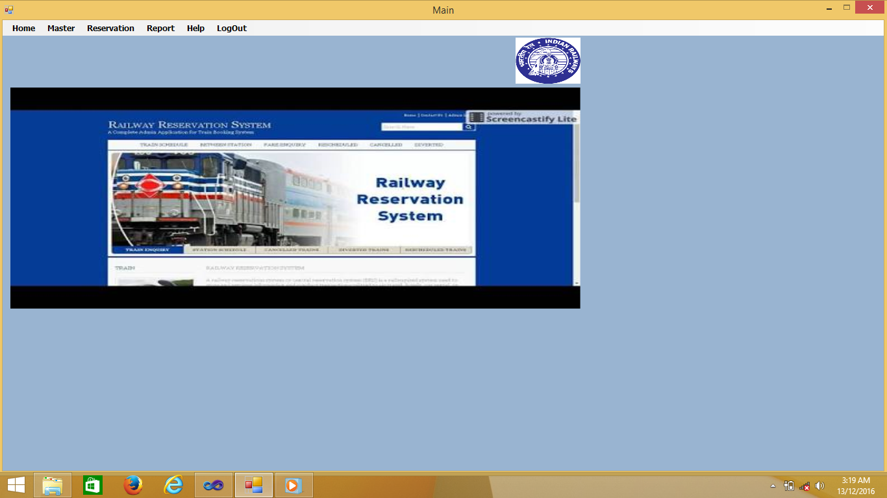

**Time Table Form:-**

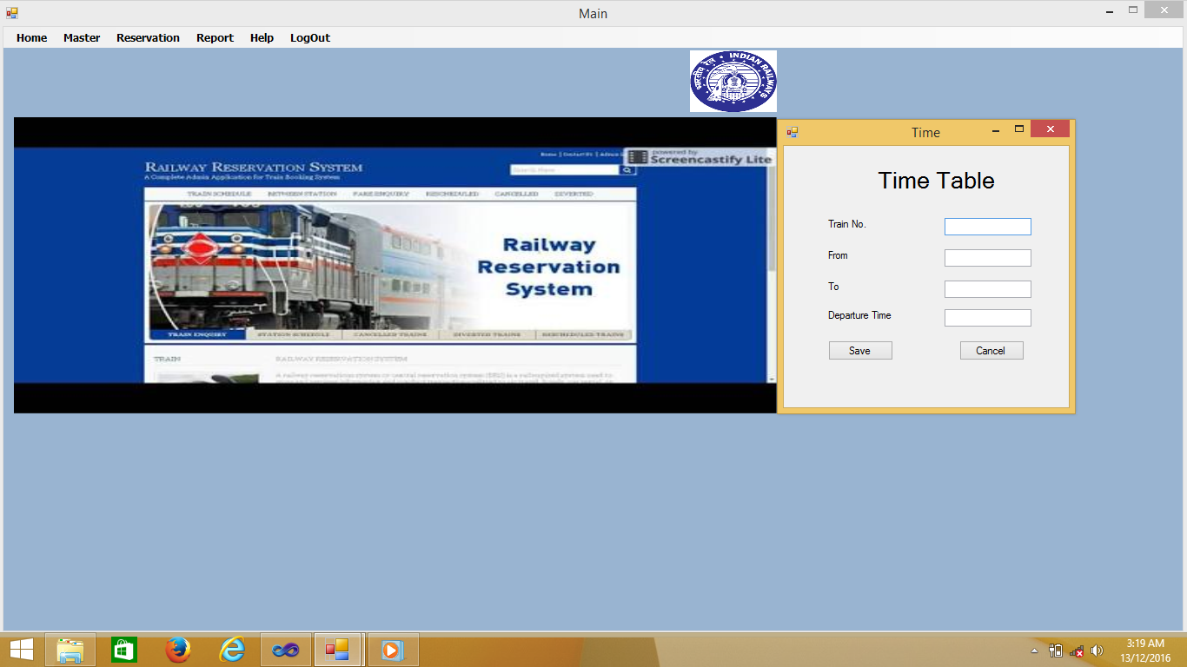

**Type Master Form:**

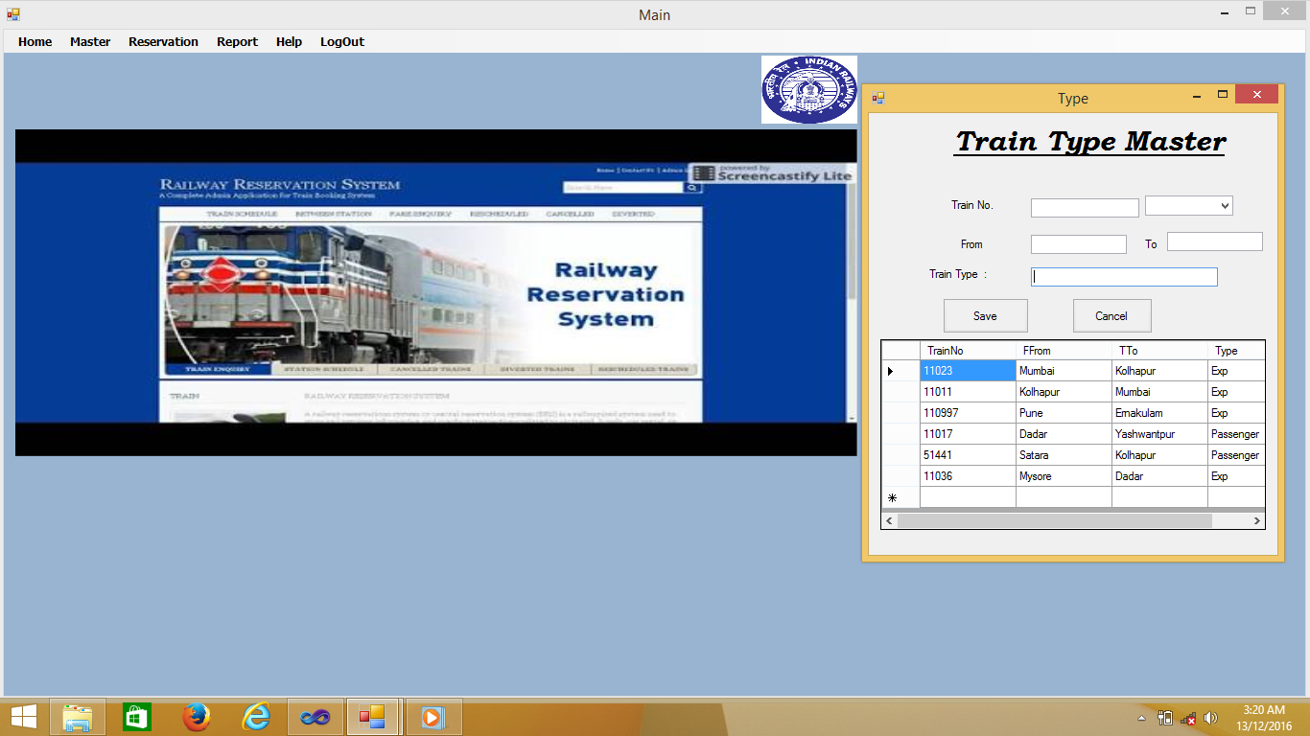

**Reservation Form :**

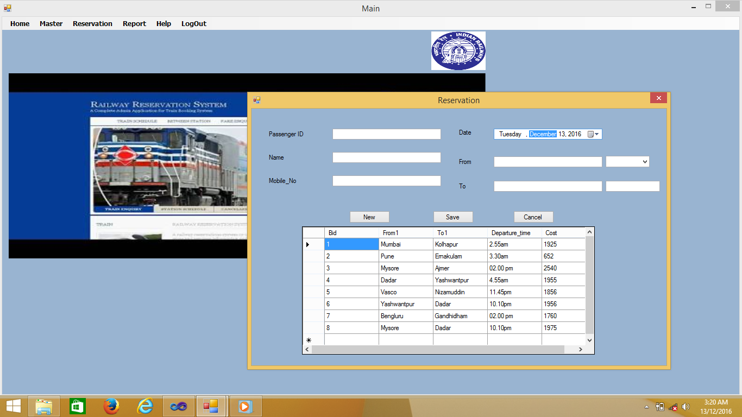

**Cancellation Form :-**

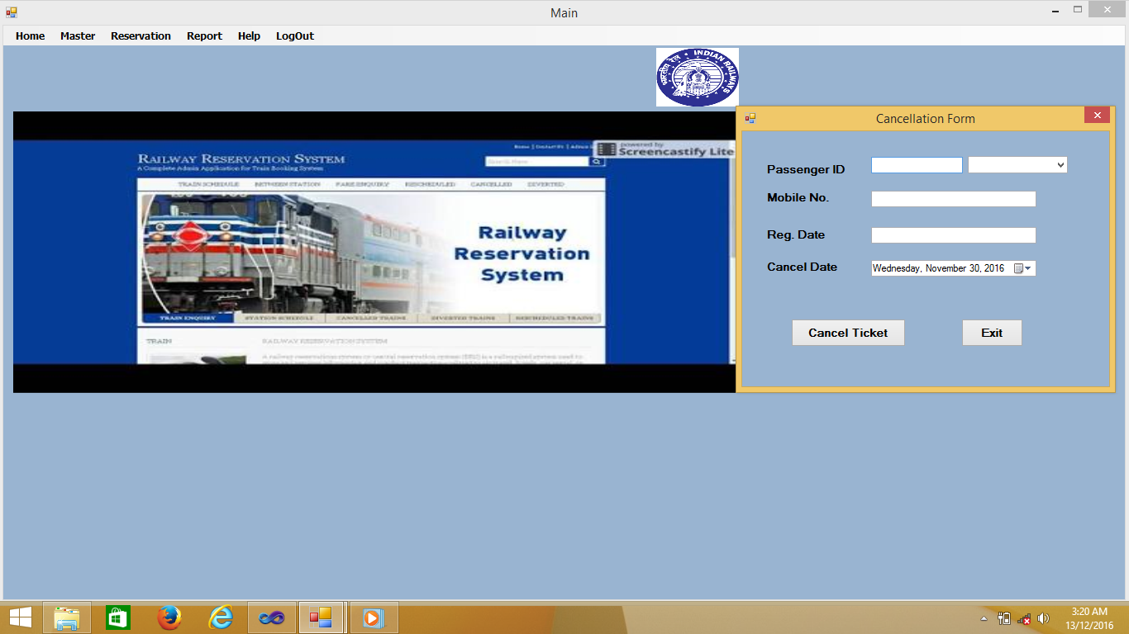

**Booking Cost Form :-**

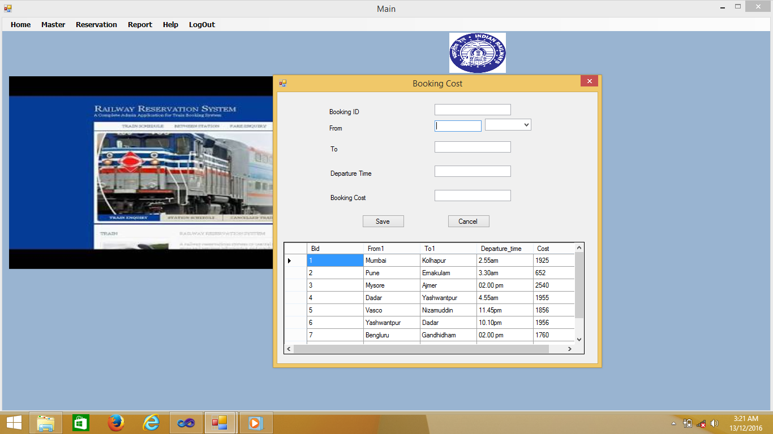

**Reservation Ratio :**

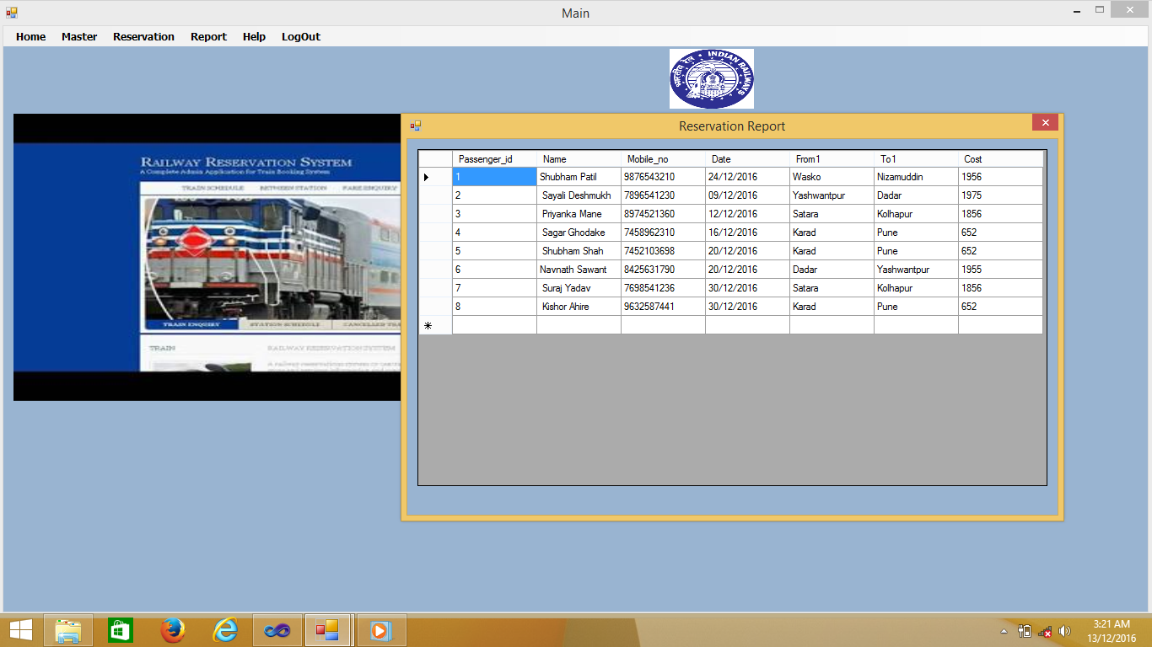

**About us Form :-**

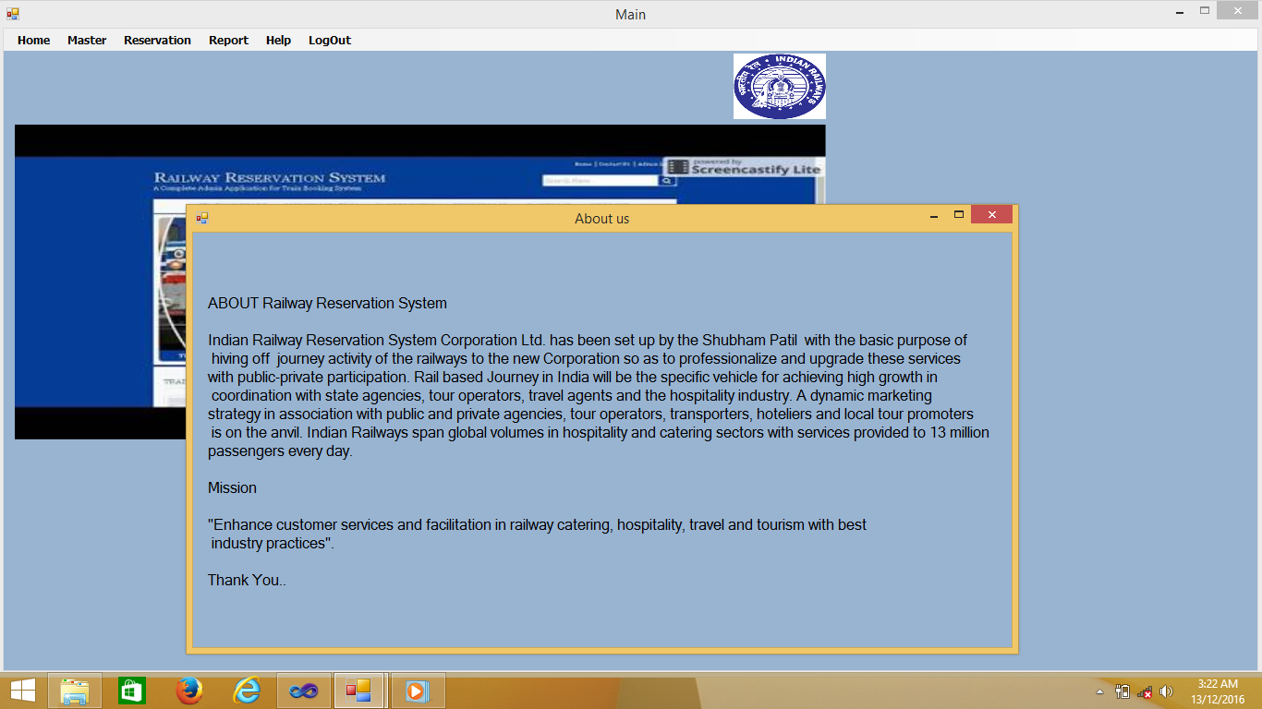

**Reservation Report :-**

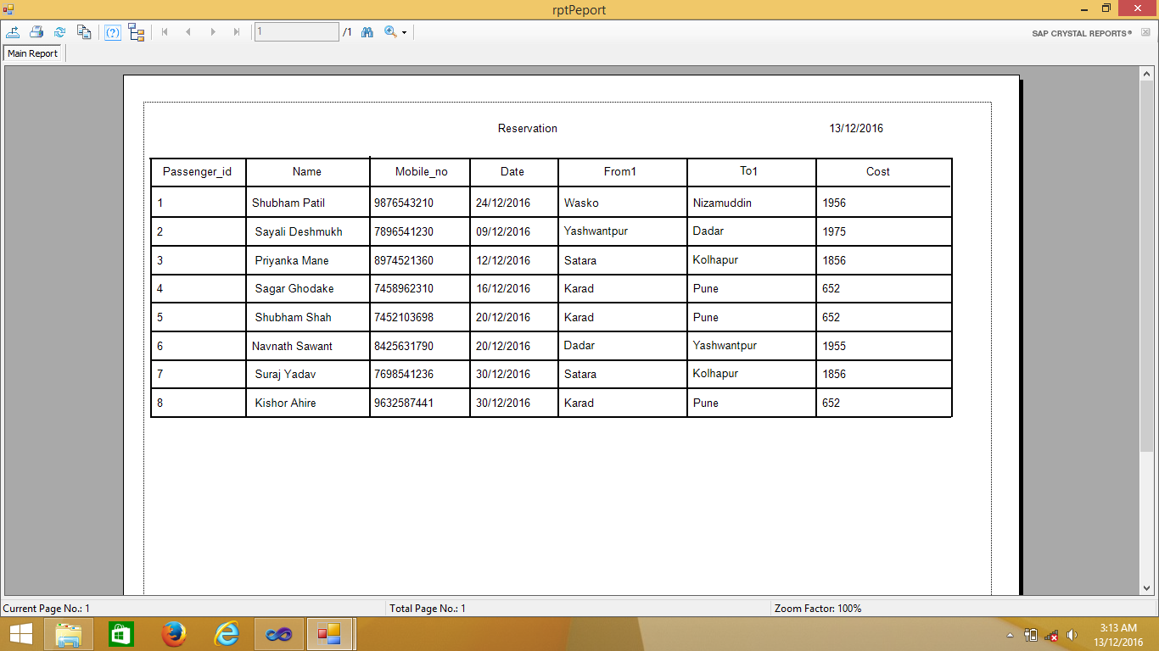

**Booking Report :-**

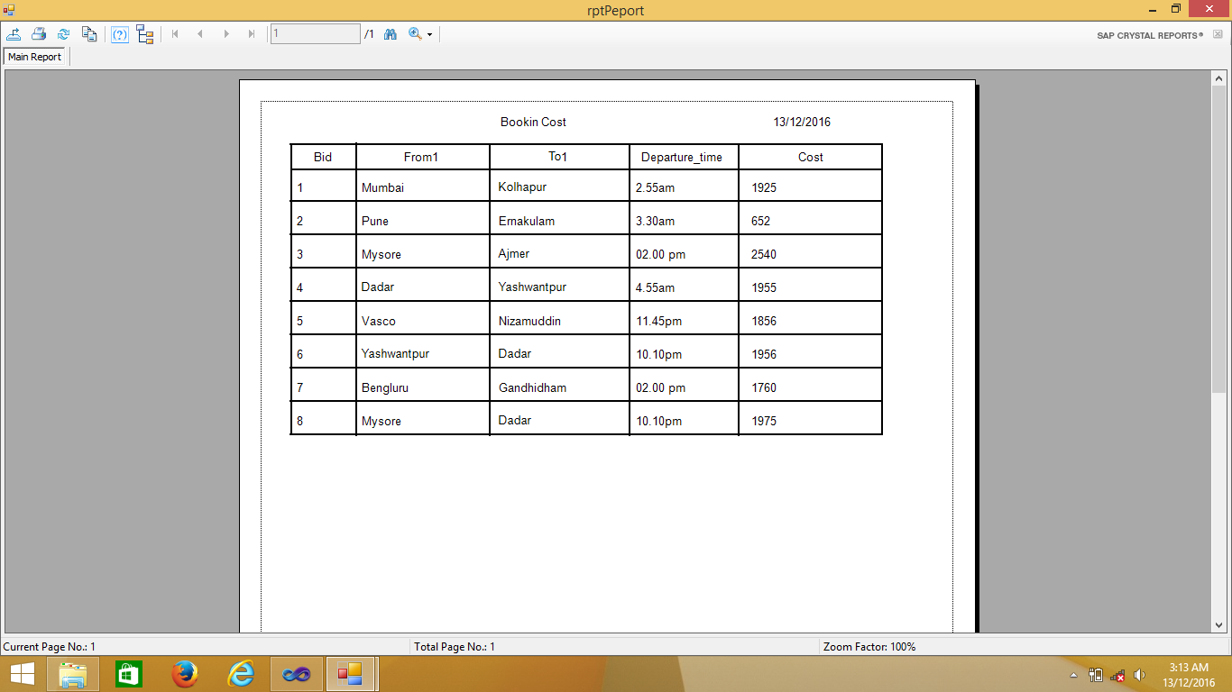

**Time Table Report :-**

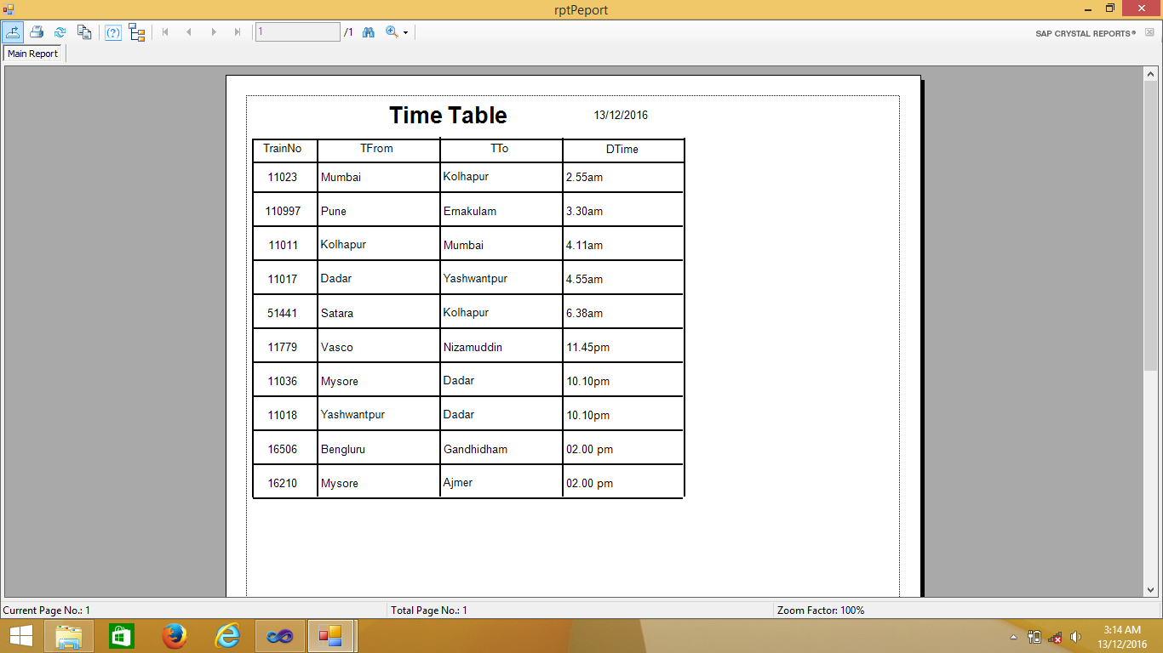

**Train Type Report :-**

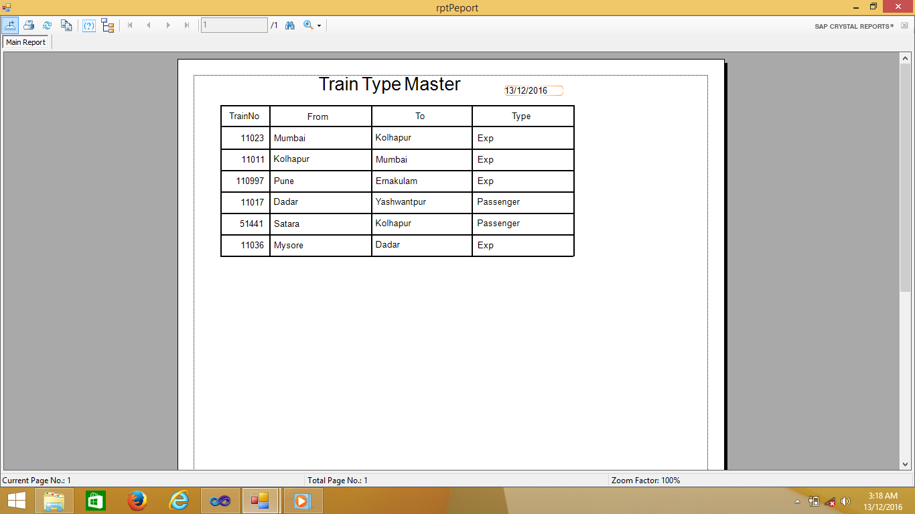

**Main Form :-**

using System;

using System.Collections.Generic;

using System.ComponentModel;

using System.Data;

using System.Drawing;

using System.Linq;

using System.Text;

using System.Windows.Forms;

namespace WindowsFormsApplication10

{

publicpartialclassmainform : Form

{

public mainform()

{

InitializeComponent();

}

privatevoid reservationToolStripMenuItem_Click(object sender, EventArgs e)

{

reservationform frm = newreservationform();

frm.Show();

}

privatevoid cancellationToolStripMenuItem_Click(object sender, EventArgs e)

{

cancellationform frm = newcancellationform();

frm.Show();

}

privatevoid bookingCostToolStripMenuItem_Click(object sender, EventArgs e)

{

Bookingcostform frm = newBookingcostform();

frm.Show();

}

privatevoid aboutUsToolStripMenuItem_Click(object sender, EventArgs e)

{

Aboutusform frm = newAboutusform();

frm.Show();

}

privatevoid logOutToolStripMenuItem_Click(object sender, EventArgs e)

{

this.Close();

}

privatevoid reportToolStripMenuItem_Click(object sender, EventArgs e)

{

}

privatevoid reservationReportToolStripMenuItem_Click(object sender, EventArgs e)

{

rptReport r = newrptReport();

r.Customer();

r.Show();

}

privatevoid bookingToolStripMenuItem_Click(object sender, EventArgs e)

{

rptReport r = newrptReport();

r.Booking();

r.Show();

}

privatevoid reservatioToolStripMenuItem_Click(object sender, EventArgs e)

{

reservationreportform frm = newreservationreportform();

frm.Show();

}

privatevoid timeToolStripMenuItem_Click(object sender, EventArgs e)

{

Time frm = newTime();

frm.Show();

}

privatevoid timeTableToolStripMenuItem_Click(object sender, EventArgs e)

{

rptReport frm = newrptReport();

frm.Time();

frm.Show();

}

privatevoid typeMasterToolStripMenuItem_Click(object sender, EventArgs e)

{

Type frm = newType();

frm.Show();

}

privatevoid typeToolStripMenuItem_Click(object sender, EventArgs e)

{

rptReport frm = newrptReport();

frm.Type_rpt();

frm.Show();

}

}

}

**Reservation Form :-**

using System;

using System.Collections.Generic;

using System.ComponentModel;

using System.Data;

using System.Drawing;

using System.Linq;

using System.Text;

using System.Windows.Forms;

using System.Data.Common;

using System.Data.SqlClient;

namespace WindowsFormsApplication10

{

publicpartialclassreservationform : Form

{

public reservationform()

{

InitializeComponent();

}

SqlConnection con = newSqlConnection("Data Source=.\\SQLEXPRESS;AttachDbFilename=D:\\WINDOWSFORMSAPPLICATION10\\WINDOWSFORMSAPPLICATION10\\DATABASE.MDF;Integrated Security=True;User Instance=True");

SqlCommand cmd;

SqlDataReader dr;

string strsql;

privatevoid clear()

{

txtpassenger.Text = "";

txtname.Text = "";

txtmobile.Text = "";

comboBox1.Text = "";

textBox1.Text = "";

textBox2.Text = "";

//comboBox2.Text = "";

}

privatevoid button1_Click(object sender, EventArgs e)

{

try

{

con.Open();

strsql = "insert into Reservation values(@Passenger_id,@Name,@Mobile_no,@Date,@From1,@To1,@cost)";

cmd = newSqlCommand(strsql, con);

cmd.Parameters.AddWithValue("@Passenger_id", txtpassenger.Text);

cmd.Parameters.AddWithValue("@Name", txtname.Text);

cmd.Parameters.AddWithValue("@Mobile_no", txtmobile.Text);

cmd.Parameters.AddWithValue("@Date", date.Value.ToString("MM-dd-yyyy"));

cmd.Parameters.AddWithValue("@From1", textBox1.Text);

cmd.Parameters.AddWithValue("@To1", textBox2.Text);

cmd.Parameters.AddWithValue("@cost", txtamount.Text);

int no = cmd.ExecuteNonQuery();

MessageBox.Show("Save Record successfully ", no.ToString());

con.Close();

}

catch (Exception ex)

{

MessageBox.Show(ex.Message);

}

clear();

}

privatevoid button2_Click(object sender, EventArgs e)

{

this.Close();

}

privatevoid comb()

{

string s = "select * from Booking_cost";

SqlDataAdapter sda = newSqlDataAdapter(s, con);

DataSet ds = newDataSet();

sda.Fill(ds, "Booking_cost");

DataTable dt = newDataTable();

dt = ds.Tables["Booking_cost"];

comboBox1.Items.Clear();

for (int i = 0; i < dt.Rows.Count; i++)

{

comboBox1.Items.Add(dt.Rows[i][0].ToString());

}

//dataGridView1.DataSource = dt;

}

privatevoid reservationform_Load(object sender, EventArgs e)

{

comb();

string s = "select * from Booking_cost";

SqlDataAdapter sda = newSqlDataAdapter(s, con);

DataSet ds = newDataSet();

sda.Fill(ds, "Booking_cost");

DataTable dt = newDataTable();

dt = ds.Tables["Booking_cost"];

dataGridView1.DataSource = dt;

}

privatevoid comboBox1_SelectedIndexChanged(object sender, EventArgs e)

{

con.Open();

string s = "select * from Booking_cost where Bid=" + comboBox1.Text;

//MessageBox.Show(comboBox1.Text);

SqlDataAdapter sda = newSqlDataAdapter(s, con);

DataSet ds = newDataSet();

sda.Fill(ds, "Booking_cost");

DataTable dt = newDataTable();

dt = ds.Tables["Booking_cost"];

textBox1.Text = dt.Rows[0][1].ToString();

textBox2.Text = dt.Rows[0][2].ToString();

txtamount.Text = dt.Rows[0][4].ToString();

con.Close();

}

privatevoid btnNew_Click(object sender, EventArgs e)

{

con.Open();

try

{

foreach (Control ctrl inthis.Controls)

{

if (ctrl isTextBox)

{

ctrl.Text = " ";

}

}

strsql = "select count(Passenger_id) from Reservation";

cmd = newSqlCommand(strsql, con);

int no = Convert.ToInt32(cmd.ExecuteScalar());

if (no == 0)

no = 1;

else

{

strsql = "select max(Passenger_id) from Reservation";

cmd = newSqlCommand(strsql, con);

no = Convert.ToInt32(cmd.ExecuteScalar());

no = no + 1;

}

txtpassenger.ReadOnly = true;

txtpassenger.Text = no.ToString();

txtpassenger.Focus();

//btnNew.Enabled = false;

//BtnSave.Enabled = true;

//BtnDelete.Enabled = false;

//Update.Enabled = false;

}

catch (Exception ex)

{

}

con.Close();

}

}

}

**Cancellation Form :-**

using System;

using System.Collections.Generic;

using System.ComponentModel;

using System.Data;

using System.Drawing;

using System.Linq;

using System.Text;

using System.Windows.Forms;

using System.Data.Common;

using System.Data.SqlClient;

namespace WindowsFormsApplication10

{

publicpartialclasscancellationform : Form

{

public cancellationform()

{

InitializeComponent();

}

SqlConnection con = newSqlConnection("Data Source=.\\SQLEXPRESS;AttachDbFilename=D:\\WINDOWSFORMSAPPLICATION10\\WINDOWSFORMSAPPLICATION10\\DATABASE.MDF;Integrated Security=True;User Instance=True");

SqlCommand cmd;

string strsql;

privatevoid comboBox1_SelectedIndexChanged(object sender, EventArgs e)

{

con.Open();

if (comboBox1.SelectedIndex >= 0)

{

string s = "select * from Reservation where Passenger_id=" + comboBox1.Text;

//MessageBox.Show(comboBox1.Text);

SqlDataAdapter sda = newSqlDataAdapter(s, con);

DataSet ds = newDataSet();

sda.Fill(ds, "Reservation");

DataTable dt = newDataTable();

dt = ds.Tables["Reservation"];

textBox1.Text = dt.Rows[0][0].ToString();

textBox2.Text = dt.Rows[0][2].ToString();

textBox3.Text = dt.Rows[0][3].ToString();

}

con.Close();

}

privatevoid comb()

{

string s = "select * from Reservation";

SqlDataAdapter sda = newSqlDataAdapter(s, con);

DataSet ds = newDataSet();

sda.Fill(ds, "Reservation");

DataTable dt = newDataTable();

dt = ds.Tables["Reservation"];

comboBox1.Items.Clear();

for (int i = 0; i < dt.Rows.Count; i++)

{

comboBox1.Items.Add(dt.Rows[i][0].ToString());

}

//dataGridView1.DataSource = dt;

}

privatevoid cancellationform_Load(object sender, EventArgs e)

{

comb();

}

privatevoid button2_Click(object sender, EventArgs e)

{

this.Close();

}

privatevoid c()

{

textBox1.Text = "";

textBox2.Text = "";

textBox3.Text = "";

}

privatevoid button1_Click(object sender, EventArgs e)

{

con.Open();

try

{

strsql = "delete from Reservation where Passenger_id=" + textBox1.Text;

cmd = newSqlCommand(strsql, con);

int j = cmd.ExecuteNonQuery();

MessageBox.Show("Record is deleted" + j.ToString());

// clear();

comb();

}

catch (Exception ex)

{

MessageBox.Show(ex.Message);

}

finally

{

con.Close();

}

c();

}

}

}

**Booking Form :-**

using System;

using System.Collections.Generic;

using System.ComponentModel;

using System.Data;

using System.Drawing;

using System.Linq;

using System.Text;

using System.Windows.Forms;

using System.Data.Common;

using System.Data.SqlClient;

namespace WindowsFormsApplication10

{

publicpartialclassBookingcostform : Form

{

public Bookingcostform()

{

InitializeComponent();

}

SqlConnection con = newSqlConnection("Data Source=.\\SQLEXPRESS;AttachDbFilename=D:\\WINDOWSFORMSAPPLICATION10\\WINDOWSFORMSAPPLICATION10\\DATABASE.MDF;Integrated Security=True;User Instance=True");

SqlCommand cmd;

string strsql;

privatevoid clear()

{

txtBid.Text = "";

textBox1.Text = "";

textBox2.Text = "";

textBox3.Text = "";

textBox4.Text = "";

}

privatevoid button1_Click(object sender, EventArgs e)

{

try

{

con.Open();

strsql = "insert into Booking_cost values(@Bid,@Form1,@To1,@Departure_time,@Cost)";

cmd = newSqlCommand(strsql, con);

cmd.Parameters.AddWithValue("@Bid", txtBid.Text);

cmd.Parameters.AddWithValue("@Form1", textBox1.Text);

cmd.Parameters.AddWithValue("@To1",textBox2.Text);

cmd.Parameters.AddWithValue("@Departure_time", textBox3.Text);

cmd.Parameters.AddWithValue("@Cost", textBox4.Text);

int no = cmd.ExecuteNonQuery();

MessageBox.Show("Save Record successfully ", no.ToString());

string s = "select * from Booking_cost";

SqlDataAdapter sda = newSqlDataAdapter(s, con);

DataSet ds = newDataSet();

sda.Fill(ds, "Booking_cost");

DataTable dt = newDataTable();

dt = ds.Tables["Booking_cost"];

dataGridView1.DataSource = dt;

con.Close();

comb();

}

catch (Exception ex)

{

MessageBox.Show(ex.Message);

}

clear();

}

privatevoid comb()

{

string s = "select * from Time";

SqlDataAdapter sda = newSqlDataAdapter(s, con);

DataSet ds = newDataSet();

sda.Fill(ds, "Time");

DataTable dt = newDataTable();

dt = ds.Tables["Time"];

comboBox1.Items.Clear();

for (int i = 0; i < dt.Rows.Count; i++)

{

comboBox1.Items.Add(dt.Rows[i][0].ToString());

}

}

privatevoid button2_Click(object sender, EventArgs e)

{

this.Close();

}

privatevoid Bookingcostform_Load(object sender, EventArgs e)

{

comb();

string s = "select * from Booking_cost";

SqlDataAdapter sda = newSqlDataAdapter(s, con);

DataSet ds = newDataSet();

sda.Fill(ds, "Booking_cost");

DataTable dt = newDataTable();

dt = ds.Tables["Booking_cost"];

dataGridView1.DataSource = dt;

}

privatevoid comboBox1_SelectedIndexChanged(object sender, EventArgs e)

{

con.Open();

string s = "select * from Time where TrainNo=" + comboBox1.Text;

//MessageBox.Show(comboBox1.Text);

SqlDataAdapter sda = newSqlDataAdapter(s, con);

DataSet ds = newDataSet();

sda.Fill(ds, "Time");

DataTable dt = newDataTable();

dt = ds.Tables["Time"];

textBox1.Text = dt.Rows[0][1].ToString();

textBox2.Text = dt.Rows[0][2].ToString();

textBox3.Text = dt.Rows[0][3].ToString();

con.Close();

}

}

}

**SYSTEM SPECIFICATION**

* **Hardware/Software Requirement**
* Minimum Hardware Platform-
  + - Processor – Pentium core and above.
    - Processor – 1.86GH and above.
    - RAM – 1GB and above.
    - Hard Disk – 20 GB.
* Software Platform –
  + - Frontend Used – Microsoft Visual Studio 2010
    - Backend Used – SQL Server Management 2008
* Operating System – Windows 2007 and Above.

**LIMITATION**

No system can cover all aspects of any details. Any developed system should have the flexibility of absorbing any possible changes. I have tried to make the software more user friendly.

There are some limitations of this project such as:

1. In this system, we are not provided search facility.
2. We are not providing way, spot/ destination maps.

**CONCLUSION**

Practical Training is a very important part of the curriculum as it strengthens the concepts and enhances knowledge about the practical implementation of all the theory concepts, we have learnt so far in different subjects.

This summer training helped us learn a lot. In this training we did the project on railway reservation system. This project is used to keep a track on reserving the seat to the passenger. It helps managing the system very efficiently and conveniently.

Finally, this gives us a lot of mental satisfaction that the project we have worked upon is a real time project, which will be installed at the customer site after some more session of regress testing.

Although the project work has been done in a complete and detailed manner but due to the constraint of time, we could not include some more features we wanted to. We left these features as a part of the future development. As soon as we’ll get time we’ll try to add them to my project.

**BIBLIOGRAPHY**

1. Systems Analysis & Design –

- By- Elias M.Awad

2. Database Management System-

-Ramakrishna

3. Pro C# 2010 and the .NET 4 platforms-

-Androw Troelsen

* **Web Sites:**

1. [www.irctc.com](http://www.irctc.com)
2. www.wikipidia.com
3. www.indianrailways.com.