Agency Name: Yesdoc Healthcare Limited

Candidate Name |  | {fullName} |  |  | Known As |  | {fullName}
Address | {fullAddress} |  |  |  | Contact Tel |  | 02081294836
Address |  |  |  |  | D.O.B. |  | {dateOfBirth}
Date of last DBS |  | 11/03/2026 |  |  | DBS No: |  | {dbsNumber}
DBS is clear |  | Yes
Fit for work |  |  |  |  |  | Yes
All agencies engaged with Swanton Care & Community Limited confirm that their organisation is committed to safe and fair recruitment, safeguarding and protecting those we support by ensuring that individuals they place are vetted, selected, trained so that they can provide safe, effective, and compassionate care.

All compliance has been carried out by the agency, as per CQC Regulation 19 (https://www.cqc.org.uk/sites/default/files/fid2932547-employment-requirements-regulation-19.pdf), specifically, that the agency, as the employer, holds on record:

Checks |  |  | Confirmed | Insert Photo/further details
The individuals’ full right to work in the UK, which has been verified according to the statutory requirements. |  |  | Yes | 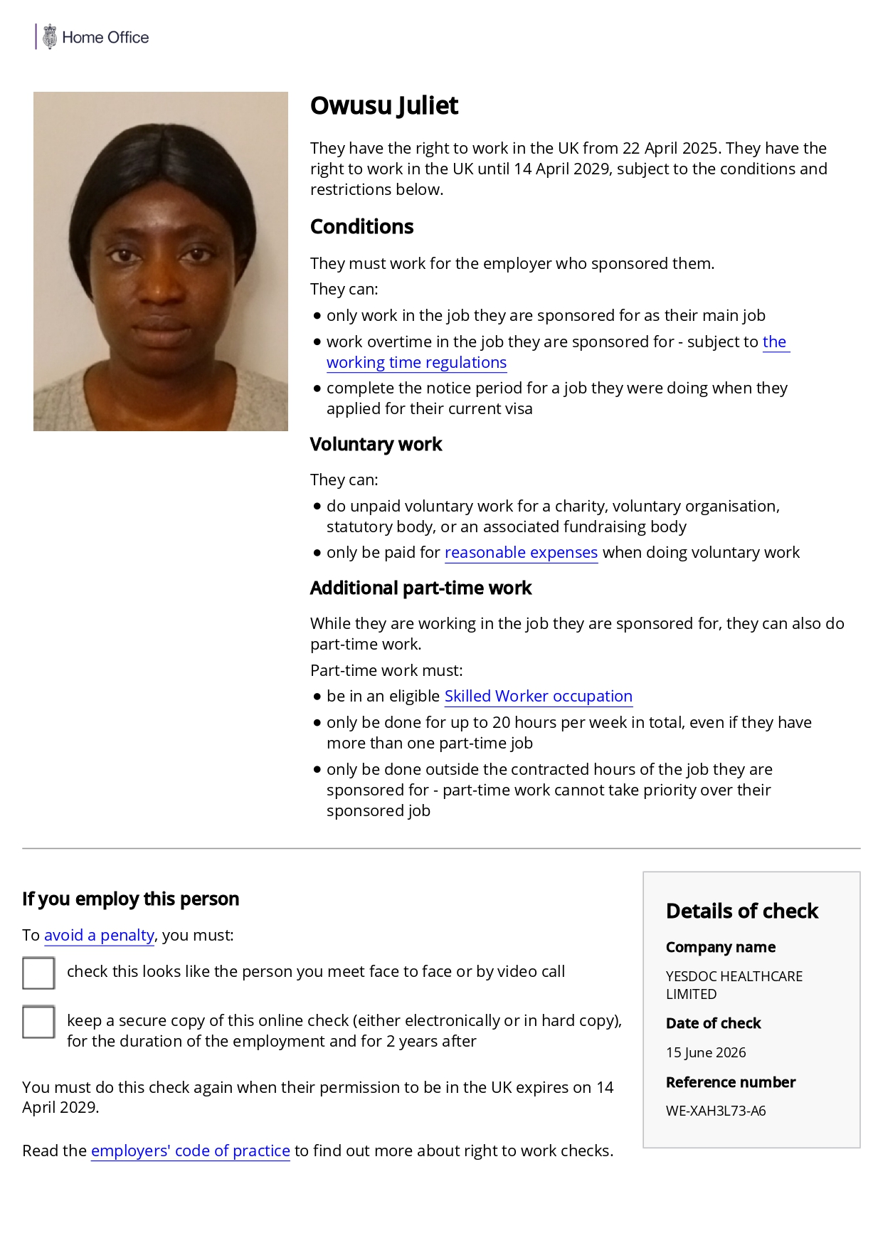{%images.RightToWorkShareCode}
Staff eligible to work in the UK:  Passport  Visa (up to date) |  |  | Yes | {%images.Passport}
Confirmation of Identity |  |  | Yes | Passport  RTW Online Check
The individual’s Enhanced DBS must be conducted by the agency or obtained via the Update Service. If a criminal record is reported, evidence that any risks posed by the staff member have been considered and assessed. This must be disclosed to Swanton prior to the agreement of individuals’ being placed to ensure appropriate risk assessments are carried out |  |  | Yes | 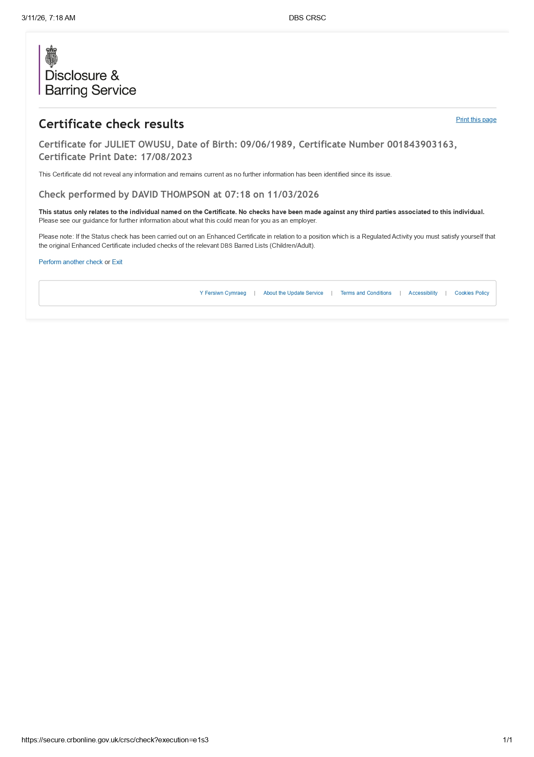{%images.EnhancedDbsCertificate}
Satisfactory referencing and evidence of conduct in previous employment concerned with the provision of services relating to— (a) health or social care, or (b) children or vulnerable adults. (This does not apply if member of staff has not previous worked in health or social care / worked with children or vulnerable adults). |  |  | Yes | Good Feedback, No Safeguarding Issues  Confirmation of Dates and no concerns regarding professional conduct
Where a person has been previously employed in a position whose duties involved work with children or vulnerable adults, satisfactory verification, so far as reasonably practicable, of the reason why the person’s employment in that position ended. (This does not apply if member of staff has not previous worked with children or vulnerable adults) |  |  | Yes
In so far as it is reasonably practicable to obtain, satisfactory documentary evidence of any qualification relevant to the duties for which the person is employed or appointed to perform. |  |  | Yes
A full employment history, together with a satisfactory written explanation of any gaps in employment. A “full employment history” means a career history from the age of first employment. This information may be in the form of a Curriculum Vitae but need not be. Information may be held electronically and must outline all periods of employment or self-employment (whether or not related to health or social care), showing beginning and end dates, (actual or approximated month and year), together with an explanation of periods of non-employment. |  |  | Yes | {#experiences}  {organization}  {#location}({location}){/location}  Position Held: {positionHeld}  {startDate | formatDate:"MMM YYYY"} –{#endDate}{endDate | formatDate:"MMM YYYY"}{/endDate}{^endDate}Till Date{/endDate}  {/experiences}
Satisfactory information about any physical or mental health conditions which are relevant to the person's capability, after reasonable adjustments are made, to properly perform tasks which are intrinsic to appointment for the purposes of the regulated activity. |  |  | Yes | VC Interview
All Working Time Regulation information completed by the individual and responsibilities adhered to accordingly. |  |  | Yes
Driving License (if required) |  |  | No | Driving Business Insurance (if required) No
All required paperwork checked: Yes |  |  | Mandatory training up to date: Yes
Registered under the disability act: No
Staff happy to work under Swanton policies and procedures: Yes
Confirm that temporary resource has been assessed for Verbal and Written English language skills | ☐ | ☐
Method of testing:
Interview | ☐ | ☐
International English Language Testing System (IELTS) | ☐ | ☐
Other (please state and enter date):

Mandatory Training with required refreshers undertaken- Training Dates Required:
MANDATORY TRAINING | YES | NO | N/A | Date:
Safeguarding Adults and Children | {#trainings.safeguarding.date}☒{/trainings.safeguarding.date}{^trainings.safeguarding.date}☐{/trainings.safeguarding.date} | {^trainings.safeguarding.date}☒{/trainings.safeguarding.date}{#trainings.safeguarding.date}☐{/trainings.safeguarding.date} |  | {trainings.safeguarding.date | formatDate}
Moving and Handling (People and Objects) Practical & Theory | {#trainings.movingAndHandling.date}☒{/trainings.movingAndHandling.date}{^trainings.movingAndHandling.date}☐{/trainings.movingAndHandling.date} | {^trainings.movingAndHandling.date}☒{/trainings.movingAndHandling.date}{#trainings.movingAndHandling.date}☐{/trainings.movingAndHandling.date} |  | {trainings.movingAndHandling.date | formatDate}
Infection Prevention and Control | {#trainings.infectionPreventionAndControl.date}☒{/trainings.infectionPreventionAndControl.date}{^trainings.infectionPreventionAndControl.date}☐{/trainings.infectionPreventionAndControl.date} | {^trainings.infectionPreventionAndControl.date}☒{/trainings.infectionPreventionAndControl.date}{#trainings.infectionPreventionAndControl.date}☐{/trainings.infectionPreventionAndControl.date} |  | {trainings.infectionPreventionAndControl.date | formatDate}
Information Governance | {#trainings.informationGovernance.date}☒{/trainings.informationGovernance.date}{^trainings.informationGovernance.date}☐{/trainings.informationGovernance.date} | {^trainings.informationGovernance.date}☒{/trainings.informationGovernance.date}{#trainings.informationGovernance.date}☐{/trainings.informationGovernance.date} |  | {trainings.informationGovernance.date | formatDate}
Fire Safety | {#trainings.fireSafety.date}☒{/trainings.fireSafety.date}{^trainings.fireSafety.date}☐{/trainings.fireSafety.date} | {^trainings.fireSafety.date}☒{/trainings.fireSafety.date}{#trainings.fireSafety.date}☐{/trainings.fireSafety.date} |  | {trainings.fireSafety.date | formatDate}
Health and Safety Training | {#trainings.healthAndSafety.date}☒{/trainings.healthAndSafety.date}{^trainings.healthAndSafety.date}☐{/trainings.healthAndSafety.date} | {^trainings.healthAndSafety.date}☒{/trainings.healthAndSafety.date}{#trainings.healthAndSafety.date}☐{/trainings.healthAndSafety.date} |  | {trainings.healthAndSafety.date | formatDate}
First Aid | {#trainings.emergencyFirstAidAtWork.date}☒{/trainings.emergencyFirstAidAtWork.date}{^trainings.emergencyFirstAidAtWork.date}☐{/trainings.emergencyFirstAidAtWork.date} | {^trainings.emergencyFirstAidAtWork.date}☒{/trainings.emergencyFirstAidAtWork.date}{#trainings.emergencyFirstAidAtWork.date}☐{/trainings.emergencyFirstAidAtWork.date} |  | {trainings.emergencyFirstAidAtWork.date | formatDate}
Equality and Diversity | {#trainings.equalityAndDiversity.date}☒{/trainings.equalityAndDiversity.date}{^trainings.equalityAndDiversity.date}☐{/trainings.equalityAndDiversity.date} | {^trainings.equalityAndDiversity.date}☒{/trainings.equalityAndDiversity.date}{#trainings.equalityAndDiversity.date}☐{/trainings.equalityAndDiversity.date} |  | {trainings.equalityAndDiversity.date | formatDate}
MCA/DoLS | {#trainings.mcaDols.date}☒{/trainings.mcaDols.date}{^trainings.mcaDols.date}☐{/trainings.mcaDols.date} | {^trainings.mcaDols.date}☒{/trainings.mcaDols.date}{#trainings.mcaDols.date}☐{/trainings.mcaDols.date} |  | {trainings.mcaDols.date | formatDate}
Medication Administration (with competencies checked) | {#trainings.medicationAdministration.date}☒{/trainings.medicationAdministration.date}{^trainings.medicationAdministration.date}☐{/trainings.medicationAdministration.date} | {^trainings.medicationAdministration.date}☒{/trainings.medicationAdministration.date}{#trainings.medicationAdministration.date}☐{/trainings.medicationAdministration.date} |  | {trainings.medicationAdministration.date | formatDate}
Food Hygiene | {#trainings.foodHygiene.date}☒{/trainings.foodHygiene.date}{^trainings.foodHygiene.date}☐{/trainings.foodHygiene.date} | {^trainings.foodHygiene.date}☒{/trainings.foodHygiene.date}{#trainings.foodHygiene.date}☐{/trainings.foodHygiene.date} |  | {trainings.foodHygiene.date | formatDate}
Food Safety and Nutrition | {#trainings.foodSafetyAndNutrition.date}☒{/trainings.foodSafetyAndNutrition.date}{^trainings.foodSafetyAndNutrition.date}☐{/trainings.foodSafetyAndNutrition.date} | {^trainings.foodSafetyAndNutrition.date}☒{/trainings.foodSafetyAndNutrition.date}{#trainings.foodSafetyAndNutrition.date}☐{/trainings.foodSafetyAndNutrition.date} |  | {trainings.foodSafetyAndNutrition.date | formatDate}
COSHH | {#trainings.coshh.date}☒{/trainings.coshh.date}{^trainings.coshh.date}☐{/trainings.coshh.date} | {^trainings.coshh.date}☒{/trainings.coshh.date}{#trainings.coshh.date}☐{/trainings.coshh.date} |  | {trainings.coshh.date | formatDate}
Dignity and Respect | {#trainings.dignityAndRespect.date}☒{/trainings.dignityAndRespect.date}{^trainings.dignityAndRespect.date}☐{/trainings.dignityAndRespect.date} | {^trainings.dignityAndRespect.date}☒{/trainings.dignityAndRespect.date}{#trainings.dignityAndRespect.date}☐{/trainings.dignityAndRespect.date} |  | {trainings.dignityAndRespect.date | formatDate}
Managing challenging behaviors (for example; breakaway/escalation training) | {#trainings.managingChallengingBehaviours.date}☒{/trainings.managingChallengingBehaviours.date}{^trainings.managingChallengingBehaviours.date}☐{/trainings.managingChallengingBehaviours.date} | {^trainings.managingChallengingBehaviours.date}☒{/trainings.managingChallengingBehaviours.date}{#trainings.managingChallengingBehaviours.date}☐{/trainings.managingChallengingBehaviours.date} |  | {trainings.managingChallengingBehaviours.date | formatDate}
Other Training with required refreshers undertaken - Training Dates Required:
Maybo Level 2 | {#trainings.mayboLevel2.date}☒{/trainings.mayboLevel2.date}{^trainings.mayboLevel2.date}☐{/trainings.mayboLevel2.date} | {^trainings.mayboLevel2.date}☒{/trainings.mayboLevel2.date}{#trainings.mayboLevel2.date}☐{/trainings.mayboLevel2.date} |  | {trainings.mayboLevel2.date | formatDate}
PMVA | {#trainings.pmva.date}☒{/trainings.pmva.date}{^trainings.pmva.date}☐{/trainings.pmva.date} | {^trainings.pmva.date}☒{/trainings.pmva.date}{#trainings.pmva.date}☐{/trainings.pmva.date} |  | {trainings.pmva.date | formatDate}
CPI Training | {#trainings.cpiTraining.date}☒{/trainings.cpiTraining.date}{^trainings.cpiTraining.date}☐{/trainings.cpiTraining.date} | {^trainings.cpiTraining.date}☒{/trainings.cpiTraining.date}{#trainings.cpiTraining.date}☐{/trainings.cpiTraining.date} |  | {trainings.cpiTraining.date | formatDate}
Dysphasia Training | {#trainings.dysphagiaCare.date}☒{/trainings.dysphagiaCare.date}{^trainings.dysphagiaCare.date}☐{/trainings.dysphagiaCare.date} | {^trainings.dysphagiaCare.date}☒{/trainings.dysphagiaCare.date}{#trainings.dysphagiaCare.date}☐{/trainings.dysphagiaCare.date} |  | {trainings.dysphagiaCare.date | formatDate}
Autism Awareness | {#trainings.autismAwareness.date}☒{/trainings.autismAwareness.date}{^trainings.autismAwareness.date}☐{/trainings.autismAwareness.date} | {^trainings.autismAwareness.date}☒{/trainings.autismAwareness.date}{#trainings.autismAwareness.date}☐{/trainings.autismAwareness.date} |  | {trainings.autismAwareness.date | formatDate}
Learning Disabilities Awareness | {#trainings.learningDisabilitiesAwareness.date}☒{/trainings.learningDisabilitiesAwareness.date}{^trainings.learningDisabilitiesAwareness.date}☐{/trainings.learningDisabilitiesAwareness.date} | {^trainings.learningDisabilitiesAwareness.date}☒{/trainings.learningDisabilitiesAwareness.date}{#trainings.learningDisabilitiesAwareness.date}☐{/trainings.learningDisabilitiesAwareness.date} |  | {trainings.learningDisabilitiesAwareness.date | formatDate}
Mental Health Awareness | {#trainings.mentalHealthAwareness.date}☒{/trainings.mentalHealthAwareness.date}{^trainings.mentalHealthAwareness.date}☐{/trainings.mentalHealthAwareness.date} | {^trainings.mentalHealthAwareness.date}☒{/trainings.mentalHealthAwareness.date}{#trainings.mentalHealthAwareness.date}☐{/trainings.mentalHealthAwareness.date} |  | {trainings.mentalHealthAwareness.date | formatDate}
Other relevant Training to the role (Please List): {#trainings.basicLifeSupport.date}{trainings.basicLifeSupport.name} – {trainings.basicLifeSupport.date | formatDate}{/trainings.basicLifeSupport.date} {#trainings.coronavirusAwareness.date}{trainings.coronavirusAwareness.name} – {trainings.coronavirusAwareness.date | formatDate}{/trainings.coronavirusAwareness.date} {#trainings.complaintsHandling.date}{trainings.complaintsHandling.name} – {trainings.complaintsHandling.date | formatDate}{/trainings.complaintsHandling.date} {#trainings.conflictManagement.date}{trainings.conflictManagement.name} – {trainings.conflictManagement.date | formatDate}{/trainings.conflictManagement.date} {#trainings.dementiaAwareness.date}{trainings.dementiaAwareness.name} – {trainings.dementiaAwareness.date | formatDate}{/trainings.dementiaAwareness.date} {#trainings.endOfLifeCare.date}{trainings.endOfLifeCare.name} – {trainings.endOfLifeCare.date | formatDate}{/trainings.endOfLifeCare.date} {#trainings.epilepsyAwareness.date}{trainings.epilepsyAwareness.name} – {trainings.epilepsyAwareness.date | formatDate}{/trainings.epilepsyAwareness.date} {#trainings.fallsPrevention.date}{trainings.fallsPrevention.name} – {trainings.fallsPrevention.date | formatDate}{/trainings.fallsPrevention.date} {#trainings.foodAllergensAwareness.date}{trainings.foodAllergensAwareness.name} – {trainings.foodAllergensAwareness.date | formatDate}{/trainings.foodAllergensAwareness.date} {#trainings.gdprAndDataProtection.date}{trainings.gdprAndDataProtection.name} – {trainings.gdprAndDataProtection.date | formatDate}{/trainings.gdprAndDataProtection.date} {#trainings.immediateLifeSupport.date}{trainings.immediateLifeSupport.name} – {trainings.immediateLifeSupport.date | formatDate}{/trainings.immediateLifeSupport.date} {#trainings.personalCare.date}{trainings.personalCare.name} – {trainings.personalCare.date | formatDate}{/trainings.personalCare.date} {#trainings.privacyAndDignity.date}{trainings.privacyAndDignity.name} – {trainings.privacyAndDignity.date | formatDate}{/trainings.privacyAndDignity.date} {#trainings.promotingPersonCenteredCare.date}{trainings.promotingPersonCenteredCare.name} – {trainings.promotingPersonCenteredCare.date | formatDate}{/trainings.promotingPersonCenteredCare.date} {#trainings.riddor.date}{trainings.riddor.name} – {trainings.riddor.date | formatDate}{/trainings.riddor.date} {#trainings.whistleblowing.date}{trainings.whistleblowing.name} – {trainings.whistleblowing.date | formatDate}{/trainings.whistleblowing.date}

Form completed by | David Thompson | Signature | David
Position | Senior Recruitment Consultant | Date | 31/07/2026

