Day -4 :- Bus Stand
Cleanliness Drive at Bus stand

We visited the nearby bus stand to carry out a cleanliness drive. The area was crowded and required immediate attention to maintain hygiene. Our team actively cleaned the surroundings by collecting waste and disposing of it properly. This activity helped us understand the importance of public cleanliness and civic responsibility. It also created awareness among commuters about maintaining cleanliness in public places and encouraged community participation for a healthier environment.
Under the NSS program, we conducted a cleanliness drive at the local bus stand to promote hygiene and social responsibility. Volunteers worked together to clean platforms and surrounding areas, ensuring proper waste disposal. The activity highlighted the role of youth in maintaining public spaces. Through this initiative, we learned the value of teamwork, discipline, and community service. The drive also helped spread awareness among the public about keeping shared spaces clean and supporting sustainable environmental practices.
As a part of our NSS initiative, we organized a cleanliness drive at the bus stand to improve sanitation and public awareness. The volunteers enthusiastically participated in cleaning the area and managing waste responsibly. This activity emphasized the importance of maintaining cleanliness in frequently used public spaces. It strengthened our sense of social.

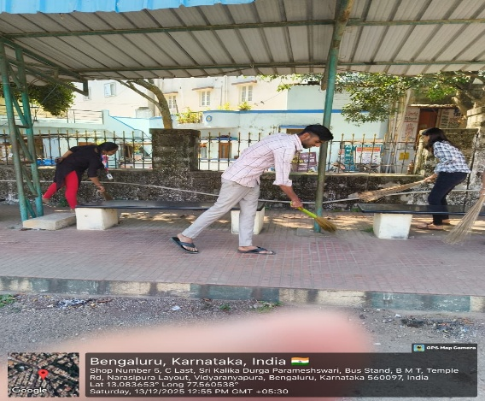
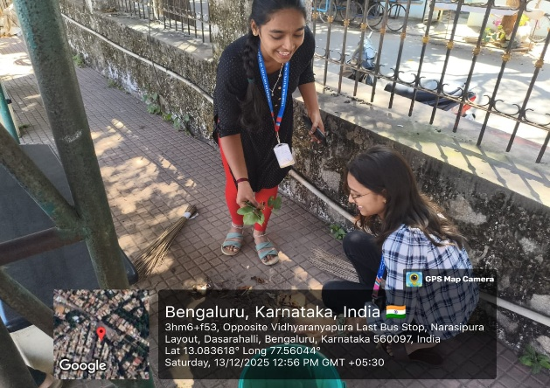

Fig 2.4 Cleanliness Drive Fig 2.5 Public Hygiene

As part of the NSS program, we carried out a cleanliness and awareness activity at the bus stand. Volunteers interacted with the public and encouraged them to maintain cleanliness in shared spaces. The activity focused on improving hygiene and creating awareness about responsible behavior in public areas. Through teamwork and active participation, students contributed to a cleaner environment. This initiative helped develop leadership qualities, social awareness, and a strong sense of civic duty among the participants.
As part of the NSS program, students carried out a cleanliness and awareness activity at the bus stand. Volunteers interacted with the public and encouraged them to maintain cleanliness in shared spaces. The activity focused on improving hygiene and creating awareness about responsible behavior in public areas. Through teamwork and active participation, students contributed to a cleaner environment. This initiative helped develop leadership qualities, social awareness, and a strong sense of civic duty among the participants.

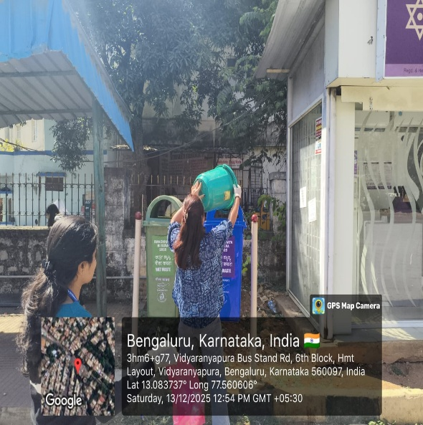
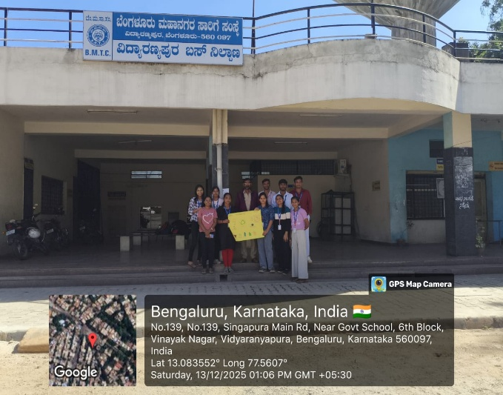

Fig 2.6 Swachh Abhiyan Fig 2.7 Community Clean-up

Day -6 :- Railway Station

Cleaning a waste in railway station :

During our NSS camp, I visited Yelahanka Railway Station as part of the waste management awareness program. The station is a busy public area where a large amount of waste is generated every day due to passengers, vendors, and railway operations. I observed different types of waste such as plastic bottles, food wrappers, paper waste, and leftover food scattered on platforms and near waiting areas. Although dustbins were available, improper disposal and lack of waste segregation were common problems. As NSS volunteers, we actively participated in cleaning the premises and spreading awareness among passengers and shopkeepers about the importance of using dustbins and avoiding plastic waste. We also explained the need for separating dry and wet waste for effective recycling. This visit helped me understand the challenges of waste management in public places and highlighted the importance of public responsibility in maintaining cleanliness and hygiene.

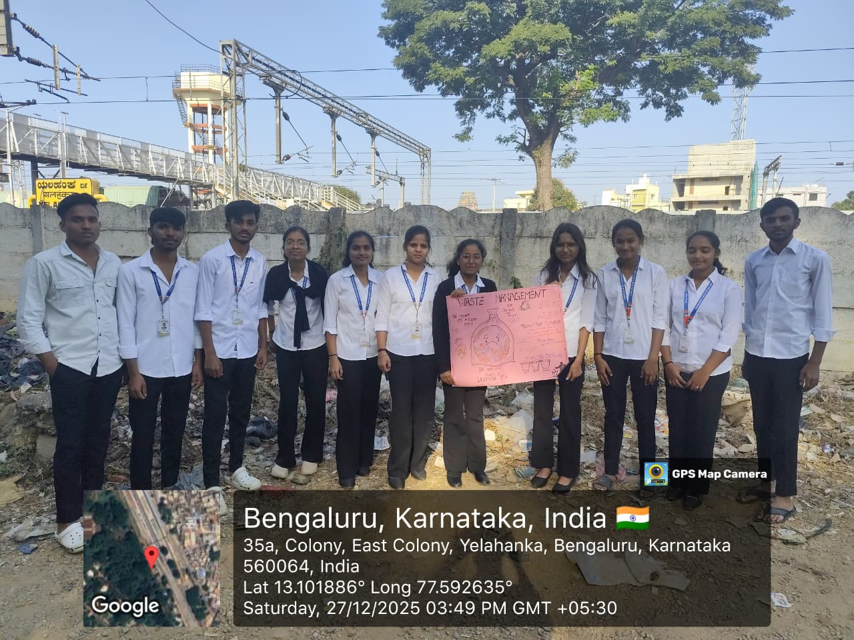
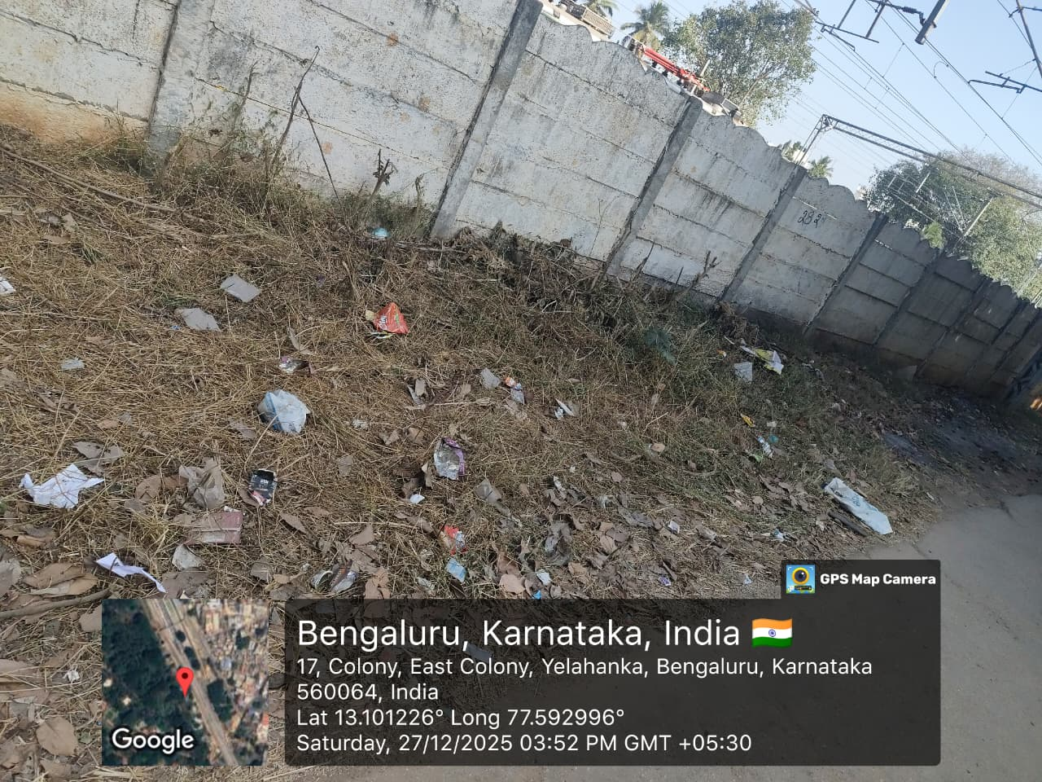
Fig : Group photo before cleaning Fig : Before cleaning

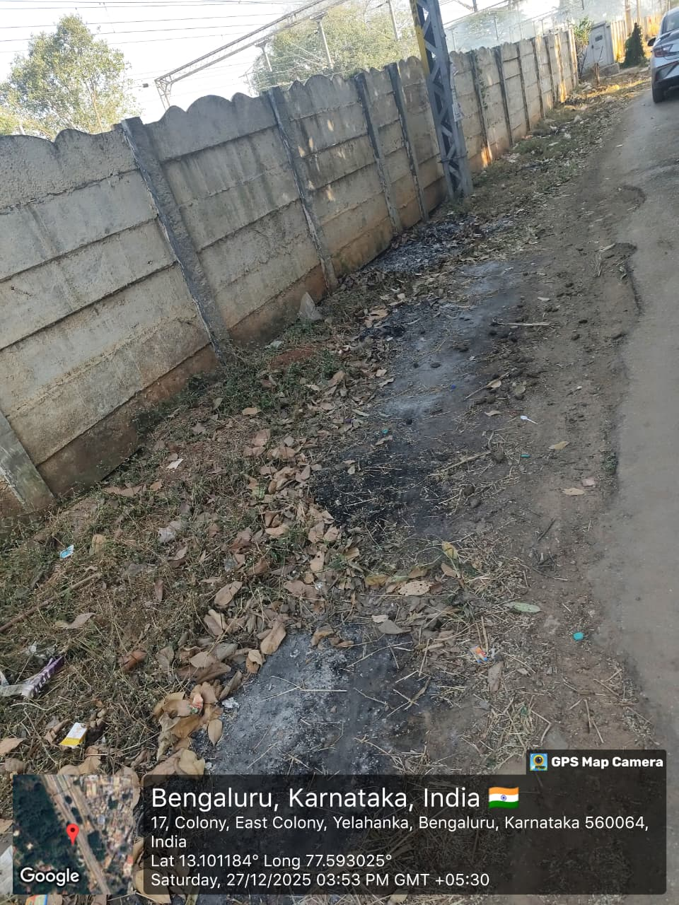

Fig : After cleaning
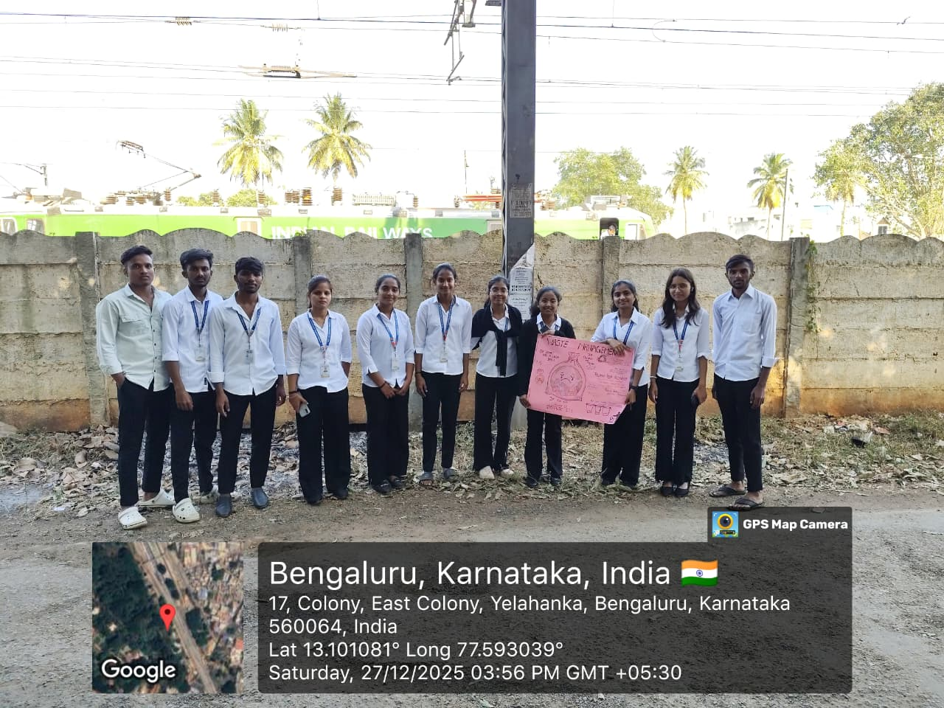

Fig : After Cleaning with Group Photo

REFLECTION NOTES

Participating in the NSS waste management activity was a meaningful and eye-opening experience for me. The activity was carried out near a temple located beside a mountain, where a large amount of waste had accumulated due to frequent visitors and lack of proper disposal facilities. Being part of this cleanliness drive made me realize the importance of environmental responsibility and community service.
Through this activity, I understood how careless human behavior can negatively impact natural and religious places. Working together with my teammates to clean the area strengthened our sense of unity, discipline, and cooperation. It also taught me the value of teamwork and leadership while performing social service.
This activity helped me develop a sense of social responsibility and awareness about waste management practices. It motivated me to adopt eco-friendly habits in my daily life and encouraged me to spread awareness among others about maintaining cleanliness in public places. Overall, the NSS activity was a rewarding experience that contributed to my personal growth and reinforced the true spirit of “Not Me, But You.”

Outcomes of the NSS Activity Conducted :
1. Importance of Cleanliness and Hygiene
- Clean surroundings are essential for public health, environmental protection, and overall well-being.
- Cleanliness helps prevent diseases and promote a healthy living environment.
2. Impact of Increased Awareness
Awareness initiatives encouraged individuals to adopt better hygiene habits, avoid littering, and take personal responsibility for maintaining cleanliness in their surroundings.
3. Role of Education and Outreach
Educational programs, street plays, rallies, and community campaigns played a key role in spreading messages about sanitation, waste segregation, and sustainable practices.
4. Community and Policy Impact
The campaigns led to increased community involvement in cleanliness activities and motivated local authorities to support sanitation initiatives more effectively.
5. Challenges and Opportunities
- While significant progress was achieved, challenges remain in ensuring sustained participation and behavior change.
- Continuous engagement and innovative approaches are needed to overcome these
- challenges and achieve long-term cleanliness goals.

“Clean surroundings reflect responsible citizens and a caring society.”
“True service lies in actions that benefit the community and the environment.”
“Awareness is the first step towards responsible waste management.”

CONCLUSION

The NSS waste management activity was successfully carried out with active participation from all volunteers and effectively met its objectives of promoting cleanliness and environmental awareness. The activity fostered teamwork, discipline, and a strong sense of social responsibility among students. It highlighted the adverse effects of improper waste disposal on natural and religious surroundings and emphasized the need for sustainable waste management practices. The experience encouraged volunteers to adopt eco-friendly habits and to serve as responsible citizens by spreading awareness in the community. Overall, the activity was impactful and truly reflected the spirit and values of the National Service Scheme, “Not Me, But You.”

