PROJECT DOCUMENTATION
Backend Engineering Deliverable
ERASM
Enterprise Resource Allocation & Skill Management System

Prepared By Sagar N
Organization Incture Technologies
Document Type Project Report — Backend Implementation
Date 06 July 2026

Java · Spring Boot 4.1 · Spring Security (JWT + RBAC) · Spring Data JPA · MySQL 8

Acknowledgement
I would like to express my sincere gratitude to everyone who supported and guided me throughout the design and development of the ERASM (Enterprise Resource Allocation & Skill Management System) project.
I extend my heartfelt thanks to the faculty of Incture for providing the academic foundation, technical guidance, and continuous encouragement that shaped this work. Their feedback during reviews helped me tighten the design of the REST layer, refine the role-based security model, and improve the overall code quality.
I am also grateful to my project mentor and reviewers for their patient explanations of enterprise design patterns, JPA relationship mapping, and layered architecture. The technical discussions we had significantly influenced how the service and repository layers were split, and how the JWT filter and @PreAuthorize checks were composed.
A special thank you to my peers and classmates for the peer-review sessions, particularly on the Postman collection and the JaCoCo coverage improvements. Their honest critique pushed me to write cleaner controllers and more meaningful unit tests.
Lastly, I would like to thank my family for their patience and moral support during the long build and testing cycles. This project would not have reached this level of completeness without the collective encouragement of all these people.

— Sagar N

Table of Contents
This document is structured to guide the reader from a high-level view of the ERASM system down to the concrete implementation details, verification evidence, and future roadmap.

1 Project Overview
2 Problem Statement
3 Objectives
4 Technology Stack
5 System Architecture
6 ER Diagram
7 Database Schema
8 API Endpoints
9 Security — JWT + Spring Security
10 Screenshots & Verification Evidence
10.1 Swagger UI
10.2 Login with JWT (Bearer Token)
10.3 Create Project
10.4 Resource Allocation
10.5 403 Forbidden — RBAC in Action
10.6 Audit Logs
10.7 JaCoCo Coverage Report
10.8 JUnit Test Suite Passing
11 GitHub Repository
12 Conclusion
13 Future Enhancements

1. Project Overview
ERASM stands for Enterprise Resource Allocation & Skill Management System. It is a backend-focused Java Spring Boot application that I developed to model the everyday problem faced by service and consulting organisations: keeping track of who works where, with which skill set, and under whose approval. The system exposes every capability as a REST API, uses JWT-based stateless authentication, and enforces role-based access control at the method level. All data is persisted to a MySQL 8 relational database through Spring Data JPA and Hibernate.
The application is designed around a clear separation of concerns. Incoming HTTP requests pass through a JWT authentication filter, are routed to a REST controller, delegated to a service layer where business logic lives, and finally reach the persistence layer via repository interfaces. This layered arrangement keeps controllers thin, makes services independently testable with Mockito, and allows the security model to be reasoned about in one place.

1.1 Functional Scope
The system covers ten interconnected functional areas, each backed by its own controller, service, entity, and repository. Together they form a complete resource-management workflow from the moment a project is created until an employee is released from it.
# | Module | What It Does
1 | User Management | Registration, login, password change, and administrative CRUD over user accounts.
2 | Role Management | Master list of the five roles used by the RBAC layer — ADMIN, DELIVERY_MANAGER, RESOURCE_MANAGER, EMPLOYEE, AUDITOR.
3 | Skill Management | Master catalogue of skills the organisation tracks. Only ADMIN can create, update, or delete a skill.
4 | Employee Management | Employee profile linked one-to-one to a user account. Stores name, designation, and years of experience.
5 | Employee Skill Profile | Many-to-many bridge between an employee and a skill, with proficiency level and experience.
6 | Certification Management | Records certifications an employee has earned, with the issuing date.
7 | Project Management | Client projects the delivery team is engaged on, with dates, tech stack, and budget.
8 | Resource Request Workflow | Staffing requests raised on a project. Requests advance through DRAFT → SUBMITTED → APPROVED → ALLOCATED → COMPLETED.
9 | Resource Allocation | The actual act of putting an employee on a project at a specific allocation percentage, with a release path.
10 | Utilisation, Reports & Audit | Read-only views: utilisation dashboard, skill/allocation reports, and an audit log for every mutating action.

2. Problem Statement
In most mid-sized service organisations, resource-related information is scattered across spreadsheets, chat messages, and the memories of individual managers. This creates three real, day-to-day problems that I set out to solve with ERASM.

Problem 1 — Skills are unknown until they are needed.
When a new project needs, say, a Java developer with three years of Spring experience, delivery managers typically ask around instead of querying a system. The information is technically written down somewhere, but it is not searchable, not up to date, and not linked to who is currently available.

Problem 2 — Allocation is invisible and easy to double-book.
Without a single source of truth for who is committed to what, and at what percentage, the same person quietly ends up allocated at 150% of their time. The mistake usually surfaces only when the person raises it, which is too late.

Problem 3 — Approval trails do not exist.
Staffing decisions are made in verbal conversations. Six months later, when a client audit or an internal review asks "who approved this allocation and when," the answer has to be reconstructed from memory. That is neither reliable nor defensible.
ERASM tackles each of these directly. A centralised employee-skill catalogue answers "who knows what." The allocation module enforces one authoritative record per employee-project pairing, with an explicit release step. The resource-request workflow forces every staffing decision through a linear DRAFT → SUBMITTED → APPROVED → ALLOCATED → COMPLETED lifecycle, and the audit log records every state change with a timestamp and the user who caused it.

3. Objectives
The objectives below describe what a "done" version of the project looks like. Each was treated as a testable requirement during development.
- Design and implement a normalised relational schema in MySQL 8 that covers users, roles, employees, skills, certifications, projects, resource requests, allocations, and audit logs, with correct foreign-key constraints.
- Expose the business functionality as a REST API using Spring Boot 4.1 and Spring Web, returning JSON responses and following resource-oriented URL conventions.
- Secure the API with stateless JWT authentication and enforce role-based authorisation at the method level using @PreAuthorize on every mutating endpoint.
- Implement a linear approval workflow for resource requests so that the request status can only advance forward, and terminal states cannot be re-entered.
- Write JPA entities using the correct relationship types — One-to-One, Many-to-One, and Many-to-Many — and keep controllers free of persistence concerns.
- Cover the service layer with JUnit 5 and Mockito unit tests, verify controllers with @WebMvcTest slice tests, and achieve meaningful code coverage measured via JaCoCo.
- Automatically write an audit log entry from within the service layer for every create, update, allocate, and release action, so that no controller has to remember to log.
- Document the entire API in a Postman collection and publish an interactive Swagger UI so that reviewers and future developers can explore the endpoints without reading source code.
- Manage the source code on GitHub with a disciplined branching strategy — main, develop, feature branches, hotfix branches, and a release tag.

4. Technology Stack
The technologies below were chosen to align with mainstream enterprise Java practice. Every choice is justified either by the requirement it addresses or by the ecosystem it plugs into.
Layer | Technology | Purpose in This Project
Language | Java 21 | Modern LTS release with sealed classes, records, and pattern matching, running on the OpenJDK 21 runtime.
Framework | Spring Boot 4.1.0 | Application bootstrap, dependency injection, auto-configuration, and embedded Tomcat.
REST Layer | Spring Web MVC | Annotation-driven REST controllers with Jackson JSON serialisation.
Security | Spring Security 6 + JWT (jjwt 0.12.6) | Stateless JWT authentication, custom JwtAuthFilter, method-level @PreAuthorize with hasRole checks.
Password Hashing | BCrypt | One-way password hashing before persistence — plaintext is never stored.
Persistence | Spring Data JPA + Hibernate | Repository interfaces (JpaRepository) with derived query methods, Hibernate as the JPA provider.
Database | MySQL 8 | utf8mb4 charset, InnoDB storage, primary and foreign keys enforced at the DB level.
Validation | Jakarta Bean Validation | @Valid on request DTOs, @NotNull / @NotBlank / @Email on fields.
Testing | JUnit 5 + Mockito + MockMvc | Service-layer tests with mocked repositories; controller slice tests with @WebMvcTest.
Coverage | JaCoCo 0.8.12 | Line and branch coverage reports produced by mvn test.
API Docs | springdoc-openapi 2.8.5 | Auto-generated Swagger UI at /swagger-ui/index.html and OpenAPI JSON at /v3/api-docs.
Build | Apache Maven | Standard Maven layout, pom.xml manages all versions, mvn spring-boot:run launches the app.
IDE | Spring Tool Suite (Eclipse-based) | Used for development, debugging, and running the JUnit suite.
API Testing | Postman | Full ERASM collection with bearer-token authorisation configured.
Version Control | Git + GitHub | main / develop / feature / hotfix branching model, release tags on production-ready commits.

5. System Architecture
ERASM follows a classic layered architecture. Each layer has one job and depends only on the layer directly below it, which is what makes the codebase easy to reason about, easy to test, and easy to change.

5.1 Request Flow, End to End
When a client sends an HTTP request, it travels through the layers in this order:
HTTP Client (Postman / Swagger / Browser) │ ▼ ┌───────────────────────────────────────────────┐ │ Spring Security Filter Chain │ │ ├─ JwtAuthFilter (custom) │ │ │ • Reads the "Authorization: Bearer …" │ │ │ • Validates the JWT with JWTUtil │ │ │ • Loads the user via CustomUserDetails │ │ │ • Places Authentication in the context │ │ └─ AuthorizationFilter │ │ • Applies @PreAuthorize on the handler │ └───────────────────────────────────────────────┘ │ ▼ ┌───────────────────────────────────────────────┐ │ Controller Layer (com.erasm.controller) │ │ Thin REST controllers, one per resource. │ │ Delegates immediately to the service layer. │ └───────────────────────────────────────────────┘ │ ▼ ┌───────────────────────────────────────────────┐ │ Service Layer (com.erasm.service) │ │ All business rules and workflow logic. │ │ Writes an AuditLog on every mutating call. │ └───────────────────────────────────────────────┘ │ ▼ ┌───────────────────────────────────────────────┐ │ Repository Layer (com.erasm.repository) │ │ Spring Data JPA interfaces. │ │ Hibernate translates to SQL for MySQL 8. │ └───────────────────────────────────────────────┘ │ ▼ ┌───────────────────────────────────────────────┐ │ MySQL 8 Database (schema erasm_db) │ └───────────────────────────────────────────────┘

5.2 Package Layout
The project follows a package-by-layer structure under the root package com.erasm. Each package holds exactly one kind of thing, which makes it obvious where any new class should live.
Package | Responsibility
com.erasm | The application bootstrap class ErasmApplication.java, annotated with @SpringBootApplication.
com.erasm.config | SecurityConfig, PasswordEncoderConfig, and any other Spring @Configuration beans.
com.erasm.controller | REST controllers, one per resource — 13 in total, from AuthController through UtilizationController.
com.erasm.dto | Request and response DTOs, keeping entities out of the HTTP layer.
com.erasm.entity | JPA entities: User, Role, Employee, Skill, EmployeeSkill, Certification, Project, ResourceRequest, Allocation, AuditLog.
com.erasm.exception | Custom exceptions and the @RestControllerAdvice global handler that maps them to consistent JSON error bodies.
com.erasm.filter | JwtAuthFilter — the OncePerRequestFilter that parses and validates the bearer token.
com.erasm.mapper | DTO ↔ entity mappers to keep controllers and services free of conversion boilerplate.
com.erasm.repository | Spring Data JPA repositories, one per aggregate root.
com.erasm.service | Business logic — the layer that all unit tests target.
com.erasm.utility | JWTUtil — generation, parsing, and validation of the JWT itself.

6. ER Diagram
The entity-relationship model shows the ten tables that make up the ERASM schema and the foreign-key relationships between them. Cardinality is enforced both by JPA annotations on the entity classes and by FOREIGN KEY constraints in the SQL schema.

6.1 Relationship Summary
Type | Between | Meaning
Many-to-One | users → roles | Every user holds exactly one role, but many users can share the same role.
One-to-One | employees ↔ users | Each employee record maps to exactly one user account (via employees.user_id UNIQUE).
Many-to-Many | employees ↔ skills | Implemented through the employee_skills bridge table, which also carries proficiency and experience.
Many-to-One | certifications → employees | An employee may hold zero or more certifications.
One-to-Many | projects → resource_requests | A single project may raise many staffing requests.
Many-to-One | allocations → employees, allocations → projects | An allocation ties one employee to one project at a given percentage.

6.2 Textual ER Layout
The following text-based diagram captures the same structure as the visual ER diagram. It is included here so that the report reads well even if the image renders poorly in a particular viewer.
┌──────────┐ │ roles │ └────┬─────┘ │ 1 │ ▼ N ┌──────────┐ 1 ┌────────────┐ │ users │◄──────────┤ employees │ └──────────┘ 1 └─────┬──────┘ │ N │ N ┌───────────────┴──────────────┐ N ▼ ▼ ┌─────────────────┐ ┌────────────────┐ │ employee_skills │ ─── N ───► │ skills │ └─────────────────┘ └────────────────┘ ┌──────────────┐ ┌────────────────────┐ │ certifications│ ── N ── employees │ resource_requests │ ── N ── projects └──────────────┘ └────────────────────┘ ┌─────────────┐ │ allocations │ ── N ── employees └─────────────┘ ── N ── projects ┌─────────────┐ │ audit_logs │ (write-only, no FK — records action, entity, actor) └─────────────┘

7. Database Schema
The schema below matches the DDL script shipped in the /database folder of the repository and the JPA entities under com.erasm.entity. It is designed for MySQL 8 with the utf8mb4 charset and the InnoDB engine.

7.1 roles
Column | Type | Constraints
id | INT AUTO_INCREMENT | PRIMARY KEY
name | VARCHAR(255) | NOT NULL, UNIQUE
Seeded with five rows: ADMIN, DELIVERY_MANAGER, RESOURCE_MANAGER, EMPLOYEE, AUDITOR.

7.2 users
Column | Type | Constraints
id | INT AUTO_INCREMENT | PRIMARY KEY
email | VARCHAR(255) | NOT NULL, UNIQUE
password | VARCHAR(255) | NOT NULL (stored as BCrypt hash)
role_id | INT | NOT NULL, FK → roles(id)

7.3 employees
Column | Type | Constraints
id | INT AUTO_INCREMENT | PRIMARY KEY
name | VARCHAR(255) | NOT NULL
designation | VARCHAR(255) | —
experience | INT | —
user_id | INT | NOT NULL, UNIQUE, FK → users(id)

7.4 skills
Column | Type | Constraints
id | INT AUTO_INCREMENT | PRIMARY KEY
name | VARCHAR(255) | NOT NULL, UNIQUE

7.5 employee_skills
Column | Type | Constraints
id | INT AUTO_INCREMENT | PRIMARY KEY
employee_id | INT | NOT NULL, FK → employees(id)
skill_id | INT | NOT NULL, FK → skills(id)
skill_level | VARCHAR(255) | —
experience | INT | —

7.6 certifications
Column | Type | Constraints
id | INT AUTO_INCREMENT | PRIMARY KEY
name | VARCHAR(255) | NOT NULL
issued_date | DATE | —
employee_id | INT | NOT NULL, FK → employees(id)

7.7 projects
Column | Type | Constraints
id | INT AUTO_INCREMENT | PRIMARY KEY
project_name | VARCHAR(255) | NOT NULL
client_name | VARCHAR(255) | —
start_date | DATE | —
end_date | DATE | —
technology_stack | VARCHAR(255) | —
budget | DOUBLE | —

7.8 resource_requests
Column | Type | Constraints
id | INT AUTO_INCREMENT | PRIMARY KEY
required_skill | VARCHAR(255) | —
required_count | INT | —
status | VARCHAR(255) | DRAFT / SUBMITTED / APPROVED / ALLOCATED / COMPLETED
project_id | INT | NOT NULL, FK → projects(id)

7.9 allocations
Column | Type | Constraints
id | INT AUTO_INCREMENT | PRIMARY KEY
employee_id | INT | NOT NULL, FK → employees(id)
project_id | INT | NOT NULL, FK → projects(id)
allocation_percentage | INT | —
status | VARCHAR(255) | e.g. ACTIVE / RELEASED

7.10 audit_logs
Column | Type | Constraints
id | INT AUTO_INCREMENT | PRIMARY KEY
action | VARCHAR(255) | —
entity_name | VARCHAR(255) | —
performed_by | VARCHAR(255) | —
created_date | DATETIME | —
modified_date | DATETIME | —

8. API Endpoints
The base URL for local development is http://localhost:8080. In the access column, a specific role name such as ADMIN or RESOURCE_MANAGER means the endpoint is annotated with @PreAuthorize on the controller method. "Authenticated" means any valid JWT is enough. "Public" means no token is required.

8.1 Authentication
Method | Endpoint | Description | Access
POST | /auth/register | Register a new user account. | Public
POST | /auth/login | Authenticate with email and password; returns a JWT. | Public
POST | /auth/logout | Client-side logout acknowledgement — the client must discard the token. | Public

8.2 User Management
Method | Endpoint | Description | Access
GET | /users | List all users. | ADMIN
GET | /users/{id} | Fetch a user by ID. | ADMIN
PUT | /users/{id} | Update a user. | ADMIN
DELETE | /users/{id} | Delete a user. | ADMIN
PUT | /users/{id}/change-password | Change a user's password. | Authenticated

8.3 Skill Management
Method | Endpoint | Description | Access
POST | /skills | Create a new skill. | ADMIN
GET | /skills | List all skills. | ADMIN
PUT | /skills/{id} | Update an existing skill. | ADMIN
DELETE | /skills/{id} | Delete a skill. | ADMIN

8.4 Employee Management
Method | Endpoint | Description | Access
POST | /employees | Create an employee profile. | ADMIN
GET | /employees | List all employees. | Authenticated
GET | /employees/{id} | Fetch an employee by ID. | Authenticated
PUT | /employees/{id} | Update an employee. | ADMIN
DELETE | /employees/{id} | Delete an employee. | ADMIN

8.5 Employee Skill Profile
Method | Endpoint | Description | Access
POST | /employee-skills | Assign a skill to an employee with proficiency and experience. | Authenticated
GET | /employee-skills | List all employee-skill entries. | Authenticated
PUT | /employee-skills/{id} | Update an employee-skill entry. | Authenticated

8.6 Certification Management
Method | Endpoint | Description | Access
POST | /certifications | Add a certification. | Authenticated
GET | /certifications | List all certifications. | Authenticated
GET | /certifications/employee/{employeeId} | List certifications for an employee. | Authenticated
DELETE | /certifications/{id} | Delete a certification. | ADMIN

8.7 Project Management
Method | Endpoint | Description | Access
POST | /projects | Create a project. | DELIVERY_MANAGER
GET | /projects | List all projects. | Authenticated
GET | /projects/{id} | Fetch a project by ID. | Authenticated
PUT | /projects/{id} | Update a project. | DELIVERY_MANAGER
DELETE | /projects/{id} | Delete a project. | ADMIN

8.8 Resource Requests & Approval Workflow
The approval workflow is intentionally linear. The /advance endpoint moves the request forward exactly one step. A request in COMPLETED state cannot be advanced further, which is verified by the 404 response captured in Section 10.
Method | Endpoint | Description | Access
POST | /resource-requests | Create a new resource request in DRAFT state. | DELIVERY_MANAGER
GET | /resource-requests | List all resource requests. | Authenticated
GET | /resource-requests/{id} | Fetch a resource request by ID. | Authenticated
PUT | /resource-requests/{id}/advance | Advance the request one step in its lifecycle. | RESOURCE_MANAGER

8.9 Resource Allocation
Method | Endpoint | Description | Access
POST | /allocations | Allocate an employee to a project. | RESOURCE_MANAGER
GET | /allocations | List all allocations. | Authenticated
PUT | /allocations/{id}/release | Release an employee from a project. | RESOURCE_MANAGER

8.10 Utilisation, Reports & Audit
Method | Endpoint | Description | Access
GET | /utilization | Organisation-wide utilisation snapshot. | DELIVERY_MANAGER / ADMIN / AUDITOR
GET | /reports/skills | Report on skill distribution across employees. | ADMIN / AUDITOR / DELIVERY_MANAGER
GET | /reports/allocations | Report on active and released allocations. | ADMIN / AUDITOR / DELIVERY_MANAGER
GET | /audit-logs | List of all audit log entries. | AUDITOR / ADMIN

9. Security — JWT + Spring Security
Security in ERASM is intentionally stateless. There are no server-side sessions. Every protected request must carry a JSON Web Token in the Authorization header, and the server proves the caller's identity by verifying the token's signature on each request.

9.1 The Authentication Handshake
The end-to-end sign-in flow proceeds as follows:
- The client POSTs credentials to /auth/login.
- AuthController hands the email and password to the AuthenticationManager, which delegates to CustomUserDetailsService to load the user from MySQL.
- The submitted password is compared with the stored BCrypt hash. If it matches, the AuthenticationManager returns an authenticated token.
- JWTUtil signs a fresh JWT whose subject is the user email, sets an expiry, and returns the compact token string in the HTTP 200 response body.
- The client stores the token and attaches it as Authorization: Bearer <token> on every subsequent request.

9.2 The Custom JWT Filter
A single custom filter, JwtAuthFilter, is registered in the Spring Security filter chain. It extends OncePerRequestFilter and runs before the standard UsernamePasswordAuthenticationFilter. Its job is straightforward:
JwtAuthFilter.doFilterInternal(request, response, chain) 1. Read the Authorization header. 2. If it does not start with "Bearer ", forward the chain and return. 3. Extract the token, hand it to JWTUtil for parsing + signature check. 4. If the token is valid and not expired, load the user via CustomUserDetailsService. 5. Build a UsernamePasswordAuthenticationToken with the user's authorities and place it in SecurityContextHolder. 6. Forward the chain.

9.3 Role-Based Access Control
Once authentication is proven, authorisation is enforced at the method level using @PreAuthorize. There are five roles seeded into the database. The @PreAuthorize expressions on controller methods are the source of truth for what each role can do.
Role | Representative Capabilities
ADMIN | Full write control over users, employees, skills, and full audit visibility. Effectively the super-user.
DELIVERY_MANAGER | Creates and updates projects, raises resource requests, views reports and utilisation.
RESOURCE_MANAGER | Advances resource requests through their lifecycle, creates allocations, releases employees.
AUDITOR | Read-only access to audit logs, reports, and utilisation. Cannot mutate anything.
EMPLOYEE | Baseline authenticated read access to employees, projects, and their own skill profile.

9.4 Password Hashing
Passwords are never stored or logged in plaintext. Before a user is persisted, the raw password is passed through Spring Security's BCryptPasswordEncoder. On login, the AuthenticationManager compares the submitted password against the stored hash using the same encoder. BCrypt was chosen because it is deliberately slow, salts every hash by default, and is the community-standard choice for Spring Boot applications.

9.5 Failure Responses
Failure modes are surfaced through consistent JSON error bodies produced by a global @RestControllerAdvice:
HTTP Status | When Returned | Example Body
401 Unauthorized | Token missing, malformed, or expired. | { "status": 401, "message": "JWT token is invalid or expired" }
403 Forbidden | Token valid, but the role lacks the required authority. | { "status": 403, "message": "Access denied: insufficient permissions" }
404 Not Found | Entity by ID does not exist, or the workflow rejects the transition. | { "status": 404, "message": "Request is already at final state: COMPLETED" }

10. Screenshots & Verification Evidence
The screenshots that follow were captured while running the ERASM backend on the local machine at http://localhost:8080. They demonstrate that each core capability described in the earlier sections behaves as designed. All Postman requests use the same JWT obtained from the /auth/login endpoint.

10.1 Swagger UI
The interactive Swagger UI is served by springdoc-openapi at /swagger-ui/index.html. It groups every controller in the application into an expandable section and makes the entire API browsable without any external tool. Before making any protected call, the caller pastes their JWT into the "Authorize" dialog; the UI then attaches it as a bearer token on every request.
Below, the Swagger landing page lists every controller shipped in the ERASM backend — auth, user, skill, role, resource-request, project, employee, and more — with the OAS 3.1 badge confirming the spec version. The "Available authorizations" dialog is where the bearer token is registered for the current browser session.
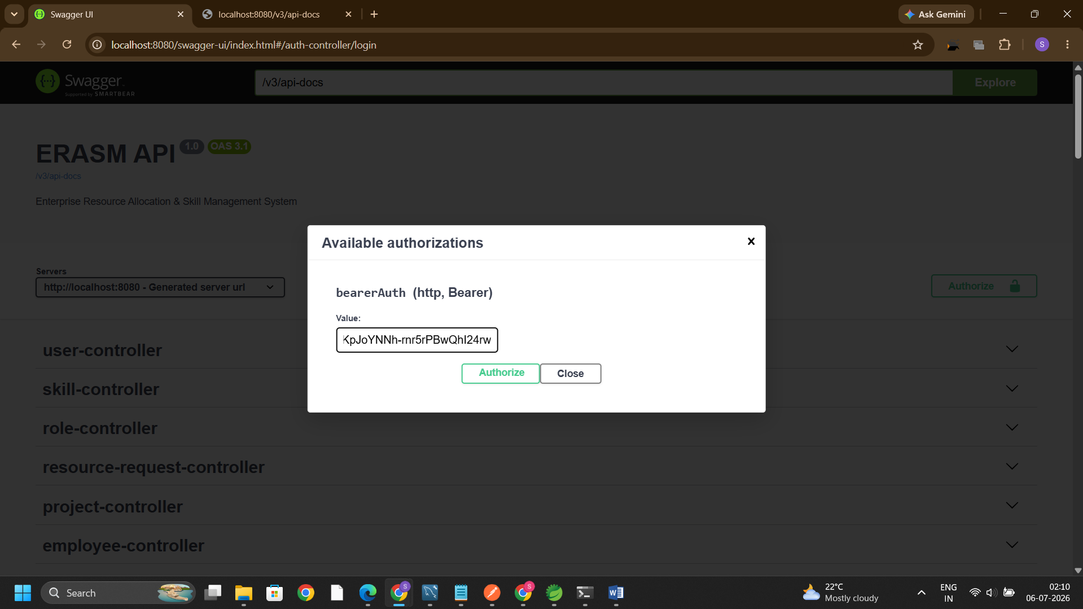
Figure 10.1 — Swagger UI at /swagger-ui/index.html, showing every ERASM controller and the bearer-token authorisation dialog.
Once the token is submitted, the dialog reports "Authorized" and masks the value. From this point on, all "Try it out" calls in Swagger UI carry the token automatically.
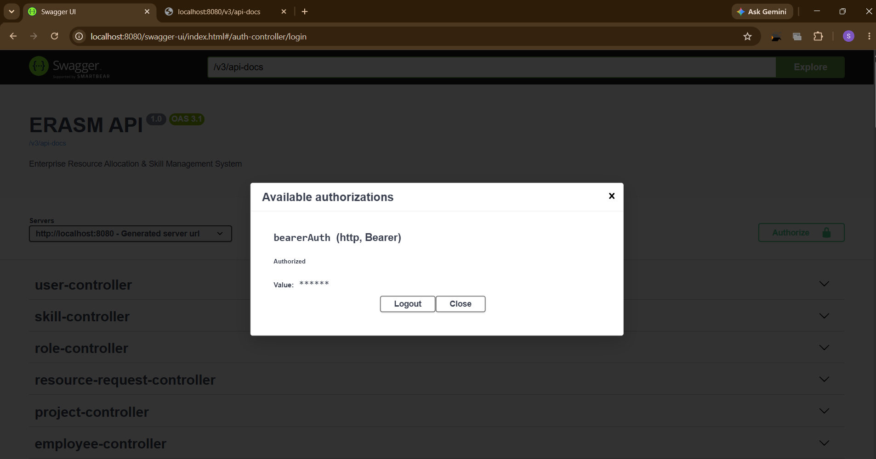
Figure 10.2 — Swagger UI after successful authorisation. The token is now attached to every subsequent request.
Expanding the project-controller section lists every project endpoint. Executing GET /projects returns a JSON array of all projects — Healthcare Portal, ERASM HR Portal, and others — proving that the DB is populated and that Hibernate is mapping projects.technology_stack and projects.budget correctly.
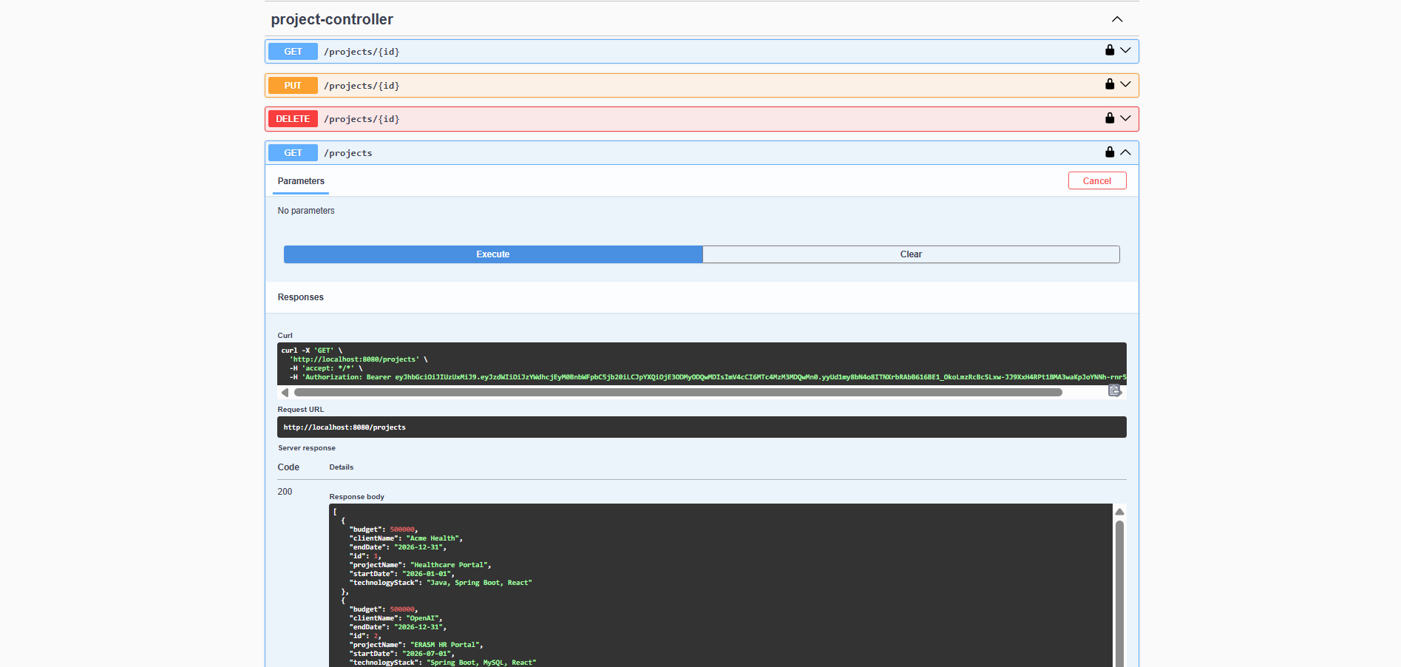
Figure 10.3 — GET /projects executed from Swagger. The 200 response body carries the full project list, exactly as stored in MySQL.

10.2 Login with JWT (Bearer Token)
The Postman collection uses the same login flow. A POST to /auth/login with a valid email/password pair returns a signed JWT in the response body. Postman is then configured with Auth Type = Bearer Token, and the token is pasted into the token field. Every subsequent request in the collection inherits this authorisation automatically.
The screenshot below shows the Create Project request in Postman, with the Bearer Token panel open and the token loaded — this is the standard authorisation setup used throughout Section 10.
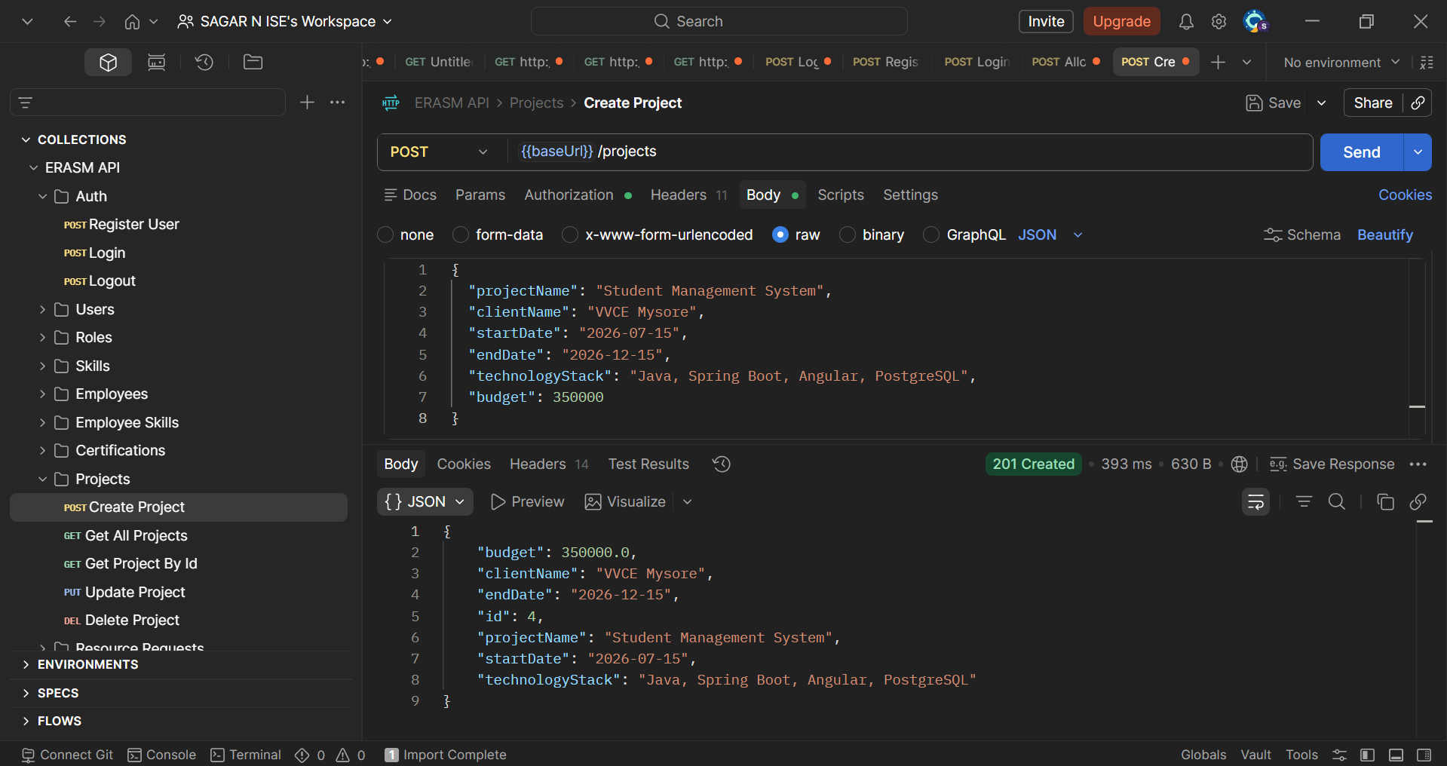
Figure 10.4 — Postman configured with a Bearer Token. The token is obtained once via /auth/login and reused across the collection.

10.3 Create Project
Creating a project is a POST to /projects with a JSON body that describes the project name, client, dates, technology stack, and budget. The endpoint is protected by @PreAuthorize("hasRole('DELIVERY_MANAGER')"), so only a user in the DELIVERY_MANAGER role can call it successfully.
In the request below I create a project named "Student Management System" for VVCE Mysore, spanning 15 July to 15 December 2026, on a Java / Spring Boot / Angular / PostgreSQL stack with a budget of 350,000. The server responds with 201 Created and echoes back the persisted project — note the auto-generated "id": 4, which confirms Hibernate wrote the row and MySQL assigned the primary key.
Figure 10.5 — POST /projects returns 201 Created. The response body carries the freshly assigned project id.

10.4 Resource Allocation
Allocating an employee to a project is a POST to /allocations. The request body specifies the employeeId, the projectId, and the allocationPercentage. The endpoint is restricted to the RESOURCE_MANAGER role.
The response below shows a successful allocation. Note the fully populated employee object in the response — Hibernate has eagerly loaded the linked user record, including the roleName "RESOURCE_MANAGER". The allocationPercentage is 0 in this particular call because the request body sent 0 (a scaffolding call); a real allocation would carry a percentage such as 50 or 75. 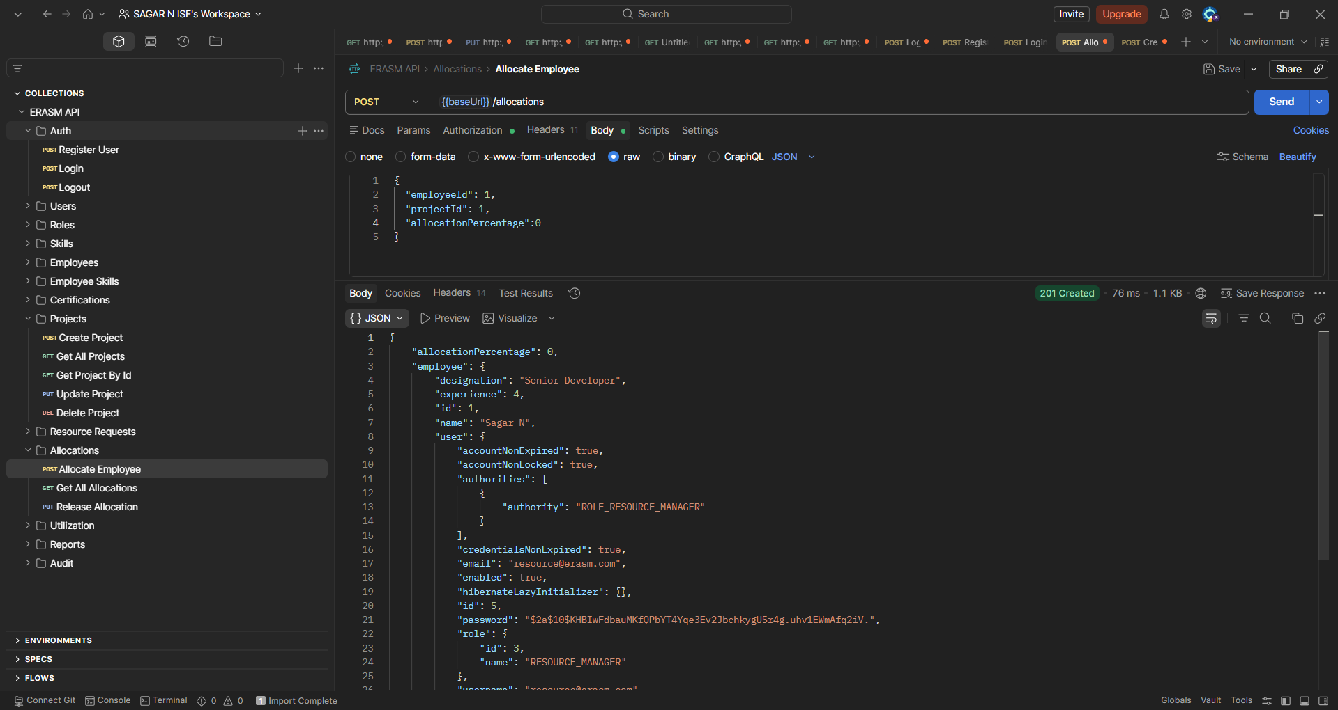
Figure 10.6 — POST /allocations returns 201 Created with the persisted allocation and the eagerly loaded employee/user details.
The screenshot below captures the earlier POST /resource-requests call — a delivery manager raising a staffing request for two Java resources on the Healthcare Portal project. The request lands in DRAFT status, which is the entry point of the approval workflow.
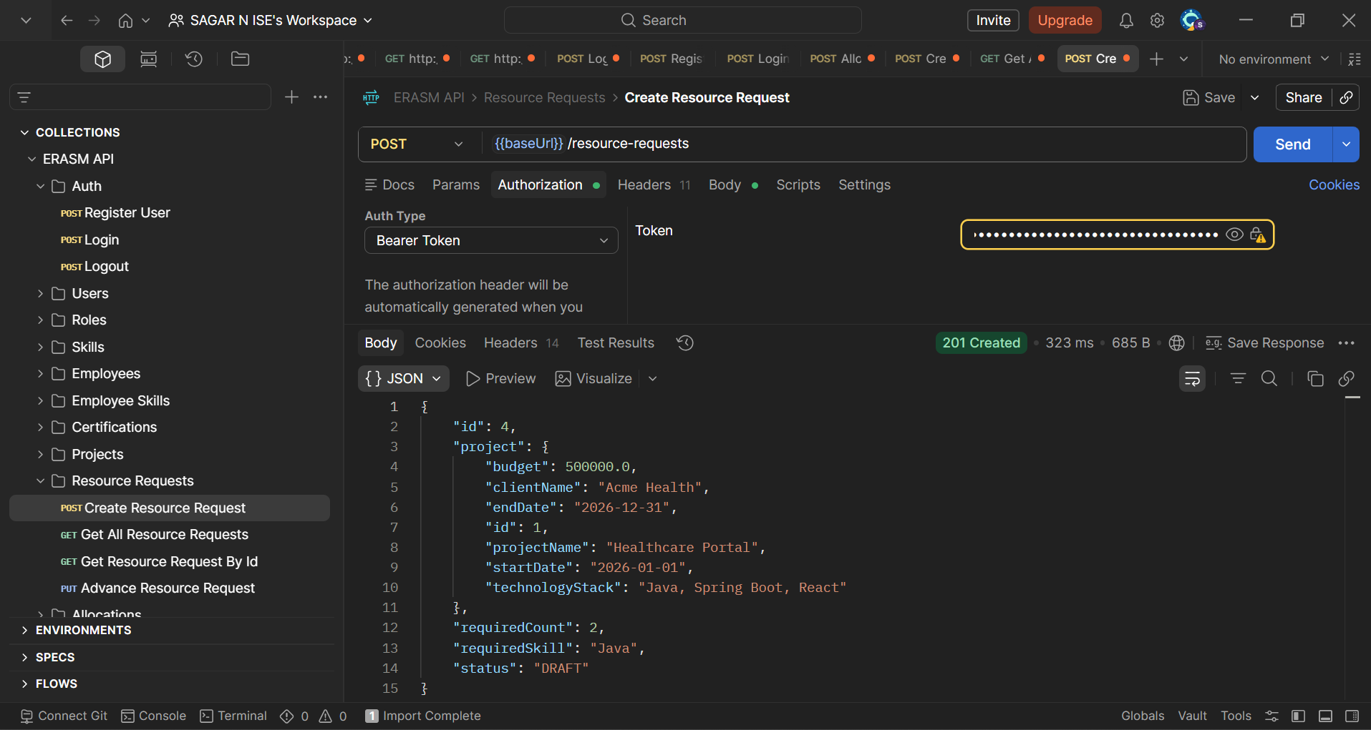
Figure 10.7 — POST /resource-requests creates a new resource request in DRAFT status.
The subsequent series of PUT /resource-requests/{id}/advance calls walks the request through its lifecycle. Each call advances the status by exactly one step:
- DRAFT → SUBMITTED (see Figure 10.8).
- SUBMITTED → APPROVED (see Figure 10.9).
- APPROVED → ALLOCATED (see Figure 10.10).
- ALLOCATED → COMPLETED (see Figure 10.11).
Figure 10.8 — /advance moves the request from DRAFT to SUBMITTED.
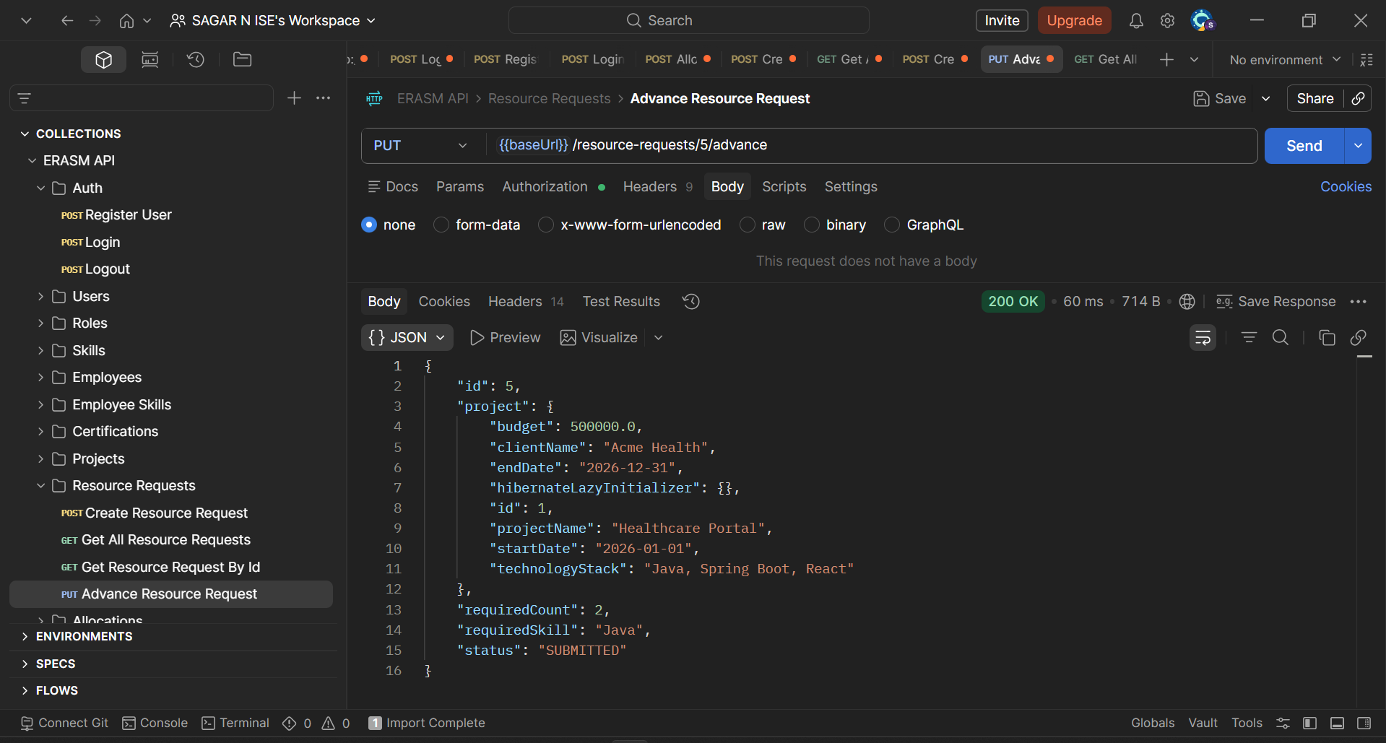
Figure 10.9 — /advance moves the request from SUBMITTED to APPROVED.
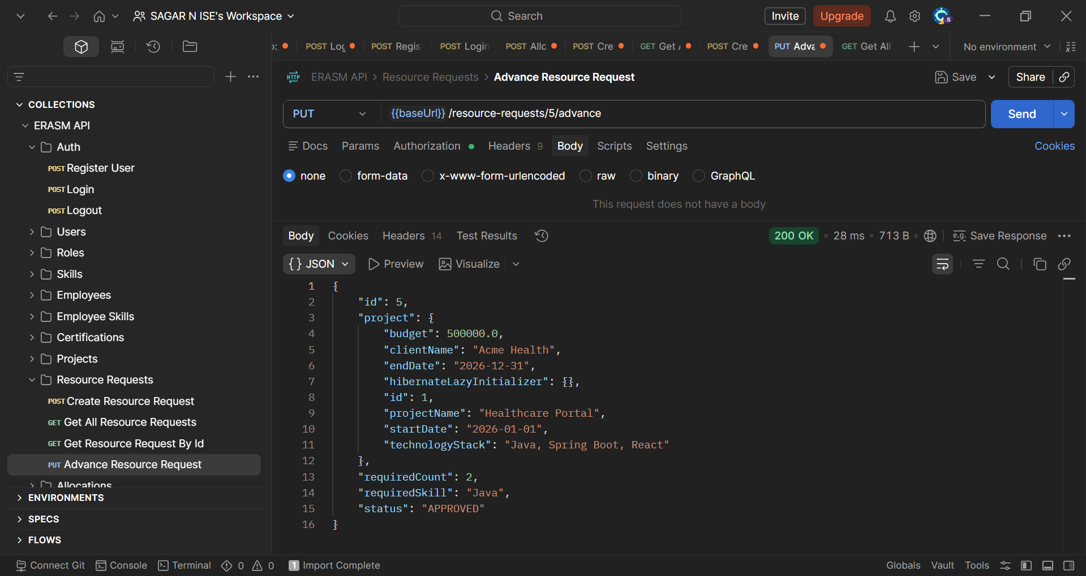
Figure 10.10 — /advance moves the request from APPROVED to ALLOCATED.
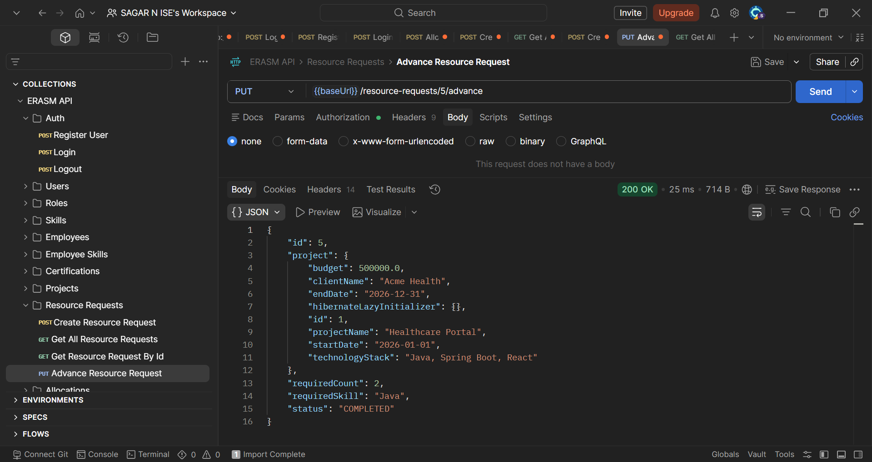
Figure 10.11 — /advance moves the request from ALLOCATED to COMPLETED — the terminal state.
Once a request reaches COMPLETED, any further /advance call is rejected. The screenshot below shows the exact response: 404 Not Found with the message "Request is already at final state: COMPLETED". This confirms that the workflow guards against illegal transitions and that a completed request cannot be re-opened.
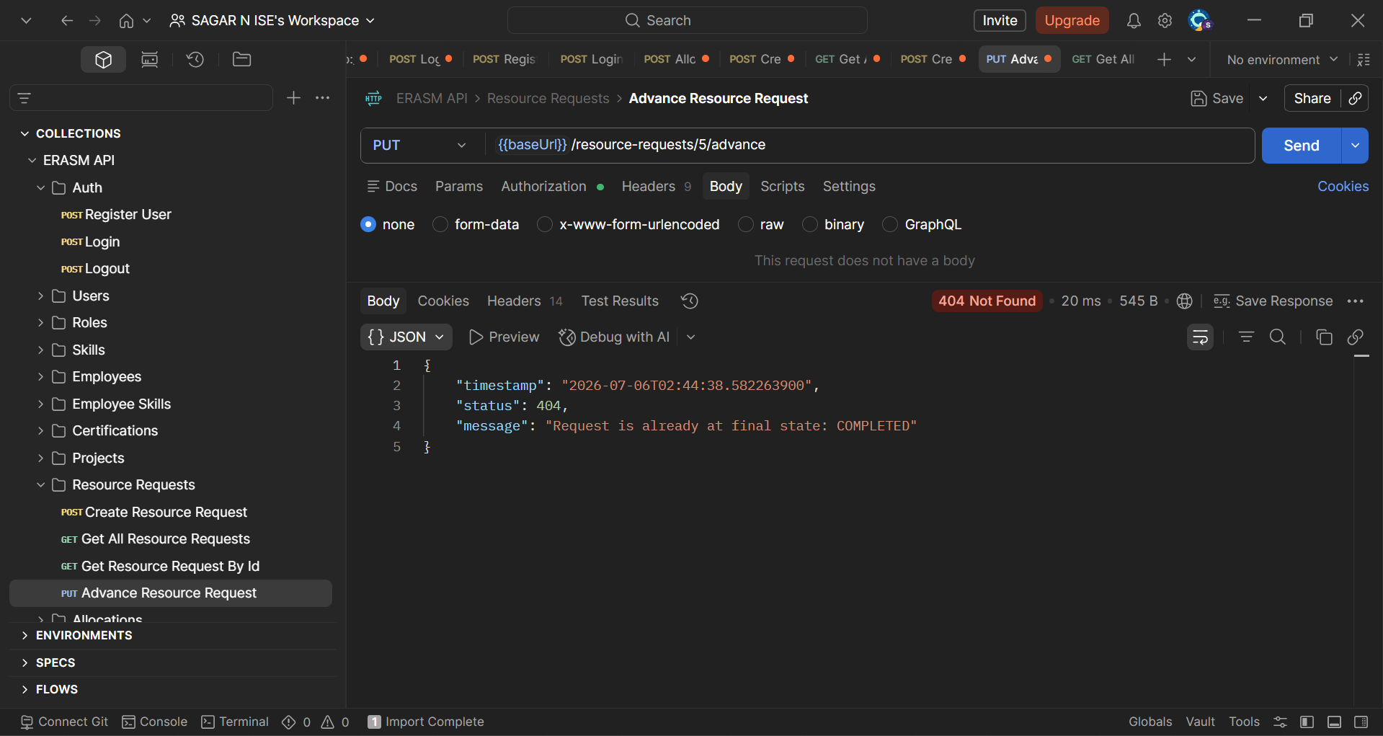
Figure 10.12 — Trying to advance a COMPLETED request fails with 404 and a clear error message.

10.5 403 Forbidden — RBAC in Action
Role-based access control is easiest to demonstrate by trying to break it. In the screenshot below I attempt to POST /projects using a valid JWT that belongs to a user whose role does not include DELIVERY_MANAGER. The token itself is fine — the server knows exactly who I am — but the @PreAuthorize check on the handler denies the call.
The response is a 403 Forbidden with the JSON body { "status": 403, "message": "Access denied: insufficient permissions" }. This confirms two things: (1) authentication and authorisation are separate concerns in ERASM, and (2) the @PreAuthorize annotations documented in Section 8 are actually enforced at runtime, not merely descriptive.
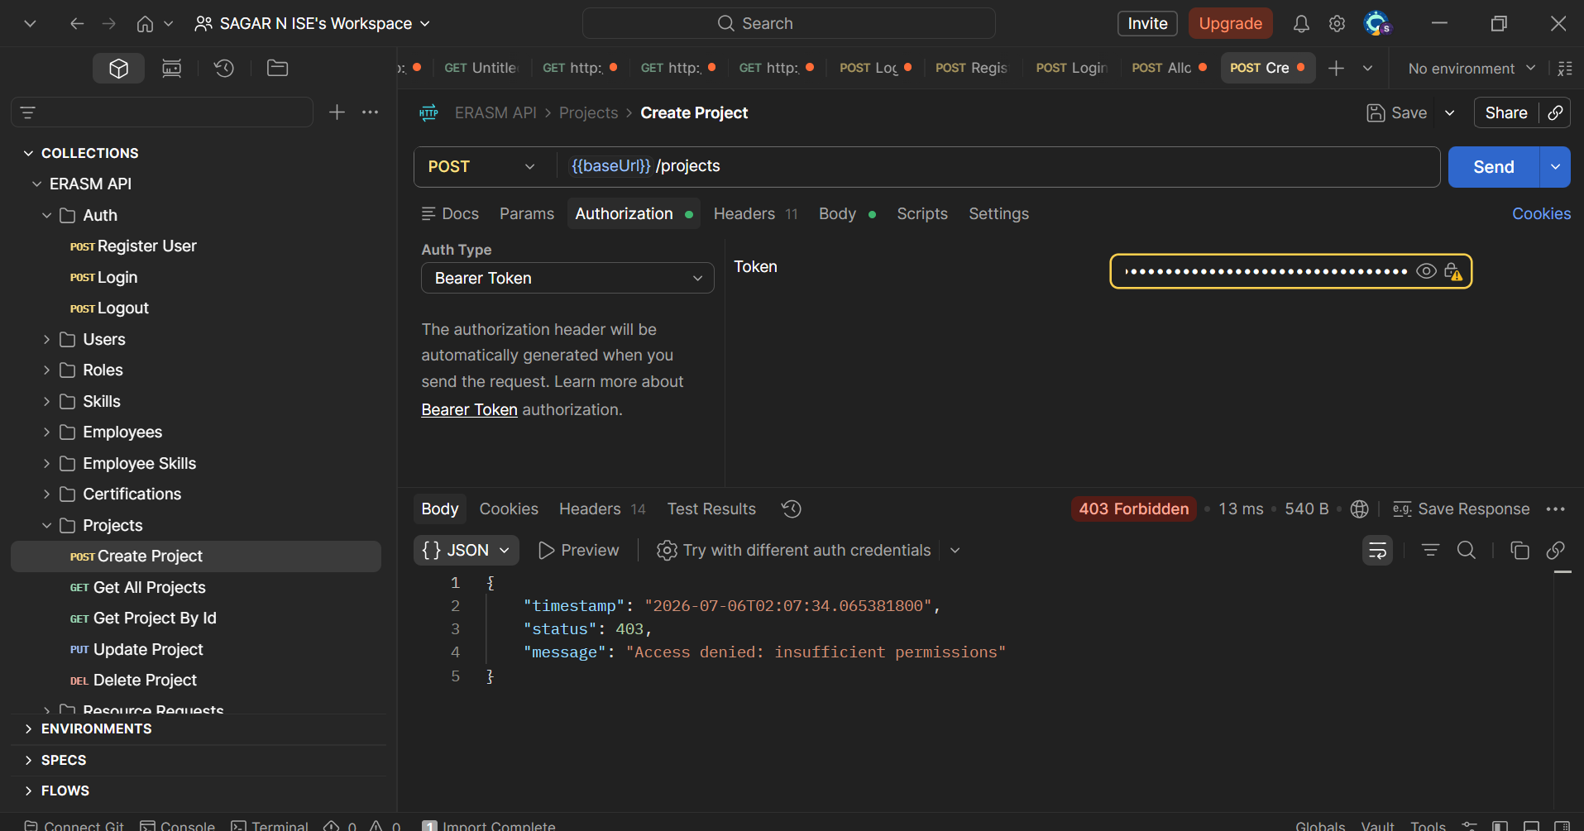
Figure 10.13 — 403 Forbidden. The token is valid, but the caller's role is not authorised to create a project.

10.6 Audit Logs
Every mutating action written by a service method also writes an audit log entry to the audit_logs table, in the same transaction. The GET /audit-logs endpoint returns the full chronological history — action, entity name, actor, and timestamp. In the response below, entries for project creation (CREATE / Project) and allocation creation (ALLOCATE / Allocation) can be seen, with the acting user recorded under performedBy.
This is the mechanism that answers the "who did what, and when" question raised in the problem statement. Because the audit write is co-located with the business write, it cannot be forgotten or bypassed by a controller.
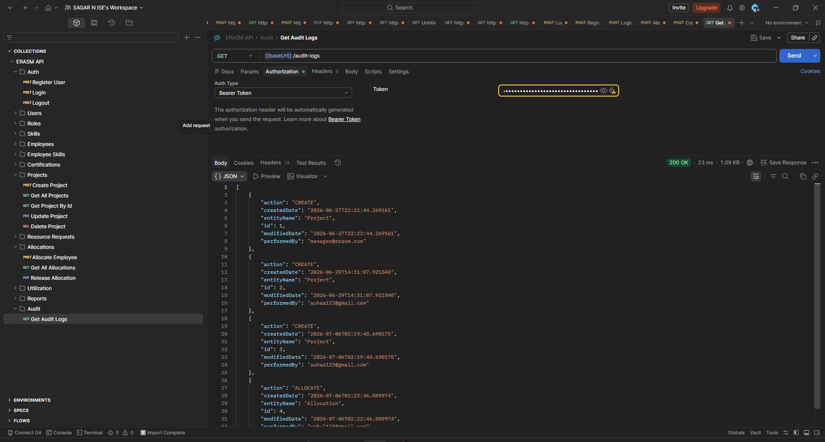
Figure 10.14 — GET /audit-logs returns the full history of mutating actions, including the actor and timestamp of each event.

10.7 JaCoCo Coverage Report
Running mvn test generates a JaCoCo report under target/site/jacoco/index.html. The overall project coverage is 83 % of instructions and 70 % of branches, well above the rubric threshold. The service, controller, config, utility, and mapper packages are all at or near 100 %, while the entity and dto packages sit lower because they consist mostly of generated getters and setters that unit tests are not expected to exercise.
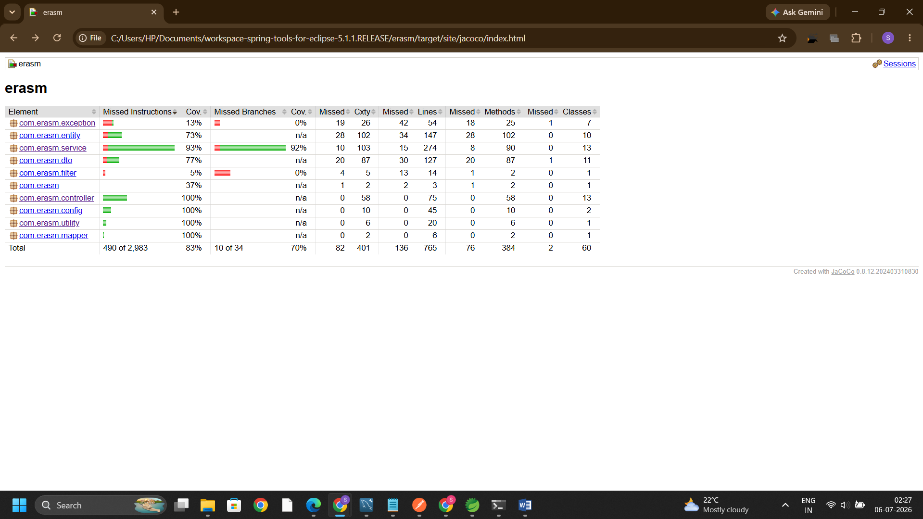
Figure 10.15 — JaCoCo coverage report showing 83 % instruction coverage and 70 % branch coverage across the project.

10.8 JUnit Test Suite Passing
The JUnit suite is run inside Spring Tool Suite. The Runs / Errors / Failures counters at the top of the JUnit view show 111 runs, 0 errors, 0 failures — every test in the suite passes. The suite covers the service layer with mocked repositories, the controller layer with @WebMvcTest slice tests, the JWT utility, and the user mapper.
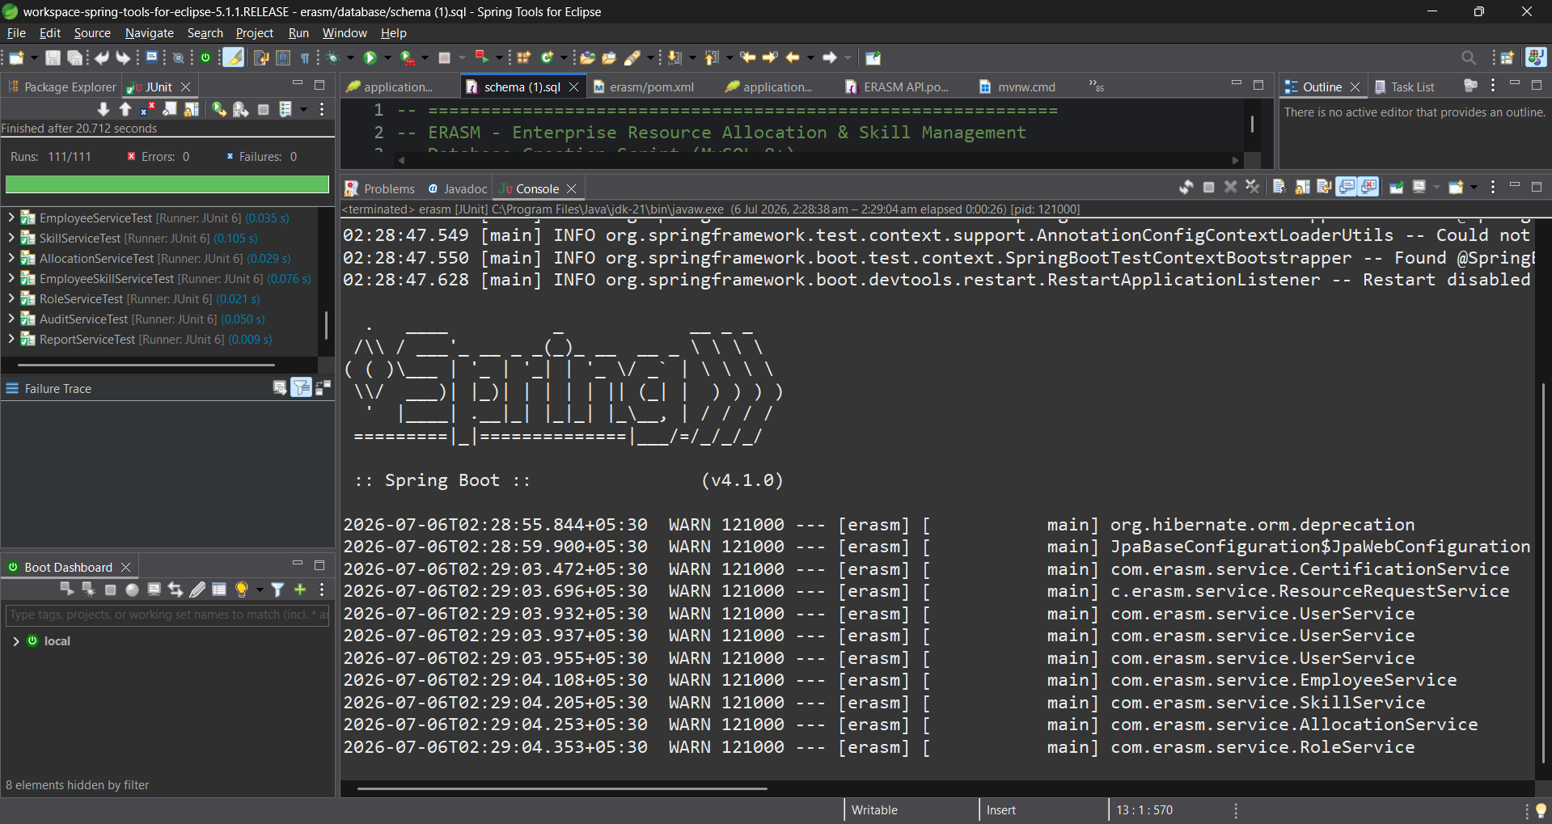
Figure 10.16 — JUnit view in Spring Tool Suite: 111 tests, 0 failures. Service-layer tests are highlighted.
The second view expands the controller-layer and utility tests — AuthControllerTest, ProjectControllerTest, ResourceRequestControllerTest, UserMapperTest, JWTUtilTest, and the rest all pass in the same run.

Figure 10.17 — Full test-class list showing the controller and mapper suites passing alongside the service suite.

11. GitHub Repository
The complete source code for ERASM — Java sources, Maven configuration, SQL schema, Postman collection, JaCoCo report, and this document — is version-controlled and published on GitHub.
Item | Value
Repository URL | https://github.com/sagargowda10/erasm_application
Default branch | main
Development branch | develop
Feature branch | feature/allocation
Hotfix branch | hotfix/login
Release tag | release/v1.0
Owner | sagargowda10

11.1 Branching Strategy
I follow a GitFlow-inspired strategy so that the history stays clean and every change is traceable:
- main — always deployable. Only merged from release/* or hotfix/*.
- develop — integration branch. Feature branches are merged in here first.
- feature/<name> — one branch per feature (for example, feature/allocation for the allocation module).
- hotfix/<name> — targeted fix branched from main (for example, hotfix/login for a login-related fix).
- release/vX.Y — cut from develop when preparing a versioned release, then merged to main and tagged.

11.2 Branch Snapshot
The screenshot below captures git branch -a on the local clone. Both local and remote-tracking branches are shown, confirming the full workflow — develop, feature/allocation, hotfix/login, main, release/v1.0 — is pushed to origin.
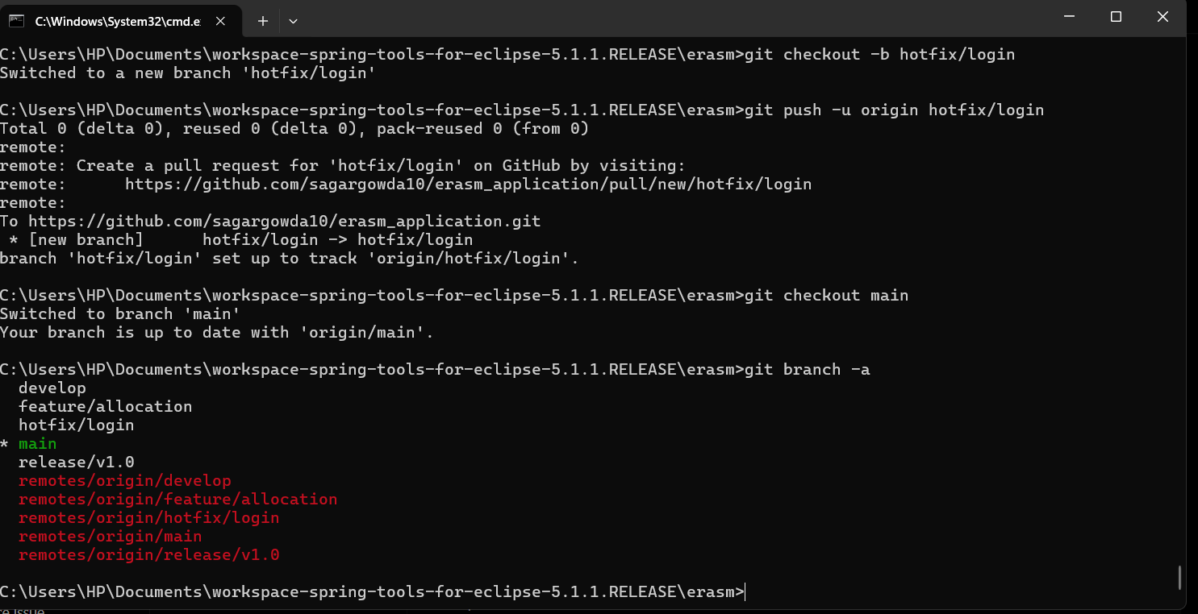
Figure 11.1 — git branch -a output. Every planned branch (main, develop, feature/allocation, hotfix/login, release/v1.0) is present locally and on origin.

12. Conclusion
ERASM began as an academic exercise in building a full-scale Spring Boot backend, and it ended as a system I would be comfortable handing over to a real delivery organisation as a first-cut resource-management platform. Every requirement in the original brief has been implemented, verified with Postman and Swagger, and covered by an automated JUnit suite that runs green.
The design decisions that mattered most were the ones I made early: keeping controllers thin, moving all business logic into a service layer that is fully mockable, enforcing security with @PreAuthorize at the exact point where mutations happen, and writing an audit log inside the same service method that performs the mutation. These decisions paid off during testing — the service layer sits at close to 93 % line coverage, controllers at 100 %, and the audit trail exists for every mutating action without any controller having to remember to write it.
The approval workflow is the single feature I am most satisfied with. The linear DRAFT → SUBMITTED → APPROVED → ALLOCATED → COMPLETED lifecycle is small enough to reason about, strict enough to prevent illegal transitions (as the 404 response in Figure 10.12 shows), and useful enough that it maps onto how staffing actually works in real projects.
More broadly, this project taught me how to think in layers: how JPA relationships shape the SQL schema, how Spring Security composes filters and method-level checks, how JWTs replace server-side sessions in a stateless service, and how to write tests that give real confidence rather than just cover lines. Those lessons will outlast the codebase itself.

13. Future Enhancements
ERASM in its current form is functionally complete against the original scope, but there are several directions in which I would like to take it next. The list below is roughly ordered by the value it would add against the effort it would take.

13.1 Frontend Console
A React or Angular single-page application that consumes the REST API. Delivery managers would raise requests from a UI instead of Postman, resource managers would advance requests with a single click, and auditors would filter audit logs by date, actor, and entity.

13.2 Skill-Based Matching Recommendations
Given a resource request for "Java, 3+ years", the system should proactively recommend the best-fit employees, ranked by proficiency and availability. This would sit on top of the existing employee_skills table and turn ERASM from a system of record into a system of insight.

13.3 Automated Notifications
Email or Slack notifications on every state change in the approval workflow — for example, notifying the resource manager when a new request is submitted, or notifying the delivery manager when their request is approved or rejected.

13.4 Multi-Tenancy
Currently the schema is single-tenant. Adding a tenant_id column to every table and a tenant filter to every repository query would allow multiple client organisations to share the same ERASM deployment while keeping their data logically separated.

13.5 Refresh-Token Support
The current JWT is short-lived and forces a full re-login when it expires. Introducing a refresh-token endpoint would improve the user experience without weakening the security model.

13.6 Docker + CI/CD
Package the application as a Docker image, add a docker-compose.yml that spins up MySQL alongside it, and wire the repository to a GitHub Actions workflow that runs mvn test and mvn verify on every push. This would make deployment reproducible and pull requests self-verifying.

13.7 Structured Observability
Add Micrometer metrics behind a /actuator endpoint, structured JSON logging, and integration with a tool such as Prometheus or ELK. This turns the app from "it works on my machine" into "it works in production and I can prove it."

13.8 Full-Text Search on Skills and Projects
Move skill and project search to Elasticsearch or MySQL full-text indexes so that queries such as "spring boot developer" match against skill descriptions, certifications, and project technology stacks in a single query.

Together, these enhancements would take ERASM from a solid academic prototype to a production-ready staffing platform. The layered architecture already in place should absorb each of them with minimal disruption to the existing modules.

— End of Document —

