**## Create Table:**

[CREATE](http://localhost/phpmyadmin/url.php?url=https://dev.mysql.com/doc/refman/8.0/en/create-table.html) [TABLE](http://localhost/phpmyadmin/url.php?url=https://dev.mysql.com/doc/refman/8.0/en/create-table.html) `lab_03`.`employees` (`employee_id` CHAR(10) [NOT](http://localhost/phpmyadmin/url.php?url=https://dev.mysql.com/doc/refman/8.0/en/logical-operators.html%23operator_not) NULL , `first_name` VARCHAR(20) [NOT](http://localhost/phpmyadmin/url.php?url=https://dev.mysql.com/doc/refman/8.0/en/logical-operators.html%23operator_not) NULL , `last_name` VARCHAR(20) [NOT](http://localhost/phpmyadmin/url.php?url=https://dev.mysql.com/doc/refman/8.0/en/logical-operators.html%23operator_not) NULL , `email` VARCHAR(60) [NOT](http://localhost/phpmyadmin/url.php?url=https://dev.mysql.com/doc/refman/8.0/en/logical-operators.html%23operator_not) NULL , `phone_number` CHAR(14) [NOT](http://localhost/phpmyadmin/url.php?url=https://dev.mysql.com/doc/refman/8.0/en/logical-operators.html%23operator_not) NULL , `hire_date` DATE [NOT](http://localhost/phpmyadmin/url.php?url=https://dev.mysql.com/doc/refman/8.0/en/logical-operators.html%23operator_not) NULL , `job_id` INT(255) [NOT](http://localhost/phpmyadmin/url.php?url=https://dev.mysql.com/doc/refman/8.0/en/logical-operators.html%23operator_not) NULL , `salary` INT(255) [NOT](http://localhost/phpmyadmin/url.php?url=https://dev.mysql.com/doc/refman/8.0/en/logical-operators.html%23operator_not) NULL , `commission_pct` DECIMAL(10) [NOT](http://localhost/phpmyadmin/url.php?url=https://dev.mysql.com/doc/refman/8.0/en/logical-operators.html%23operator_not) NULL , `manager_id` CHAR(10) [NOT](http://localhost/phpmyadmin/url.php?url=https://dev.mysql.com/doc/refman/8.0/en/logical-operators.html%23operator_not) NULL , `department_id` INT(255) [NOT](http://localhost/phpmyadmin/url.php?url=https://dev.mysql.com/doc/refman/8.0/en/logical-operators.html%23operator_not) NULL );

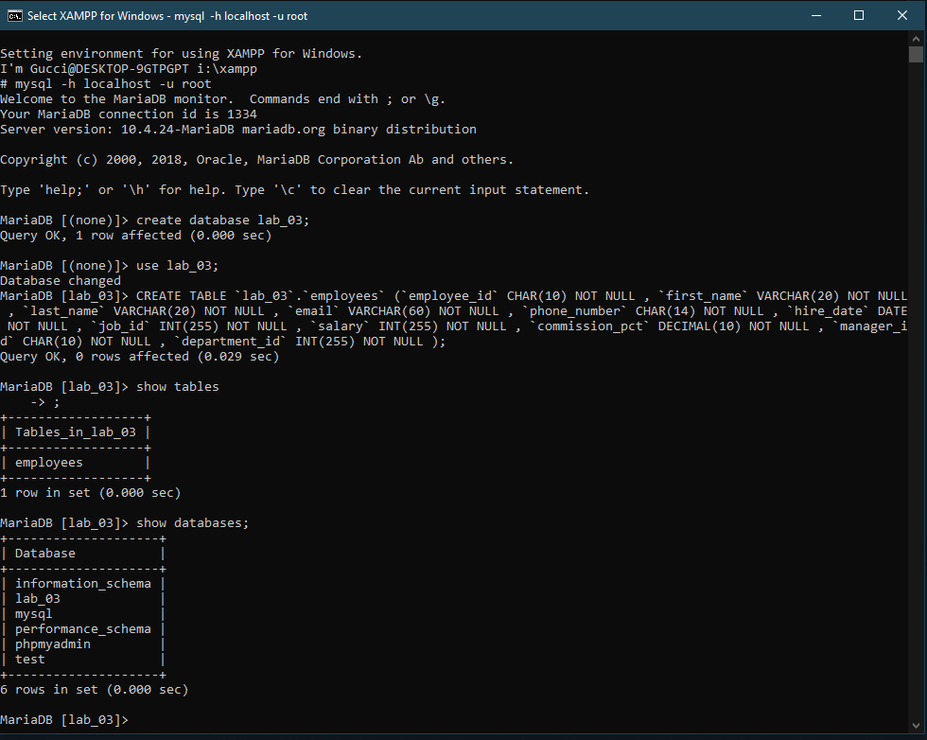

**## Insert Table:**

INSERT INTO `employees` (`employee_id`, `first_name`, `last_name`, `email`, `phone_number`, `hire_date`, `job_id`, `salary`, `commission_pct`, `manager_id`, `department_id`) VALUES ('221', 'Sabrina', 'hasan', 'sagarhasan@gmail.com', '01944444444', '2022-11-10', '331', '35000', '5', '441', '551');

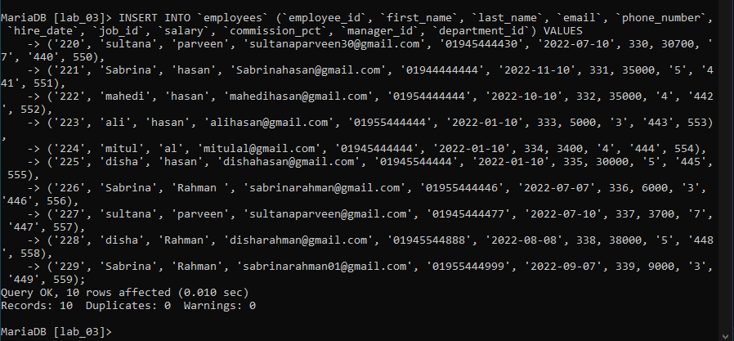

**## Answer 01:**

[SELECT](http://localhost/phpmyadmin/url.php?url=https://dev.mysql.com/doc/refman/8.0/en/select.html) `first_name`, `last_name`, `email`, `phone_number`, `hire_date`, `department_id` FROM `employees` WHERE `hire_date` = ([SELECT](http://localhost/phpmyadmin/url.php?url=https://dev.mysql.com/doc/refman/8.0/en/select.html) [MAX](http://localhost/phpmyadmin/url.php?url=https://dev.mysql.com/doc/refman/8.0/en/aggregate-functions.html%23function_max)(`hire_date`) FROM `employees`);

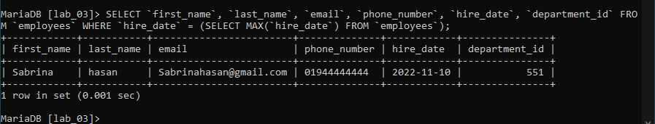

**## Answer 02:**

[SELECT](http://localhost/phpmyadmin/url.php?url=https://dev.mysql.com/doc/refman/8.0/en/select.html) `first_name`, `last_name`, `employee_id`, `phone_number`, `salary`, `department_id` FROM `employees` WHERE `salary` = ([SELECT](http://localhost/phpmyadmin/url.php?url=https://dev.mysql.com/doc/refman/8.0/en/select.html) [MIN](http://localhost/phpmyadmin/url.php?url=https://dev.mysql.com/doc/refman/8.0/en/aggregate-functions.html%23function_min)(`salary`) FROM `employees`) GROUP BY `department_id`;

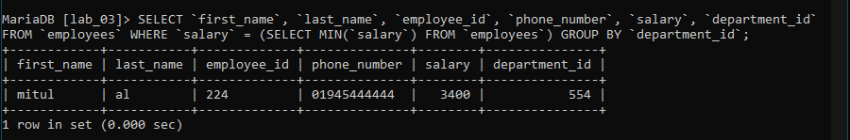

**## Answer 03:**

[SELECT](http://localhost/phpmyadmin/url.php?url=https://dev.mysql.com/doc/refman/8.0/en/select.html) `first_name`, `last_name`, `employee_id`, `phone_number`, `commission_pct`, `department_id` FROM `employees` WHERE `commission_pct` = ([SELECT](http://localhost/phpmyadmin/url.php?url=https://dev.mysql.com/doc/refman/8.0/en/select.html) [MIN](http://localhost/phpmyadmin/url.php?url=https://dev.mysql.com/doc/refman/8.0/en/aggregate-functions.html%23function_min)(`commission_pct`) FROM `employees` WHERE `department_id` = 557);

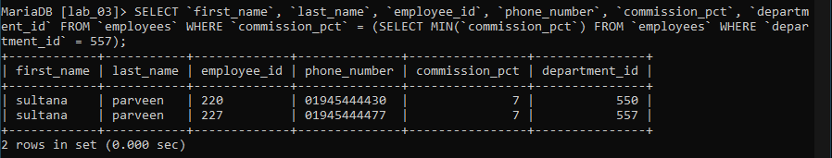

**## Answer 04:**

[SELECT](http://localhost/phpmyadmin/url.php?url=https://dev.mysql.com/doc/refman/8.0/en/select.html) `department_id` FROM `employees` WHERE `salary` > 30000;

[SELECT](http://localhost/phpmyadmin/url.php?url=https://dev.mysql.com/doc/refman/8.0/en/select.html) [COUNT](http://localhost/phpmyadmin/url.php?url=https://dev.mysql.com/doc/refman/8.0/en/aggregate-functions.html%23function_count)(`department_id`) FROM `employees` WHERE `salary` > 30000;

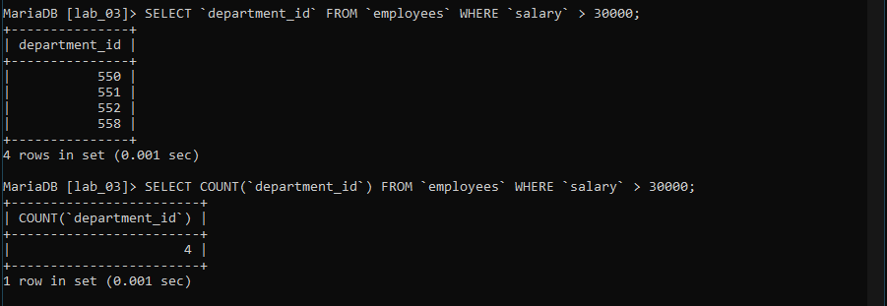

**## Answer 05:**

[SELECT](http://localhost/phpmyadmin/url.php?url=https://dev.mysql.com/doc/refman/8.0/en/select.html) `department_id` `job_id`, `commission_pct` FROM `employees` WHERE `job_id` = ([SELECT](http://localhost/phpmyadmin/url.php?url=https://dev.mysql.com/doc/refman/8.0/en/select.html) [MIN](http://localhost/phpmyadmin/url.php?url=https://dev.mysql.com/doc/refman/8.0/en/aggregate-functions.html%23function_min)(`job_id`) FROM `employees` WHERE `commission_pct` = 5);

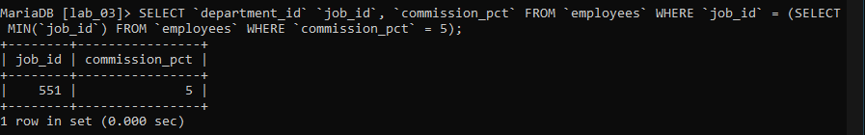

**## Answer 06:**

[SELECT](http://localhost/phpmyadmin/url.php?url=https://dev.mysql.com/doc/refman/8.0/en/select.html) `manager_id` FROM `employees` WHERE `salary` >= 3500;

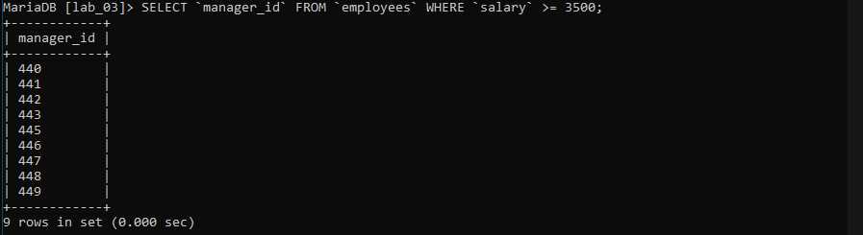

**## Answer 07:**

SELECT `first_name`, `last_name`, `employee_id`, `email`, `salary`, `commission_pct` FROM `employees` WHERE `commission_pct` = (SELECT MIN(`commission_pct`) FROM `employees`);

