1. Prerequisites and Network Configuration
Before installing any roles, I standardised the network settings and server hostnames so every machine could communicate reliably inside the domain.
Domain Controller (DC) setup
- Static IP configuration: assigned a dedicated static IP address to the primary Domain Controller.
- Pointed the primary DNS to the server's own IP address to prepare for the integrated DNS role.
Control Panel → Network and Sharing Center → Change adapter settings → Ethernet0 → Properties → Internet Protocol Version 4 (TCP/IPv4) → Properties – Assigns the static IP 192.168.96.134/24, gateway 192.168.96.2 and points DNS to the server itself. A Domain Controller needs a fixed address because clients locate it through DNS, and it will host the AD-integrated DNS zone.
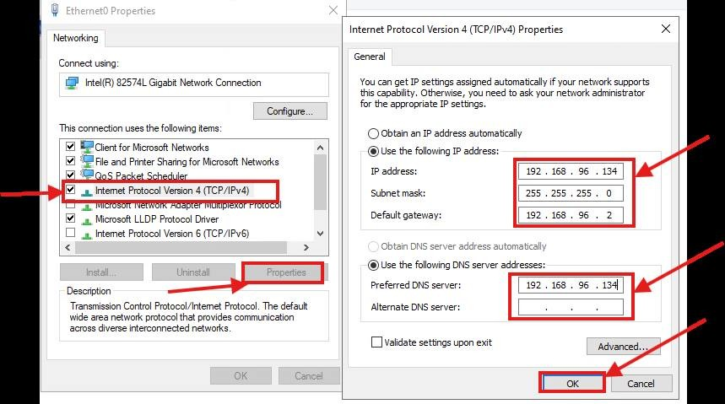
Figure 1: Configuring a static IP address on the DC
- Verified connectivity and configuration in Command Prompt with ipconfig /all.
Start → Command Prompt → ipconfig /all – Confirms the static IP, gateway and DNS settings took effect and DHCP is off. Checking this before promotion avoids DNS registration and replication problems later.
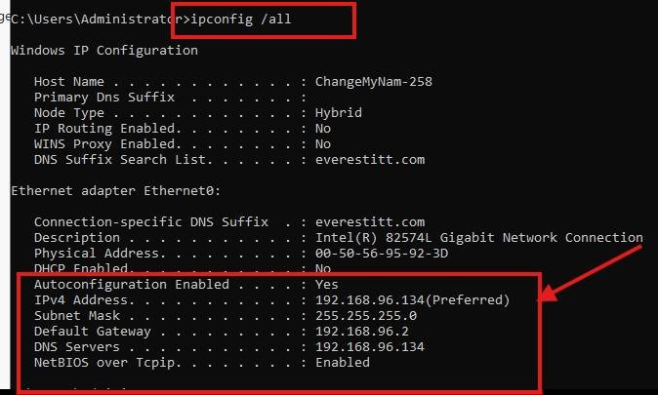
Figure 2: Verifying the DC network settings
- Renamed the server to Admin to replace the default Windows-generated name. (In production, a descriptive name such as DC-01 is recommended.)
Server Manager → Local Server → Computer name → System Properties → Computer Name tab → Change – Replaces the random hostname (ChangeMyNam-258) with the server name Admin. The name must be set before promotion, because renaming a Domain Controller afterwards is complex and risky.
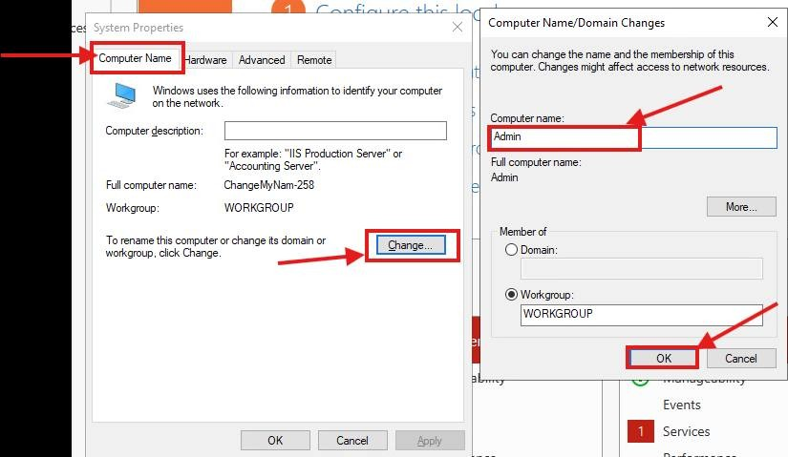
Figure 3: Renaming the Domain Controller
- Restart: restarted the server to apply the new hostname before installing Active Directory.
System Properties → Change → OK – Windows asks for a restart to apply the new hostname. The reboot is required so the new name is registered before Active Directory is installed.
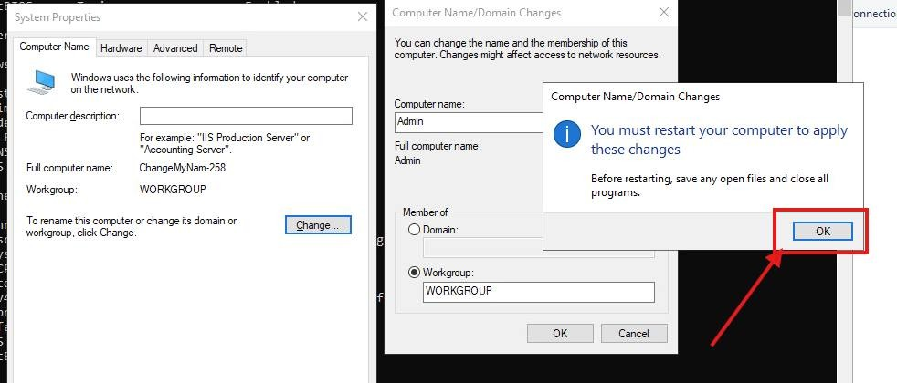
Figure 4: Restarting to apply the DC hostname
File Server (FS) setup
- Static IP configuration: configured a unique static IP address in the same subnet as the Domain Controller, with DNS pointing to the DC.
Control Panel → Network and Sharing Center → Change adapter settings → Ethernet0 → Properties → Internet Protocol Version 4 (TCP/IPv4) → Properties – Assigns the File Server the static IP 192.168.96.135/24 in the same subnet, with DNS pointing to the DC. Servers need fixed addresses, and the DNS setting lets FS find the domain when it joins.
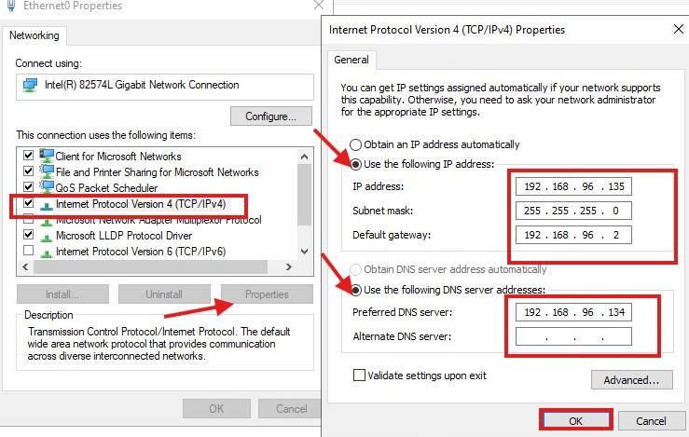
Figure 5: Configuring a static IP address on the File Server
Start → Command Prompt → ipconfig /all – Verifies the File Server's IP, gateway and DNS server (the DC). Confirming DNS points to the DC is the most important check before any domain join.
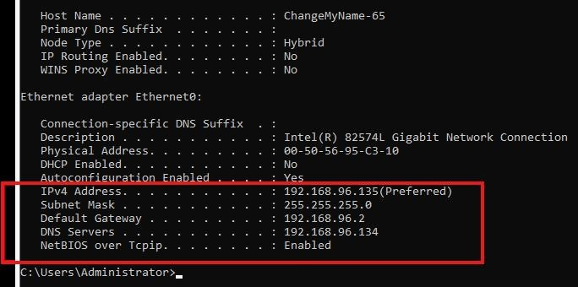
Figure 6: Verifying the File Server network settings
- Hostname update: renamed the server to FS.
Server Manager → Local Server → Computer name → System Properties → Computer Name tab → Change – Renames the File Server to FS while it is still in a workgroup. A clear, predictable name makes shares easy to reference, for example \\FS\Sales.
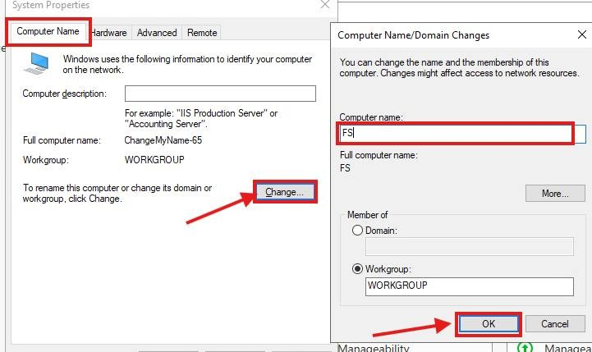
Figure 7: Renaming the File Server to FS
- Reboot: restarted the server to finalise the name change before joining the domain.
System Properties → Change → OK – Windows asks for a restart to apply the FS hostname. Restarting before the domain join makes sure the computer account is created with the correct name.
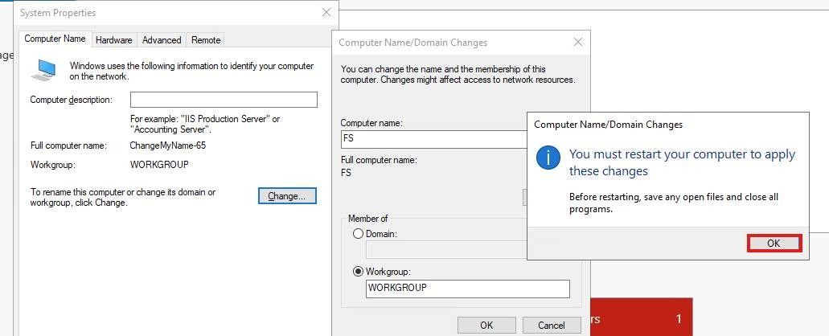
Figure 8: Restarting to apply the FS hostname
2. Active Directory Domain Services (AD DS) Installation
- Role installation: added the Active Directory Domain Services (AD DS) role and the DNS Server role through Server Manager on the Domain Controller.
Server Manager → Dashboard → Add roles and features – Opens the Add Roles and Features Wizard on the Domain Controller. This wizard is the standard way to install server roles such as AD DS.
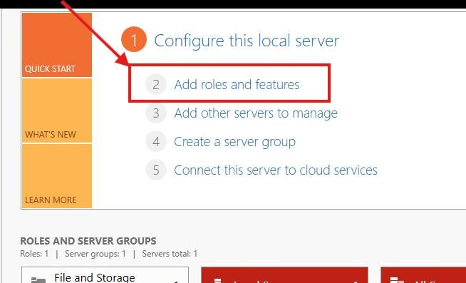
Figure 9: Starting the Add Roles and Features Wizard
Click Next through the wizard, confirming the server's IP address and name are correct on the server selection page.
Add Roles and Features Wizard → Server Selection – Selects the local server (192.168.96.134, Windows Server 2022) as the destination. Confirming the name and IP here ensures the role is installed on the correct machine.
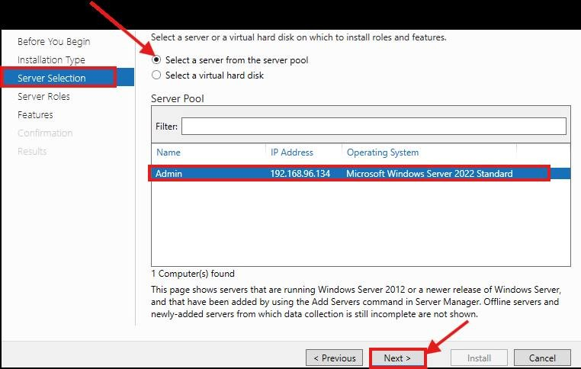
Figure 10: Selecting the destination server
Add Roles and Features Wizard → Server Roles → Active Directory Domain Services – Ticks Active Directory Domain Services. AD DS is the core role that provides centralised users, computers, authentication and Group Policy.
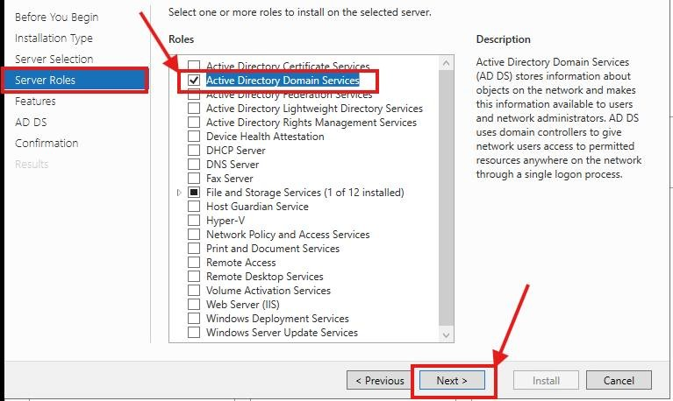
Figure 11: Selecting the AD DS role
Server Roles → Active Directory Domain Services → Add Features – Accepts the required management tools: Group Policy Management, ADAC, the AD DS snap-ins and the AD PowerShell module. These tools are needed to manage the domain after installation.
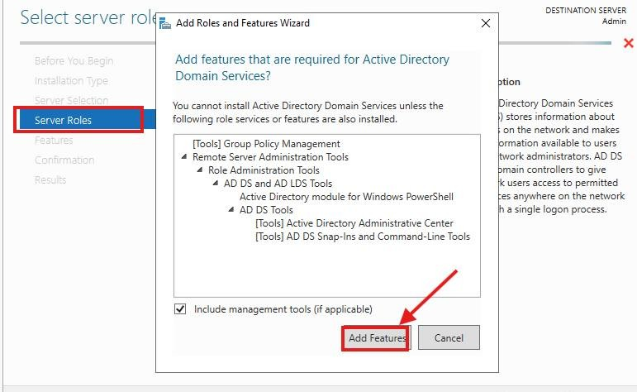
Figure 12: Adding the required AD DS management tools
Add Roles and Features Wizard → Confirmation → Install – Reviews the selections, enables automatic restart and starts the install. A final review prevents installing the wrong components.
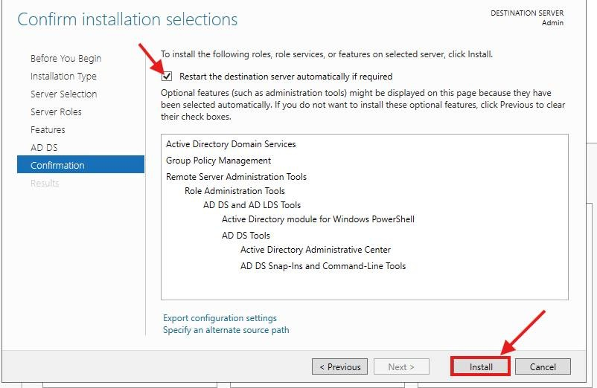
Figure 13: Confirming the AD DS installation
- Domain promotion: promoted the server to a Domain Controller, creating a new forest with the root domain name sagartech.local.
Server Manager → Notifications → Promote this server to a domain controller – Launches the AD DS Configuration Wizard from the post-deployment notification. Installing the role only copies the binaries; promotion is what actually creates the domain.
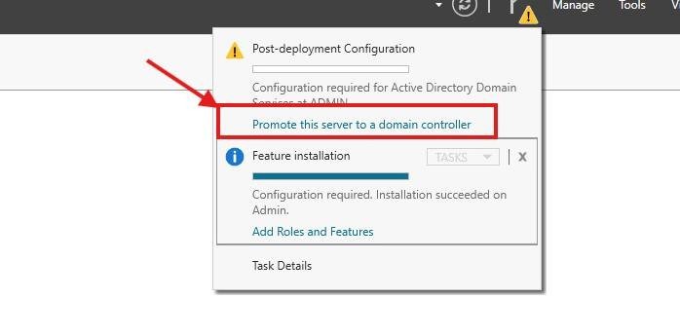
Figure 14: Promoting the server to a Domain Controller
AD DS Configuration Wizard → Deployment Configuration → Add a new forest – Creates a new forest with the root domain prakash.local. A new forest is required because this is the first Domain Controller in the environment.
Set the forest/domain functional level, set the DSRM password, then continue with Next through the NetBIOS name, paths and prerequisite check, and click Install.
AD DS Configuration Wizard → Domain Controller Options – Sets the forest and domain functional level to Windows Server 2016, enables DNS and Global Catalog, and sets the DSRM password. The DSRM password is essential for recovering Active Directory if it ever fails.
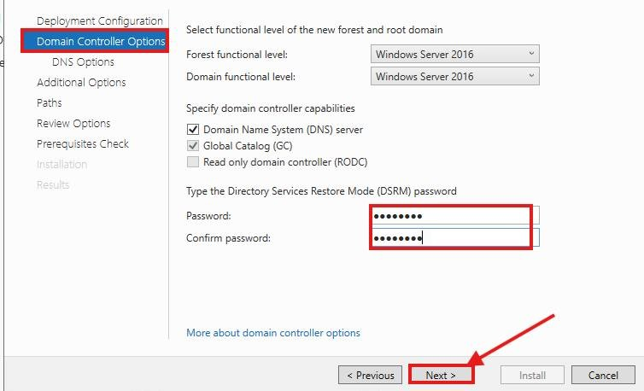
Figure 16: Setting functional levels and the DSRM password
AD DS Configuration Wizard → Additional Options – Confirms the NetBIOS name PRAKASH. Older applications and the DOMAIN\username sign-in format rely on this short name.
AD DS Configuration Wizard → Prerequisites Check → Install – All prerequisite checks passed. The DNS delegation warning is normal for a new internal forest and can safely be ignored.
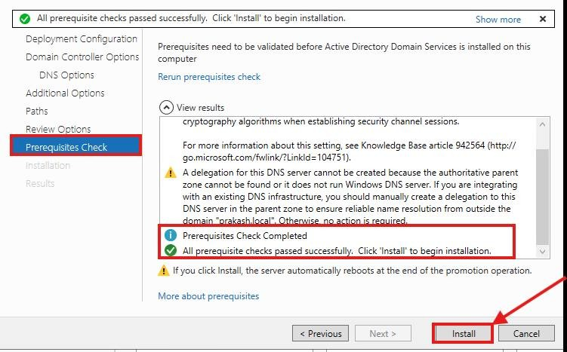
Figure 18: Passing the prerequisites check
- Post-deployment restart: the server restarts to initialise the Active Directory database, SYSVOL and Global Catalog services. After the reboot, sign in as PRAKASH\Administrator.
Automatic restart after promotion – The server restarts automatically after promotion. This reboot initialises the AD database, SYSVOL and the Global Catalog.

Figure 19: Restarting after promotion
Windows sign-in screen → SAGARTECH\Administrator – Signs in as SAGARTECH\Administrator. Logging in with a domain account proves the server is now a working Domain Controller.
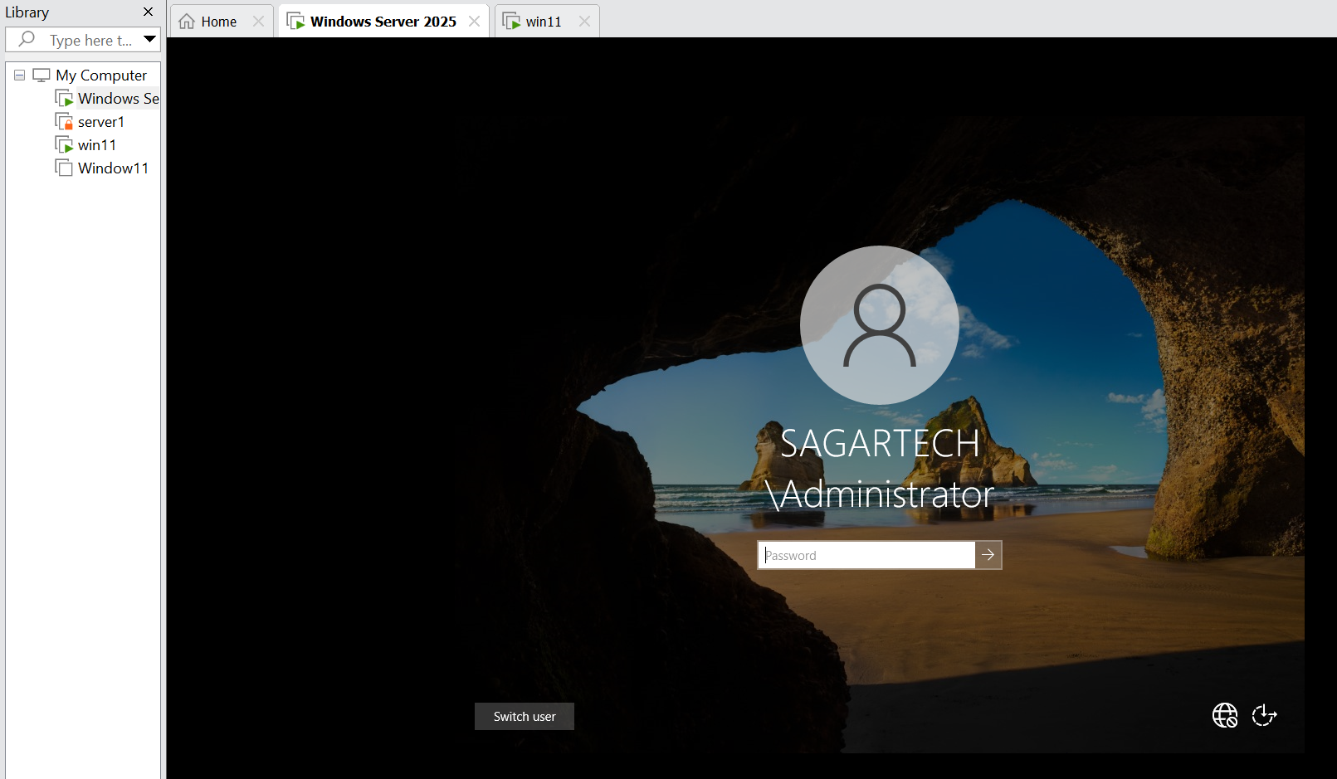
Figure 20: Signing in with the domain Administrator account
3. Joining the File Server to the Domain
- Domain join: opened System Properties on FS and changed the membership from Workgroup to the domain SAGARTECH.local.
- Authentication: authorised the join with the Domain Administrator credentials.
FS: Server Manager → Local Server → Computer name → Change → Member of: Domain → SAGARTECH.local – Joins FS to prakash.local using domain administrator credentials. Domain membership lets FS use domain accounts and groups for share permissions and Group Policy.
- Verification: confirmed the server name updated to the FQDN FS.sagartech.local.
- Reboot: restarted the machine to complete the domain join.
Server Manager → Local Server → Properties – After the restart, FS shows Domain: prakash.local. This confirms the domain join completed successfully.
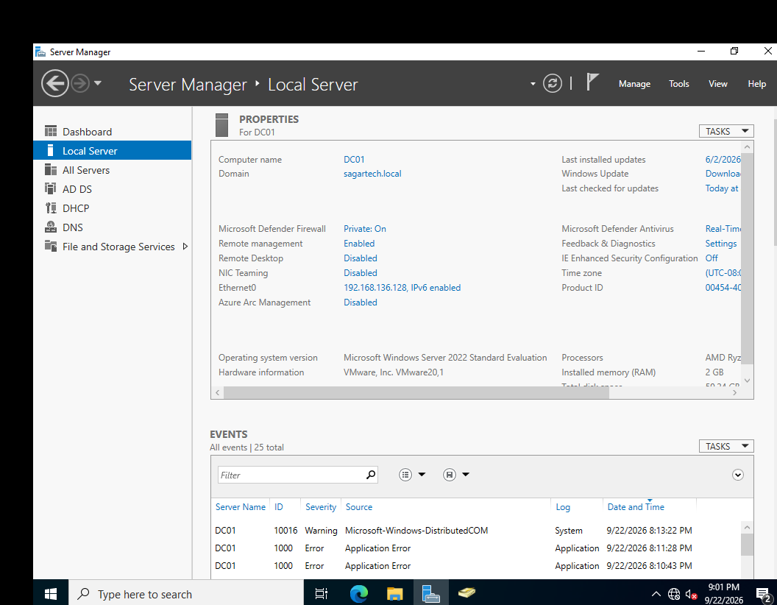
Figure 22: Verifying the File Server domain membership

