LAB_10  
  
1. (a) Write a program in assembly language to print the numbers from 0 to 9.  
  
ORG 100h ; Program starts at offset 100h

; Display message for printing numbers from 0 to 9

mov dx, OFFSET msg_output ; Load the offset of the message

mov ah, 09h ; DOS interrupt to print a string

int 21h ; Call DOS interrupt to print the message

; Initialize counter to 0

mov cx, 0 ; CX will hold the current number (0 to 9)

print_loop:

; Convert the number in CX to ASCII and display it

mov ah, 02h ; DOS interrupt to print a character

add cl, '0' ; Convert digit to ASCII

mov dl, cl ; Move ASCII digit to DL for printing

int 21h ; Print the character

; Print a space after each number for clarity

mov dl, ' ' ; Space character in ASCII

int 21h ; Print the space

; Restore CX to its numeric value for the loop

sub cl, '0'

; Increment the counter

inc cx

cmp cx, 10 ; Check if we've printed 0 to 9

jl print_loop ; If CX < 10, continue the loop

done:

; Exit program  
mov ah, 4Ch ; DOS interrupt to exit the program

int 21h

; Data section

msg_output db 0Dh, 0Ah, 'The numbers from 0 to 9 are: $'  
  
  
(b) Write an assembly language program to print the characters from A to Z in reverse order.  
  
ORG 100h ; Program starts at offset 100h

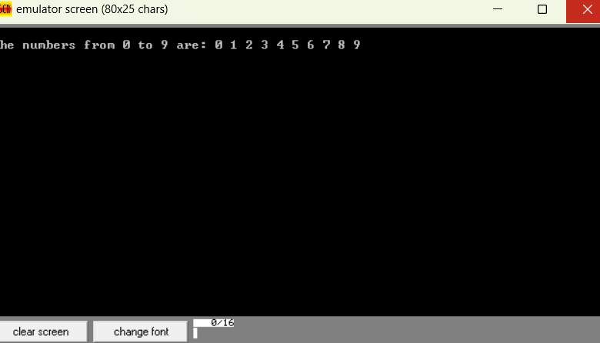

; Initialize counter to ASCII code for 'Z'

mov cx, 'Z' ; CX will hold the current character (starting from 'Z')

print_loop:

; Display the character in CX

mov ah, 02h ; DOS interrupt to print a character

mov dl, cl ; Move the character in CX to DL for printing

int 21h ; Print the character

; Print a space after each character for clarity

mov dl, ' ' ; Space character in ASCII

int 21h ; Print the space

; tDecrementhe character

dec cx

cmp cx, 'A' ; Check if we've printed down to 'A'

jge print_loop ; If CX >= 'A', continue the loop

done:

; Exit program

mov ah, 4Ch ; DOS interrupt to exit the program

int 21h  
  
  
  
  
  
  
  
Practice set:

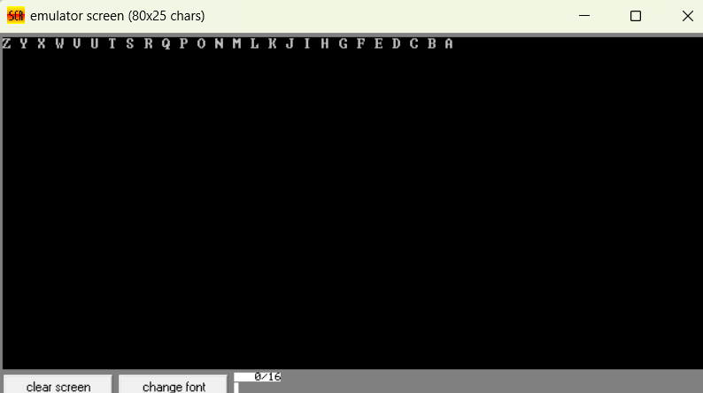

2. (a) Write a program in assembly language to print the numbers from 0 to 9 in reverse order.  
  
ORG 100h ; Program starts at offset 100h

; Initialize counter to ASCII code for '9'

mov cx, '9' ; CX will hold the current number (starting from '9')

print_loop:

; Display the number in CX

mov ah, 02h ; DOS interrupt to print a character

mov dl, cl ; Move the character in CX to DL for printing

int 21h ; Print the character

; Print a space after each number for clarity

mov dl, ' ' ; Space character in ASCII

int 21h ; Print the space

; Decrement the number

dec cx

cmp cx, '0' ; Check if we've printed down to '0'

jge print_loop ; If CX >= '0', continue the loop

done:

; Exit program

mov ah, 4Ch ; DOS interrupt to exit the program  
int 21h  
  
  
  
  
(b) Write an assembly language program to print the characters from A to Z.  
  
ORG 100h ; Program starts at offset 100h

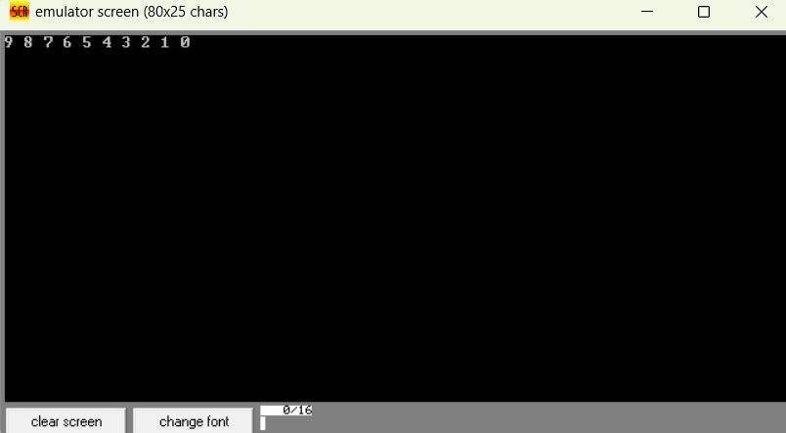

; Initialize counter to ASCII code for 'A'

mov cx, 'A' ; CX will hold the current character (starting from 'A')

print_loop:

; Display the character in CX

mov ah, 02h ; DOS interrupt to print a character

mov dl, cl ; Move the character in CX to DL for printing

int 21h ; Print the character

; Print a space after each character for clarity

mov dl, ' ' ; Space character in ASCII

int 21h ; Print the space

; Increment the character

inc cx

cmp cx, 'Z' ; Check if we've printed up to 'Z'

jle print_loop ; If CX <= 'Z', continue the loop

done:

; Exit program

mov ah, 4Ch ; DOS interrupt to exit the program

int 21h  
