LAB_08  
1 (a) Write a program in assembly language to print single character on screen.  
  
ORG 100h

MOV DX, OFFSET msg

MOV AH, 09h

INT 21h

MOV SI, OFFSET input_buffer

ReadCharacters:

MOV AH, 01h

INT 21h

CMP AL, 0Dh

JE DoneInput

MOV [SI], AL

INC SI

JMP ReadCharacters

DoneInput:

MOV BYTE PTR [SI], '$'

MOV DX, OFFSET msg_output

MOV AH, 09h

INT 21h

MOV DX, OFFSET input_buffer

MOV AH, 09h

INT 21h

MOV AH, 4Ch

INT 21h

msg DB 'Enter characters: $'

msg_output DB 0Dh, 0Ah, 'You entered: $'

input_buffer DB 50 DUP('$')

END   
  
 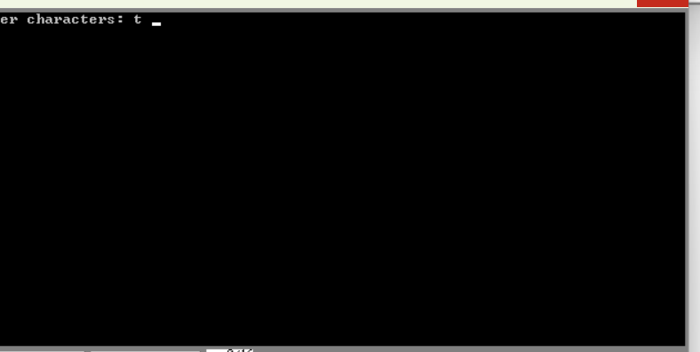  
 (b) Write an assembly language program to convert an upper-case letter to the corresponding lower-case letter.  
  
ORG 100h

MOV DX, OFFSET msg_input

MOV AH, 09h

INT 21h

MOV AH, 01h

INT 21h

MOV BL, AL

CMP BL, 'A'

JL NotUpperCase

CMP BL, 'Z'

JG NotUpperCase

ADD BL, 20h   
MOV DX, OFFSET msg_output

MOV AH, 09h

INT 21h

MOV DL, BL

MOV AH, 02h

INT 21h

JMP EndProgram

NotUpperCase:

MOV DX, OFFSET msg_error

MOV AH, 09h

INT 21h

EndProgram:

MOV AH, 4Ch

INT 21h

msg_input DB 'Enter an uppercase letter: $'

msg_output DB 0Dh, 0Ah, 'The lowercase letter is: $'

msg_error DB 0Dh, 0Ah, 'Error: Not an uppercase letter! $'

END   
  
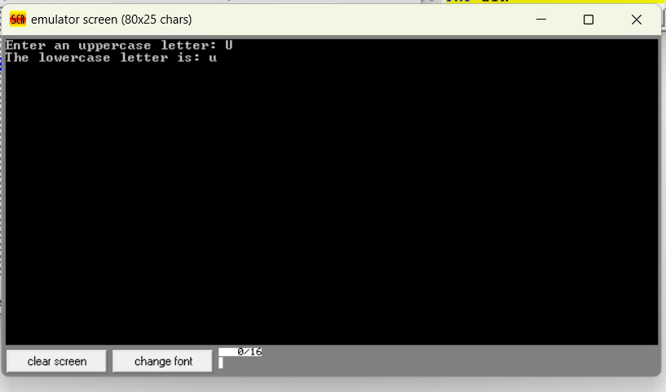  
  
  
Practice set:

2. (a) Write a program in assembly language to print multiple characters on screen.  
  
   
ORG 100h

MOV DX, OFFSET msg

MOV AH, 09h

INT 21h

MOV SI, OFFSET input_buffer

ReadCharacters:

MOV AH, 01h

INT 21h

CMP AL, 0Dh

JE DoneInput

MOV [SI], AL

INC SI

JMP ReadCharacters

DoneInput:

MOV BYTE PTR [SI], '$'

MOV DX, OFFSET msg_output

MOV AH, 09h

INT 21h

MOV DX, OFFSET input_buffer

MOV AH, 09h

INT 21h

MOV AH, 4Ch

INT 21h

msg DB 'Enter characters: $'

msg_output DB 0Dh, 0Ah, 'You entered: $'

input_buffer DB 50 DUP('$')

END   
  
   
  
 (b) Write an assembly language program to convert a lower-case letter to the corresponding upper-case letter.  
CODE:

ORG 100h

MOV DX, OFFSET msg_input

MOV AH, 09h

INT 21h

MOV AH, 01h

INT 21h

MOV BL, AL

CMP BL, 'a'

JL NotLowerCase

CMP BL, 'z'

JG NotLowerCase

SUB BL, 20h

MOV DX, OFFSET msg_output

MOV AH, 09h

INT 21h

MOV DL, BL

MOV AH, 02h

INT 21h

JMP EndProgram

NotLowerCase:

MOV DX, OFFSET msg_error

MOV AH, 09h

INT 21h

EndProgram:

MOV AH, 4Ch

INT 21h

msg_input DB 'Enter a lowercase letter: $'

msg_output DB 0Dh, 0Ah, 'The uppercase letter is: $'

msg_error DB 0Dh, 0Ah, 'Error: Not a lowercase letter! $'

END

