1).Write an assembly language program to perform multiplication of 8-bit data.



**Code:-**

.model small

.stack 100h

.data

num1 db 6h

num2 db 2h

result dw 0

msg db '$'

newline db 0Dh, 0Ah, '$'

.code

main proc

mov ax, @data

mov ds, ax

mov al, num1

mov bl, num2

xor cx, cx

xor dx, dx

multiply:

test bl, 1

jz skip_add

add cx, ax

skip_add:

shl ax, 1

shr bl, 1

inc dx

cmp dx, 8

jl multiply

mov result, cx

lea dx, msg

mov ah, 09h

int 21h

mov ax, result

call DisplayResult

mov ah, 4Ch

int 21h

main endp

DisplayResult proc

mov bx, 10

xor cx, cx

convert_digit:

xor dx, dx

div bx

add dl, '0'

push dx

inc cx

test ax, ax

jnz convert_digit

display_digit:

pop dx

mov ah, 02h

int 21h

loop display_digit

lea dx, newline

mov ah, 09h

int 21h

ret

DisplayResult endp

end main

(OUTPUT)  
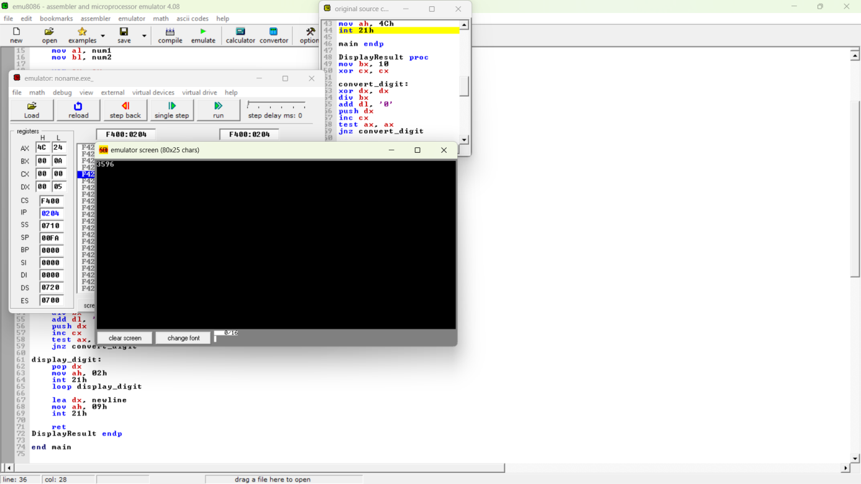



2. Write a program in assembly language to perform multiplication of 16-bit data.



**Code:-**



.model small

.stack 100h

.data

msg db 'Your output is: $'

num1 dw 4321h num2 dw 1234h result dw 0

result_hi dw 0



.code

main proc

mov ax, @data mov ds, ax



mov ah, 09h

lea dx, msg int 21h



mov ax, num1

mov dx, num2



mul dx



mov result, ax

mov result_hi, dx



call DisplayHex32



mov ah, 4Ch

int 21h



main endp



DisplayHex32 proc

mov ax, result_hi call DisplayHex16 mov ax, result call DisplayHex16



ret

DisplayHex32 endp



DisplayHex16 proc

push ax mov cx, 4



next_digit:

rol ax, 4

mov dx, ax and dx, 0Fh cmp dx, 0Ah

jl display_digit add dl, 7h

display_digit: add dl, '0'

mov ah, 02h int 21h

loop next_digit pop ax

ret

DisplayHex16 endp



end main



Output:-

