**Industrial Internship Report on**

**”** **Traffic Pattern Prediction Using Machine Learning”**

**Prepared by**

**Sagar H V**

|  |
| --- |
| *Executive Summary* |
| This report provides details of the Industrial Internship provided by upskill Campus and The IoT Academy in collaboration with Industrial Partner UniConverge Technologies Pvt Ltd (UCT). This internship was focused on a project/problem statement provided by UCT. We had to finish the project including the report in 6 weeks’ time.  My project was focused on predicting traffic patterns using machine learning algorithms and data science principles. This internship gave me a very good opportunity to get exposure to industrial problems and design/implement solutions for them. It was an overall great experience to have this internship. |

**TABLE OF CONTENTS**

1 Preface 3

2 Introduction 4

2.1 About UniConverge Technologies Pvt Ltd 4

2.2 About upskill Campus 8

2.3 Objective 9

2.4 Reference 9

2.5 Glossary 10

3 Problem Statement 11

4 Existing and Proposed solution 12

5 Proposed Design/ Model 13

6 Performance Test 14

6.1 Test Plan/ Test Cases 14

6.2 Test Procedure 14

6.3 Performance Outcome 14

7 My learnings 15

8 Future work scope 16

# Preface

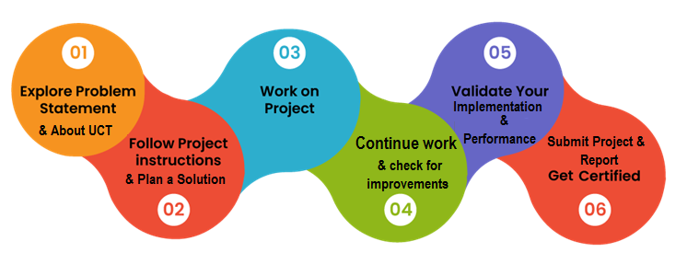

During my internship, I was involved in several key activities that provided a comprehensive understanding of the industrial application of machine learning and data science.

Week 1:

Introduction to the project and understanding the problem statement.

Gathering and exploring the dataset.

Cleaning and preprocessing the data to prepare it for analysis.

Week 2:

Performing exploratory data analysis (EDA) to identify trends and patterns in the traffic data.

Visualizing the data using various plotting techniques.

Understanding the relationships between different variables.

Week 3:

Implementing basic machine learning models such as Linear Regression and Decision Trees.

Evaluating the performance of these models using metrics like Mean Squared Error (MSE) and R² score.

Understanding the limitations of basic models in capturing complex patterns.

Week 4:

Building and training advanced machine learning models, including LSTM and Sequential models.

Tuning the hyperparameters of these models to improve their performance.

Assessing the effectiveness of these models in predicting traffic patterns.

Week 5:

Developing a dynamic traffic management system to address peak traffic hours based on model predictions.

Integrating the trained models into the system for real-time traffic prediction.

Evaluating the performance of the system under different traffic conditions.

Week 6:

Training and evaluating additional machine learning models (RandomForestRegressor, GradientBoostingRegressor, SupportVectorRegressor, XGBoostRegressor).

Comparing the performance of these models to identify the best one for traffic prediction.

Finalizing the project report and preparing for the final presentation.

I would like to thank all those who helped me directly or indirectly, including my mentors and peers at upskill Campus and UniConverge Technologies Pvt Ltd.

# Introduction

## About UniConverge Technologies Pvt Ltd

A company established in 2013 and working in Digital Transformation domain and providing Industrial solutions with prime focus on sustainability and RoI.

For developing its products and solutions it is leveraging various**Cutting Edge Technologies e.g. Internet of Things (IoT), Cyber Security, Cloud computing (AWS, Azure), Machine Learning, Communication Technologies (4G/5G/LoRaWAN), Java Full Stack, Python, Front end**etc.

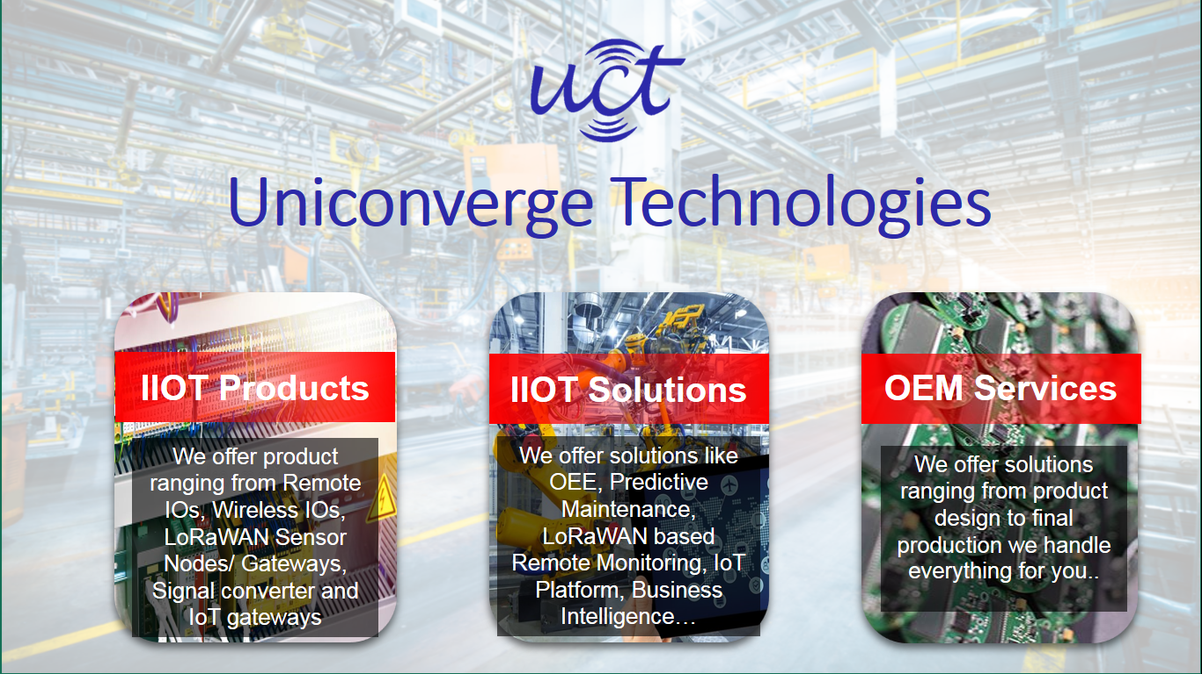

1. UCT IoT Platform **(****)**

**UCT Insight** is an IOT platform designed for quick deployment of IOT applications on the same time providing valuable “insight” for your process/business. It has been built in Java for backend and ReactJS for Front end. It has support for MySQL and various NoSql Databases.

* It enables device connectivity via industry standard IoT protocols - MQTT, CoAP, HTTP, Modbus TCP, OPC UA
* It supports both cloud and on-premises deployments.

It has features to  
• Build Your own dashboard  
• Analytics and Reporting  
• Alert and Notification  
• Integration with third party application(Power BI, SAP, ERP)  
• Rule Engine

 

1. **Smart Factory Platform (****)**

Factory watch is a platform for smart factory needs.

It provides Users/ Factory

* with a scalable solution for their Production and asset monitoring
* OEE and predictive maintenance solution scaling up to digital twin for your assets.
* to unleased the true potential of the data that their machines are generating and helps to identify the KPIs and also improve them.
* A modular architecture that allows users to choose the service that they what to start and then can scale to more complex solutions as per their demands.

Its unique SaaS model helps users to save time, cost and money.

 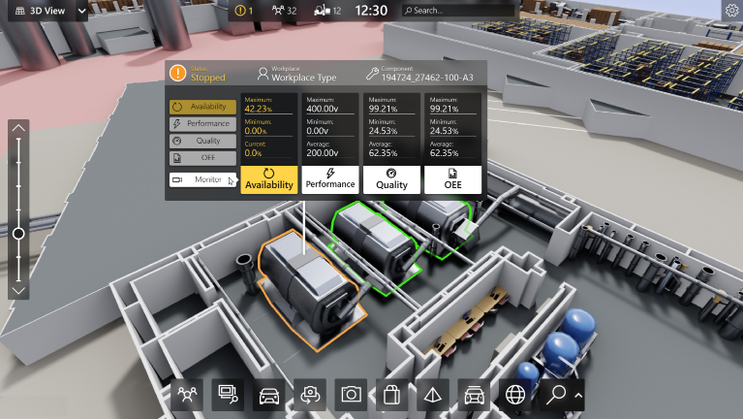

1. 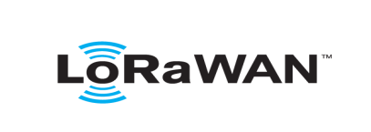 based Solution

UCT is one of the early adopters of LoRAWAN teschnology and providing solution in Agritech, Smart cities, Industrial Monitoring, Smart Street Light, Smart Water/ Gas/ Electricity metering solutions etc.

1. Predictive Maintenance

UCT is providing Industrial Machine health monitoring and Predictive maintenance solution leveraging Embedded system, Industrial IoT and Machine Learning Technologies by finding Remaining useful life time of various Machines used in production process.



## About upskill Campus (USC)

upskill Campus along with The IoT Academy and in association with Uniconverge technologies has facilitated the smooth execution of the complete internship process.

USC is a career development platform that delivers **personalized executive coaching** in a more affordable, scalable and measurable way.



Seeing need of upskilling in self paced manner along-with additional support services e.g. Internship, projects, interaction with Industry experts, Career growth Services

<https://www.upskillcampus.com/>

upSkill Campus aiming to upskill 1 million learners in next 5 year

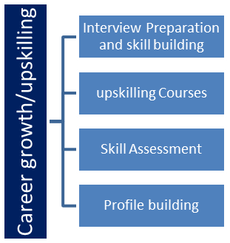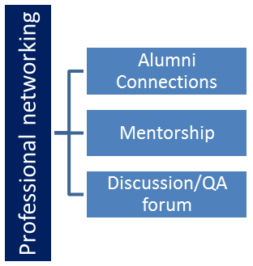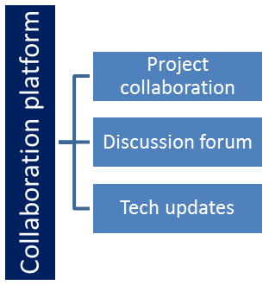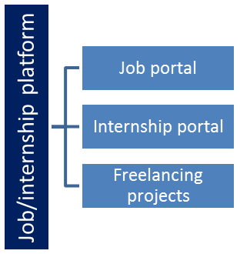

## The IoT Academy

The IoT academy is EdTech Division of UCT that is running long executive certification programs in collaboration with EICT Academy, IITK, IITR and IITG in multiple domains.

## Objectives of this Internship program

The objective for this internship program was to

 ☛ get practical experience of working in the industry.

 ☛ to solve real world problems.

 ☛ to have improved job prospects.

 ☛ to have Improved understanding of our field and its applications.

 ☛ to have Personal growth like better communication and problem solving.

## Reference

[1]

[2]

[3]

## Glossary

|  |  |
| --- | --- |
| Terms | Acronym |
|  |  |
|  |  |
|  |  |
|  |  |
|  |  |

# Problem Statement

In this project, we aimed to predict traffic patterns using historical data on vehicle counts. This involved cleaning the dataset, exploring data trends, and applying machine learning models to forecast future traffic volumes.

# Existing and Proposed solution

### Existing Solutions

Existing solutions for traffic prediction typically use basic statistical methods and simple regression models, which may not capture complex patterns in traffic data.

### Proposed Solution

We proposed using advanced machine learning techniques, including LSTM and Sequential models, to improve the accuracy of traffic predictions. These models can capture temporal dependencies and complex relationships in the data, leading to better performance compared to traditional methods.

## Code submission (Github link)

[*https://github.com/sagarhv001/upskillcampus/blob/main/Forecasting_of_Smart_city_traffic_patterns.ipynb*](https://github.com/sagarhv001/upskillcampus/blob/main/Forecasting_of_Smart_city_traffic_patterns.ipynb)

## Report submission (Github link) :

## [link](https://github.com/sagarhv001/upskillcampus/blob/main/Forecasting_of_Smart_city_traffic_patterns.ipynb)

# Proposed Design/ Model

Given more details about design flow of your solution. This is applicable for all domains. DS/ML Students can cover it after they have their algorithm implementation. There is always a start, intermediate stages and then final outcome.

## High Level Diagram (if applicable)

### High-Level Diagram

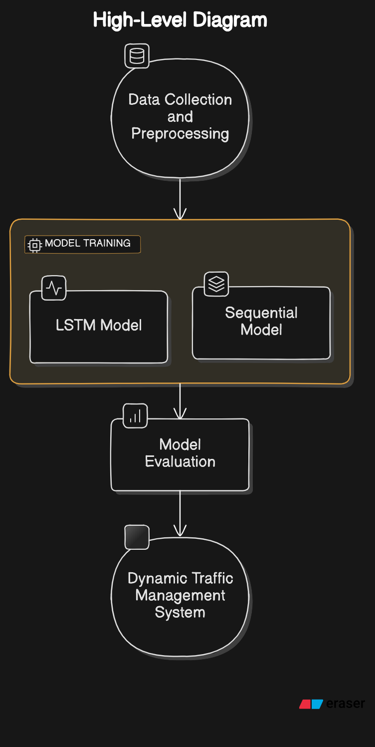

## Interfaces (if applicable)

### Interfaces

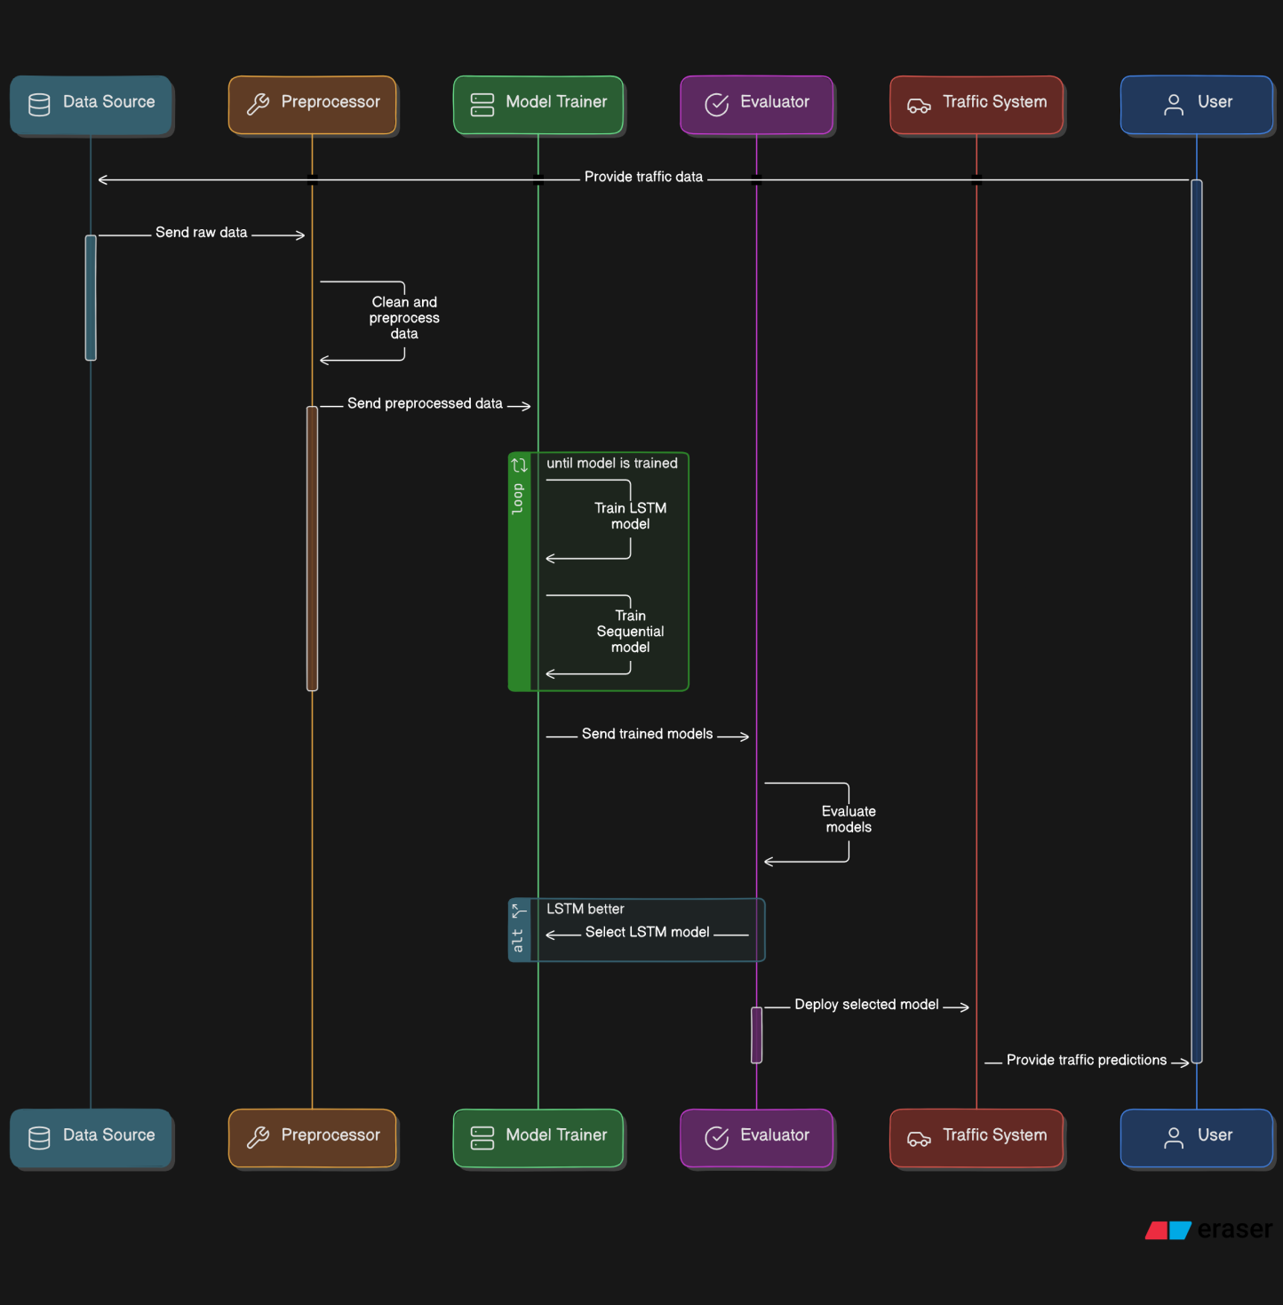

# Performance Test

## Performance Outcome

The performance of the models was evaluated using Mean Squared Error (MSE) and R² score:

Additionally, I trained and evaluated various other machine learning models to find the best performing one for traffic prediction. The results are as follows:

|  |  |  |
| --- | --- | --- |
| **Model** | **MSE** | **R²** |
| LSTM Model | 31.150006073341206 | 0.9235670348578169 |
| Sequential Model | 46.95028283252831 | 0.8847977967418303 |
| RandomForestRegressor | 23.407134 | 0.942566 |
| LinearRegression | 44.818202 | 0.890029 |
| GradientBoostingRegressor | 30.579604 | 0.924967 |
| SupportVectorRegressor | 150.240907 | 0.631353 |
| XGBoostRegressor | 21.724491 | 0.946694 |

The best performing model was the **XGBoostRegressor** with an R² score of **0.946694**.

# My learnings

## My Learnings

During this week, I learned about the implementation of advanced machine learning models and their evaluation. The hands-on experience with LSTM and Sequential models enhanced my understanding of time series forecasting. Additionally, designing a dynamic traffic management system helped me appreciate the practical applications of predictive modeling. Training and evaluating multiple models provided insights into model performance and selection.

# Future work scope

Future work can involve further tuning of the models, exploring other advanced algorithms, and integrating real-time traffic data for live predictions. Additionally, expanding the dynamic traffic management system to incorporate more sophisticated strategies and real-time adjustments can improve its effectiveness.