**Sparkify Data Analysis using Cassandra**

**Purpose**

The purpose of the project is to analyse data stored in various csv files by leveraging Cassandra NoSQL database. Data is modelled based on queries provided.

**Schema**

After analysing the data, it is clear that every entry can be uniquely identified by a combination of userId, sessionId and itemInSession as itemInSession is an incremental value of number of songs a user plays in a session. Hence the **primary key must be a compound key including userId, sessionId and itemInSession** by changing the parition key and clustering keys and adding any other clustering keys if necessary.

We have 3 tables based on the queries.

**Query 1- Give me the artist, song title and song's length in the music app history that was heard during sessionId = 338, and itemInSession = 4**

The data is being ordered by sessionId and itemInSession.

**Query 2 - Give me only the following: name of artist, song (sorted by itemInSession) and user (first and last name) for userid = 10, sessionid = 182**

The data is being queried by userId and SessionId and sorted by itemInSession. Hence, we use itemInSession as a clustering key and it is sorted in ascending order.

**Query 3 - Give me every user name (first and last) in my music app history who listened to the song 'All Hands Against His Own'**

The data is being queried by song name. Hence, we partition by song name and add clustering keys based on above attributes.

**How to run?**

We have 2 python scripts.

1. **create_tables.py** : Used to create key space, drop tables if they exist and create them.
2. **etl.py**: Used to extract data from the list, consolidate them into one csv file and then insert the data into tables. This data is queried based on the input.

**Results**

Sample input dataset.

[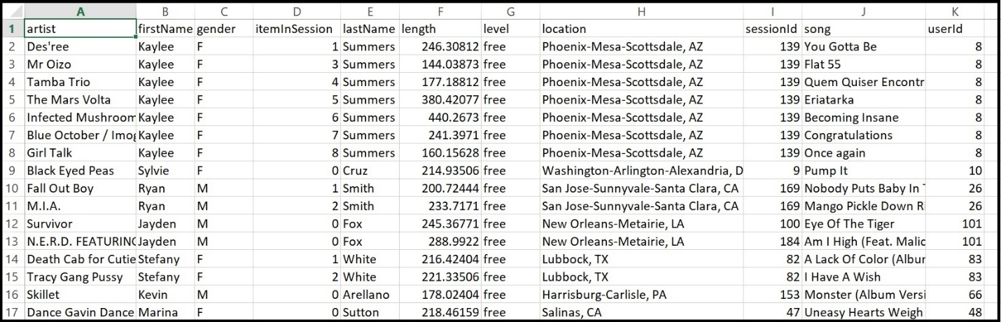](https://github.com/anilkrishnach/DataEngineering_Cassandra/blob/master/images/image_event_datafile_new.jpg)

Test queries output.

[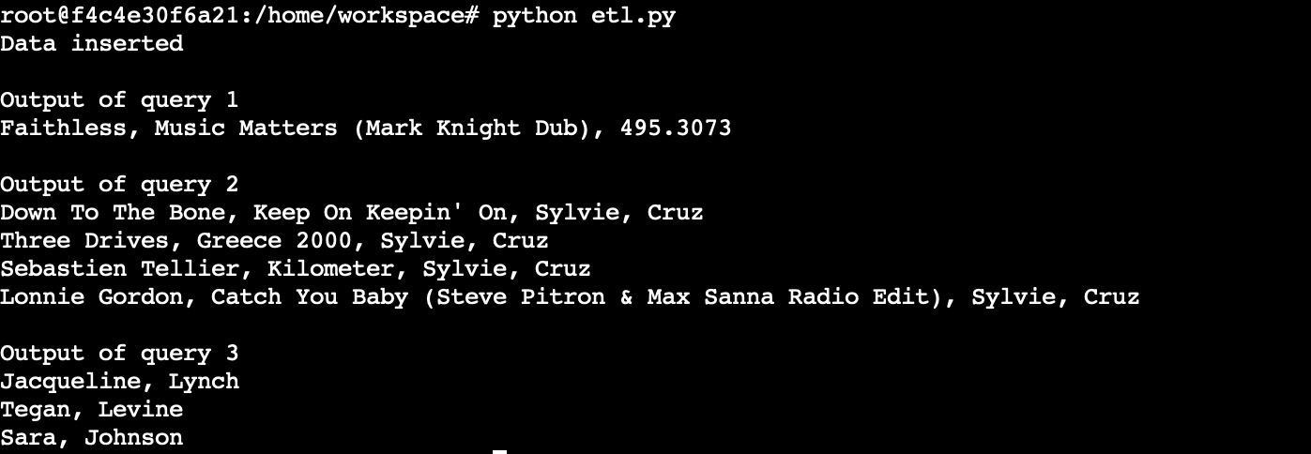](https://github.com/anilkrishnach/DataEngineering_Cassandra/blob/master/images/output.png)