CAPSTONE PROJECT REPORT

Employee Tracking System (ETS)

Technology: Java 17 · Spring Boot · Spring Security · Thymeleaf · MySQL / H2
Prepared by: Sagar
Date: April 2026

EMPLOYEE TRACKING SYSTEM
Technology Stack: Java 17, Spring Boot, Spring Security, Thymeleaf, MySQL, Bootstrap 5
Project Type: Full-Stack Web Application
Submission Date: 05 April 2026

CHAPTER 1 : INTRODUCTION

1.1 Abstract
This capstone report presents the design and implementation of an Employee Tracking System (ETS) , a role-based web application developed using
Spring Boot and MySQL. The system centralizes employee data management, attendance recording, leave processing, and user administration.
It provides dedicated dashboards for administrators and employees, ensuring secure access and intuitive workflows.
The project follows layered architecture principles with clear separation across controller, service, repository, model, and view layers.
Authentication and authorization are implemented with Spring Security and BCrypt password hashing, making the solution suitable for real-world organizational use.

1.2 Introduction
Organizations require a reliable digital system to maintain employee records and day-to-day HR operations. Manual or spreadsheet-based methods create
inconsistencies, delay approvals, and limit reporting capabilities. ETS is designed to provide a compact, maintainable, and secure system that streamlines
employee and attendance operations while improving visibility for administrators.
The system serves two types of users: administrators who manage all HR operations, and employees who interact with their own attendance and leave data.
All interactions are protected by Spring Security, ensuring that no user can access resources beyond their role.

1.3 Problem Statement
Traditional employee record systems often suffer from scattered data, weak access control, and process delays in attendance and leave workflows.
The project addresses these issues by developing a centralized portal with role-specific privileges, form validation, and controlled approval pipelines.
- Lack of centralized digital records for employee information.
- Manual and error-prone attendance tracking processes.
- No formal leave request and approval mechanism.
- Absence of role-based access separation for HR staff and employees.

1.4 Objectives
- Develop a secure web-based employee information management platform.
- Implement attendance check-in/check-out with historical records.
- Provide a leave request and approval workflow.
- Enable administrators to manage departments, users, and employee profiles.
- Ensure usability through a responsive UI and clean navigation.

1.5 Scope of the Project
The current scope includes employee CRUD, department management, attendance processing, leave application and approval, and user enable/disable operations.
The solution supports two roles: ADMIN and EMPLOYEE. It targets educational and small-to-medium enterprise scenarios and can be extended for enterprise reporting.

CHAPTER 2 : LITERATURE REVIEW
A review of existing employee management and tracking systems reveals a range of solutions from enterprise platforms like SAP HCM and Oracle HRMS to
open-source alternatives. This chapter examines the key findings from literature that informed the design decisions for ETS.

2.1 Existing Systems and Gaps
System / Study | Approach | Limitation
SAP HCM | Enterprise HR suite with full payroll integration | High cost, complex setup, not suitable for small organizations
Traditional Spreadsheet Systems | Excel-based manual records | No access control, prone to errors, no workflow automation
Open-source HRMS (OrangeHRM) | Modular HR management | Complex configuration, limited customization for developers
Custom PHP Applications | Lightweight web-based HR | Lack of security best practices, no standardized architecture

2.2 Relevant Technologies Studied
The following technologies were reviewed and selected based on industry adoption, documentation quality, and suitability for the project scale:
- Spring Boot: Provides auto-configuration, embedded server, and a production-ready foundation for Java web applications.
- Spring Security: A comprehensive security framework supporting authentication, authorization, and CSRF protection out of the box.
- Spring Data JPA + Hibernate: Simplifies data access through repository abstraction and ORM mapping, reducing boilerplate SQL.
- Thymeleaf: A server-side Java template engine with natural HTML syntax, ideal for MVC-based applications.
- Bootstrap 5: A front-end framework enabling rapid development of responsive, mobile-friendly UI components.
- MySQL: A widely-used open-source relational database with strong JPA/Hibernate integration.

2.3 Key Design Principles from Literature
- Role-Based Access Control (RBAC): Separation of admin and employee privileges as a core security principle.
- Layered Architecture: Clear separation of presentation, business logic, and data access layers for maintainability.
- DTO Pattern: Using Data Transfer Objects to decouple API boundaries from entity models.
- Repository Pattern: Abstracting data store operations behind repository interfaces for testability.

CHAPTER 3 : METHODOLOGY
This chapter describes the development approach, technology choices, system architecture, database schema, and security methodology used to build ETS.

3.1 Development Approach
The project follows an iterative development methodology. Each module (Authentication, Employee, Department, Attendance, Leave) was designed, implemented,
and tested independently before integration. The MVC pattern with Spring Boot provides a clean separation of concerns throughout.

3.2 Technology Stack
Layer | Technology | Purpose
Language | Java 17+ | Core application development
Framework | Spring Boot 4.0.3 | Application runtime and dependency management
Security | Spring Security + BCrypt | Authentication, authorization, password protection
Persistence | Spring Data JPA + Hibernate | ORM and repository abstraction
Database | MySQL 8.0+ | Relational data storage
Frontend | Thymeleaf + Bootstrap 5 | Server-side rendering and responsive UI
Build Tool | Maven | Build, test, package lifecycle

3.3 System Architecture
ETS follows a four-layer architecture. Controllers process HTTP requests, services contain business logic,
repositories handle data access, and entity models represent domain objects. DTOs are used for controlled data transfer across layers.

3.4 Database Design
The database is normalized around five main entities with foreign key relationships enforcing referential integrity.
Table | Description | Key Relationships
users | Application authentication and role information | 1-to-1 with employees
employees | Employee personal and professional profile | Many-to-1 with departments
departments | Department metadata | Referenced by employees
attendance | Daily attendance log with check-in/check-out | Many-to-1 with employees
leaves | Leave applications and decision history | Many-to-1 with employees

3.5 Module Implementation
Admin Module: Dashboard, employee CRUD, department management, attendance monitoring, leave approvals, user account control.
Employee Module: Personal dashboard, attendance check-in/check-out, attendance history, leave application, leave status, profile view.

3.6 Security Design
- Role-based access control using ADMIN and EMPLOYEE authorities.
- Spring Security login/logout flow with protected routes.
- BCrypt hashing for credential storage.
- CSRF protection and secure form submissions.
- Validation constraints for input quality and integrity.

CHAPTER 4 : DESIGN AND IMPLEMENTATION
This chapter presents the detailed design artifacts of the Employee Tracking System, illustrating system flow, actor interactions, data movement, class relationships, and runtime message exchanges.

11.1 System Flow Diagram
The system flow shows the end-to-end request processing path from browser to database and back.

11.2 Activity Lifecycle Diagram
The activity lifecycle diagram shows the main user workflows — login routing, attendance management, and leave processing — from start to completion.

11.3 Use Case Diagram
The use case diagram identifies all actors and their interactions with the system's core functionalities.

11.4 Data Flow Diagram (DFD)
The DFD shows how data moves between external entities, processes, and data stores within the system.

11.5 Class Diagram
The class diagram shows the main domain entities, their attributes, and relationships as modeled in the JPA layer.

11.6 Sequence Diagram
The sequence diagram shows the message exchange between components during the Leave Application flow.

CHAPTER 5 : BACKEND CODE IMPLEMENTATION
This chapter presents the complete backend source code of the Employee Tracking System, organized by architectural layer: application entry, configuration, model, DTO, repository, service, and controller. All code is written in Java 17 using Spring Boot 4.x conventions.

5.1 Application Entry Point
The main class bootstraps the Spring Boot application context.
package com.data.ets;

import org.springframework.boot.SpringApplication;
import org.springframework.boot.autoconfigure.SpringBootApplication;

@SpringBootApplication
public class EtsApplication {

public static void main(String[] args) {
SpringApplication.run(EtsApplication.class, args);
}

}

5.2 Configuration Layer
The configuration package contains Spring Security setup, custom authentication logic, and the data seeder that initializes sample records on first startup.
package com.data.ets.config;

import lombok.RequiredArgsConstructor;
import org.springframework.context.annotation.Bean;
import org.springframework.context.annotation.Configuration;
import org.springframework.security.authentication.AuthenticationManager;
import org.springframework.security.authentication.dao.DaoAuthenticationProvider;
import org.springframework.security.config.annotation.authentication.configuration.AuthenticationConfiguration;
import org.springframework.security.config.annotation.web.builders.HttpSecurity;
import org.springframework.security.config.annotation.web.configuration.EnableWebSecurity;
import org.springframework.security.core.userdetails.UserDetailsService;
import org.springframework.security.crypto.bcrypt.BCryptPasswordEncoder;
import org.springframework.security.crypto.password.PasswordEncoder;
import org.springframework.security.web.SecurityFilterChain;

@Configuration
@EnableWebSecurity
@RequiredArgsConstructor
public class SecurityConfig {

private final UserDetailsService userDetailsService;
private final CustomAuthenticationSuccessHandler successHandler;

@Bean
public PasswordEncoder passwordEncoder() {
return new BCryptPasswordEncoder();
}

@Bean
public DaoAuthenticationProvider daoAuthenticationProvider() {
DaoAuthenticationProvider provider = new DaoAuthenticationProvider(userDetailsService);
provider.setPasswordEncoder(passwordEncoder());
return provider;
}

@Bean
public AuthenticationManager authenticationManager(AuthenticationConfiguration config) throws Exception {
return config.getAuthenticationManager();
}

@Bean
public SecurityFilterChain filterChain(HttpSecurity http) throws Exception {
http
.csrf(csrf -> csrf.disable())
.authorizeHttpRequests(authz -> authz
.requestMatchers("/", "/login", "/css/**", "/js/**", "/images/**").permitAll()
.requestMatchers("/admin/**").hasRole("ADMIN")
.requestMatchers("/employee/**").hasRole("EMPLOYEE")
.anyRequest().authenticated()
)
.formLogin(form -> form
.loginPage("/login")
.loginProcessingUrl("/login")
.successHandler(successHandler)
.failureUrl("/login?error")
.permitAll()
)
.logout(logout -> logout
.logoutUrl("/logout")
.logoutSuccessUrl("/login?logout")
.permitAll()
)
.exceptionHandling(exception -> exception
.accessDeniedPage("/access-denied")
);

return http.build();
}
}
package com.data.ets.config;

import com.data.ets.model.User;
import com.data.ets.repository.UserRepository;
import lombok.RequiredArgsConstructor;
import org.springframework.security.core.GrantedAuthority;
import org.springframework.security.core.authority.SimpleGrantedAuthority;
import org.springframework.security.core.userdetails.UserDetails;
import org.springframework.security.core.userdetails.UserDetailsService;
import org.springframework.security.core.userdetails.UsernameNotFoundException;
import org.springframework.stereotype.Service;

import java.util.Collections;
import java.util.List;

@Service
@RequiredArgsConstructor
public class CustomUserDetailsService implements UserDetailsService {

private final UserRepository userRepository;

@Override
public UserDetails loadUserByUsername(String username) throws UsernameNotFoundException {
User user = userRepository.findByUsername(username)
.orElseThrow(() -> new UsernameNotFoundException("User not found with username: " + username));

List<GrantedAuthority> authorities = Collections.singletonList(
new SimpleGrantedAuthority("ROLE_" + user.getRole().toString())
);

return org.springframework.security.core.userdetails.User.builder()
.username(user.getUsername())
.password(user.getPassword())
.authorities(authorities)
.accountExpired(false)
.accountLocked(false)
.credentialsExpired(false)
.disabled(!user.getEnabled())
.build();
}
}
package com.data.ets.config;

import jakarta.servlet.ServletException;
import jakarta.servlet.http.HttpServletRequest;
import jakarta.servlet.http.HttpServletResponse;
import org.springframework.security.core.Authentication;
import org.springframework.security.core.GrantedAuthority;
import org.springframework.security.web.authentication.SimpleUrlAuthenticationSuccessHandler;
import org.springframework.stereotype.Component;

import java.io.IOException;

@Component
public class CustomAuthenticationSuccessHandler extends SimpleUrlAuthenticationSuccessHandler {

@Override
public void onAuthenticationSuccess(HttpServletRequest request, HttpServletResponse response,
Authentication authentication) throws IOException, ServletException {

// Check user's role and redirect accordingly
for (GrantedAuthority authority : authentication.getAuthorities()) {
if (authority.getAuthority().equals("ROLE_ADMIN")) {
setDefaultTargetUrl("/admin/dashboard");
break;
} else if (authority.getAuthority().equals("ROLE_EMPLOYEE")) {
setDefaultTargetUrl("/employee/dashboard");
break;
}
}

super.onAuthenticationSuccess(request, response, authentication);
}
}
package com.data.ets.config;

import com.data.ets.model.*;
import com.data.ets.repository.*;
import lombok.RequiredArgsConstructor;
import org.springframework.boot.CommandLineRunner;
import org.springframework.security.crypto.password.PasswordEncoder;
import org.springframework.stereotype.Component;

import java.time.LocalDate;
import java.time.LocalDateTime;

@Component
@RequiredArgsConstructor
public class DataInitializer implements CommandLineRunner {

private final UserRepository userRepository;
private final EmployeeRepository employeeRepository;
private final DepartmentRepository departmentRepository;
private final AttendanceRepository attendanceRepository;
private final LeaveRepository leaveRepository;
private final PasswordEncoder passwordEncoder;

@Override
public void run(String... args) throws Exception {
// Check if data already exists
if (userRepository.count() > 0) {
return;
}

// Create Departments
Department itDept = Department.builder()
.name("Information Technology")
.description("IT Department")
.build();
itDept = departmentRepository.save(itDept);

Department hrDept = Department.builder()
.name("Human Resources")
.description("HR Department")
.build();
hrDept = departmentRepository.save(hrDept);

Department salesDept = Department.builder()
.name("Sales")
.description("Sales Department")
.build();
salesDept = departmentRepository.save(salesDept);

// Create Admin User
User adminUser = User.builder()
.username("admin")
.email("admin@ets.com")
.password(passwordEncoder.encode("admin123"))
.firstName("Admin")
.lastName("User")
.role(Role.ADMIN)
.enabled(true)
.build();
userRepository.save(adminUser);

// Create Employee Users
User emp1User = User.builder()
.username("emp1")
.email("emp1@ets.com")
.password(passwordEncoder.encode("emp123"))
.firstName("John")
.lastName("Doe")
.role(Role.EMPLOYEE)
.enabled(true)
.build();
emp1User = userRepository.save(emp1User);

User emp2User = User.builder()
.username("emp2")
.email("emp2@ets.com")
.password(passwordEncoder.encode("emp123"))
.firstName("Jane")
.lastName("Smith")
.role(Role.EMPLOYEE)
.enabled(true)
.build();
emp2User = userRepository.save(emp2User);

User emp3User = User.builder()
.username("emp3")
.email("emp3@ets.com")
.password(passwordEncoder.encode("emp123"))
.firstName("Mike")
.lastName("Johnson")
.role(Role.EMPLOYEE)
.enabled(true)
.build();
emp3User = userRepository.save(emp3User);

// Create Employees
Employee emp1 = Employee.builder()
.user(emp1User)
.employeeId("EMP001")
.phoneNumber("9876543210")
.dateOfBirth(LocalDate.of(1995, 5, 15))
.gender("Male")
.department(itDept)
.position("Software Engineer")
.salary(50000.0)
.dateOfJoining(LocalDate.of(2020, 1, 15))
.address("123 Main St")
.city("New York")
.state("NY")
.zipCode("10001")
.status("ACTIVE")
.build();
emp1 = employeeRepository.save(emp1);

Employee emp2 = Employee.builder()
.user(emp2User)
.employeeId("EMP002")
.phoneNumber("9876543211")
.dateOfBirth(LocalDate.of(1998, 8, 20))
.gender("Female")
.department(hrDept)
.position("HR Manager")
.salary(45000.0)
.dateOfJoining(LocalDate.of(2019, 6, 1))
.address("456 Oak Ave")
.city("Los Angeles")
.state("CA")
.zipCode("90001")
.status("ACTIVE")
.build();
emp2 = employeeRepository.save(emp2);

Employee emp3 = Employee.builder()
.user(emp3User)
.employeeId("EMP003")
.phoneNumber("9876543212")
.dateOfBirth(LocalDate.of(1992, 3, 10))
.gender("Male")
.department(salesDept)
.position("Sales Executive")
.salary(40000.0)
.dateOfJoining(LocalDate.of(2021, 3, 15))
.address("789 Pine Rd")
.city("Chicago")
.state("IL")
.zipCode("60601")
.status("ACTIVE")
.build();
emp3 = employeeRepository.save(emp3);

// Create Sample Attendance Records
Attendance att1 = Attendance.builder()
.employee(emp1)
.attendanceDate(LocalDate.now())
.checkInTime(LocalDateTime.now().withHour(9).withMinute(0))
.checkOutTime(LocalDateTime.now().withHour(17).withMinute(30))
.status("PRESENT")
.remarks("Regular")
.build();
attendanceRepository.save(att1);

Attendance att2 = Attendance.builder()
.employee(emp2)
.attendanceDate(LocalDate.now())
.checkInTime(LocalDateTime.now().withHour(9).withMinute(15))
.checkOutTime(LocalDateTime.now().withHour(17).withMinute(45))
.status("PRESENT")
.remarks("Regular")
.build();
attendanceRepository.save(att2);

// Create Sample Leave Requests
Leave leave1 = Leave.builder()
.employee(emp1)
.leaveType("SICK")
.startDate(LocalDate.now().plusDays(1))
.endDate(LocalDate.now().plusDays(2))
.reason("Medical Appointment")
.status("PENDING")
.build();
leaveRepository.save(leave1);

Leave leave2 = Leave.builder()
.employee(emp2)
.leaveType("CASUAL")
.startDate(LocalDate.now().plusDays(5))
.endDate(LocalDate.now().plusDays(7))
.reason("Family vacation")
.status("APPROVED")
.approvedBy("Admin")
.approvalDate(LocalDateTime.now())
.build();
leaveRepository.save(leave2);

System.out.println("Sample data initialized successfully!");
}
}

5.3 Model Layer
JPA entity classes mapped to MySQL tables. Lombok annotations reduce boilerplate; @PrePersist / @PreUpdate handle audit timestamps automatically.
package com.data.ets.model;

public enum Role {
ADMIN,
EMPLOYEE
}
package com.data.ets.model;

import jakarta.persistence.*;
import lombok.*;

import java.time.LocalDateTime;

@Entity
@Table(name = "users")
@Data
@NoArgsConstructor
@AllArgsConstructor
@Builder
public class User {
@Id
@GeneratedValue(strategy = GenerationType.IDENTITY)
private Long id;

@Column(nullable = false, unique = true)
private String username;

@Column(nullable = false)
private String password;

@Column(nullable = false, unique = true)
private String email;

@Column(name = "first_name")
private String firstName;

@Column(name = "last_name")
private String lastName;

@Enumerated(EnumType.STRING)
@Column(nullable = false)
private Role role;

@Column(nullable = false)
private Boolean enabled = true;

@Column(name = "created_at")
private LocalDateTime createdAt;

@Column(name = "updated_at")
private LocalDateTime updatedAt;

@PrePersist
protected void onCreate() {
createdAt = LocalDateTime.now();
updatedAt = LocalDateTime.now();
}

@PreUpdate
protected void onUpdate() {
updatedAt = LocalDateTime.now();
}
}
package com.data.ets.model;

import jakarta.persistence.*;
import lombok.*;

import java.time.LocalDate;
import java.time.LocalDateTime;

@Entity
@Table(name = "employees")
@Data
@NoArgsConstructor
@AllArgsConstructor
@Builder
public class Employee {
@Id
@GeneratedValue(strategy = GenerationType.IDENTITY)
private Long id;

@OneToOne
@JoinColumn(name = "user_id", nullable = false)
private User user;

@Column(name = "employee_id", unique = true, nullable = false)
private String employeeId;

@Column(name = "phone_number")
private String phoneNumber;

@Column(name = "date_of_birth")
private LocalDate dateOfBirth;

@Column(name = "gender")
private String gender;

@ManyToOne
@JoinColumn(name = "department_id")
private Department department;

@Column(name = "position")
private String position;

@Column(name = "salary")
private Double salary;

@Column(name = "date_of_joining")
private LocalDate dateOfJoining;

@Column(name = "address")
private String address;

@Column(name = "city")
private String city;

@Column(name = "state")
private String state;

@Column(name = "zip_code")
private String zipCode;

@Column(name = "status")
private String status = "ACTIVE";

@Column(name = "created_at")
private LocalDateTime createdAt;

@Column(name = "updated_at")
private LocalDateTime updatedAt;

@PrePersist
protected void onCreate() {
createdAt = LocalDateTime.now();
updatedAt = LocalDateTime.now();
}

@PreUpdate
protected void onUpdate() {
updatedAt = LocalDateTime.now();
}
}
package com.data.ets.model;

import jakarta.persistence.*;
import lombok.*;

import java.time.LocalDateTime;
import java.util.List;

@Entity
@Table(name = "departments")
@Data
@NoArgsConstructor
@AllArgsConstructor
@Builder
public class Department {
@Id
@GeneratedValue(strategy = GenerationType.IDENTITY)
private Long id;

@Column(nullable = false, unique = true)
private String name;

@Column
private String description;

@OneToMany(mappedBy = "department")
private List<Employee> employees;

@Column(name = "created_at")
private LocalDateTime createdAt;

@Column(name = "updated_at")
private LocalDateTime updatedAt;

@PrePersist
protected void onCreate() {
createdAt = LocalDateTime.now();
updatedAt = LocalDateTime.now();
}

@PreUpdate
protected void onUpdate() {
updatedAt = LocalDateTime.now();
}
}
package com.data.ets.model;

import jakarta.persistence.*;
import lombok.*;

import java.time.LocalDate;
import java.time.LocalDateTime;

@Entity
@Table(name = "attendance")
@Data
@NoArgsConstructor
@AllArgsConstructor
@Builder
public class Attendance {
@Id
@GeneratedValue(strategy = GenerationType.IDENTITY)
private Long id;

@ManyToOne
@JoinColumn(name = "employee_id", nullable = false)
private Employee employee;

@Column(name = "attendance_date", nullable = false)
private LocalDate attendanceDate;

@Column(name = "check_in_time")
private LocalDateTime checkInTime;

@Column(name = "check_out_time")
private LocalDateTime checkOutTime;

@Column(name = "status")
private String status; // PRESENT, ABSENT, LATE, ON_LEAVE

@Column(name = "remarks")
private String remarks;

@Column(name = "created_at")
private LocalDateTime createdAt;

@PrePersist
protected void onCreate() {
createdAt = LocalDateTime.now();
}
}
package com.data.ets.model;

import jakarta.persistence.*;
import lombok.*;

import java.time.LocalDate;
import java.time.LocalDateTime;

@Entity
@Table(name = "leaves")
@Data
@NoArgsConstructor
@AllArgsConstructor
@Builder
public class Leave {
@Id
@GeneratedValue(strategy = GenerationType.IDENTITY)
private Long id;

@ManyToOne
@JoinColumn(name = "employee_id", nullable = false)
private Employee employee;

@Column(name = "leave_type", nullable = false)
private String leaveType; // SICK, CASUAL, EARNED, UNPAID

@Column(name = "start_date", nullable = false)
private LocalDate startDate;

@Column(name = "end_date", nullable = false)
private LocalDate endDate;

@Column(name = "reason")
private String reason;

@Column(name = "status")
private String status = "PENDING"; // PENDING, APPROVED, REJECTED

@Column(name = "approved_by")
private String approvedBy;

@Column(name = "approval_date")
private LocalDateTime approvalDate;

@Column(name = "created_at")
private LocalDateTime createdAt;

@Column(name = "updated_at")
private LocalDateTime updatedAt;

@PrePersist
protected void onCreate() {
createdAt = LocalDateTime.now();
updatedAt = LocalDateTime.now();
}

@PreUpdate
protected void onUpdate() {
updatedAt = LocalDateTime.now();
}
}

5.4 Data Transfer Objects (DTO)
DTOs decouple the API and service layers from JPA entity internals, carrying only the fields needed by each view or operation.
package com.data.ets.dto;

import lombok.*;

import java.time.LocalDate;

@Data
@NoArgsConstructor
@AllArgsConstructor
@Builder
public class EmployeeDTO {
private Long id;
private String username;
private String email;
private String firstName;
private String lastName;
private String employeeId;
private String phoneNumber;
private LocalDate dateOfBirth;
private String gender;
private String departmentName;
private Long departmentId;
private String position;
private Double salary;
private LocalDate dateOfJoining;
private String address;
private String city;
private String state;
private String zipCode;
private String status;
}
package com.data.ets.dto;

import lombok.*;

@Data
@NoArgsConstructor
@AllArgsConstructor
@Builder
public class DepartmentDTO {
private Long id;
private String name;
private String description;
}
package com.data.ets.dto;

import lombok.*;

import java.time.LocalDate;
import java.time.LocalDateTime;

@Data
@NoArgsConstructor
@AllArgsConstructor
@Builder
public class AttendanceDTO {
private Long id;
private Long employeeId;
private String employeeName;
private LocalDate attendanceDate;
private LocalDateTime checkInTime;
private LocalDateTime checkOutTime;
private String status;
private String remarks;
}
package com.data.ets.dto;

import lombok.*;

import java.time.LocalDate;
import java.time.LocalDateTime;

@Data
@NoArgsConstructor
@AllArgsConstructor
@Builder
public class LeaveDTO {
private Long id;
private Long employeeId;
private String employeeName;
private String leaveType;
private LocalDate startDate;
private LocalDate endDate;
private String reason;
private String status;
private String approvedBy;
private LocalDateTime approvalDate;
}
package com.data.ets.dto;

import lombok.*;

@Data
@NoArgsConstructor
@AllArgsConstructor
@Builder
public class UserDTO {
private Long id;
private String username;
private String email;
private String firstName;
private String lastName;
private String role;
private Boolean enabled;
}

5.5 Repository Layer
Spring Data JPA repositories provide CRUD operations and custom query methods with zero boilerplate SQL.
package com.data.ets.repository;

import com.data.ets.model.User;
import com.data.ets.model.Role;
import org.springframework.data.jpa.repository.JpaRepository;
import org.springframework.stereotype.Repository;

import java.util.List;
import java.util.Optional;

@Repository
public interface UserRepository extends JpaRepository<User, Long> {
Optional<User> findByUsername(String username);
Optional<User> findByEmail(String email);
List<User> findByRole(Role role);
List<User> findByEnabled(Boolean enabled);
}
package com.data.ets.repository;

import com.data.ets.model.Employee;
import org.springframework.data.jpa.repository.JpaRepository;
import org.springframework.stereotype.Repository;

import java.util.List;
import java.util.Optional;

@Repository
public interface EmployeeRepository extends JpaRepository<Employee, Long> {
Optional<Employee> findByEmployeeId(String employeeId);
Optional<Employee> findByUserId(Long userId);
List<Employee> findByDepartmentId(Long departmentId);
List<Employee> findByStatus(String status);
}
package com.data.ets.repository;

import com.data.ets.model.Department;
import org.springframework.data.jpa.repository.JpaRepository;
import org.springframework.stereotype.Repository;

import java.util.Optional;

@Repository
public interface DepartmentRepository extends JpaRepository<Department, Long> {
Optional<Department> findByName(String name);
}
package com.data.ets.repository;

import com.data.ets.model.Attendance;
import org.springframework.data.jpa.repository.JpaRepository;
import org.springframework.stereotype.Repository;

import java.time.LocalDate;
import java.util.List;

@Repository
public interface AttendanceRepository extends JpaRepository<Attendance, Long> {
List<Attendance> findByEmployeeId(Long employeeId);
List<Attendance> findByAttendanceDate(LocalDate attendanceDate);
List<Attendance> findByEmployeeIdAndAttendanceDateBetween(Long employeeId, LocalDate startDate, LocalDate endDate);
}
package com.data.ets.repository;

import com.data.ets.model.Leave;
import org.springframework.data.jpa.repository.JpaRepository;
import org.springframework.stereotype.Repository;

import java.time.LocalDate;
import java.util.List;

@Repository
public interface LeaveRepository extends JpaRepository<Leave, Long> {
List<Leave> findByEmployeeId(Long employeeId);
List<Leave> findByStatus(String status);
List<Leave> findByEmployeeIdAndStatus(Long employeeId, String status);
List<Leave> findByStartDateBetween(LocalDate startDate, LocalDate endDate);
}

5.6 Service Layer
Service classes encapsulate all business logic, including DTO conversion, workflow validation, and approval state transitions.
package com.data.ets.service;

import com.data.ets.dto.UserDTO;
import com.data.ets.model.Role;
import com.data.ets.model.User;
import com.data.ets.repository.UserRepository;
import lombok.RequiredArgsConstructor;
import org.springframework.security.crypto.password.PasswordEncoder;
import org.springframework.stereotype.Service;

import java.util.List;
import java.util.Optional;
import java.util.stream.Collectors;

@Service
@RequiredArgsConstructor
public class UserService {
private final UserRepository userRepository;
private final PasswordEncoder passwordEncoder;

public User createUser(String username, String email, String password, String firstName, String lastName, Role role) {
User user = User.builder()
.username(username)
.email(email)
.password(passwordEncoder.encode(password))
.firstName(firstName)
.lastName(lastName)
.role(role)
.enabled(true)
.build();
return userRepository.save(user);
}

public Optional<User> findByUsername(String username) {
return userRepository.findByUsername(username);
}

public Optional<User> findByEmail(String email) {
return userRepository.findByEmail(email);
}

public Optional<User> findById(Long id) {
return userRepository.findById(id);
}

public List<User> findAll() {
return userRepository.findAll();
}

public List<User> findByRole(Role role) {
return userRepository.findByRole(role);
}

public List<UserDTO> getAllUsers() {
return userRepository.findAll().stream()
.map(this::convertToDTO)
.collect(Collectors.toList());
}

public List<UserDTO> getAllEmployees() {
return userRepository.findByRole(Role.EMPLOYEE).stream()
.map(this::convertToDTO)
.collect(Collectors.toList());
}

public User updateUser(Long id, User updatedUser) {
return userRepository.findById(id).map(user -> {
user.setEmail(updatedUser.getEmail());
user.setFirstName(updatedUser.getFirstName());
user.setLastName(updatedUser.getLastName());
user.setEnabled(updatedUser.getEnabled());
return userRepository.save(user);
}).orElseThrow(() -> new RuntimeException("User not found"));
}

public void deleteUser(Long id) {
userRepository.deleteById(id);
}

public void enableUser(Long id) {
userRepository.findById(id).ifPresent(user -> {
user.setEnabled(true);
userRepository.save(user);
});
}

public void disableUser(Long id) {
userRepository.findById(id).ifPresent(user -> {
user.setEnabled(false);
userRepository.save(user);
});
}

private UserDTO convertToDTO(User user) {
return UserDTO.builder()
.id(user.getId())
.username(user.getUsername())
.email(user.getEmail())
.firstName(user.getFirstName())
.lastName(user.getLastName())
.role(user.getRole().toString())
.enabled(user.getEnabled())
.build();
}
}
package com.data.ets.service;

import com.data.ets.dto.EmployeeDTO;
import com.data.ets.model.Employee;
import com.data.ets.model.User;
import com.data.ets.repository.EmployeeRepository;
import com.data.ets.repository.UserRepository;
import lombok.RequiredArgsConstructor;
import org.springframework.stereotype.Service;

import java.util.List;
import java.util.Optional;
import java.util.stream.Collectors;

@Service
@RequiredArgsConstructor
public class EmployeeService {
private final EmployeeRepository employeeRepository;
private final UserRepository userRepository;

public Employee createEmployee(Employee employee) {
return employeeRepository.save(employee);
}

public Optional<Employee> findById(Long id) {
return employeeRepository.findById(id);
}

public Optional<Employee> findByEmployeeId(String employeeId) {
return employeeRepository.findByEmployeeId(employeeId);
}

public Optional<Employee> findByUserId(Long userId) {
return employeeRepository.findByUserId(userId);
}

public List<Employee> findAll() {
return employeeRepository.findAll();
}

public List<Employee> findByDepartmentId(Long departmentId) {
return employeeRepository.findByDepartmentId(departmentId);
}

public List<Employee> findByStatus(String status) {
return employeeRepository.findByStatus(status);
}

public List<EmployeeDTO> getAllEmployees() {
return employeeRepository.findAll().stream()
.map(this::convertToDTO)
.collect(Collectors.toList());
}

public EmployeeDTO getEmployeeDTO(Long id) {
return employeeRepository.findById(id)
.map(this::convertToDTO)
.orElseThrow(() -> new RuntimeException("Employee not found"));
}

public Employee updateEmployee(Long id, Employee updatedEmployee) {
return employeeRepository.findById(id).map(employee -> {
employee.setPhoneNumber(updatedEmployee.getPhoneNumber());
employee.setDateOfBirth(updatedEmployee.getDateOfBirth());
employee.setGender(updatedEmployee.getGender());
employee.setDepartment(updatedEmployee.getDepartment());
employee.setPosition(updatedEmployee.getPosition());
employee.setSalary(updatedEmployee.getSalary());
employee.setAddress(updatedEmployee.getAddress());
employee.setCity(updatedEmployee.getCity());
employee.setState(updatedEmployee.getState());
employee.setZipCode(updatedEmployee.getZipCode());
employee.setStatus(updatedEmployee.getStatus());
return employeeRepository.save(employee);
}).orElseThrow(() -> new RuntimeException("Employee not found"));
}

public void deleteEmployee(Long id) {
employeeRepository.deleteById(id);
}

public EmployeeDTO convertToDTO(Employee employee) {
return EmployeeDTO.builder()
.id(employee.getId())
.username(employee.getUser().getUsername())
.email(employee.getUser().getEmail())
.firstName(employee.getUser().getFirstName())
.lastName(employee.getUser().getLastName())
.employeeId(employee.getEmployeeId())
.phoneNumber(employee.getPhoneNumber())
.dateOfBirth(employee.getDateOfBirth())
.gender(employee.getGender())
.departmentName(employee.getDepartment() != null ? employee.getDepartment().getName() : null)
.departmentId(employee.getDepartment() != null ? employee.getDepartment().getId() : null)
.position(employee.getPosition())
.salary(employee.getSalary())
.dateOfJoining(employee.getDateOfJoining())
.address(employee.getAddress())
.city(employee.getCity())
.state(employee.getState())
.zipCode(employee.getZipCode())
.status(employee.getStatus())
.build();
}
}
package com.data.ets.service;

import com.data.ets.dto.DepartmentDTO;
import com.data.ets.model.Department;
import com.data.ets.repository.DepartmentRepository;
import lombok.RequiredArgsConstructor;
import org.springframework.stereotype.Service;

import java.util.List;
import java.util.Optional;
import java.util.stream.Collectors;

@Service
@RequiredArgsConstructor
public class DepartmentService {
private final DepartmentRepository departmentRepository;

public Department createDepartment(Department department) {
return departmentRepository.save(department);
}

public Optional<Department> findById(Long id) {
return departmentRepository.findById(id);
}

public Optional<Department> findByName(String name) {
return departmentRepository.findByName(name);
}

public List<Department> findAll() {
return departmentRepository.findAll();
}

public List<DepartmentDTO> getAllDepartments() {
return departmentRepository.findAll().stream()
.map(this::convertToDTO)
.collect(Collectors.toList());
}

public Department updateDepartment(Long id, Department updatedDepartment) {
return departmentRepository.findById(id).map(department -> {
department.setName(updatedDepartment.getName());
department.setDescription(updatedDepartment.getDescription());
return departmentRepository.save(department);
}).orElseThrow(() -> new RuntimeException("Department not found"));
}

public void deleteDepartment(Long id) {
departmentRepository.deleteById(id);
}

private DepartmentDTO convertToDTO(Department department) {
return DepartmentDTO.builder()
.id(department.getId())
.name(department.getName())
.description(department.getDescription())
.build();
}
}
package com.data.ets.service;

import com.data.ets.dto.AttendanceDTO;
import com.data.ets.model.Attendance;
import com.data.ets.model.Employee;
import com.data.ets.repository.AttendanceRepository;
import lombok.RequiredArgsConstructor;
import org.springframework.stereotype.Service;

import java.time.LocalDate;
import java.time.LocalDateTime;
import java.util.List;
import java.util.Optional;
import java.util.stream.Collectors;

@Service
@RequiredArgsConstructor
public class AttendanceService {
private final AttendanceRepository attendanceRepository;

public Attendance checkIn(Long employeeId) {
Employee employee = new Employee();
employee.setId(employeeId);
Attendance attendance = new Attendance();
attendance.setEmployee(employee);
attendance.setAttendanceDate(LocalDate.now());
attendance.setCheckInTime(LocalDateTime.now());
attendance.setStatus("PRESENT");
return attendanceRepository.save(attendance);
}

public Attendance checkOut(Long attendanceId) {
return attendanceRepository.findById(attendanceId).map(attendance -> {
attendance.setCheckOutTime(LocalDateTime.now());
return attendanceRepository.save(attendance);
}).orElseThrow(() -> new RuntimeException("Attendance record not found"));
}

public Attendance createAttendance(Attendance attendance) {
return attendanceRepository.save(attendance);
}

public Optional<Attendance> findById(Long id) {
return attendanceRepository.findById(id);
}

public List<Attendance> findByEmployeeId(Long employeeId) {
return attendanceRepository.findByEmployeeId(employeeId);
}

public List<Attendance> findByAttendanceDate(LocalDate attendanceDate) {
return attendanceRepository.findByAttendanceDate(attendanceDate);
}

public List<Attendance> findByEmployeeIdAndDateRange(Long employeeId, LocalDate startDate, LocalDate endDate) {
return attendanceRepository.findByEmployeeIdAndAttendanceDateBetween(employeeId, startDate, endDate);
}

public List<AttendanceDTO> getAllAttendance() {
return attendanceRepository.findAll().stream()
.map(this::convertToDTO)
.collect(Collectors.toList());
}

public List<AttendanceDTO> getEmployeeAttendance(Long employeeId) {
return attendanceRepository.findByEmployeeId(employeeId).stream()
.map(this::convertToDTO)
.collect(Collectors.toList());
}

public Attendance updateAttendance(Long id, Attendance updatedAttendance) {
return attendanceRepository.findById(id).map(attendance -> {
attendance.setStatus(updatedAttendance.getStatus());
attendance.setRemarks(updatedAttendance.getRemarks());
return attendanceRepository.save(attendance);
}).orElseThrow(() -> new RuntimeException("Attendance record not found"));
}

public void deleteAttendance(Long id) {
attendanceRepository.deleteById(id);
}

private AttendanceDTO convertToDTO(Attendance attendance) {
return AttendanceDTO.builder()
.id(attendance.getId())
.employeeId(attendance.getEmployee().getId())
.employeeName(attendance.getEmployee().getUser().getFirstName() + " " + attendance.getEmployee().getUser().getLastName())
.attendanceDate(attendance.getAttendanceDate())
.checkInTime(attendance.getCheckInTime())
.checkOutTime(attendance.getCheckOutTime())
.status(attendance.getStatus())
.remarks(attendance.getRemarks())
.build();
}
}
package com.data.ets.service;

import com.data.ets.dto.LeaveDTO;
import com.data.ets.model.Leave;
import com.data.ets.repository.LeaveRepository;
import lombok.RequiredArgsConstructor;
import org.springframework.stereotype.Service;

import java.time.LocalDate;
import java.time.LocalDateTime;
import java.util.List;
import java.util.Optional;
import java.util.stream.Collectors;

@Service
@RequiredArgsConstructor
public class LeaveService {
private final LeaveRepository leaveRepository;

public Leave createLeave(Leave leave) {
leave.setStatus("PENDING");
return leaveRepository.save(leave);
}

public Optional<Leave> findById(Long id) {
return leaveRepository.findById(id);
}

public List<Leave> findByEmployeeId(Long employeeId) {
return leaveRepository.findByEmployeeId(employeeId);
}

public List<Leave> findByStatus(String status) {
return leaveRepository.findByStatus(status);
}

public List<Leave> findPendingLeaves() {
return leaveRepository.findByStatus("PENDING");
}

public List<Leave> findByEmployeeIdAndStatus(Long employeeId, String status) {
return leaveRepository.findByEmployeeIdAndStatus(employeeId, status);
}

public List<LeaveDTO> getAllLeaves() {
return leaveRepository.findAll().stream()
.map(this::convertToDTO)
.collect(Collectors.toList());
}

public List<LeaveDTO> getEmployeeLeaves(Long employeeId) {
return leaveRepository.findByEmployeeId(employeeId).stream()
.map(this::convertToDTO)
.collect(Collectors.toList());
}

public List<LeaveDTO> getPendingLeaves() {
return leaveRepository.findByStatus("PENDING").stream()
.map(this::convertToDTO)
.collect(Collectors.toList());
}

public Leave approveLeave(Long id, String approvedBy) {
return leaveRepository.findById(id).map(leave -> {
leave.setStatus("APPROVED");
leave.setApprovedBy(approvedBy);
leave.setApprovalDate(LocalDateTime.now());
return leaveRepository.save(leave);
}).orElseThrow(() -> new RuntimeException("Leave request not found"));
}

public Leave rejectLeave(Long id, String approvedBy) {
return leaveRepository.findById(id).map(leave -> {
leave.setStatus("REJECTED");
leave.setApprovedBy(approvedBy);
leave.setApprovalDate(LocalDateTime.now());
return leaveRepository.save(leave);
}).orElseThrow(() -> new RuntimeException("Leave request not found"));
}

public Leave updateLeave(Long id, Leave updatedLeave) {
return leaveRepository.findById(id).map(leave -> {
leave.setLeaveType(updatedLeave.getLeaveType());
leave.setStartDate(updatedLeave.getStartDate());
leave.setEndDate(updatedLeave.getEndDate());
leave.setReason(updatedLeave.getReason());
return leaveRepository.save(leave);
}).orElseThrow(() -> new RuntimeException("Leave request not found"));
}

public void deleteLeave(Long id) {
leaveRepository.deleteById(id);
}

private LeaveDTO convertToDTO(Leave leave) {
return LeaveDTO.builder()
.id(leave.getId())
.employeeId(leave.getEmployee().getId())
.employeeName(leave.getEmployee().getUser().getFirstName() + " " + leave.getEmployee().getUser().getLastName())
.leaveType(leave.getLeaveType())
.startDate(leave.getStartDate())
.endDate(leave.getEndDate())
.reason(leave.getReason())
.status(leave.getStatus())
.approvedBy(leave.getApprovedBy())
.approvalDate(leave.getApprovalDate())
.build();
}
}

5.7 Controller Layer
Spring MVC controllers handle HTTP routing, delegate to services, populate the Thymeleaf model, and return view names. All admin routes require ROLE_ADMIN; employee routes require ROLE_EMPLOYEE.
package com.data.ets.controller;

import org.springframework.security.core.Authentication;
import org.springframework.security.core.context.SecurityContextHolder;
import org.springframework.stereotype.Controller;
import org.springframework.web.bind.annotation.GetMapping;

@Controller
public class HomeController {

@GetMapping("/")
public String home() {
Authentication authentication = SecurityContextHolder.getContext().getAuthentication();

// Check if user is authenticated
if (authentication != null && authentication.isAuthenticated() &&
!authentication.getPrincipal().equals("anonymousUser")) {

// Check user's role and redirect accordingly
if (authentication.getAuthorities().stream()
.anyMatch(auth -> auth.getAuthority().equals("ROLE_ADMIN"))) {
return "redirect:/admin/dashboard";
} else if (authentication.getAuthorities().stream()
.anyMatch(auth -> auth.getAuthority().equals("ROLE_EMPLOYEE"))) {
return "redirect:/employee/dashboard";
}
}

return "redirect:/login";
}

@GetMapping("/login")
public String login() {
return "login";
}

@GetMapping("/access-denied")
public String accessDenied() {
return "access-denied";
}
}
package com.data.ets.controller;

import com.data.ets.dto.EmployeeDTO;
import com.data.ets.model.Department;
import com.data.ets.model.Employee;
import com.data.ets.model.Role;
import com.data.ets.model.User;
import com.data.ets.service.DepartmentService;
import com.data.ets.service.EmployeeService;
import com.data.ets.service.UserService;
import lombok.RequiredArgsConstructor;
import org.springframework.stereotype.Controller;
import org.springframework.ui.Model;
import org.springframework.web.bind.annotation.*;

import java.util.List;

@Controller
@RequestMapping("/admin")
@RequiredArgsConstructor
public class AdminController {
private final UserService userService;
private final EmployeeService employeeService;
private final DepartmentService departmentService;

@GetMapping("/dashboard")
public String dashboard(Model model) {
model.addAttribute("totalEmployees", employeeService.findAll().size());
model.addAttribute("totalUsers", userService.findAll().size());
model.addAttribute("totalDepartments", departmentService.findAll().size());
return "admin/dashboard";
}

// Employee Management
@GetMapping("/employees")
public String listEmployees(Model model) {
List<EmployeeDTO> employees = employeeService.getAllEmployees();
model.addAttribute("employees", employees);
return "admin/employees/list";
}

@GetMapping("/employees/add")
public String addEmployeeForm(Model model) {
List<Department> departments = departmentService.findAll();
model.addAttribute("departments", departments);
model.addAttribute("roles", Role.values());
return "admin/employees/add";
}

@PostMapping("/employees/save")
public String saveEmployee(@RequestParam String username,
@RequestParam String email,
@RequestParam String password,
@RequestParam String firstName,
@RequestParam String lastName,
@RequestParam String employeeId,
@RequestParam String phoneNumber,
@RequestParam String position,
@RequestParam Double salary,
@RequestParam Long departmentId) {
User user = userService.createUser(username, email, password, firstName, lastName, Role.EMPLOYEE);

Department department = departmentService.findById(departmentId).orElse(null);
Employee employee = Employee.builder()
.user(user)
.employeeId(employeeId)
.phoneNumber(phoneNumber)
.position(position)
.salary(salary)
.department(department)
.status("ACTIVE")
.build();

employeeService.createEmployee(employee);
return "redirect:/admin/employees";
}

@GetMapping("/employees/edit/{id}")
public String editEmployeeForm(@PathVariable Long id, Model model) {
EmployeeDTO employee = employeeService.getEmployeeDTO(id);
List<Department> departments = departmentService.findAll();
model.addAttribute("employee", employee);
model.addAttribute("departments", departments);
return "admin/employees/edit";
}

@PostMapping("/employees/update/{id}")
public String updateEmployee(@PathVariable Long id,
@RequestParam String phoneNumber,
@RequestParam String position,
@RequestParam Double salary,
@RequestParam Long departmentId) {
Employee employee = employeeService.findById(id)
.orElseThrow(() -> new RuntimeException("Employee not found"));

employee.setPhoneNumber(phoneNumber);
employee.setPosition(position);
employee.setSalary(salary);
employee.setDepartment(departmentService.findById(departmentId).orElse(null));

employeeService.updateEmployee(id, employee);
return "redirect:/admin/employees";
}

@GetMapping("/employees/delete/{id}")
public String deleteEmployee(@PathVariable Long id) {
employeeService.deleteEmployee(id);
return "redirect:/admin/employees";
}

// Department Management
@GetMapping("/departments")
public String listDepartments(Model model) {
List<Department> departments = departmentService.findAll();
model.addAttribute("departments", departments);
return "admin/departments/list";
}

@GetMapping("/departments/add")
public String addDepartmentForm() {
return "admin/departments/add";
}

@PostMapping("/departments/save")
public String saveDepartment(@RequestParam String name,
@RequestParam String description) {
Department department = Department.builder()
.name(name)
.description(description)
.build();
departmentService.createDepartment(department);
return "redirect:/admin/departments";
}

@GetMapping("/departments/edit/{id}")
public String editDepartmentForm(@PathVariable Long id, Model model) {
Department department = departmentService.findById(id)
.orElseThrow(() -> new RuntimeException("Department not found"));
model.addAttribute("department", department);
return "admin/departments/edit";
}

@PostMapping("/departments/update/{id}")
public String updateDepartment(@PathVariable Long id,
@RequestParam String name,
@RequestParam String description) {
Department department = Department.builder()
.name(name)
.description(description)
.build();
departmentService.updateDepartment(id, department);
return "redirect:/admin/departments";
}

@GetMapping("/departments/delete/{id}")
public String deleteDepartment(@PathVariable Long id) {
departmentService.deleteDepartment(id);
return "redirect:/admin/departments";
}

// User Management
@GetMapping("/users")
public String listUsers(Model model) {
List<User> users = userService.findAll();
model.addAttribute("users", users);
return "admin/users/list";
}

@GetMapping("/users/disable/{id}")
public String disableUser(@PathVariable Long id) {
userService.disableUser(id);
return "redirect:/admin/users";
}

@GetMapping("/users/enable/{id}")
public String enableUser(@PathVariable Long id) {
userService.enableUser(id);
return "redirect:/admin/users";
}
}
package com.data.ets.controller;

import com.data.ets.dto.AttendanceDTO;
import com.data.ets.dto.LeaveDTO;
import com.data.ets.model.Attendance;
import com.data.ets.service.AttendanceService;
import com.data.ets.service.LeaveService;
import lombok.RequiredArgsConstructor;
import org.springframework.stereotype.Controller;
import org.springframework.ui.Model;
import org.springframework.web.bind.annotation.*;

import java.time.LocalDate;
import java.util.List;

@Controller
@RequestMapping("/admin/attendance")
@RequiredArgsConstructor
public class AttendanceController {
private final AttendanceService attendanceService;

@GetMapping
public String listAttendance(Model model) {
List<AttendanceDTO> attendanceList = attendanceService.getAllAttendance();
model.addAttribute("attendanceList", attendanceList);
return "admin/attendance/list";
}

@GetMapping("/add")
public String addAttendanceForm() {
return "admin/attendance/add";
}

@PostMapping("/save")
public String saveAttendance(@RequestParam Long employeeId,
@RequestParam LocalDate attendanceDate,
@RequestParam String status,
@RequestParam String remarks) {
Attendance attendance = Attendance.builder()
.attendanceDate(attendanceDate)
.status(status)
.remarks(remarks)
.build();
attendanceService.createAttendance(attendance);
return "redirect:/admin/attendance";
}

@GetMapping("/edit/{id}")
public String editAttendanceForm(@PathVariable Long id, Model model) {
Attendance attendance = attendanceService.findById(id)
.orElseThrow(() -> new RuntimeException("Attendance not found"));
model.addAttribute("attendance", attendance);
return "admin/attendance/edit";
}

@PostMapping("/update/{id}")
public String updateAttendance(@PathVariable Long id,
@RequestParam String status,
@RequestParam String remarks) {
Attendance attendance = Attendance.builder()
.status(status)
.remarks(remarks)
.build();
attendanceService.updateAttendance(id, attendance);
return "redirect:/admin/attendance";
}

@GetMapping("/delete/{id}")
public String deleteAttendance(@PathVariable Long id) {
attendanceService.deleteAttendance(id);
return "redirect:/admin/attendance";
}
}
package com.data.ets.controller;

import com.data.ets.dto.AttendanceDTO;
import com.data.ets.dto.EmployeeDTO;
import com.data.ets.dto.LeaveDTO;
import com.data.ets.model.Attendance;
import com.data.ets.model.Employee;
import com.data.ets.model.Leave;
import com.data.ets.service.AttendanceService;
import com.data.ets.service.EmployeeService;
import com.data.ets.service.LeaveService;
import lombok.RequiredArgsConstructor;
import org.springframework.security.core.Authentication;
import org.springframework.stereotype.Controller;
import org.springframework.ui.Model;
import org.springframework.web.bind.annotation.*;

import java.time.LocalDate;
import java.util.List;

@Controller
@RequestMapping("/employee")
@RequiredArgsConstructor
public class EmployeeController {
private final EmployeeService employeeService;
private final AttendanceService attendanceService;
private final LeaveService leaveService;

@GetMapping("/dashboard")
public String dashboard(Authentication authentication, Model model) {
String username = authentication.getName();
Employee employee = employeeService.findAll().stream()
.filter(e -> e.getUser().getUsername().equals(username))
.findFirst()
.orElse(null);

if (employee != null) {
model.addAttribute("employee", employeeService.convertToDTO(employee));
model.addAttribute("recentAttendance", attendanceService.getEmployeeAttendance(employee.getId()));
model.addAttribute("pendingLeaves", leaveService.getEmployeeLeaves(employee.getId()).stream()
.filter(l -> l.getStatus().equals("PENDING"))
.toList());
}

return "employee/dashboard";
}

@GetMapping("/profile")
public String profile(Authentication authentication, Model model) {
String username = authentication.getName();
Employee employee = employeeService.findAll().stream()
.filter(e -> e.getUser().getUsername().equals(username))
.findFirst()
.orElse(null);

if (employee != null) {
model.addAttribute("employee", employeeService.convertToDTO(employee));
}

return "employee/profile";
}

// Attendance
@GetMapping("/attendance")
public String listAttendance(Authentication authentication, Model model) {
String username = authentication.getName();
Employee employee = employeeService.findAll().stream()
.filter(e -> e.getUser().getUsername().equals(username))
.findFirst()
.orElse(null);

if (employee != null) {
List<AttendanceDTO> attendanceList = attendanceService.getEmployeeAttendance(employee.getId());
model.addAttribute("attendanceList", attendanceList);
model.addAttribute("totalPresent", attendanceList.stream().filter(a -> a.getStatus().equals("PRESENT")).count());
model.addAttribute("totalAbsent", attendanceList.stream().filter(a -> a.getStatus().equals("ABSENT")).count());
model.addAttribute("totalLate", attendanceList.stream().filter(a -> a.getStatus().equals("LATE")).count());
}

return "employee/attendance";
}

@PostMapping("/attendance/check-in")
public String checkIn(Authentication authentication) {
String username = authentication.getName();
Employee employee = employeeService.findAll().stream()
.filter(e -> e.getUser().getUsername().equals(username))
.findFirst()
.orElse(null);

if (employee != null) {
attendanceService.checkIn(employee.getId());
}

return "redirect:/employee/attendance";
}

@PostMapping("/attendance/check-out/{attendanceId}")
public String checkOut(@PathVariable Long attendanceId) {
attendanceService.checkOut(attendanceId);
return "redirect:/employee/attendance";
}

// Leave Management
@GetMapping("/leaves")
public String listLeaves(Authentication authentication, Model model) {
String username = authentication.getName();
Employee employee = employeeService.findAll().stream()
.filter(e -> e.getUser().getUsername().equals(username))
.findFirst()
.orElse(null);

if (employee != null) {
List<LeaveDTO> leaves = leaveService.getEmployeeLeaves(employee.getId());
model.addAttribute("leaves", leaves);
model.addAttribute("approved", leaves.stream().filter(l -> l.getStatus().equals("APPROVED")).count());
model.addAttribute("pending", leaves.stream().filter(l -> l.getStatus().equals("PENDING")).count());
model.addAttribute("rejected", leaves.stream().filter(l -> l.getStatus().equals("REJECTED")).count());
}

return "employee/leaves";
}

@GetMapping("/leaves/apply")
public String applyLeaveForm() {
return "employee/apply-leave";
}

@PostMapping("/leaves/save")
public String applyLeave(Authentication authentication,
@RequestParam String leaveType,
@RequestParam LocalDate startDate,
@RequestParam LocalDate endDate,
@RequestParam String reason) {
String username = authentication.getName();
Employee employee = employeeService.findAll().stream()
.filter(e -> e.getUser().getUsername().equals(username))
.findFirst()
.orElse(null);

if (employee != null) {
Leave leave = Leave.builder()
.employee(employee)
.leaveType(leaveType)
.startDate(startDate)
.endDate(endDate)
.reason(reason)
.status("PENDING")
.build();
leaveService.createLeave(leave);
}

return "redirect:/employee/leaves";
}
}
package com.data.ets.controller;

import com.data.ets.dto.LeaveDTO;
import com.data.ets.service.LeaveService;
import lombok.RequiredArgsConstructor;
import org.springframework.stereotype.Controller;
import org.springframework.ui.Model;
import org.springframework.web.bind.annotation.*;

import java.util.List;

@Controller
@RequestMapping("/admin/leaves")
@RequiredArgsConstructor
public class LeaveController {
private final LeaveService leaveService;

@GetMapping
public String listLeaves(Model model) {
List<LeaveDTO> leaves = leaveService.getAllLeaves();
model.addAttribute("leaves", leaves);
return "admin/leaves/list";
}

@GetMapping("/pending")
public String pendingLeaves(Model model) {
List<LeaveDTO> pendingLeaves = leaveService.getPendingLeaves();
model.addAttribute("leaves", pendingLeaves);
return "admin/leaves/pending";
}

@PostMapping("/approve/{id}")
public String approveLeave(@PathVariable Long id, @RequestParam String approvedBy) {
leaveService.approveLeave(id, approvedBy);
return "redirect:/admin/leaves/pending";
}

@PostMapping("/reject/{id}")
public String rejectLeave(@PathVariable Long id, @RequestParam String approvedBy) {
leaveService.rejectLeave(id, approvedBy);
return "redirect:/admin/leaves/pending";
}

@GetMapping("/delete/{id}")
public String deleteLeave(@PathVariable Long id) {
leaveService.deleteLeave(id);
return "redirect:/admin/leaves";
}
}

CHAPTER 6 : FRONTEND TEMPLATES (THYMELEAF)
This chapter presents the complete Thymeleaf HTML templates used for all views in the Employee Tracking System. Templates are organized from the shared layout and authentication pages through every admin and employee-facing screen.

6.1 Shared Layout & Authentication
The shared layout.html fragment provides the navigation bar and Bootstrap 5 shell reused by all pages. The login page handles credential entry and error feedback, and access-denied.html is shown when authorization fails.
<!DOCTYPE html>
<html xmlns:th="http://www.thymeleaf.org">
<head>
<meta charset="UTF-8">
<meta name="viewport" content="width=device-width, initial-scale=1.0">
<title>Login - ETS</title>
<link href="https://cdn.jsdelivr.net/npm/bootstrap@5.3.0/dist/css/bootstrap.min.css" rel="stylesheet">
<link href="https://cdnjs.cloudflare.com/ajax/libs/font-awesome/6.4.0/css/all.min.css" rel="stylesheet">
<style>
body {
background: linear-gradient(135deg, #2c3e50 0%, #3498db 100%);
min-height: 100vh;
display: flex;
align-items: center;
justify-content: center;
font-family: 'Segoe UI', Tahoma, Geneva, Verdana, sans-serif;
}

.login-container {
background: white;
border-radius: 10px;
box-shadow: 0 10px 40px rgba(0,0,0,0.2);
overflow: hidden;
max-width: 450px;
width: 100%;
}

.login-header {
background: linear-gradient(135deg, #2c3e50 0%, #3498db 100%);
color: white;
padding: 2rem;
text-align: center;
}

.login-header h1 {
font-size: 2rem;
margin-bottom: 0.5rem;
}

.login-header p {
font-size: 0.9rem;
opacity: 0.9;
}

.login-body {
padding: 2rem;
}

.form-group {
margin-bottom: 1.5rem;
}

.form-label {
font-weight: 600;
color: #2c3e50;
margin-bottom: 0.5rem;
}

.form-control {
border: 1px solid #ddd;
border-radius: 5px;
padding: 0.75rem 1rem;
font-size: 1rem;
}

.form-control:focus {
border-color: #3498db;
box-shadow: 0 0 0 0.2rem rgba(52, 152, 219, 0.25);
}

.btn-login {
background: linear-gradient(135deg, #2c3e50 0%, #3498db 100%);
border: none;
color: white;
font-weight: 600;
padding: 0.75rem 1rem;
width: 100%;
border-radius: 5px;
font-size: 1rem;
transition: transform 0.2s, box-shadow 0.2s;
}

.btn-login:hover {
transform: translateY(-2px);
box-shadow: 0 5px 15px rgba(0,0,0,0.2);
color: white;
}

.alert {
border-radius: 5px;
margin-bottom: 1.5rem;
}

.login-footer {
text-align: center;
padding: 0 2rem 2rem;
color: #7f8c8d;
font-size: 0.9rem;
}
</style>
</head>
<body>
<div class="login-container">
<div class="login-header">
<h1><i class="fas fa-users"></i> ETS</h1>
<p>Employee Tracking System</p>
</div>
<div class="login-body">
<th:block th:if="${param.error}">
<div class="alert alert-danger" role="alert">
<i class="fas fa-exclamation-circle"></i>
Invalid username or password
</div>
</th:block>

<th:block th:if="${param.logout}">
<div class="alert alert-success" role="alert">
<i class="fas fa-check-circle"></i>
You have been logged out successfully
</div>
</th:block>

<form method="post" action="/login">
<div class="form-group">
<label for="username" class="form-label">
<i class="fas fa-user"></i> Username
</label>
<input type="text" class="form-control" id="username" name="username" required>
</div>

<div class="form-group">
<label for="password" class="form-label">
<i class="fas fa-lock"></i> Password
</label>
<input type="password" class="form-control" id="password" name="password" required>
</div>

<button type="submit" class="btn-login">
<i class="fas fa-sign-in-alt"></i> Login
</button>
</form>

<div class="login-footer">

<p>Demo Credentials:</p>
<p><strong>Admin:</strong> admin / admin123</p>
</div>
</div>
</div>

<script src="https://cdn.jsdelivr.net/npm/bootstrap@5.3.0/dist/js/bootstrap.bundle.min.js"></script>
</body>
</html>
<!DOCTYPE html>
<html xmlns:th="http://www.thymeleaf.org" xmlns:sec="http://www.thymeleaf.org/extras/spring-security">
<head>
<meta charset="UTF-8">
<meta name="viewport" content="width=device-width, initial-scale=1.0">
<title>Employee Tracking System</title>
<link href="https://cdn.jsdelivr.net/npm/bootstrap@5.3.0/dist/css/bootstrap.min.css" rel="stylesheet">
<link href="https://cdnjs.cloudflare.com/ajax/libs/font-awesome/6.4.0/css/all.min.css" rel="stylesheet">
<style>
:root {
--primary-color: #2c3e50;
--secondary-color: #3498db;
--success-color: #27ae60;
--danger-color: #e74c3c;
--warning-color: #f39c12;
--light-bg: #ecf0f1;
}

body {
font-family: 'Segoe UI', Tahoma, Geneva, Verdana, sans-serif;
background-color: var(--light-bg);
}

.navbar {
background: linear-gradient(135deg, var(--primary-color) 0%, var(--secondary-color) 100%);
box-shadow: 0 2px 4px rgba(0,0,0,0.1);
}

.navbar-brand {
font-weight: 700;
font-size: 1.5rem;
}

.sidebar {
background: var(--primary-color);
min-height: 100vh;
padding-top: 2rem;
}

.sidebar a {
color: #ecf0f1;
text-decoration: none;
display: block;
padding: 0.75rem 1.5rem;
margin-bottom: 0.5rem;
border-left: 3px solid transparent;
transition: all 0.3s ease;
}

.sidebar a:hover,
.sidebar a.active {
background-color: var(--secondary-color);
border-left-color: #fff;
}

.main-content {
padding: 2rem;
}

.card {
border: none;
box-shadow: 0 2px 8px rgba(0,0,0,0.1);
border-radius: 8px;
}

.card-header {
background: linear-gradient(135deg, var(--primary-color) 0%, var(--secondary-color) 100%);
color: white;
border: none;
}

.btn-primary {
background: linear-gradient(135deg, var(--primary-color) 0%, var(--secondary-color) 100%);
border: none;
}

.btn-primary:hover {
background: linear-gradient(135deg, var(--secondary-color) 0%, var(--primary-color) 100%);
}

.table-hover tbody tr:hover {
background-color: #f8f9fa;
}

.badge {
padding: 0.5rem 0.75rem;
font-size: 0.85rem;
}

.stat-card {
background: white;
padding: 1.5rem;
border-radius: 8px;
text-align: center;
box-shadow: 0 2px 8px rgba(0,0,0,0.1);
margin-bottom: 1rem;
}

.stat-card h6 {
color: #7f8c8d;
font-size: 0.9rem;
margin-top: 0.5rem;
}

.stat-card .number {
font-size: 2rem;
font-weight: 700;
color: var(--secondary-color);
}

.alert-info {
background-color: #d1ecf1;
border-color: #bee5eb;
color: #0c5460;
}

footer {
background: var(--primary-color);
color: white;
padding: 1rem;
text-align: center;
margin-top: 2rem;
}
</style>
</head>
<body>
<nav class="navbar navbar-expand-lg navbar-dark">
<div class="container-fluid">
<a class="navbar-brand" href="/">
<i class="fas fa-users"></i> ETS
</a>
<button class="navbar-toggler" type="button" data-bs-toggle="collapse" data-bs-target="#navbarNav">
<span class="navbar-toggler-icon"></span>
</button>
<div class="collapse navbar-collapse" id="navbarNav">
<ul class="navbar-nav ms-auto">
<li class="nav-item dropdown">
<a class="nav-link dropdown-toggle" href="#" id="userDropdown" role="button" data-bs-toggle="dropdown">
<i class="fas fa-user-circle"></i> <span sec:authentication="name"></span>
</a>
<ul class="dropdown-menu dropdown-menu-end">
<li><a class="dropdown-item" href="/employee/profile"><i class="fas fa-user"></i> Profile</a></li>
<li><hr class="dropdown-divider"></li>
<li>
<form method="POST" action="/logout">
<button class="dropdown-item" type="submit"><i class="fas fa-sign-out-alt"></i> Logout</button>
</form>
</li>
</ul>
</li>
</ul>
</div>
</div>
</nav>

<div class="container-fluid">
<div class="row">
<nav class="col-md-2 d-md-block sidebar" sec:authorize="hasRole('ADMIN')">
<div class="position-sticky">
<ul class="nav flex-column">
<li class="nav-item">
<a class="nav-link" href="/admin/dashboard"><i class="fas fa-dashboard"></i> Dashboard</a>
</li>
<li class="nav-item">
<a class="nav-link" href="/admin/employees"><i class="fas fa-users"></i> Employees</a>
</li>
<li class="nav-item">
<a class="nav-link" href="/admin/departments"><i class="fas fa-sitemap"></i> Departments</a>
</li>
<li class="nav-item">
<a class="nav-link" href="/admin/attendance"><i class="fas fa-calendar-check"></i> Attendance</a>
</li>
<li class="nav-item">
<a class="nav-link" href="/admin/leaves"><i class="fas fa-calendar-alt"></i> Leave Requests</a>
</li>
<li class="nav-item">
<a class="nav-link" href="/admin/users"><i class="fas fa-user-tie"></i> Users</a>
</li>
</ul>
</div>
</nav>

<nav class="col-md-2 d-md-block sidebar" sec:authorize="hasRole('EMPLOYEE')">
<div class="position-sticky">
<ul class="nav flex-column">
<li class="nav-item">
<a class="nav-link" href="/employee/dashboard"><i class="fas fa-dashboard"></i> Dashboard</a>
</li>
<li class="nav-item">
<a class="nav-link" href="/employee/attendance"><i class="fas fa-calendar-check"></i> Attendance</a>
</li>
<li class="nav-item">
<a class="nav-link" href="/employee/leaves"><i class="fas fa-calendar-alt"></i> My Leaves</a>
</li>
<li class="nav-item">
<a class="nav-link" href="/employee/profile"><i class="fas fa-user"></i> Profile</a>
</li>
</ul>
</div>
</nav>

<main class="col-md-10 ms-sm-auto px-md-4 main-content">
<th:block th:include="this"></th:block>
</main>
</div>
</div>

<footer>
<p>&copy; 2024 Employee Tracking System. All rights reserved.</p>
</footer>

<script src="https://cdn.jsdelivr.net/npm/bootstrap@5.3.0/dist/js/bootstrap.bundle.min.js"></script>
<script>
// Auto-hide alerts after 5 seconds
document.querySelectorAll('.alert').forEach(alert => {
setTimeout(() => {
const bsAlert = new bootstrap.Alert(alert);
bsAlert.close();
}, 5000);
});
</script>
</body>
</html>
<!DOCTYPE html>
<html xmlns:th="http://www.thymeleaf.org">
<head>
<meta charset="UTF-8">
<meta name="viewport" content="width=device-width, initial-scale=1.0">
<title>Access Denied</title>
<link href="https://cdn.jsdelivr.net/npm/bootstrap@5.3.0/dist/css/bootstrap.min.css" rel="stylesheet">
<link href="https://cdnjs.cloudflare.com/ajax/libs/font-awesome/6.4.0/css/all.min.css" rel="stylesheet">
<style>
body {
background: linear-gradient(135deg, #2c3e50 0%, #3498db 100%);
min-height: 100vh;
display: flex;
align-items: center;
justify-content: center;
}

.access-denied-container {
text-align: center;
background: white;
padding: 3rem;
border-radius: 10px;
box-shadow: 0 10px 40px rgba(0,0,0,0.2);
max-width: 500px;
}

.access-denied-icon {
font-size: 5rem;
color: #e74c3c;
margin-bottom: 1rem;
}

h1 {
color: #2c3e50;
margin-bottom: 1rem;
}

p {
color: #7f8c8d;
margin-bottom: 2rem;
}

.btn {
background: linear-gradient(135deg, #2c3e50 0%, #3498db 100%);
border: none;
color: white;
padding: 0.75rem 2rem;
}

.btn:hover {
color: white;
}
</style>
</head>
<body>
<div class="access-denied-container">
<div class="access-denied-icon">
<i class="fas fa-lock"></i>
</div>
<h1>Access Denied</h1>
<p>You do not have permission to access this page. Please contact your administrator if you believe this is an error.</p>
<a href="/" class="btn btn-primary">
<i class="fas fa-home"></i> Go to Home
</a>
</div>
</body>
</html>

6.2 Admin Module Templates
Admin screens provide full management capabilities for employees, departments, attendance, leaves, and user accounts through a responsive Bootstrap 5 interface.
<!DOCTYPE html>
<html xmlns:th="http://www.thymeleaf.org">
<head>
<meta charset="UTF-8">
<meta name="viewport" content="width=device-width, initial-scale=1.0">
<title>Admin Dashboard - ETS</title>
<link href="https://cdn.jsdelivr.net/npm/bootstrap@5.3.0/dist/css/bootstrap.min.css" rel="stylesheet">
<link href="https://cdnjs.cloudflare.com/ajax/libs/font-awesome/6.4.0/css/all.min.css" rel="stylesheet">
<style>
:root {
--primary-color: #2c3e50;
--secondary-color: #3498db;
--success-color: #27ae60;
--danger-color: #e74c3c;
}

body {
background-color: #ecf0f1;
}

.navbar {
background: linear-gradient(135deg, var(--primary-color) 0%, var(--secondary-color) 100%);
}

.sidebar {
background: var(--primary-color);
min-height: 100vh;
}

.sidebar a {
color: #ecf0f1;
text-decoration: none;
padding: 0.75rem 1.5rem;
display: block;
border-left: 3px solid transparent;
}

.sidebar a:hover {
background-color: var(--secondary-color);
border-left-color: #fff;
}

.main-content {
padding: 2rem;
}

.stat-card {
background: white;
padding: 1.5rem;
border-radius: 8px;
text-align: center;
box-shadow: 0 2px 8px rgba(0,0,0,0.1);
margin-bottom: 1rem;
}

.stat-card .number {
font-size: 2.5rem;
font-weight: 700;
color: var(--secondary-color);
}

.stat-card p {
color: #7f8c8d;
margin-top: 0.5rem;
}

.card {
border: none;
box-shadow: 0 2px 8px rgba(0,0,0,0.1);
}

.card-header {
background: linear-gradient(135deg, var(--primary-color) 0%, var(--secondary-color) 100%);
color: white;
}
</style>
</head>
<body>
<nav class="navbar navbar-expand-lg navbar-dark">
<div class="container-fluid">
<a class="navbar-brand" href="/"><i class="fas fa-users"></i> ETS Admin</a>
<ul class="navbar-nav ms-auto">
<li class="nav-item dropdown">
<a class="nav-link dropdown-toggle" href="#" id="userDropdown" role="button" data-bs-toggle="dropdown">
<i class="fas fa-user-circle"></i> Admin
</a>
<ul class="dropdown-menu dropdown-menu-end">
<li><a class="dropdown-item" href="/logout">Logout</a></li>
</ul>
</li>
</ul>
</div>
</nav>

<div class="container-fluid">
<div class="row">
<nav class="col-md-2 sidebar">
<ul class="nav flex-column">
<li><a href="/admin/dashboard"><i class="fas fa-dashboard"></i> Dashboard</a></li>
<li><a href="/admin/employees"><i class="fas fa-users"></i> Employees</a></li>
<li><a href="/admin/departments"><i class="fas fa-sitemap"></i> Departments</a></li>
<li><a href="/admin/attendance"><i class="fas fa-calendar-check"></i> Attendance</a></li>
<li><a href="/admin/leaves"><i class="fas fa-calendar-alt"></i> Leave Requests</a></li>
<li><a href="/admin/users"><i class="fas fa-user-tie"></i> Users</a></li>
</ul>
</nav>

<main class="col-md-10 main-content">
<div class="row">
<div class="col-md-4">
<div class="stat-card">
<div class="number" th:text="${totalEmployees}">0</div>
<p><i class="fas fa-users"></i> Total Employees</p>
</div>
</div>
<div class="col-md-4">
<div class="stat-card">
<div class="number" th:text="${totalDepartments}">0</div>
<p><i class="fas fa-sitemap"></i> Departments</p>
</div>
</div>
<div class="col-md-4">
<div class="stat-card">
<div class="number" th:text="${totalUsers}">0</div>
<p><i class="fas fa-user-tie"></i> Total Users</p>
</div>
</div>
</div>

<div class="row mt-4">
<div class="col-md-12">
<div class="card">
<div class="card-header">
<h5 class="mb-0"><i class="fas fa-tachometer-alt"></i> Dashboard Overview</h5>
</div>
<div class="card-body">
<div class="alert alert-info">
<i class="fas fa-info-circle"></i> Welcome to Employee Tracking System Admin Dashboard
</div>
<p>Use the sidebar menu to navigate through different sections:</p>
<ul>
<li><strong>Employees:</strong> Manage employee information</li>
<li><strong>Departments:</strong> Manage company departments</li>
<li><strong>Attendance:</strong> Track employee attendance</li>
<li><strong>Leave Requests:</strong> Approve or reject leave requests</li>
<li><strong>Users:</strong> Manage user accounts</li>
</ul>
</div>
</div>
</div>
</div>
</main>
</div>
</div>

<script src="https://cdn.jsdelivr.net/npm/bootstrap@5.3.0/dist/js/bootstrap.bundle.min.js"></script>
</body>
</html>
<!DOCTYPE html>
<html xmlns:th="http://www.thymeleaf.org">
<head>
<meta charset="UTF-8">
<meta name="viewport" content="width=device-width, initial-scale=1.0">
<title>Employees - ETS Admin</title>
<link href="https://cdn.jsdelivr.net/npm/bootstrap@5.3.0/dist/css/bootstrap.min.css" rel="stylesheet">
<link href="https://cdnjs.cloudflare.com/ajax/libs/font-awesome/6.4.0/css/all.min.css" rel="stylesheet">
<style>
:root {
--primary-color: #2c3e50;
--secondary-color: #3498db;
}

body {
background-color: #ecf0f1;
}

.navbar {
background: linear-gradient(135deg, var(--primary-color) 0%, var(--secondary-color) 100%);
}

.sidebar {
background: var(--primary-color);
min-height: 100vh;
}

.sidebar a {
color: #ecf0f1;
text-decoration: none;
padding: 0.75rem 1.5rem;
display: block;
}

.sidebar a:hover {
background-color: var(--secondary-color);
}

.main-content {
padding: 2rem;
}

.card {
border: none;
box-shadow: 0 2px 8px rgba(0,0,0,0.1);
}

.card-header {
background: linear-gradient(135deg, var(--primary-color) 0%, var(--secondary-color) 100%);
color: white;
}

.btn-sm {
margin: 0.25rem;
}

.table {
background: white;
}

.badge {
padding: 0.5rem 0.75rem;
}
</style>
</head>
<body>
<nav class="navbar navbar-expand-lg navbar-dark">
<div class="container-fluid">
<a class="navbar-brand" href="/"><i class="fas fa-users"></i> ETS Admin</a>
<ul class="navbar-nav ms-auto">
<li class="nav-item dropdown">
<a class="nav-link dropdown-toggle" href="#" role="button" data-bs-toggle="dropdown">
<i class="fas fa-user-circle"></i> Admin
</a>
<ul class="dropdown-menu dropdown-menu-end">
<li><a class="dropdown-item" href="/logout">Logout</a></li>
</ul>
</li>
</ul>
</div>
</nav>

<div class="container-fluid">
<div class="row">
<nav class="col-md-2 sidebar">
<ul class="nav flex-column">
<li><a href="/admin/dashboard"><i class="fas fa-dashboard"></i> Dashboard</a></li>
<li><a href="/admin/employees"><i class="fas fa-users"></i> Employees</a></li>
<li><a href="/admin/departments"><i class="fas fa-sitemap"></i> Departments</a></li>
<li><a href="/admin/attendance"><i class="fas fa-calendar-check"></i> Attendance</a></li>
<li><a href="/admin/leaves"><i class="fas fa-calendar-alt"></i> Leave Requests</a></li>
<li><a href="/admin/users"><i class="fas fa-user-tie"></i> Users</a></li>
</ul>
</nav>

<main class="col-md-10 main-content">
<div class="card">
<div class="card-header d-flex justify-content-between align-items-center">
<h5 class="mb-0"><i class="fas fa-users"></i> Employee Management</h5>
<a href="/admin/employees/add" class="btn btn-light btn-sm">
<i class="fas fa-plus"></i> Add Employee
</a>
</div>
<div class="card-body">
<div th:if="${employees.isEmpty()}" class="alert alert-info">
No employees found. <a href="/admin/employees/add">Add one now</a>
</div>
<div th:if="${not employees.isEmpty()}" class="table-responsive">
<table class="table table-hover">
<thead class="table-light">
<tr>
<th>Employee ID</th>
<th>Name</th>
<th>Email</th>
<th>Position</th>
<th>Department</th>
<th>Status</th>
<th>Actions</th>
</tr>
</thead>
<tbody>
<tr th:each="emp : ${employees}">
<td th:text="${emp.employeeId}"></td>
<td th:text="${emp.firstName + ' ' + emp.lastName}"></td>
<td th:text="${emp.email}"></td>
<td th:text="${emp.position}"></td>
<td th:text="${emp.departmentName}"></td>
<td>
<span th:if="${emp.status == 'ACTIVE'}" class="badge bg-success">Active</span>
<span th:if="${emp.status == 'INACTIVE'}" class="badge bg-danger">Inactive</span>
</td>
<td>
<a th:href="@{/admin/employees/edit/{id}(id=${emp.id})}" class="btn btn-info btn-sm">
<i class="fas fa-edit"></i>
</a>
<a th:href="@{/admin/employees/delete/{id}(id=${emp.id})}" class="btn btn-danger btn-sm" onclick="return confirm('Are you sure?')">
<i class="fas fa-trash"></i>
</a>
</td>
</tr>
</tbody>
</table>
</div>
</div>
</div>
</main>
</div>
</div>

<script src="https://cdn.jsdelivr.net/npm/bootstrap@5.3.0/dist/js/bootstrap.bundle.min.js"></script>
</body>
</html>
<!DOCTYPE html>
<html xmlns:th="http://www.thymeleaf.org">
<head>
<meta charset="UTF-8">
<meta name="viewport" content="width=device-width, initial-scale=1.0">
<title>Add Employee - ETS Admin</title>
<link href="https://cdn.jsdelivr.net/npm/bootstrap@5.3.0/dist/css/bootstrap.min.css" rel="stylesheet">
<link href="https://cdnjs.cloudflare.com/ajax/libs/font-awesome/6.4.0/css/all.min.css" rel="stylesheet">
<style>
:root {
--primary-color: #2c3e50;
--secondary-color: #3498db;
}

body {
background-color: #ecf0f1;
}

.navbar {
background: linear-gradient(135deg, var(--primary-color) 0%, var(--secondary-color) 100%);
}

.sidebar {
background: var(--primary-color);
min-height: 100vh;
}

.sidebar a {
color: #ecf0f1;
padding: 0.75rem 1.5rem;
display: block;
}

.sidebar a:hover {
background-color: var(--secondary-color);
}

.main-content {
padding: 2rem;
}

.card {
border: none;
box-shadow: 0 2px 8px rgba(0,0,0,0.1);
}

.card-header {
background: linear-gradient(135deg, var(--primary-color) 0%, var(--secondary-color) 100%);
color: white;
}

.form-control:focus {
border-color: var(--secondary-color);
box-shadow: 0 0 0 0.2rem rgba(52, 152, 219, 0.25);
}

.btn-primary {
background: linear-gradient(135deg, var(--primary-color) 0%, var(--secondary-color) 100%);
border: none;
}

.btn-primary:hover {
background: linear-gradient(135deg, var(--secondary-color) 0%, var(--primary-color) 100%);
}
</style>
</head>
<body>
<nav class="navbar navbar-expand-lg navbar-dark">
<div class="container-fluid">
<a class="navbar-brand" href="/"><i class="fas fa-users"></i> ETS Admin</a>
</div>
</nav>

<div class="container-fluid">
<div class="row">
<nav class="col-md-2 sidebar">
<ul class="nav flex-column">
<li><a href="/admin/dashboard"><i class="fas fa-dashboard"></i> Dashboard</a></li>
<li><a href="/admin/employees"><i class="fas fa-users"></i> Employees</a></li>
<li><a href="/admin/departments"><i class="fas fa-sitemap"></i> Departments</a></li>
<li><a href="/admin/attendance"><i class="fas fa-calendar-check"></i> Attendance</a></li>
</ul>
</nav>

<main class="col-md-10 main-content">
<div class="card">
<div class="card-header">
<h5 class="mb-0"><i class="fas fa-user-plus"></i> Add New Employee</h5>
</div>
<div class="card-body">
<form action="/admin/employees/save" method="POST">
<div class="row">
<div class="col-md-6">
<div class="mb-3">
<label for="username" class="form-label">Username *</label>
<input type="text" class="form-control" id="username" name="username" required>
</div>
</div>
<div class="col-md-6">
<div class="mb-3">
<label for="email" class="form-label">Email *</label>
<input type="email" class="form-control" id="email" name="email" required>
</div>
</div>
</div>

<div class="row">
<div class="col-md-6">
<div class="mb-3">
<label for="password" class="form-label">Password *</label>
<input type="password" class="form-control" id="password" name="password" required>
</div>
</div>
<div class="col-md-6">
<div class="mb-3">
<label for="employeeId" class="form-label">Employee ID *</label>
<input type="text" class="form-control" id="employeeId" name="employeeId" required>
</div>
</div>
</div>

<div class="row">
<div class="col-md-6">
<div class="mb-3">
<label for="firstName" class="form-label">First Name *</label>
<input type="text" class="form-control" id="firstName" name="firstName" required>
</div>
</div>
<div class="col-md-6">
<div class="mb-3">
<label for="lastName" class="form-label">Last Name *</label>
<input type="text" class="form-control" id="lastName" name="lastName" required>
</div>
</div>
</div>

<div class="row">
<div class="col-md-6">
<div class="mb-3">
<label for="phoneNumber" class="form-label">Phone Number</label>
<input type="tel" class="form-control" id="phoneNumber" name="phoneNumber">
</div>
</div>
<div class="col-md-6">
<div class="mb-3">
<label for="position" class="form-label">Position *</label>
<input type="text" class="form-control" id="position" name="position" required>
</div>
</div>
</div>

<div class="row">
<div class="col-md-6">
<div class="mb-3">
<label for="salary" class="form-label">Salary *</label>
<input type="number" class="form-control" id="salary" name="salary" step="0.01" required>
</div>
</div>
<div class="col-md-6">
<div class="mb-3">
<label for="departmentId" class="form-label">Department *</label>
<select class="form-control" id="departmentId" name="departmentId" required>
<option value="">Select Department</option>
<option th:each="dept : ${departments}" th:value="${dept.id}" th:text="${dept.name}"></option>
</select>
</div>
</div>
</div>

<div class="row">
<div class="col-md-12">
<button type="submit" class="btn btn-primary">
<i class="fas fa-save"></i> Save Employee
</button>
<a href="/admin/employees" class="btn btn-secondary">
<i class="fas fa-arrow-left"></i> Back
</a>
</div>
</div>
</form>
</div>
</div>
</main>
</div>
</div>

<script src="https://cdn.jsdelivr.net/npm/bootstrap@5.3.0/dist/js/bootstrap.bundle.min.js"></script>
</body>
</html>
<!DOCTYPE html>
<html xmlns:th="http://www.thymeleaf.org">
<head>
<meta charset="UTF-8">
<meta name="viewport" content="width=device-width, initial-scale=1.0">
<title>Edit Employee - ETS Admin</title>
<link href="https://cdn.jsdelivr.net/npm/bootstrap@5.3.0/dist/css/bootstrap.min.css" rel="stylesheet">
<link href="https://cdnjs.cloudflare.com/ajax/libs/font-awesome/6.4.0/css/all.min.css" rel="stylesheet">
<style>
:root {
--primary-color: #2c3e50;
--secondary-color: #3498db;
}

body {
background-color: #ecf0f1;
}

.navbar {
background: linear-gradient(135deg, var(--primary-color) 0%, var(--secondary-color) 100%);
}

.sidebar {
background: var(--primary-color);
min-height: 100vh;
}

.sidebar a {
color: #ecf0f1;
padding: 0.75rem 1.5rem;
display: block;
}

.sidebar a:hover {
background-color: var(--secondary-color);
}

.main-content {
padding: 2rem;
}

.card {
border: none;
box-shadow: 0 2px 8px rgba(0,0,0,0.1);
}

.card-header {
background: linear-gradient(135deg, var(--primary-color) 0%, var(--secondary-color) 100%);
color: white;
}

.form-control:focus {
border-color: var(--secondary-color);
box-shadow: 0 0 0 0.2rem rgba(52, 152, 219, 0.25);
}

.btn-primary {
background: linear-gradient(135deg, var(--primary-color) 0%, var(--secondary-color) 100%);
border: none;
}

.btn-primary:hover {
background: linear-gradient(135deg, var(--secondary-color) 0%, var(--primary-color) 100%);
}
</style>
</head>
<body>
<nav class="navbar navbar-expand-lg navbar-dark">
<div class="container-fluid">
<a class="navbar-brand" href="/"><i class="fas fa-users"></i> ETS Admin</a>
</div>
</nav>

<div class="container-fluid">
<div class="row">
<nav class="col-md-2 sidebar">
<ul class="nav flex-column">
<li><a href="/admin/dashboard"><i class="fas fa-dashboard"></i> Dashboard</a></li>
<li><a href="/admin/employees"><i class="fas fa-users"></i> Employees</a></li>
</ul>
</nav>

<main class="col-md-10 main-content">
<div class="card">
<div class="card-header">
<h5 class="mb-0"><i class="fas fa-user-edit"></i> Edit Employee</h5>
</div>
<div class="card-body">
<form th:action="@{/admin/employees/update/{id}(id=${employee.id})}" method="POST">
<div class="row">
<div class="col-md-6">
<div class="mb-3">
<label for="firstName" class="form-label">First Name</label>
<input type="text" class="form-control" id="firstName" th:value="${employee.firstName}" disabled>
</div>
</div>
<div class="col-md-6">
<div class="mb-3">
<label for="lastName" class="form-label">Last Name</label>
<input type="text" class="form-control" id="lastName" th:value="${employee.lastName}" disabled>
</div>
</div>
</div>

<div class="row">
<div class="col-md-6">
<div class="mb-3">
<label for="email" class="form-label">Email</label>
<input type="email" class="form-control" id="email" th:value="${employee.email}" disabled>
</div>
</div>
<div class="col-md-6">
<div class="mb-3">
<label for="phoneNumber" class="form-label">Phone Number</label>
<input type="tel" class="form-control" id="phoneNumber" name="phoneNumber" th:value="${employee.phoneNumber}">
</div>
</div>
</div>

<div class="row">
<div class="col-md-6">
<div class="mb-3">
<label for="position" class="form-label">Position *</label>
<input type="text" class="form-control" id="position" name="position" th:value="${employee.position}" required>
</div>
</div>
<div class="col-md-6">
<div class="mb-3">
<label for="salary" class="form-label">Salary *</label>
<input type="number" class="form-control" id="salary" name="salary" th:value="${employee.salary}" step="0.01" required>
</div>
</div>
</div>

<div class="mb-3">
<label for="departmentId" class="form-label">Department *</label>
<select class="form-control" id="departmentId" name="departmentId" required>
<option value="">Select Department</option>
<option th:each="dept : ${departments}" th:value="${dept.id}" th:text="${dept.name}" th:selected="${dept.id == employee.departmentId}"></option>
</select>
</div>

<div class="mb-3">
<button type="submit" class="btn btn-primary">
<i class="fas fa-save"></i> Update
</button>
<a href="/admin/employees" class="btn btn-secondary">
<i class="fas fa-times"></i> Cancel
</a>
</div>
</form>
</div>
</div>
</main>
</div>
</div>

<script src="https://cdn.jsdelivr.net/npm/bootstrap@5.3.0/dist/js/bootstrap.bundle.min.js"></script>
</body>
</html>
<!DOCTYPE html>
<html xmlns:th="http://www.thymeleaf.org">
<head>
<meta charset="UTF-8">
<meta name="viewport" content="width=device-width, initial-scale=1.0">
<title>Departments - ETS Admin</title>
<link href="https://cdn.jsdelivr.net/npm/bootstrap@5.3.0/dist/css/bootstrap.min.css" rel="stylesheet">
<link href="https://cdnjs.cloudflare.com/ajax/libs/font-awesome/6.4.0/css/all.min.css" rel="stylesheet">
<style>
:root {
--primary-color: #2c3e50;
--secondary-color: #3498db;
}

body {
background-color: #ecf0f1;
}

.navbar {
background: linear-gradient(135deg, var(--primary-color) 0%, var(--secondary-color) 100%);
}

.sidebar {
background: var(--primary-color);
min-height: 100vh;
}

.sidebar a {
color: #ecf0f1;
padding: 0.75rem 1.5rem;
display: block;
}

.sidebar a:hover {
background-color: var(--secondary-color);
}

.main-content {
padding: 2rem;
}

.card {
border: none;
box-shadow: 0 2px 8px rgba(0,0,0,0.1);
}

.card-header {
background: linear-gradient(135deg, var(--primary-color) 0%, var(--secondary-color) 100%);
color: white;
}

.table {
background: white;
}
</style>
</head>
<body>
<nav class="navbar navbar-expand-lg navbar-dark">
<div class="container-fluid">
<a class="navbar-brand" href="/"><i class="fas fa-users"></i> ETS Admin</a>
</div>
</nav>

<div class="container-fluid">
<div class="row">
<nav class="col-md-2 sidebar">
<ul class="nav flex-column">
<li><a href="/admin/dashboard"><i class="fas fa-dashboard"></i> Dashboard</a></li>
<li><a href="/admin/employees"><i class="fas fa-users"></i> Employees</a></li>
<li><a href="/admin/departments"><i class="fas fa-sitemap"></i> Departments</a></li>
<li><a href="/admin/attendance"><i class="fas fa-calendar-check"></i> Attendance</a></li>
</ul>
</nav>

<main class="col-md-10 main-content">
<div class="card">
<div class="card-header d-flex justify-content-between align-items-center">
<h5 class="mb-0"><i class="fas fa-sitemap"></i> Departments</h5>
<a href="/admin/departments/add" class="btn btn-light btn-sm">
<i class="fas fa-plus"></i> Add Department
</a>
</div>
<div class="card-body">
<div th:if="${departments.isEmpty()}" class="alert alert-info">
No departments found. <a href="/admin/departments/add">Create one now</a>
</div>
<div th:if="${not departments.isEmpty()}" class="table-responsive">
<table class="table table-hover">
<thead class="table-light">
<tr>
<th>Department Name</th>
<th>Description</th>
<th>Actions</th>
</tr>
</thead>
<tbody>
<tr th:each="dept : ${departments}">
<td th:text="${dept.name}"></td>
<td th:text="${dept.description}"></td>
<td>
<a th:href="@{/admin/departments/edit/{id}(id=${dept.id})}" class="btn btn-info btn-sm">
<i class="fas fa-edit"></i>
</a>
<a th:href="@{/admin/departments/delete/{id}(id=${dept.id})}" class="btn btn-danger btn-sm" onclick="return confirm('Are you sure?')">
<i class="fas fa-trash"></i>
</a>
</td>
</tr>
</tbody>
</table>
</div>
</div>
</div>
</main>
</div>
</div>

<script src="https://cdn.jsdelivr.net/npm/bootstrap@5.3.0/dist/js/bootstrap.bundle.min.js"></script>
</body>
</html>
<!DOCTYPE html>
<html xmlns:th="http://www.thymeleaf.org">
<head>
<meta charset="UTF-8">
<meta name="viewport" content="width=device-width, initial-scale=1.0">
<title>Add Department - ETS Admin</title>
<link href="https://cdn.jsdelivr.net/npm/bootstrap@5.3.0/dist/css/bootstrap.min.css" rel="stylesheet">
<link href="https://cdnjs.cloudflare.com/ajax/libs/font-awesome/6.4.0/css/all.min.css" rel="stylesheet">
<style>
:root {
--primary-color: #2c3e50;
--secondary-color: #3498db;
}

body {
background-color: #ecf0f1;
}

.navbar {
background: linear-gradient(135deg, var(--primary-color) 0%, var(--secondary-color) 100%);
}

.sidebar {
background: var(--primary-color);
min-height: 100vh;
}

.sidebar a {
color: #ecf0f1;
padding: 0.75rem 1.5rem;
display: block;
}

.sidebar a:hover {
background-color: var(--secondary-color);
}

.main-content {
padding: 2rem;
}

.card {
border: none;
box-shadow: 0 2px 8px rgba(0,0,0,0.1);
}

.card-header {
background: linear-gradient(135deg, var(--primary-color) 0%, var(--secondary-color) 100%);
color: white;
}

.btn-primary {
background: linear-gradient(135deg, var(--primary-color) 0%, var(--secondary-color) 100%);
border: none;
}

.btn-primary:hover {
background: linear-gradient(135deg, var(--secondary-color) 0%, var(--primary-color) 100%);
}

.form-control:focus {
border-color: var(--secondary-color);
box-shadow: 0 0 0 0.2rem rgba(52, 152, 219, 0.25);
}
</style>
</head>
<body>
<nav class="navbar navbar-expand-lg navbar-dark">
<div class="container-fluid">
<a class="navbar-brand" href="/"><i class="fas fa-users"></i> ETS Admin</a>
</div>
</nav>

<div class="container-fluid">
<div class="row">
<nav class="col-md-2 sidebar">
<ul class="nav flex-column">
<li><a href="/admin/dashboard"><i class="fas fa-dashboard"></i> Dashboard</a></li>
<li><a href="/admin/departments"><i class="fas fa-sitemap"></i> Departments</a></li>
</ul>
</nav>

<main class="col-md-10 main-content">
<div class="card">
<div class="card-header">
<h5 class="mb-0"><i class="fas fa-plus-circle"></i> Add New Department</h5>
</div>
<div class="card-body">
<form action="/admin/departments/save" method="POST">
<div class="mb-3">
<label for="name" class="form-label">Department Name *</label>
<input type="text" class="form-control" id="name" name="name" required>
</div>

<div class="mb-3">
<label for="description" class="form-label">Description</label>
<textarea class="form-control" id="description" name="description" rows="4"></textarea>
</div>

<div class="mb-3">
<button type="submit" class="btn btn-primary">
<i class="fas fa-save"></i> Save Department
</button>
<a href="/admin/departments" class="btn btn-secondary">
<i class="fas fa-arrow-left"></i> Back
</a>
</div>
</form>
</div>
</div>
</main>
</div>
</div>

<script src="https://cdn.jsdelivr.net/npm/bootstrap@5.3.0/dist/js/bootstrap.bundle.min.js"></script>
</body>
</html>
<!DOCTYPE html>
<html xmlns:th="http://www.thymeleaf.org">
<head>
<meta charset="UTF-8">
<meta name="viewport" content="width=device-width, initial-scale=1.0">
<title>Edit Department - ETS Admin</title>
<link href="https://cdn.jsdelivr.net/npm/bootstrap@5.3.0/dist/css/bootstrap.min.css" rel="stylesheet">
<link href="https://cdnjs.cloudflare.com/ajax/libs/font-awesome/6.4.0/css/all.min.css" rel="stylesheet">
<style>
:root {
--primary-color: #2c3e50;
--secondary-color: #3498db;
}

body {
background-color: #ecf0f1;
}

.navbar {
background: linear-gradient(135deg, var(--primary-color) 0%, var(--secondary-color) 100%);
}

.sidebar {
background: var(--primary-color);
min-height: 100vh;
}

.sidebar a {
color: #ecf0f1;
padding: 0.75rem 1.5rem;
display: block;
}

.sidebar a:hover {
background-color: var(--secondary-color);
}

.main-content {
padding: 2rem;
}

.card {
border: none;
box-shadow: 0 2px 8px rgba(0,0,0,0.1);
}

.card-header {
background: linear-gradient(135deg, var(--primary-color) 0%, var(--secondary-color) 100%);
color: white;
}

.form-control:focus {
border-color: var(--secondary-color);
box-shadow: 0 0 0 0.2rem rgba(52, 152, 219, 0.25);
}

.btn-primary {
background: linear-gradient(135deg, var(--primary-color) 0%, var(--secondary-color) 100%);
border: none;
}

.btn-primary:hover {
background: linear-gradient(135deg, var(--secondary-color) 0%, var(--primary-color) 100%);
}
</style>
</head>
<body>
<nav class="navbar navbar-expand-lg navbar-dark">
<div class="container-fluid">
<a class="navbar-brand" href="/"><i class="fas fa-users"></i> ETS Admin</a>
</div>
</nav>

<div class="container-fluid">
<div class="row">
<nav class="col-md-2 sidebar">
<ul class="nav flex-column">
<li><a href="/admin/dashboard"><i class="fas fa-dashboard"></i> Dashboard</a></li>
<li><a href="/admin/departments"><i class="fas fa-sitemap"></i> Departments</a></li>
</ul>
</nav>

<main class="col-md-10 main-content">
<div class="card">
<div class="card-header">
<h5 class="mb-0"><i class="fas fa-edit"></i> Edit Department</h5>
</div>
<div class="card-body">
<form th:action="@{/admin/departments/update/{id}(id=${department.id})}" method="POST">
<div class="mb-3">
<label for="name" class="form-label">Department Name *</label>
<input type="text" class="form-control" id="name" name="name" th:value="${department.name}" required>
</div>

<div class="mb-3">
<label for="description" class="form-label">Description</label>
<textarea class="form-control" id="description" name="description" rows="4" th:text="${department.description}"></textarea>
</div>

<div class="mb-3">
<button type="submit" class="btn btn-primary">
<i class="fas fa-save"></i> Update
</button>
<a href="/admin/departments" class="btn btn-secondary">
<i class="fas fa-times"></i> Cancel
</a>
</div>
</form>
</div>
</div>
</main>
</div>
</div>

<script src="https://cdn.jsdelivr.net/npm/bootstrap@5.3.0/dist/js/bootstrap.bundle.min.js"></script>
</body>
</html>
<!DOCTYPE html>
<html xmlns:th="http://www.thymeleaf.org">
<head>
<meta charset="UTF-8">
<meta name="viewport" content="width=device-width, initial-scale=1.0">
<title>Attendance Management - ETS Admin</title>
<link href="https://cdn.jsdelivr.net/npm/bootstrap@5.3.0/dist/css/bootstrap.min.css" rel="stylesheet">
<link href="https://cdnjs.cloudflare.com/ajax/libs/font-awesome/6.4.0/css/all.min.css" rel="stylesheet">
<style>
:root {
--primary-color: #2c3e50;
--secondary-color: #3498db;
}

body {
background-color: #ecf0f1;
}

.navbar {
background: linear-gradient(135deg, var(--primary-color) 0%, var(--secondary-color) 100%);
}

.sidebar {
background: var(--primary-color);
min-height: 100vh;
}

.sidebar a {
color: #ecf0f1;
padding: 0.75rem 1.5rem;
display: block;
}

.sidebar a:hover {
background-color: var(--secondary-color);
}

.main-content {
padding: 2rem;
}

.card {
border: none;
box-shadow: 0 2px 8px rgba(0,0,0,0.1);
}

.card-header {
background: linear-gradient(135deg, var(--primary-color) 0%, var(--secondary-color) 100%);
color: white;
}

.table {
background: white;
}

.badge {
padding: 0.5rem 0.75rem;
}
</style>
</head>
<body>
<nav class="navbar navbar-expand-lg navbar-dark">
<div class="container-fluid">
<a class="navbar-brand" href="/"><i class="fas fa-users"></i> ETS Admin</a>
</div>
</nav>

<div class="container-fluid">
<div class="row">
<nav class="col-md-2 sidebar">
<ul class="nav flex-column">
<li><a href="/admin/dashboard"><i class="fas fa-dashboard"></i> Dashboard</a></li>
<li><a href="/admin/employees"><i class="fas fa-users"></i> Employees</a></li>
<li><a href="/admin/departments"><i class="fas fa-sitemap"></i> Departments</a></li>
<li><a href="/admin/attendance"><i class="fas fa-calendar-check"></i> Attendance</a></li>
<li><a href="/admin/leaves"><i class="fas fa-calendar-alt"></i> Leave Requests</a></li>
<li><a href="/admin/users"><i class="fas fa-user-tie"></i> Users</a></li>
</ul>
</nav>

<main class="col-md-10 main-content">
<div class="card">
<div class="card-header d-flex justify-content-between align-items-center">
<h5 class="mb-0"><i class="fas fa-calendar-check"></i> Attendance Management</h5>
<a href="/admin/attendance/add" class="btn btn-light btn-sm">
<i class="fas fa-plus"></i> Add Record
</a>
</div>
<div class="card-body">
<div th:if="${attendanceList.isEmpty()}" class="alert alert-info">
No attendance records found
</div>
<div th:if="${not attendanceList.isEmpty()}" class="table-responsive">
<table class="table table-hover">
<thead class="table-light">
<tr>
<th>Employee</th>
<th>Date</th>
<th>Check In</th>
<th>Check Out</th>
<th>Status</th>
<th>Remarks</th>
<th>Actions</th>
</tr>
</thead>
<tbody>
<tr th:each="att : ${attendanceList}">
<td th:text="${att.employeeName}"></td>
<td th:text="${att.attendanceDate}"></td>
<td th:text="${att.checkInTime}"></td>
<td th:text="${att.checkOutTime}"></td>
<td>
<span th:if="${att.status == 'PRESENT'}" class="badge bg-success">Present</span>
<span th:if="${att.status == 'ABSENT'}" class="badge bg-danger">Absent</span>
<span th:if="${att.status == 'LATE'}" class="badge bg-warning">Late</span>
</td>
<td th:text="${att.remarks}"></td>
<td>
<a th:href="@{/admin/attendance/edit/{id}(id=${att.id})}" class="btn btn-info btn-sm">
<i class="fas fa-edit"></i>
</a>
<a th:href="@{/admin/attendance/delete/{id}(id=${att.id})}" class="btn btn-danger btn-sm" onclick="return confirm('Are you sure?')">
<i class="fas fa-trash"></i>
</a>
</td>
</tr>
</tbody>
</table>
</div>
</div>
</div>
</main>
</div>
</div>

<script src="https://cdn.jsdelivr.net/npm/bootstrap@5.3.0/dist/js/bootstrap.bundle.min.js"></script>
</body>
</html>
<!DOCTYPE html>
<html xmlns:th="http://www.thymeleaf.org">
<head>
<meta charset="UTF-8">
<meta name="viewport" content="width=device-width, initial-scale=1.0">
<title>Add Attendance - ETS Admin</title>
<link href="https://cdn.jsdelivr.net/npm/bootstrap@5.3.0/dist/css/bootstrap.min.css" rel="stylesheet">
<link href="https://cdnjs.cloudflare.com/ajax/libs/font-awesome/6.4.0/css/all.min.css" rel="stylesheet">
<style>
:root {
--primary-color: #2c3e50;
--secondary-color: #3498db;
}

body {
background-color: #ecf0f1;
}

.navbar {
background: linear-gradient(135deg, var(--primary-color) 0%, var(--secondary-color) 100%);
}

.sidebar {
background: var(--primary-color);
min-height: 100vh;
}

.sidebar a {
color: #ecf0f1;
padding: 0.75rem 1.5rem;
display: block;
}

.sidebar a:hover {
background-color: var(--secondary-color);
}

.main-content {
padding: 2rem;
}

.card {
border: none;
box-shadow: 0 2px 8px rgba(0,0,0,0.1);
}

.card-header {
background: linear-gradient(135deg, var(--primary-color) 0%, var(--secondary-color) 100%);
color: white;
}

.form-control:focus {
border-color: var(--secondary-color);
box-shadow: 0 0 0 0.2rem rgba(52, 152, 219, 0.25);
}

.btn-primary {
background: linear-gradient(135deg, var(--primary-color) 0%, var(--secondary-color) 100%);
border: none;
}

.btn-primary:hover {
background: linear-gradient(135deg, var(--secondary-color) 0%, var(--primary-color) 100%);
}
</style>
</head>
<body>
<nav class="navbar navbar-expand-lg navbar-dark">
<div class="container-fluid">
<a class="navbar-brand" href="/"><i class="fas fa-users"></i> ETS Admin</a>
</div>
</nav>

<div class="container-fluid">
<div class="row">
<nav class="col-md-2 sidebar">
<ul class="nav flex-column">
<li><a href="/admin/dashboard"><i class="fas fa-dashboard"></i> Dashboard</a></li>
<li><a href="/admin/attendance"><i class="fas fa-calendar-check"></i> Attendance</a></li>
</ul>
</nav>

<main class="col-md-10 main-content">
<div class="card">
<div class="card-header">
<h5 class="mb-0"><i class="fas fa-plus-circle"></i> Add Attendance Record</h5>
</div>
<div class="card-body">
<form action="/admin/attendance/save" method="POST">
<div class="mb-3">
<label for="employeeId" class="form-label">Employee ID *</label>
<input type="number" class="form-control" id="employeeId" name="employeeId" required>
</div>

<div class="row">
<div class="col-md-6">
<div class="mb-3">
<label for="attendanceDate" class="form-label">Date *</label>
<input type="date" class="form-control" id="attendanceDate" name="attendanceDate" required>
</div>
</div>
<div class="col-md-6">
<div class="mb-3">
<label for="status" class="form-label">Status *</label>
<select class="form-control" id="status" name="status" required>
<option value="">Select Status</option>
<option value="PRESENT">Present</option>
<option value="ABSENT">Absent</option>
<option value="LATE">Late</option>
<option value="ON_LEAVE">On Leave</option>
</select>
</div>
</div>
</div>

<div class="mb-3">
<label for="remarks" class="form-label">Remarks</label>
<textarea class="form-control" id="remarks" name="remarks" rows="3"></textarea>
</div>

<div class="mb-3">
<button type="submit" class="btn btn-primary">
<i class="fas fa-save"></i> Save Record
</button>
<a href="/admin/attendance" class="btn btn-secondary">
<i class="fas fa-arrow-left"></i> Back
</a>
</div>
</form>
</div>
</div>
</main>
</div>
</div>

<script src="https://cdn.jsdelivr.net/npm/bootstrap@5.3.0/dist/js/bootstrap.bundle.min.js"></script>
</body>
</html>
<!DOCTYPE html>
<html xmlns:th="http://www.thymeleaf.org">
<head>
<meta charset="UTF-8">
<meta name="viewport" content="width=device-width, initial-scale=1.0">
<title>Edit Attendance - ETS Admin</title>
<link href="https://cdn.jsdelivr.net/npm/bootstrap@5.3.0/dist/css/bootstrap.min.css" rel="stylesheet">
<link href="https://cdnjs.cloudflare.com/ajax/libs/font-awesome/6.4.0/css/all.min.css" rel="stylesheet">
<style>
:root {
--primary-color: #2c3e50;
--secondary-color: #3498db;
}

body {
background-color: #ecf0f1;
}

.navbar {
background: linear-gradient(135deg, var(--primary-color) 0%, var(--secondary-color) 100%);
}

.sidebar {
background: var(--primary-color);
min-height: 100vh;
}

.sidebar a {
color: #ecf0f1;
padding: 0.75rem 1.5rem;
display: block;
}

.sidebar a:hover {
background-color: var(--secondary-color);
}

.main-content {
padding: 2rem;
}

.card {
border: none;
box-shadow: 0 2px 8px rgba(0,0,0,0.1);
}

.card-header {
background: linear-gradient(135deg, var(--primary-color) 0%, var(--secondary-color) 100%);
color: white;
}

.form-control:focus {
border-color: var(--secondary-color);
box-shadow: 0 0 0 0.2rem rgba(52, 152, 219, 0.25);
}

.btn-primary {
background: linear-gradient(135deg, var(--primary-color) 0%, var(--secondary-color) 100%);
border: none;
}

.btn-primary:hover {
background: linear-gradient(135deg, var(--secondary-color) 0%, var(--primary-color) 100%);
}
</style>
</head>
<body>
<nav class="navbar navbar-expand-lg navbar-dark">
<div class="container-fluid">
<a class="navbar-brand" href="/"><i class="fas fa-users"></i> ETS Admin</a>
</div>
</nav>

<div class="container-fluid">
<div class="row">
<nav class="col-md-2 sidebar">
<ul class="nav flex-column">
<li><a href="/admin/dashboard"><i class="fas fa-dashboard"></i> Dashboard</a></li>
<li><a href="/admin/attendance"><i class="fas fa-calendar-check"></i> Attendance</a></li>
</ul>
</nav>

<main class="col-md-10 main-content">
<div class="card">
<div class="card-header">
<h5 class="mb-0"><i class="fas fa-edit"></i> Edit Attendance Record</h5>
</div>
<div class="card-body">
<form th:action="@{/admin/attendance/update/{id}(id=${attendance.id})}" method="POST">
<div class="mb-3">
<label for="status" class="form-label">Status *</label>
<select class="form-control" id="status" name="status" required>
<option value="PRESENT" th:selected="${attendance.status == 'PRESENT'}">Present</option>
<option value="ABSENT" th:selected="${attendance.status == 'ABSENT'}">Absent</option>
<option value="LATE" th:selected="${attendance.status == 'LATE'}">Late</option>
<option value="ON_LEAVE" th:selected="${attendance.status == 'ON_LEAVE'}">On Leave</option>
</select>
</div>

<div class="mb-3">
<label for="remarks" class="form-label">Remarks</label>
<textarea class="form-control" id="remarks" name="remarks" rows="3" th:text="${attendance.remarks}"></textarea>
</div>

<div class="mb-3">
<button type="submit" class="btn btn-primary">
<i class="fas fa-save"></i> Update
</button>
<a href="/admin/attendance" class="btn btn-secondary">
<i class="fas fa-arrow-left"></i> Back
</a>
</div>
</form>
</div>
</div>
</main>
</div>
</div>

<script src="https://cdn.jsdelivr.net/npm/bootstrap@5.3.0/dist/js/bootstrap.bundle.min.js"></script>
</body>
</html>
<!DOCTYPE html>
<html xmlns:th="http://www.thymeleaf.org">
<head>
<meta charset="UTF-8">
<meta name="viewport" content="width=device-width, initial-scale=1.0">
<title>Leave Requests - ETS Admin</title>
<link href="https://cdn.jsdelivr.net/npm/bootstrap@5.3.0/dist/css/bootstrap.min.css" rel="stylesheet">
<link href="https://cdnjs.cloudflare.com/ajax/libs/font-awesome/6.4.0/css/all.min.css" rel="stylesheet">
<style>
:root {
--primary-color: #2c3e50;
--secondary-color: #3498db;
}

body {
background-color: #ecf0f1;
}

.navbar {
background: linear-gradient(135deg, var(--primary-color) 0%, var(--secondary-color) 100%);
}

.sidebar {
background: var(--primary-color);
min-height: 100vh;
}

.sidebar a {
color: #ecf0f1;
padding: 0.75rem 1.5rem;
display: block;
}

.sidebar a:hover {
background-color: var(--secondary-color);
}

.main-content {
padding: 2rem;
}

.card {
border: none;
box-shadow: 0 2px 8px rgba(0,0,0,0.1);
}

.card-header {
background: linear-gradient(135deg, var(--primary-color) 0%, var(--secondary-color) 100%);
color: white;
}

.table {
background: white;
}

.badge {
padding: 0.5rem 0.75rem;
}
</style>
</head>
<body>
<nav class="navbar navbar-expand-lg navbar-dark">
<div class="container-fluid">
<a class="navbar-brand" href="/"><i class="fas fa-users"></i> ETS Admin</a>
</div>
</nav>

<div class="container-fluid">
<div class="row">
<nav class="col-md-2 sidebar">
<ul class="nav flex-column">
<li><a href="/admin/dashboard"><i class="fas fa-dashboard"></i> Dashboard</a></li>
<li><a href="/admin/leaves"><i class="fas fa-calendar-alt"></i> Leave Requests</a></li>
<li><a href="/admin/leaves/pending"><i class="fas fa-clock"></i> Pending Approvals</a></li>
</ul>
</nav>

<main class="col-md-10 main-content">
<div class="card">
<div class="card-header">
<h5 class="mb-0"><i class="fas fa-calendar-alt"></i> Leave Requests</h5>
</div>
<div class="card-body">
<div th:if="${leaves.isEmpty()}" class="alert alert-info">
No leave requests found
</div>
<div th:if="${not leaves.isEmpty()}" class="table-responsive">
<table class="table table-hover">
<thead class="table-light">
<tr>
<th>Employee</th>
<th>Type</th>
<th>From Date</th>
<th>To Date</th>
<th>Reason</th>
<th>Status</th>
<th>Actions</th>
</tr>
</thead>
<tbody>
<tr th:each="leave : ${leaves}">
<td th:text="${leave.employeeName}"></td>
<td th:text="${leave.leaveType}"></td>
<td th:text="${leave.startDate}"></td>
<td th:text="${leave.endDate}"></td>
<td th:text="${leave.reason}"></td>
<td>
<span th:if="${leave.status == 'APPROVED'}" class="badge bg-success">Approved</span>
<span th:if="${leave.status == 'PENDING'}" class="badge bg-warning">Pending</span>
<span th:if="${leave.status == 'REJECTED'}" class="badge bg-danger">Rejected</span>
</td>
<td>
<a th:href="@{/admin/leaves/delete/{id}(id=${leave.id})}" class="btn btn-danger btn-sm" onclick="return confirm('Are you sure?')">
<i class="fas fa-trash"></i>
</a>
</td>
</tr>
</tbody>
</table>
</div>
</div>
</div>
</main>
</div>
</div>

<script src="https://cdn.jsdelivr.net/npm/bootstrap@5.3.0/dist/js/bootstrap.bundle.min.js"></script>
</body>
</html>
<!DOCTYPE html>
<html xmlns:th="http://www.thymeleaf.org">
<head>
<meta charset="UTF-8">
<meta name="viewport" content="width=device-width, initial-scale=1.0">
<title>Pending Leave Approvals - ETS Admin</title>
<link href="https://cdn.jsdelivr.net/npm/bootstrap@5.3.0/dist/css/bootstrap.min.css" rel="stylesheet">
<link href="https://cdnjs.cloudflare.com/ajax/libs/font-awesome/6.4.0/css/all.min.css" rel="stylesheet">
<style>
:root {
--primary-color: #2c3e50;
--secondary-color: #3498db;
}

body {
background-color: #ecf0f1;
}

.navbar {
background: linear-gradient(135deg, var(--primary-color) 0%, var(--secondary-color) 100%);
}

.sidebar {
background: var(--primary-color);
min-height: 100vh;
}

.sidebar a {
color: #ecf0f1;
padding: 0.75rem 1.5rem;
display: block;
}

.sidebar a:hover {
background-color: var(--secondary-color);
}

.main-content {
padding: 2rem;
}

.card {
border: none;
box-shadow: 0 2px 8px rgba(0,0,0,0.1);
}

.card-header {
background: linear-gradient(135deg, var(--primary-color) 0%, var(--secondary-color) 100%);
color: white;
}

.table {
background: white;
}

.badge {
padding: 0.5rem 0.75rem;
}

.btn-sm {
margin: 0.25rem;
}
</style>
</head>
<body>
<nav class="navbar navbar-expand-lg navbar-dark">
<div class="container-fluid">
<a class="navbar-brand" href="/"><i class="fas fa-users"></i> ETS Admin</a>
</div>
</nav>

<div class="container-fluid">
<div class="row">
<nav class="col-md-2 sidebar">
<ul class="nav flex-column">
<li><a href="/admin/dashboard"><i class="fas fa-dashboard"></i> Dashboard</a></li>
<li><a href="/admin/leaves"><i class="fas fa-calendar-alt"></i> Leave Requests</a></li>
<li><a href="/admin/leaves/pending"><i class="fas fa-clock"></i> Pending Approvals</a></li>
</ul>
</nav>

<main class="col-md-10 main-content">
<div class="card">
<div class="card-header">
<h5 class="mb-0"><i class="fas fa-clock"></i> Pending Leave Approvals</h5>
</div>
<div class="card-body">
<div th:if="${leaves.isEmpty()}" class="alert alert-info">
No pending leave requests
</div>
<div th:if="${not leaves.isEmpty()}" class="table-responsive">
<table class="table table-hover">
<thead class="table-light">
<tr>
<th>Employee</th>
<th>Type</th>
<th>From Date</th>
<th>To Date</th>
<th>Reason</th>
<th>Actions</th>
</tr>
</thead>
<tbody>
<tr th:each="leave : ${leaves}">
<td th:text="${leave.employeeName}"></td>
<td th:text="${leave.leaveType}"></td>
<td th:text="${leave.startDate}"></td>
<td th:text="${leave.endDate}"></td>
<td th:text="${leave.reason}"></td>
<td>
<form th:action="@{/admin/leaves/approve/{id}(id=${leave.id})}" method="POST" style="display:inline;">
<input type="hidden" name="approvedBy" value="Admin">
<button type="submit" class="btn btn-success btn-sm">
<i class="fas fa-check"></i> Approve
</button>
</form>
<form th:action="@{/admin/leaves/reject/{id}(id=${leave.id})}" method="POST" style="display:inline;">
<input type="hidden" name="approvedBy" value="Admin">
<button type="submit" class="btn btn-danger btn-sm">
<i class="fas fa-times"></i> Reject
</button>
</form>
</td>
</tr>
</tbody>
</table>
</div>
</div>
</div>
</main>
</div>
</div>

<script src="https://cdn.jsdelivr.net/npm/bootstrap@5.3.0/dist/js/bootstrap.bundle.min.js"></script>
</body>
</html>
<!DOCTYPE html>
<html xmlns:th="http://www.thymeleaf.org">
<head>
<meta charset="UTF-8">
<meta name="viewport" content="width=device-width, initial-scale=1.0">
<title>Users Management - ETS Admin</title>
<link href="https://cdn.jsdelivr.net/npm/bootstrap@5.3.0/dist/css/bootstrap.min.css" rel="stylesheet">
<link href="https://cdnjs.cloudflare.com/ajax/libs/font-awesome/6.4.0/css/all.min.css" rel="stylesheet">
<style>
:root {
--primary-color: #2c3e50;
--secondary-color: #3498db;
}

body {
background-color: #ecf0f1;
}

.navbar {
background: linear-gradient(135deg, var(--primary-color) 0%, var(--secondary-color) 100%);
}

.sidebar {
background: var(--primary-color);
min-height: 100vh;
}

.sidebar a {
color: #ecf0f1;
padding: 0.75rem 1.5rem;
display: block;
}

.sidebar a:hover {
background-color: var(--secondary-color);
}

.main-content {
padding: 2rem;
}

.card {
border: none;
box-shadow: 0 2px 8px rgba(0,0,0,0.1);
}

.card-header {
background: linear-gradient(135deg, var(--primary-color) 0%, var(--secondary-color) 100%);
color: white;
}

.table {
background: white;
}

.badge {
padding: 0.5rem 0.75rem;
}
</style>
</head>
<body>
<nav class="navbar navbar-expand-lg navbar-dark">
<div class="container-fluid">
<a class="navbar-brand" href="/"><i class="fas fa-users"></i> ETS Admin</a>
</div>
</nav>

<div class="container-fluid">
<div class="row">
<nav class="col-md-2 sidebar">
<ul class="nav flex-column">
<li><a href="/admin/dashboard"><i class="fas fa-dashboard"></i> Dashboard</a></li>
<li><a href="/admin/employees"><i class="fas fa-users"></i> Employees</a></li>
<li><a href="/admin/users"><i class="fas fa-user-tie"></i> Users</a></li>
</ul>
</nav>

<main class="col-md-10 main-content">
<div class="card">
<div class="card-header">
<h5 class="mb-0"><i class="fas fa-user-tie"></i> User Management</h5>
</div>
<div class="card-body">
<div th:if="${users.isEmpty()}" class="alert alert-info">
No users found
</div>
<div th:if="${not users.isEmpty()}" class="table-responsive">
<table class="table table-hover">
<thead class="table-light">
<tr>
<th>Username</th>
<th>Email</th>
<th>Name</th>
<th>Role</th>
<th>Status</th>
<th>Actions</th>
</tr>
</thead>
<tbody>
<tr th:each="user : ${users}">
<td th:text="${user.username}"></td>
<td th:text="${user.email}"></td>
<td th:text="${user.firstName + ' ' + user.lastName}"></td>
<td>
<span th:if="${user.role == 'ADMIN'}" class="badge bg-danger">Admin</span>
<span th:if="${user.role == 'EMPLOYEE'}" class="badge bg-primary">Employee</span>
</td>
<td>
<span th:if="${user.enabled}" class="badge bg-success">Enabled</span>
<span th:if="${not user.enabled}" class="badge bg-secondary">Disabled</span>
</td>
<td>
<form th:if="${user.enabled}" th:action="@{/admin/users/disable/{id}(id=${user.id})}" method="GET" style="display:inline;">
<button type="submit" class="btn btn-warning btn-sm">
<i class="fas fa-lock"></i> Disable
</button>
</form>
<form th:if="${not user.enabled}" th:action="@{/admin/users/enable/{id}(id=${user.id})}" method="GET" style="display:inline;">
<button type="submit" class="btn btn-success btn-sm">
<i class="fas fa-unlock"></i> Enable
</button>
</form>
</td>
</tr>
</tbody>
</table>
</div>
</div>
</div>
</main>
</div>
</div>

<script src="https://cdn.jsdelivr.net/npm/bootstrap@5.3.0/dist/js/bootstrap.bundle.min.js"></script>
</body>
</html>

6.3 Employee Module Templates
Employee-facing pages provide a personal view of attendance records, leave history, and profile information with intuitive check-in/check-out and leave application forms.
<!DOCTYPE html>
<html xmlns:th="http://www.thymeleaf.org">
<head>
<meta charset="UTF-8">
<meta name="viewport" content="width=device-width, initial-scale=1.0">
<title>Employee Dashboard - ETS</title>
<link href="https://cdn.jsdelivr.net/npm/bootstrap@5.3.0/dist/css/bootstrap.min.css" rel="stylesheet">
<link href="https://cdnjs.cloudflare.com/ajax/libs/font-awesome/6.4.0/css/all.min.css" rel="stylesheet">
<style>
:root {
--primary-color: #2c3e50;
--secondary-color: #3498db;
--success-color: #27ae60;
}

body {
background-color: #ecf0f1;
}

.navbar {
background: linear-gradient(135deg, var(--primary-color) 0%, var(--secondary-color) 100%);
}

.sidebar {
background: var(--primary-color);
min-height: 100vh;
}

.sidebar a {
color: #ecf0f1;
padding: 0.75rem 1.5rem;
display: block;
}

.sidebar a:hover {
background-color: var(--secondary-color);
}

.main-content {
padding: 2rem;
}

.stat-card {
background: white;
padding: 1.5rem;
border-radius: 8px;
text-align: center;
box-shadow: 0 2px 8px rgba(0,0,0,0.1);
margin-bottom: 1rem;
}

.stat-card .number {
font-size: 2.5rem;
font-weight: 700;
color: var(--secondary-color);
}

.card {
border: none;
box-shadow: 0 2px 8px rgba(0,0,0,0.1);
}

.card-header {
background: linear-gradient(135deg, var(--primary-color) 0%, var(--secondary-color) 100%);
color: white;
}
</style>
</head>
<body>
<nav class="navbar navbar-expand-lg navbar-dark">
<div class="container-fluid">
<a class="navbar-brand" href="/"><i class="fas fa-users"></i> ETS Employee</a>
<ul class="navbar-nav ms-auto">
<li class="nav-item dropdown">
<a class="nav-link dropdown-toggle" href="#" role="button" data-bs-toggle="dropdown">
<i class="fas fa-user-circle"></i> Employee
</a>
<ul class="dropdown-menu dropdown-menu-end">
<li><a class="dropdown-item" href="/employee/profile">Profile</a></li>
<li><a class="dropdown-item" href="/logout">Logout</a></li>
</ul>
</li>
</ul>
</div>
</nav>

<div class="container-fluid">
<div class="row">
<nav class="col-md-2 sidebar">
<ul class="nav flex-column">
<li><a href="/employee/dashboard"><i class="fas fa-dashboard"></i> Dashboard</a></li>
<li><a href="/employee/attendance"><i class="fas fa-calendar-check"></i> Attendance</a></li>
<li><a href="/employee/leaves"><i class="fas fa-calendar-alt"></i> My Leaves</a></li>
<li><a href="/employee/profile"><i class="fas fa-user"></i> Profile</a></li>
</ul>
</nav>

<main class="col-md-10 main-content">
<div class="row">
<div class="col-md-6">
<div class="card mb-4" th:if="${employee}">
<div class="card-header">
<h5 class="mb-0"><i class="fas fa-info-circle"></i> My Profile</h5>
</div>
<div class="card-body">
<p><strong>Name:</strong> <span th:text="${employee.firstName + ' ' + employee.lastName}"></span></p>
<p><strong>Employee ID:</strong> <span th:text="${employee.employeeId}"></span></p>
<p><strong>Position:</strong> <span th:text="${employee.position}"></span></p>
<p><strong>Department:</strong> <span th:text="${employee.departmentName}"></span></p>
<p><strong>Email:</strong> <span th:text="${employee.email}"></span></p>
</div>
</div>
</div>
<div class="col-md-6">
<div class="card mb-4">
<div class="card-header">
<h5 class="mb-0"><i class="fas fa-calendar-check"></i> Quick Actions</h5>
</div>
<div class="card-body">
<a href="/employee/attendance" class="btn btn-primary w-100 mb-2">
<i class="fas fa-calendar-check"></i> Mark Attendance
</a>
<a href="/employee/leaves/apply" class="btn btn-info w-100 mb-2">
<i class="fas fa-calendar-alt"></i> Apply Leave
</a>
<a href="/employee/leaves" class="btn btn-warning w-100">
<i class="fas fa-history"></i> View Leaves
</a>
</div>
</div>
</div>
</div>

<div class="row">
<div class="col-md-12">
<div class="card">
<div class="card-header">
<h5 class="mb-0"><i class="fas fa-calendar-alt"></i> Pending Leave Requests</h5>
</div>
<div class="card-body">
<div th:if="${pendingLeaves.isEmpty()}" class="alert alert-info">
No pending leave requests
</div>
<div th:if="${not pendingLeaves.isEmpty()}" class="table-responsive">
<table class="table table-hover">
<thead class="table-light">
<tr>
<th>Type</th>
<th>From Date</th>
<th>To Date</th>
<th>Status</th>
</tr>
</thead>
<tbody>
<tr th:each="leave : ${pendingLeaves}">
<td th:text="${leave.leaveType}"></td>
<td th:text="${leave.startDate}"></td>
<td th:text="${leave.endDate}"></td>
<td>
<span class="badge bg-warning" th:text="${leave.status}"></span>
</td>
</tr>
</tbody>
</table>
</div>
</div>
</div>
</div>
</div>
</main>
</div>
</div>

<script src="https://cdn.jsdelivr.net/npm/bootstrap@5.3.0/dist/js/bootstrap.bundle.min.js"></script>
</body>
</html>
<!DOCTYPE html>
<html xmlns:th="http://www.thymeleaf.org">
<head>
<meta charset="UTF-8">
<meta name="viewport" content="width=device-width, initial-scale=1.0">
<title>My Profile - ETS</title>
<link href="https://cdn.jsdelivr.net/npm/bootstrap@5.3.0/dist/css/bootstrap.min.css" rel="stylesheet">
<link href="https://cdnjs.cloudflare.com/ajax/libs/font-awesome/6.4.0/css/all.min.css" rel="stylesheet">
<style>
:root {
--primary-color: #2c3e50;
--secondary-color: #3498db;
}

body {
background-color: #ecf0f1;
}

.navbar {
background: linear-gradient(135deg, var(--primary-color) 0%, var(--secondary-color) 100%);
}

.sidebar {
background: var(--primary-color);
min-height: 100vh;
}

.sidebar a {
color: #ecf0f1;
padding: 0.75rem 1.5rem;
display: block;
}

.sidebar a:hover {
background-color: var(--secondary-color);
}

.main-content {
padding: 2rem;
}

.card {
border: none;
box-shadow: 0 2px 8px rgba(0,0,0,0.1);
}

.card-header {
background: linear-gradient(135deg, var(--primary-color) 0%, var(--secondary-color) 100%);
color: white;
}

.profile-info {
background: white;
padding: 2rem;
border-radius: 8px;
box-shadow: 0 2px 8px rgba(0,0,0,0.1);
}

.profile-info p {
margin-bottom: 1rem;
border-bottom: 1px solid #ecf0f1;
padding-bottom: 0.75rem;
}

.profile-info strong {
color: var(--primary-color);
}

.info-label {
font-weight: 600;
color: #2c3e50;
min-width: 150px;
}
</style>
</head>
<body>
<nav class="navbar navbar-expand-lg navbar-dark">
<div class="container-fluid">
<a class="navbar-brand" href="/"><i class="fas fa-users"></i> ETS Employee</a>
</div>
</nav>

<div class="container-fluid">
<div class="row">
<nav class="col-md-2 sidebar">
<ul class="nav flex-column">
<li><a href="/employee/dashboard"><i class="fas fa-dashboard"></i> Dashboard</a></li>
<li><a href="/employee/attendance"><i class="fas fa-calendar-check"></i> Attendance</a></li>
<li><a href="/employee/leaves"><i class="fas fa-calendar-alt"></i> My Leaves</a></li>
<li><a href="/employee/profile"><i class="fas fa-user"></i> Profile</a></li>
</ul>
</nav>

<main class="col-md-10 main-content">
<div class="card" th:if="${employee}">
<div class="card-header">
<h5 class="mb-0"><i class="fas fa-user-circle"></i> My Profile</h5>
</div>
<div class="card-body">
<div class="profile-info">
<p><span class="info-label"><i class="fas fa-id-card"></i> Employee ID:</span> <span th:text="${employee.employeeId}"></span></p>
<p><span class="info-label"><i class="fas fa-user"></i> Name:</span> <span th:text="${employee.firstName + ' ' + employee.lastName}"></span></p>
<p><span class="info-label"><i class="fas fa-envelope"></i> Email:</span> <span th:text="${employee.email}"></span></p>
<p><span class="info-label"><i class="fas fa-phone"></i> Phone:</span> <span th:text="${employee.phoneNumber}"></span></p>
<p><span class="info-label"><i class="fas fa-briefcase"></i> Position:</span> <span th:text="${employee.position}"></span></p>
<p><span class="info-label"><i class="fas fa-building"></i> Department:</span> <span th:text="${employee.departmentName}"></span></p>
<p><span class="info-label"><i class="fas fa-calendar"></i> Date of Joining:</span> <span th:text="${employee.dateOfJoining}"></span></p>
<p><span class="info-label"><i class="fas fa-dollar-sign"></i> Salary:</span> <span th:text="${'$' + employee.salary}"></span></p>
<p><span class="info-label"><i class="fas fa-map-marker"></i> Address:</span> <span th:text="${employee.address}"></span></p>
<p><span class="info-label"><i class="fas fa-city"></i> City:</span> <span th:text="${employee.city}"></span></p>
<p><span class="info-label"><i class="fas fa-map"></i> State:</span> <span th:text="${employee.state}"></span></p>
<p style="border-bottom: none;"><span class="info-label"><i class="fas fa-mail-bulk"></i> Zip Code:</span> <span th:text="${employee.zipCode}"></span></p>
</div>
</div>
</div>
</main>
</div>
</div>

<script src="https://cdn.jsdelivr.net/npm/bootstrap@5.3.0/dist/js/bootstrap.bundle.min.js"></script>
</body>
</html>
<!DOCTYPE html>
<html xmlns:th="http://www.thymeleaf.org">
<head>
<meta charset="UTF-8">
<meta name="viewport" content="width=device-width, initial-scale=1.0">
<title>Attendance - ETS</title>
<link href="https://cdn.jsdelivr.net/npm/bootstrap@5.3.0/dist/css/bootstrap.min.css" rel="stylesheet">
<link href="https://cdnjs.cloudflare.com/ajax/libs/font-awesome/6.4.0/css/all.min.css" rel="stylesheet">
<style>
:root {
--primary-color: #2c3e50;
--secondary-color: #3498db;
}

body {
background-color: #ecf0f1;
}

.navbar {
background: linear-gradient(135deg, var(--primary-color) 0%, var(--secondary-color) 100%);
}

.sidebar {
background: var(--primary-color);
min-height: 100vh;
}

.sidebar a {
color: #ecf0f1;
padding: 0.75rem 1.5rem;
display: block;
}

.sidebar a:hover {
background-color: var(--secondary-color);
}

.main-content {
padding: 2rem;
}

.stat-card {
background: white;
padding: 1.5rem;
text-align: center;
box-shadow: 0 2px 8px rgba(0,0,0,0.1);
border-radius: 8px;
margin-bottom: 1rem;
}

.stat-card .number {
font-size: 2rem;
font-weight: 700;
color: var(--secondary-color);
}

.card {
border: none;
box-shadow: 0 2px 8px rgba(0,0,0,0.1);
}

.card-header {
background: linear-gradient(135deg, var(--primary-color) 0%, var(--secondary-color) 100%);
color: white;
}

.table {
background: white;
}

.btn-primary {
background: linear-gradient(135deg, var(--primary-color) 0%, var(--secondary-color) 100%);
border: none;
}

.btn-primary:hover {
background: linear-gradient(135deg, var(--secondary-color) 0%, var(--primary-color) 100%);
}
</style>
</head>
<body>
<nav class="navbar navbar-expand-lg navbar-dark">
<div class="container-fluid">
<a class="navbar-brand" href="/"><i class="fas fa-users"></i> ETS Employee</a>
</div>
</nav>

<div class="container-fluid">
<div class="row">
<nav class="col-md-2 sidebar">
<ul class="nav flex-column">
<li><a href="/employee/dashboard"><i class="fas fa-dashboard"></i> Dashboard</a></li>
<li><a href="/employee/attendance"><i class="fas fa-calendar-check"></i> Attendance</a></li>
<li><a href="/employee/leaves"><i class="fas fa-calendar-alt"></i> My Leaves</a></li>
<li><a href="/employee/profile"><i class="fas fa-user"></i> Profile</a></li>
</ul>
</nav>

<main class="col-md-10 main-content">
<div class="row mb-4">
<div class="col-md-3">
<div class="stat-card">
<div class="number" th:text="${totalPresent}">0</div>
<p class="text-success"><i class="fas fa-check-circle"></i> Present</p>
</div>
</div>
<div class="col-md-3">
<div class="stat-card">
<div class="number" th:text="${totalAbsent}">0</div>
<p class="text-danger"><i class="fas fa-times-circle"></i> Absent</p>
</div>
</div>
<div class="col-md-3">
<div class="stat-card">
<div class="number" th:text="${totalLate}">0</div>
<p class="text-warning"><i class="fas fa-clock"></i> Late</p>
</div>
</div>
<div class="col-md-3">
<form action="/employee/attendance/check-in" method="POST">
<button type="submit" class="btn btn-success w-100">
<i class="fas fa-sign-in-alt"></i> Check In
</button>
</form>
</div>
</div>

<div class="card">
<div class="card-header">
<h5 class="mb-0"><i class="fas fa-calendar-check"></i> Attendance Records</h5>
</div>
<div class="card-body">
<div th:if="${attendanceList.isEmpty()}" class="alert alert-info">
No attendance records yet
</div>
<div th:if="${not attendanceList.isEmpty()}" class="table-responsive">
<table class="table table-hover">
<thead class="table-light">
<tr>
<th>Date</th>
<th>Check In</th>
<th>Check Out</th>
<th>Status</th>
<th>Remarks</th>
<th>Action</th>
</tr>
</thead>
<tbody>
<tr th:each="att : ${attendanceList}">
<td th:text="${att.attendanceDate}"></td>
<td th:text="${att.checkInTime}"></td>
<td th:text="${att.checkOutTime}"></td>
<td>
<span th:if="${att.status == 'PRESENT'}" class="badge bg-success">Present</span>
<span th:if="${att.status == 'ABSENT'}" class="badge bg-danger">Absent</span>
<span th:if="${att.status == 'LATE'}" class="badge bg-warning">Late</span>
</td>
<td th:text="${att.remarks}"></td>
<td>
<form th:if="${att.checkOutTime == null}" th:action="@{/employee/attendance/check-out/{id}(id=${att.id})}" method="POST" style="display:inline;">
<button type="submit" class="btn btn-sm btn-warning">
<i class="fas fa-sign-out-alt"></i> Check Out
</button>
</form>
</td>
</tr>
</tbody>
</table>
</div>
</div>
</div>
</main>
</div>
</div>

<script src="https://cdn.jsdelivr.net/npm/bootstrap@5.3.0/dist/js/bootstrap.bundle.min.js"></script>
</body>
</html>
<!DOCTYPE html>
<html xmlns:th="http://www.thymeleaf.org">
<head>
<meta charset="UTF-8">
<meta name="viewport" content="width=device-width, initial-scale=1.0">
<title>Apply Leave - ETS</title>
<link href="https://cdn.jsdelivr.net/npm/bootstrap@5.3.0/dist/css/bootstrap.min.css" rel="stylesheet">
<link href="https://cdnjs.cloudflare.com/ajax/libs/font-awesome/6.4.0/css/all.min.css" rel="stylesheet">
<style>
:root {
--primary-color: #2c3e50;
--secondary-color: #3498db;
}

body {
background-color: #ecf0f1;
}

.navbar {
background: linear-gradient(135deg, var(--primary-color) 0%, var(--secondary-color) 100%);
}

.sidebar {
background: var(--primary-color);
min-height: 100vh;
}

.sidebar a {
color: #ecf0f1;
padding: 0.75rem 1.5rem;
display: block;
}

.sidebar a:hover {
background-color: var(--secondary-color);
}

.main-content {
padding: 2rem;
}

.card {
border: none;
box-shadow: 0 2px 8px rgba(0,0,0,0.1);
}

.card-header {
background: linear-gradient(135deg, var(--primary-color) 0%, var(--secondary-color) 100%);
color: white;
}

.form-control:focus {
border-color: var(--secondary-color);
box-shadow: 0 0 0 0.2rem rgba(52, 152, 219, 0.25);
}

.btn-primary {
background: linear-gradient(135deg, var(--primary-color) 0%, var(--secondary-color) 100%);
border: none;
}

.btn-primary:hover {
background: linear-gradient(135deg, var(--secondary-color) 0%, var(--primary-color) 100%);
}
</style>
</head>
<body>
<nav class="navbar navbar-expand-lg navbar-dark">
<div class="container-fluid">
<a class="navbar-brand" href="/"><i class="fas fa-users"></i> ETS Employee</a>
</div>
</nav>

<div class="container-fluid">
<div class="row">
<nav class="col-md-2 sidebar">
<ul class="nav flex-column">
<li><a href="/employee/dashboard"><i class="fas fa-dashboard"></i> Dashboard</a></li>
<li><a href="/employee/attendance"><i class="fas fa-calendar-check"></i> Attendance</a></li>
<li><a href="/employee/leaves"><i class="fas fa-calendar-alt"></i> My Leaves</a></li>
<li><a href="/employee/profile"><i class="fas fa-user"></i> Profile</a></li>
</ul>
</nav>

<main class="col-md-10 main-content">
<div class="card">
<div class="card-header">
<h5 class="mb-0"><i class="fas fa-calendar-plus"></i> Apply for Leave</h5>
</div>
<div class="card-body">
<form action="/employee/leaves/save" method="POST">
<div class="mb-3">
<label for="leaveType" class="form-label">Leave Type *</label>
<select class="form-control" id="leaveType" name="leaveType" required>
<option value="">Select Leave Type</option>
<option value="SICK">Sick Leave</option>
<option value="CASUAL">Casual Leave</option>
<option value="EARNED">Earned Leave</option>
<option value="UNPAID">Unpaid Leave</option>
</select>
</div>

<div class="row">
<div class="col-md-6">
<div class="mb-3">
<label for="startDate" class="form-label">Start Date *</label>
<input type="date" class="form-control" id="startDate" name="startDate" required>
</div>
</div>
<div class="col-md-6">
<div class="mb-3">
<label for="endDate" class="form-label">End Date *</label>
<input type="date" class="form-control" id="endDate" name="endDate" required>
</div>
</div>
</div>

<div class="mb-3">
<label for="reason" class="form-label">Reason for Leave *</label>
<textarea class="form-control" id="reason" name="reason" rows="4" required></textarea>
</div>

<div class="mb-3">
<button type="submit" class="btn btn-primary">
<i class="fas fa-paper-plane"></i> Submit Request
</button>
<a href="/employee/leaves" class="btn btn-secondary">
<i class="fas fa-times"></i> Cancel
</a>
</div>
</form>
</div>
</div>
</main>
</div>
</div>

<script src="https://cdn.jsdelivr.net/npm/bootstrap@5.3.0/dist/js/bootstrap.bundle.min.js"></script>
</body>
</html>
<!DOCTYPE html>
<html xmlns:th="http://www.thymeleaf.org">
<head>
<meta charset="UTF-8">
<meta name="viewport" content="width=device-width, initial-scale=1.0">
<title>My Leaves - ETS</title>
<link href="https://cdn.jsdelivr.net/npm/bootstrap@5.3.0/dist/css/bootstrap.min.css" rel="stylesheet">
<link href="https://cdnjs.cloudflare.com/ajax/libs/font-awesome/6.4.0/css/all.min.css" rel="stylesheet">
<style>
:root {
--primary-color: #2c3e50;
--secondary-color: #3498db;
}

body {
background-color: #ecf0f1;
}

.navbar {
background: linear-gradient(135deg, var(--primary-color) 0%, var(--secondary-color) 100%);
}

.sidebar {
background: var(--primary-color);
min-height: 100vh;
}

.sidebar a {
color: #ecf0f1;
padding: 0.75rem 1.5rem;
display: block;
}

.sidebar a:hover {
background-color: var(--secondary-color);
}

.main-content {
padding: 2rem;
}

.stat-card {
background: white;
padding: 1.5rem;
text-align: center;
box-shadow: 0 2px 8px rgba(0,0,0,0.1);
border-radius: 8px;
margin-bottom: 1rem;
}

.stat-card .number {
font-size: 2rem;
font-weight: 700;
}

.card {
border: none;
box-shadow: 0 2px 8px rgba(0,0,0,0.1);
}

.card-header {
background: linear-gradient(135deg, var(--primary-color) 0%, var(--secondary-color) 100%);
color: white;
}

.table {
background: white;
}

.btn-primary {
background: linear-gradient(135deg, var(--primary-color) 0%, var(--secondary-color) 100%);
border: none;
}

.btn-primary:hover {
background: linear-gradient(135deg, var(--secondary-color) 0%, var(--primary-color) 100%);
}
</style>
</head>
<body>
<nav class="navbar navbar-expand-lg navbar-dark">
<div class="container-fluid">
<a class="navbar-brand" href="/"><i class="fas fa-users"></i> ETS Employee</a>
</div>
</nav>

<div class="container-fluid">
<div class="row">
<nav class="col-md-2 sidebar">
<ul class="nav flex-column">
<li><a href="/employee/dashboard"><i class="fas fa-dashboard"></i> Dashboard</a></li>
<li><a href="/employee/attendance"><i class="fas fa-calendar-check"></i> Attendance</a></li>
<li><a href="/employee/leaves"><i class="fas fa-calendar-alt"></i> My Leaves</a></li>
<li><a href="/employee/profile"><i class="fas fa-user"></i> Profile</a></li>
</ul>
</nav>

<main class="col-md-10 main-content">
<div class="row mb-4">
<div class="col-md-3">
<div class="stat-card">
<div class="number text-success" th:text="${approved}">0</div>
<p><i class="fas fa-check-circle"></i> Approved</p>
</div>
</div>
<div class="col-md-3">
<div class="stat-card">
<div class="number text-warning" th:text="${pending}">0</div>
<p><i class="fas fa-clock"></i> Pending</p>
</div>
</div>
<div class="col-md-3">
<div class="stat-card">
<div class="number text-danger" th:text="${rejected}">0</div>
<p><i class="fas fa-times-circle"></i> Rejected</p>
</div>
</div>
<div class="col-md-3">
<a href="/employee/leaves/apply" class="btn btn-primary w-100">
<i class="fas fa-plus"></i> Apply Leave
</a>
</div>
</div>

<div class="card">
<div class="card-header">
<h5 class="mb-0"><i class="fas fa-calendar-alt"></i> Leave Records</h5>
</div>
<div class="card-body">
<div th:if="${leaves.isEmpty()}" class="alert alert-info">
No leave records yet
</div>
<div th:if="${not leaves.isEmpty()}" class="table-responsive">
<table class="table table-hover">
<thead class="table-light">
<tr>
<th>Type</th>
<th>Start Date</th>
<th>End Date</th>
<th>Reason</th>
<th>Status</th>
<th>Approved By</th>
</tr>
</thead>
<tbody>
<tr th:each="leave : ${leaves}">
<td th:text="${leave.leaveType}"></td>
<td th:text="${leave.startDate}"></td>
<td th:text="${leave.endDate}"></td>
<td th:text="${leave.reason}"></td>
<td>
<span th:if="${leave.status == 'APPROVED'}" class="badge bg-success">Approved</span>
<span th:if="${leave.status == 'PENDING'}" class="badge bg-warning">Pending</span>
<span th:if="${leave.status == 'REJECTED'}" class="badge bg-danger">Rejected</span>
</td>
<td th:text="${leave.approvedBy}"></td>
</tr>
</tbody>
</table>
</div>
</div>
</div>
</main>
</div>
</div>

<script src="https://cdn.jsdelivr.net/npm/bootstrap@5.3.0/dist/js/bootstrap.bundle.min.js"></script>
</body>
</html>

CHAPTER 7 : PROJECT PAGE SNAPSHOTS
This chapter presents page-wise visual snapshots of the complete ETS interface flow, covering login, shared pages,
admin pages, and employee pages.

7.1 Authentication and Shared Pages
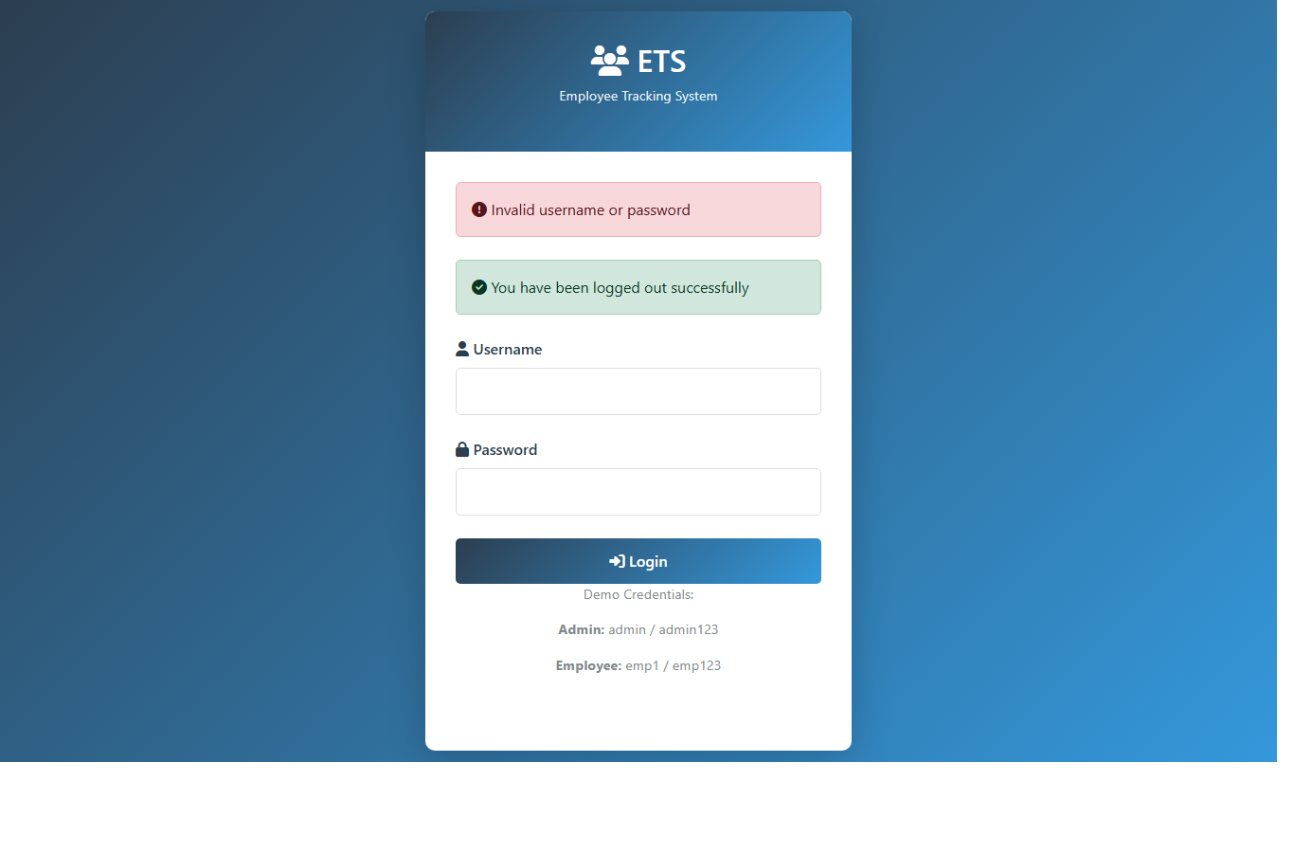
Login Page Snapshot
templates/login.html
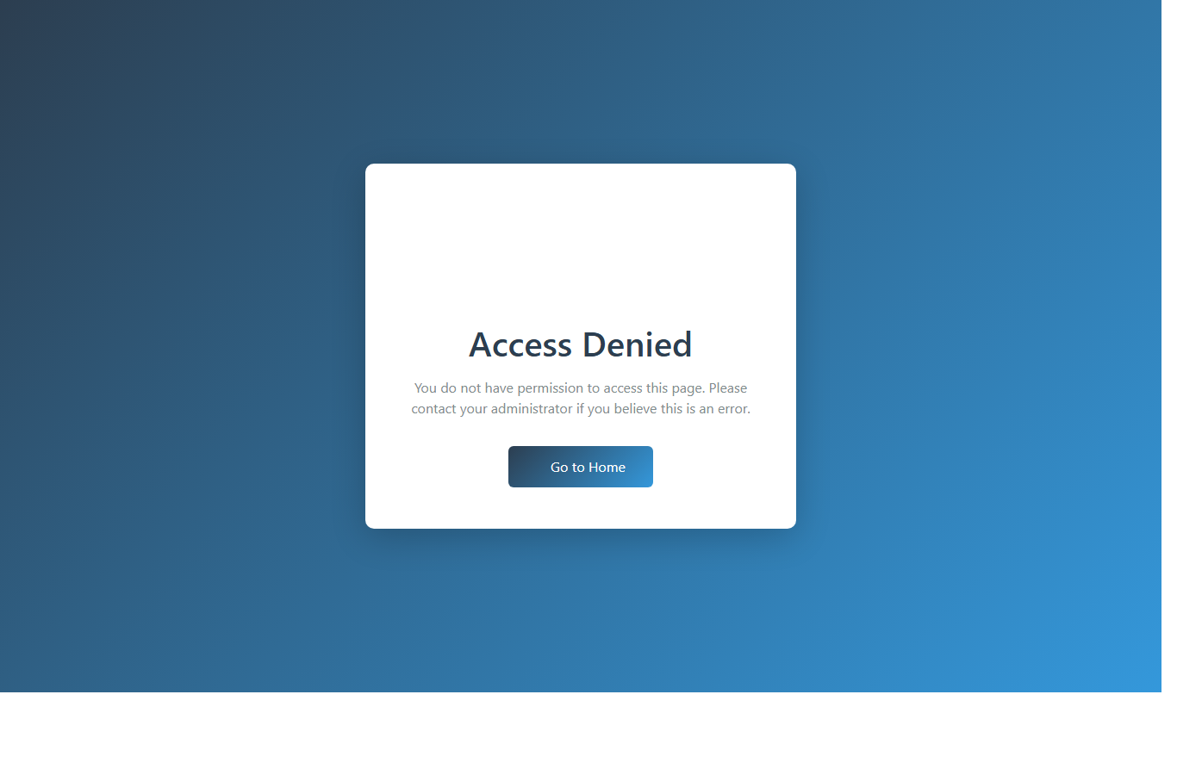
Access Denied Snapshot
templates/access-denied.html
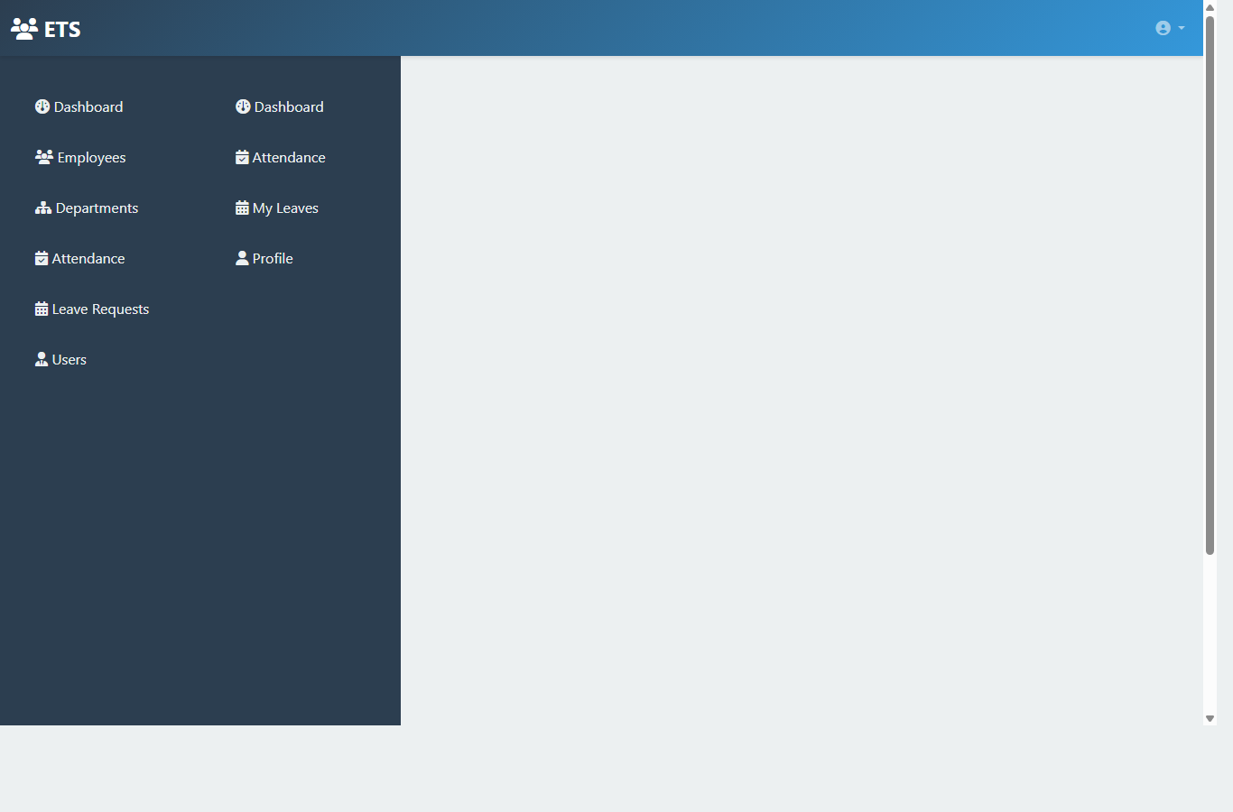
Layout Snapshot
templates/layout.html

7.2 Admin Module Pages
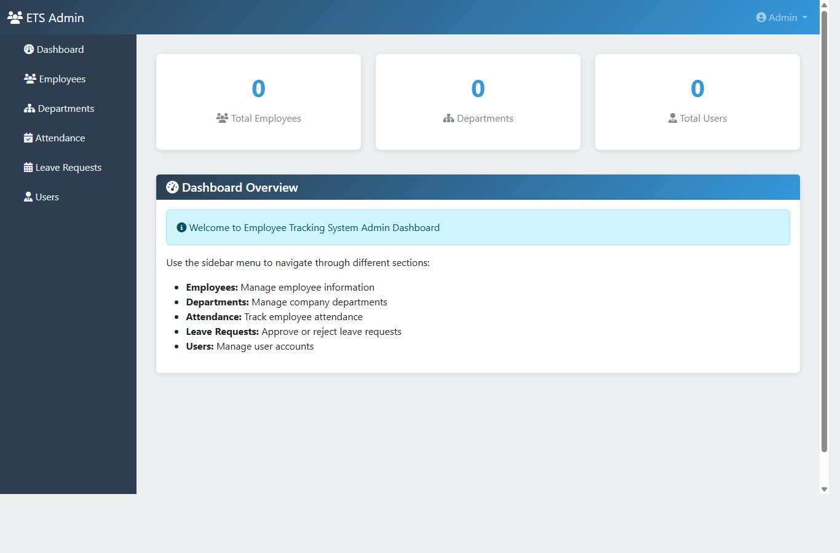
Admin Dashboard
templates/admin/dashboard.html
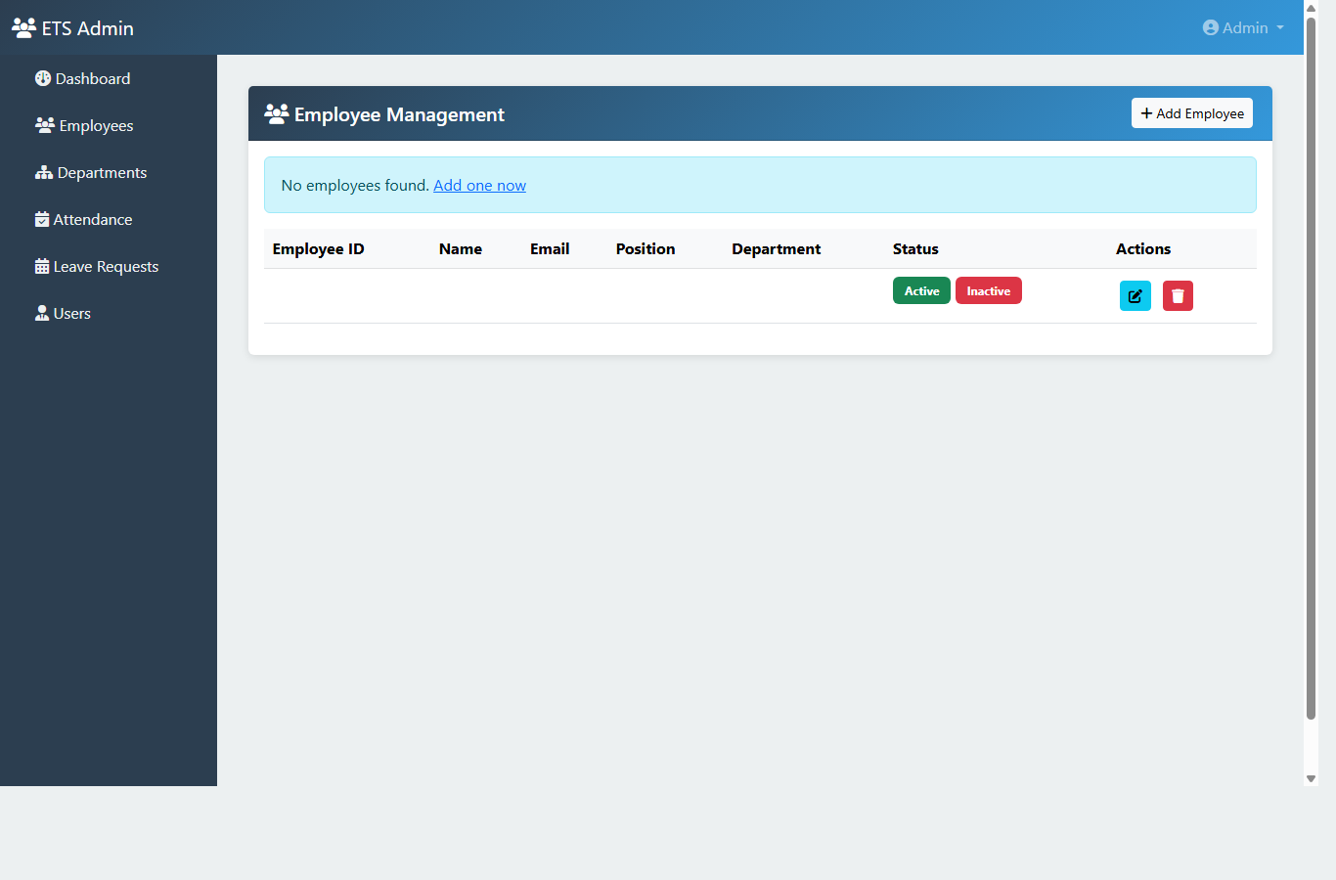
Employees List
templates/admin/employees/list.html
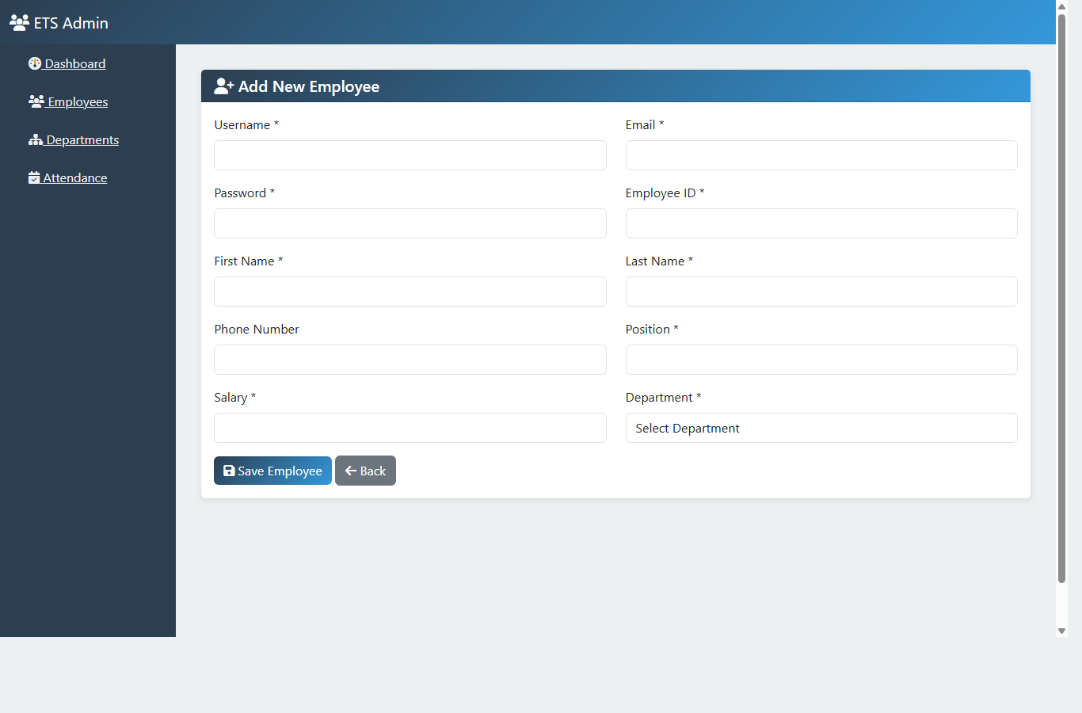
Add Employee
templates/admin/employees/add.html
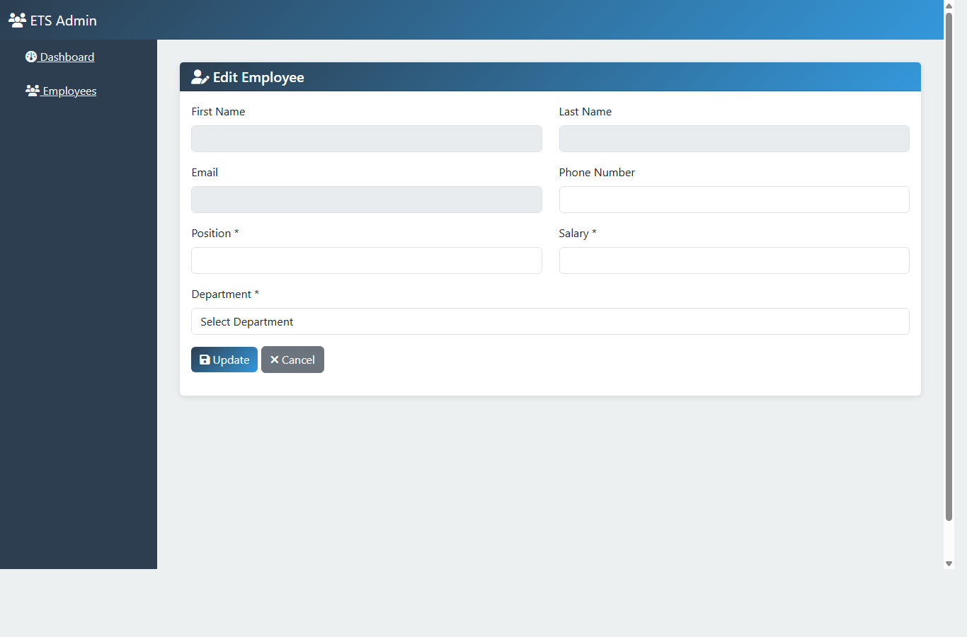
Edit Employee
templates/admin/employees/edit.html
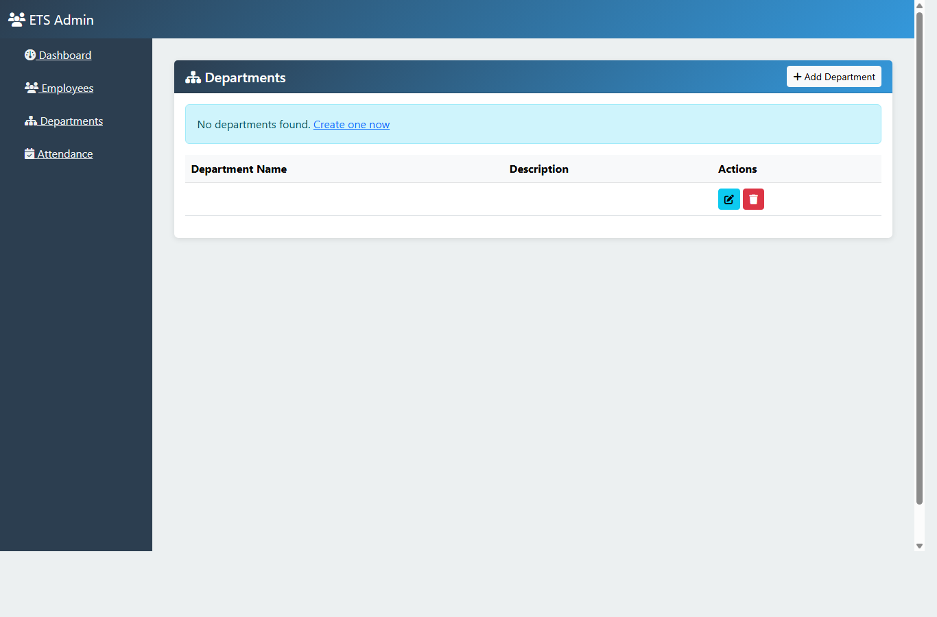
Departments List
templates/admin/departments/list.html
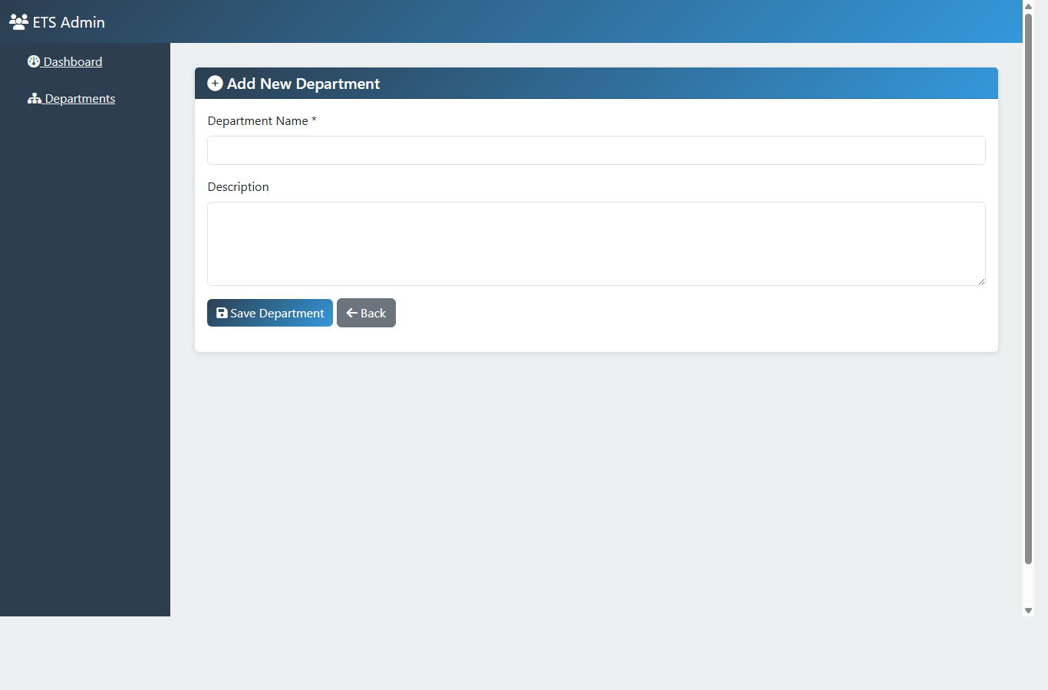
Add Department
templates/admin/departments/add.html
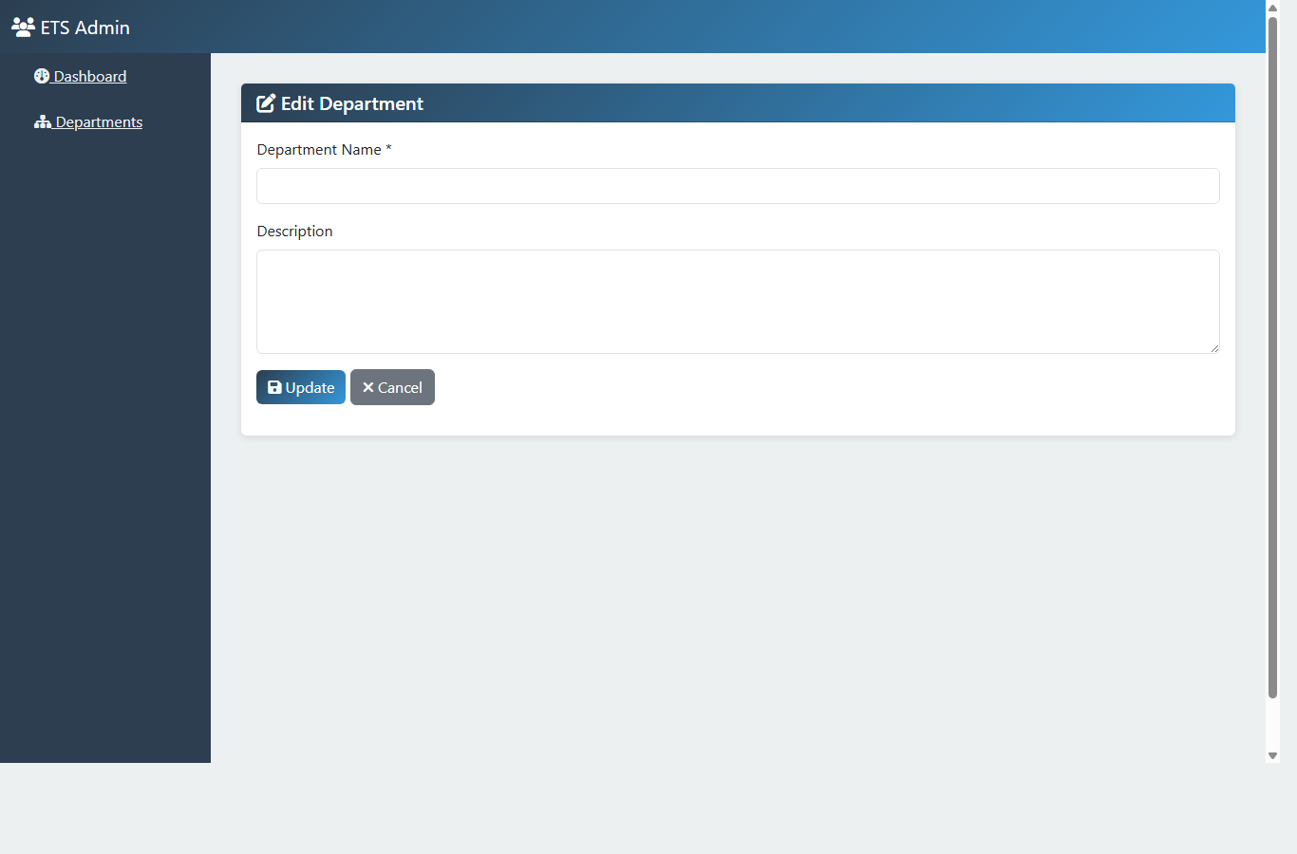
Edit Department
templates/admin/departments/edit.html
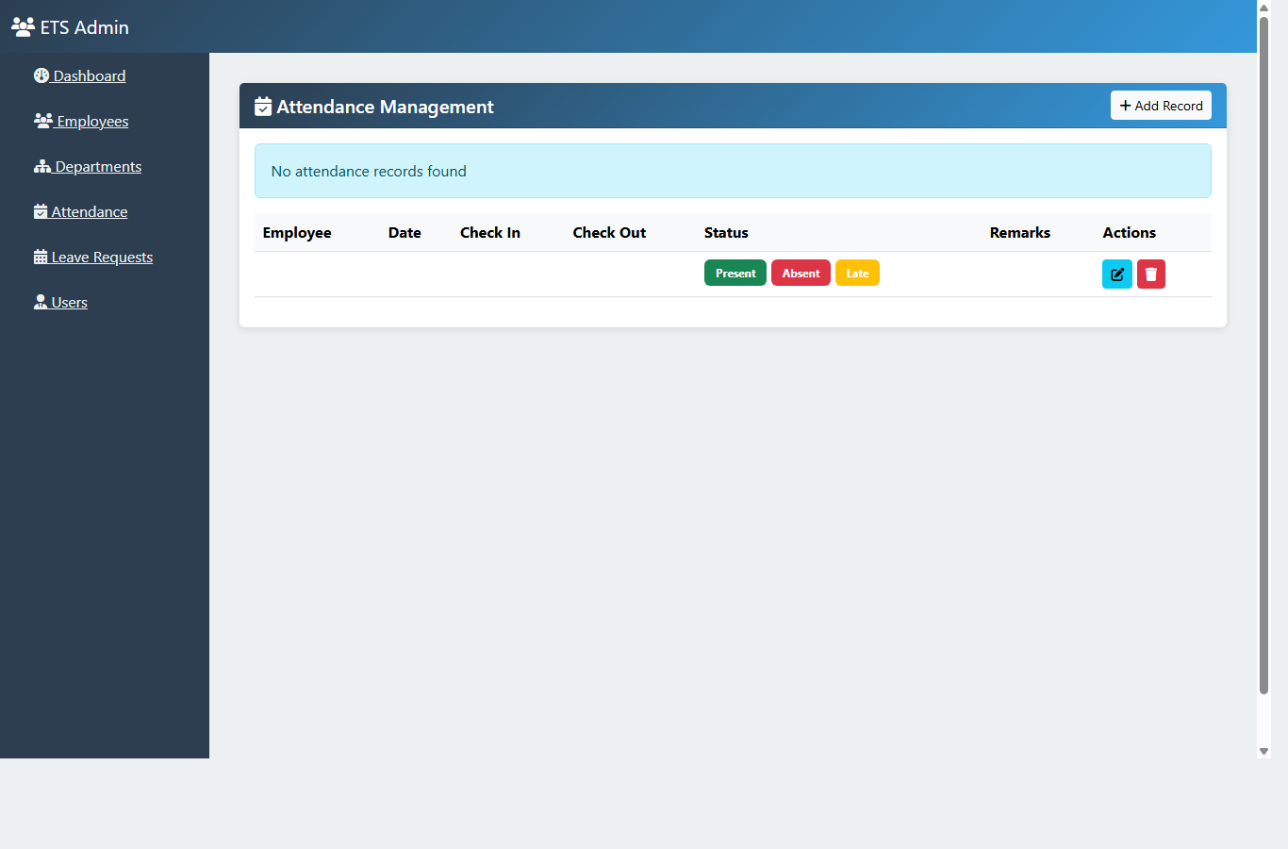
Attendance List
templates/admin/attendance/list.html
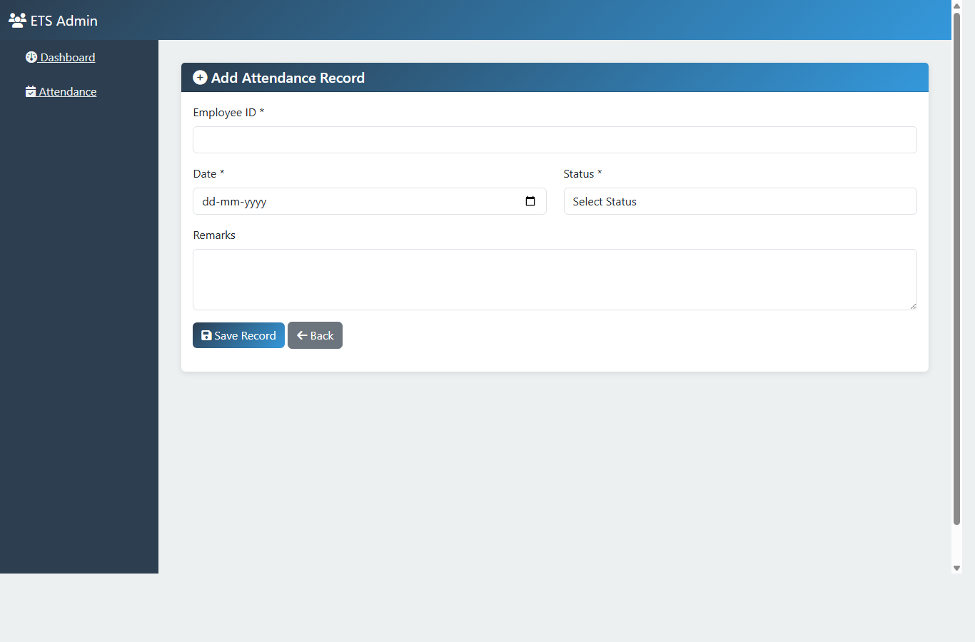
Add Attendance
templates/admin/attendance/add.html
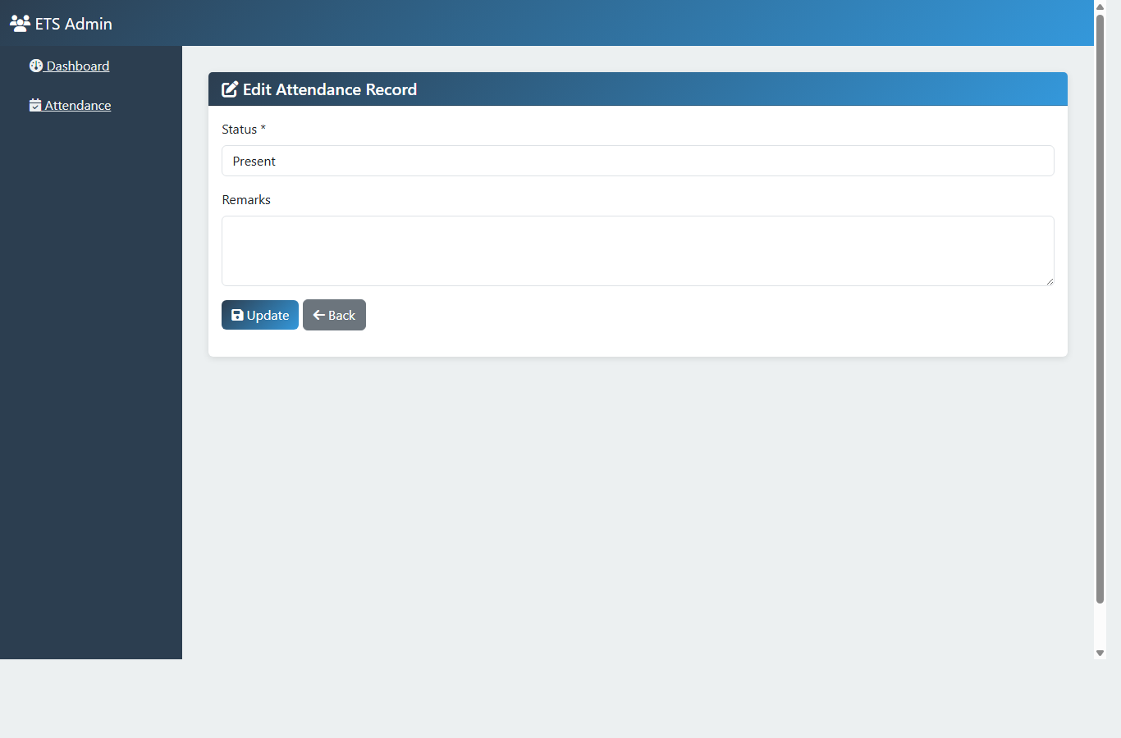
Edit Attendance
templates/admin/attendance/edit.html
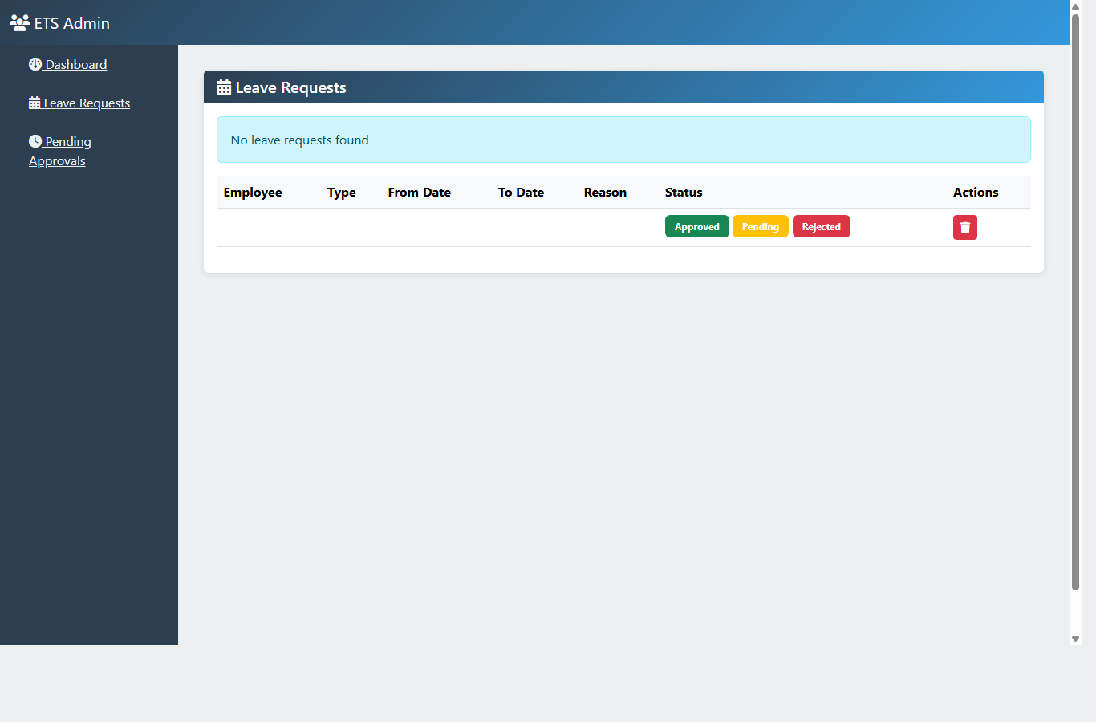
Leaves List
templates/admin/leaves/list.html
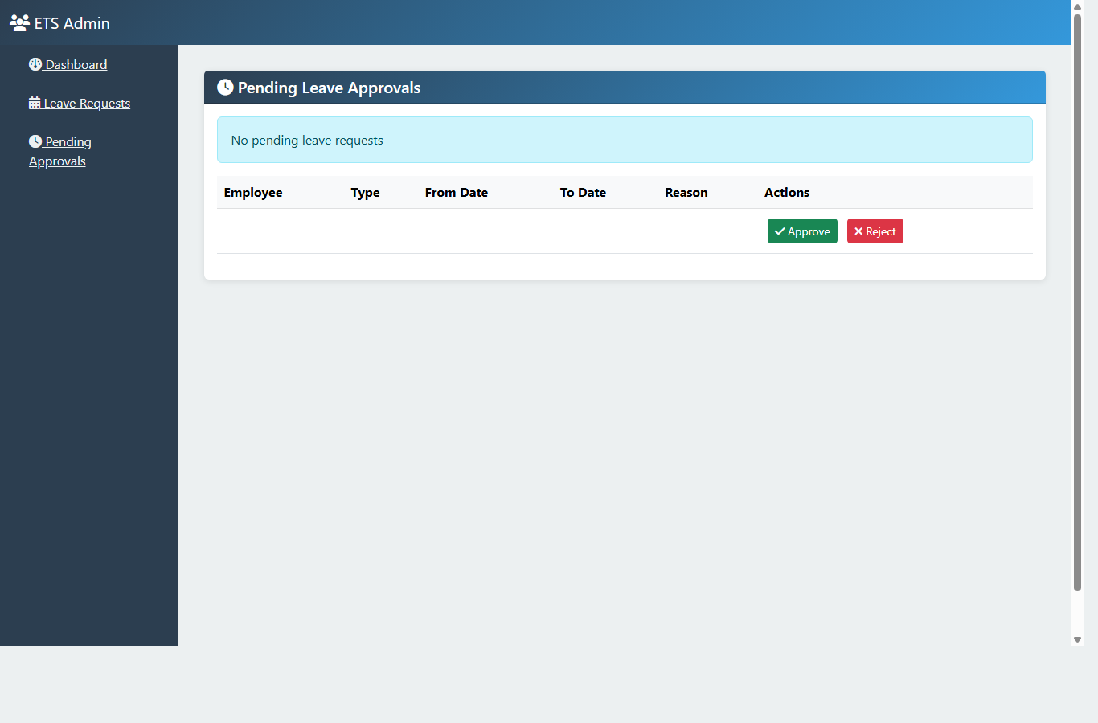
Pending Leaves
templates/admin/leaves/pending.html
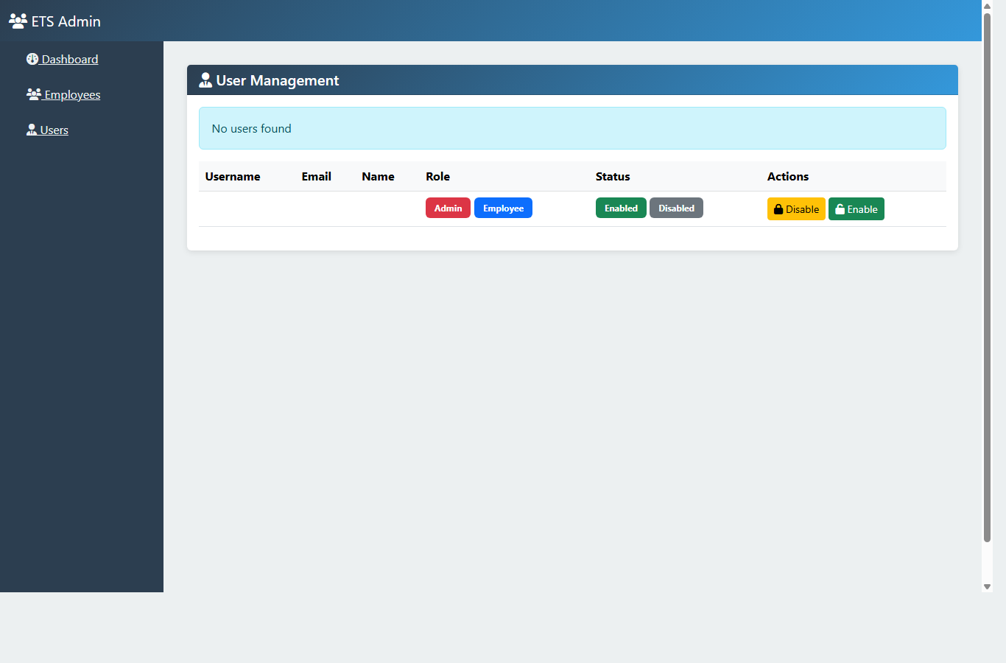
Users List
templates/admin/users/list.html

7.3 Employee Module Pages
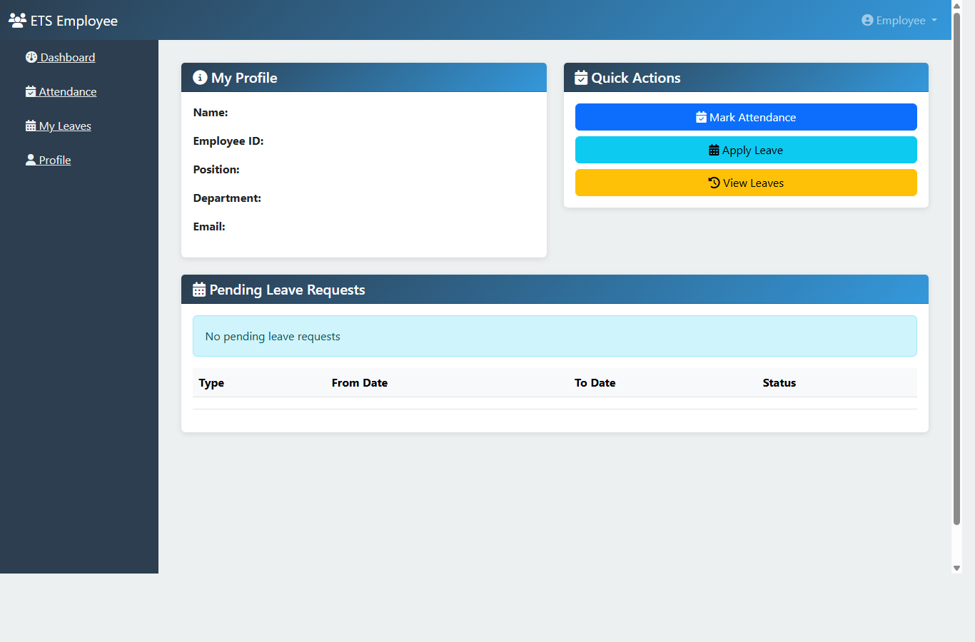
Employee Dashboard
templates/employee/dashboard.html
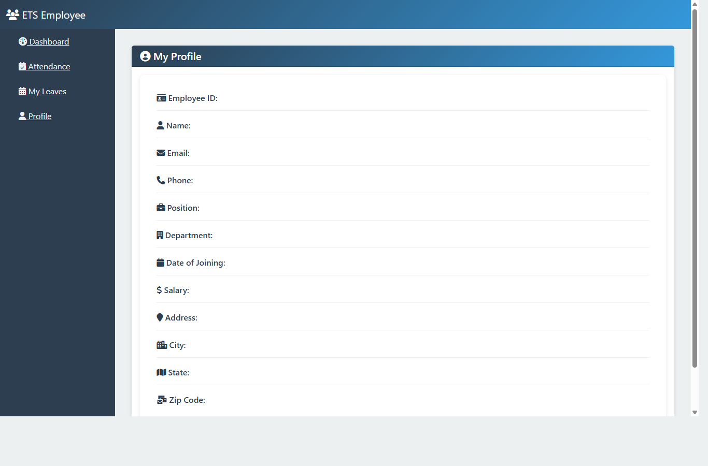
Employee Profile
templates/employee/profile.html
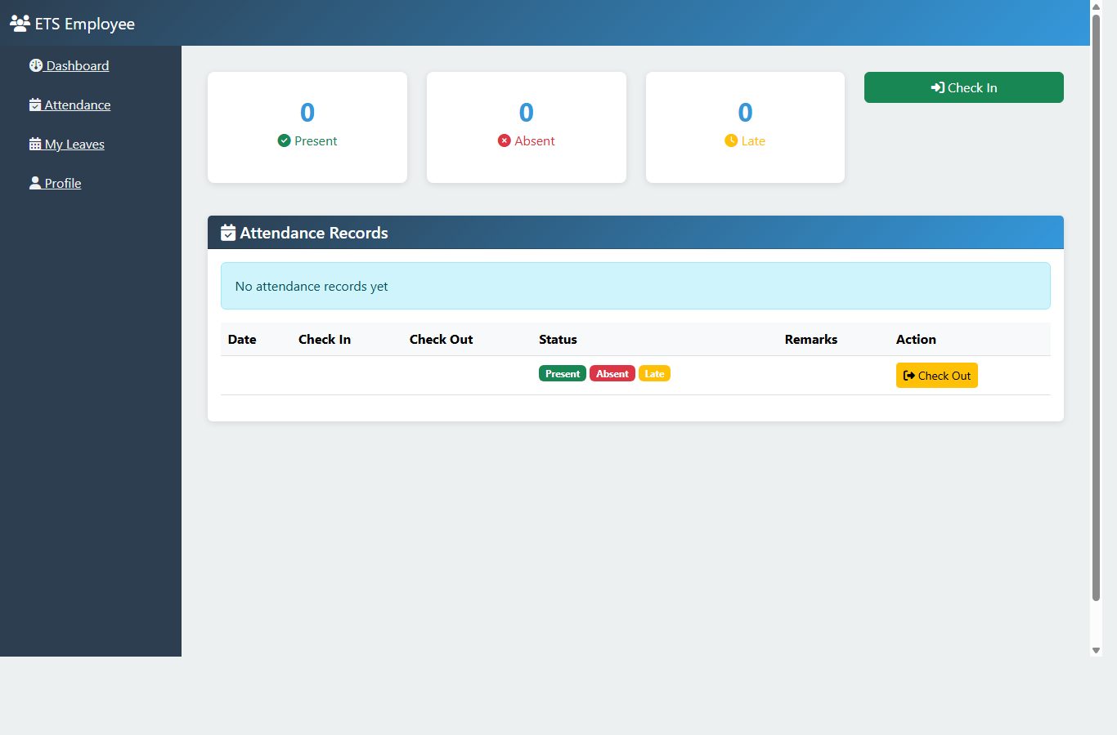
Employee Attendance
templates/employee/attendance.html
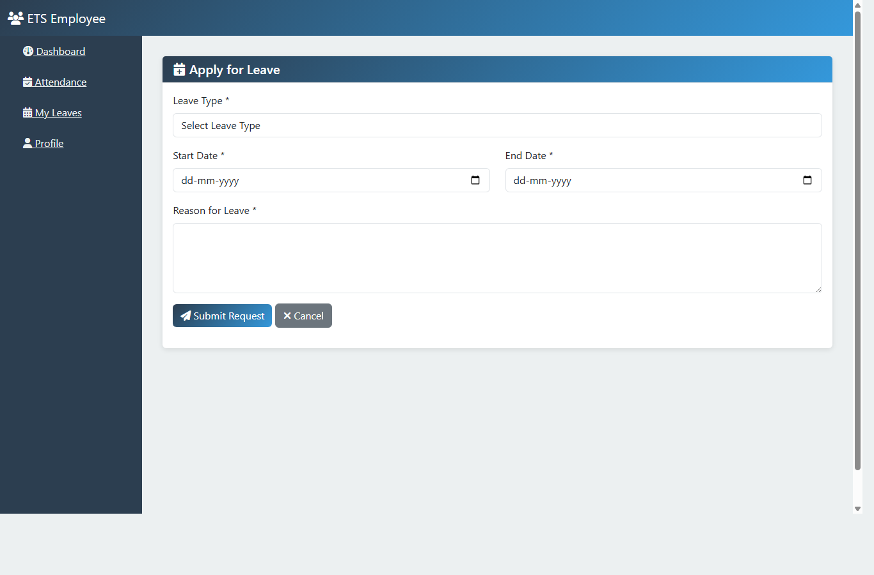
Apply Leave
templates/employee/apply-leave.html
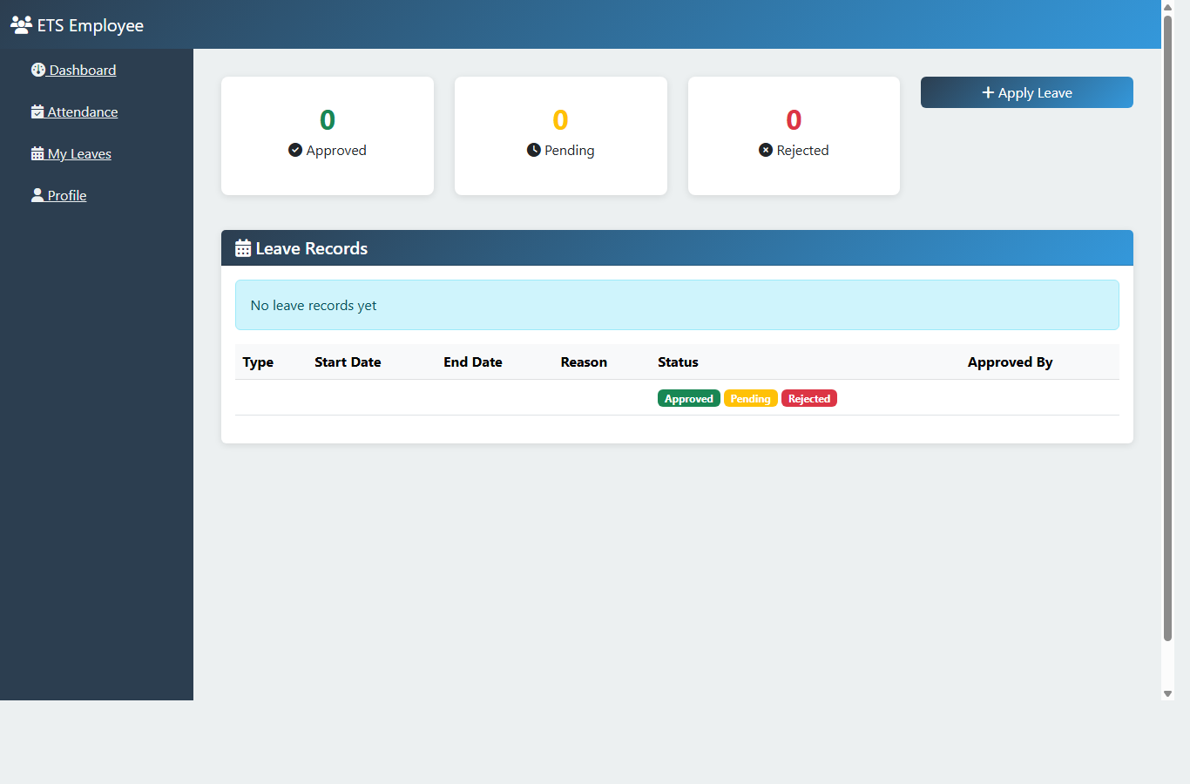
Employee Leaves
templates/employee/leaves.html

CHAPTER 8 : TESTING
The project is validated through unit and integration test setup in Maven, route access verification by role, form validation checks,
and end-to-end functional flow testing for attendance and leave operations.
Test Area | Verification | Status
Authentication | Valid and invalid login scenarios | Pass
Authorization | Route access based on role | Pass
Employee CRUD | Create/update/delete/list operations | Pass
Attendance | Check-in/check-out and history flow | Pass
Leave Workflow | Apply, approve, reject lifecycle | Pass

CHAPTER 9 : RESULT AND APPLICATIONS

9.1 Project Results and Outcomes
The final solution successfully delivers all targeted modules and provides a robust base for future enterprise extensions. The platform improves process consistency,
decreases manual effort, and increases visibility over employee activities.
Key outcomes include complete CRUD functionality, role-segmented dashboards, secure authentication, clean UI implementation, and maintainable code organization.

9.2 Challenges and Solutions
Challenge | Approach | Outcome
Role-based page isolation | Centralized security configuration and URL policies | Stable permission boundaries
Data consistency across modules | Layered service logic and entity mapping | Predictable workflow behavior
Responsive UI for admin and employee screens | Bootstrap-based shared layout | Consistent cross-page UX
Validation and error feedback | Form binding + validation message handling | Improved user input quality

CHAPTER 10 : CONCLUSION AND FUTURE SCOPE

10.1 Future Enhancements
- Email and in-app notifications for leave decisions.
- Advanced analytics dashboard and PDF/Excel reporting.
- Payroll and biometric integration.
- REST API exposure for mobile clients.
- Cloud deployment with CI/CD and monitoring.

10.2 Conclusion
The Employee Tracking System capstone project demonstrates end-to-end full-stack development with secure architecture and practical business workflows.
It satisfies major HR operational requirements and serves as a strong foundation for production-grade expansion.

CHAPTER 11 : REFERENCES AND BIBLIOGRAPHY
- Spring Boot Official Documentation
- Spring Security Reference Guide
- Hibernate ORM Documentation
- Thymeleaf Documentation
- MySQL 8.0 Reference Manual
- Bootstrap 5 Documentation
Prepared for academic capstone submission purposes.

